QUESTION 1:

#include<iostream>

using namespace std;

class employee {

private:

string name;

int rank;

long long pay, med_allowance, ep_HR, GrossPay, anuual_Increment;

public:

void display(employee p) {

cout << p.rank << endl;

cout << p.pay << endl;

cout << p.med_allowance << endl;

cout << p.name << endl;

cout << p.ep_HR << endl;

cout << p.GrossPay << endl;

cout << p.anuual_Increment << endl;

}

void friend Read_record(employee);

friend void Gross_pay(employee);

friend void Annual_increment(employee);

};

void Read_record(employee x) {

cout << "Input Name of the Employee:";

cin >> x.name;

cout << "Input Rank of Employee:";

cin >> x.rank;

cout << "Input Pay of the Employee:";

cin >> x.pay;

Gross_pay(x);

}

void Gross_pay(employee y) {

y.ep_HR = y.pay * 0.289;

y.med_allowance = y.pay * 0.6;

y.GrossPay = y.ep_HR + y.pay + y.med_allowance;

Annual_increment(y);

}

void Annual_increment(employee z) {

z.anuual_Increment = z.pay + (z.pay * 0.20);

z.display(z);

}

int main() {

employee ep;

Read_record(ep);

return 0;

}

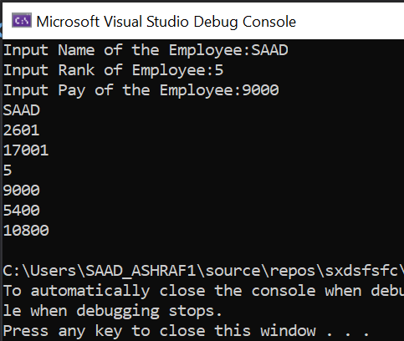

QUESTION 3:

#include <iostream>

using namespace std;

class base {

private:

int base1, base2, base3;

public:

base() {

base1 = 0;

base2 = 0;

base3 = 0;

}

base(int b1, int b2, int b3) {

base1 = b1;

base2 = b2;

base3 = b3;

}

void show() {

cout << "Base 1 = " << base1 << endl;

cout << "Base 2 = " << base2 << endl;

cout << "Base 3 = " << base3 << endl;

}

};

class Friend_Class : public base {

public:

void AccessMethod() {

base::show();

}

};

class Friend2_Class : public Friend_Class {

public:

void AcccessMethod() {

Friend_Class::AccessMethod();

}

};

int main()

{

base b1;

b1.show();

base b2(23, 34, 45);

b2.show();

cout << endl; // just to add space

Friend_Class c1;

c1.AccessMethod();

cout << endl; // just to add space

Friend2_Class f1;

f1.AcccessMethod();

}

