TASK 2:

#include <iostream>

using namespace std;

struct saxon {

float width, length, height, length1, width1;

};

void room(float length, float width) {

float area = 0.0;

area = width * length;

cout << area;

}

void pool(float length1, float width1, float height){

float area2 = 0.0;

area2 = width1 * length1 * height;

cout << area2;

}

int main() {

saxon var;

cout << "Enter The Lenght Of Room : ";

cin >> var.length;

cout << "Enter The Width Of Room : ";

cin >> var.width;

cout << "Saxon will clean area of room which is ";

room(var.length, var.width);

cout << endl;

cout << "Enter The Lenght Of POOL : ";

cin >> var.length1;

cout << "Enter The Width Of POOL : ";

cin >> var.width1;

cout << "Enter The Height Of POOL : ";

cin >> var.height;

cout << "Saxon will clean volume of pool which is ";

pool(var.length1, var.width1, var.height);

return 0;

}

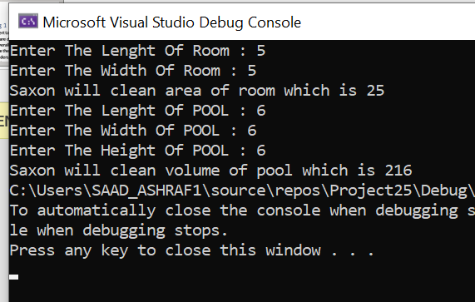

TASK 3:

#include <iostream>

using namespace std;

struct item {

int burger, drinks, sweet, x;

};

int main() {

item order;

int choice, bill = 0;

cout << "Press 1 for burger and drink\n Press 2 for Drinks and sweet\n Press 3 for sweets and burger\n Press 4 for just burger\n Press 5 for just drinks\n Press 6 for just sweets : " << endl;

cin >> choice;

if (choice == 1) {

cout << "How many burgers do you want : ";

cin >> order.burger;

cout << "HOW MANY DRINKS : ";

cin >> order.drinks;

bill = (200 * order.burger)+(60* order.drinks);

cout <<"Your Order =>>;"<< order.burger<<" Burgers and " << order.drinks <<" drinks " << "TOTAL BILL : " << bill;

}

if (choice == 2) {

cin >> order.drinks;

cin >> order.sweet;

bill = (120 * order.sweet) + (60 * order.drinks);

cout << "Your Order =>>;" << order.drinks << " drinks and " << order.sweet << " sweets " << "TOTAL BILL : " << bill;

}

if (choice == 3) {

cin >> order.sweet;

cin >> order.burger;

bill = (200 * order.burger) + (120 * order.sweet);

cout << bill;

}

if (choice == 4) {

cin >> order.burger;

bill = (200 * order.burger);

cout << bill;

}

if (choice == 5) {

cin >> order.drinks;

bill = (60 * order.drinks);

cout << bill;

}

if (choice == 6) {

cin >> order.sweet;

bill = (120 * order.sweet);

cout << bill;

}

return 0;

}

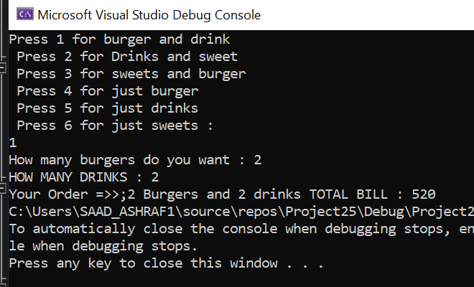

**DID NOT MAKE THE ENTIRE PROGRAM BEAUTIFUL DUE TO LESS TIME!!**

Task 5:

#include <iostream>

using namespace std;

struct x {

int feet, feet1;

float inch, inch1;

}var;

int main() {

int spec;

x varr;

cout << "Enter The 1st Distance," << endl;

cout << "Enter The 1st Feet: ";

cin >> varr.feet;

cout << "Enter The 1st Inch: ";

cin >> varr.inch;

cout << "Enter The 2nd Distance" << endl;

cout << "Enter The 2nd Feet: ";

cin >> varr.feet1;

cout << "Enter The 2nd Inch: ";

cin >> varr.inch1;

var.inch = varr.inch + varr.inch1;

var.feet = varr.feet + varr.feet1;

if ( 12 < var.inch) {

spec = var.inch / 12;

var.feet = var.feet + spec;

var.inch = var.inch - (spec * 12);

}

cout << "The Feet Distances Iss : " << var.feet << " Feet " << endl;

cout << "The Inches Are : "<< var.inch << " Inches" << endl;

return 0;

}

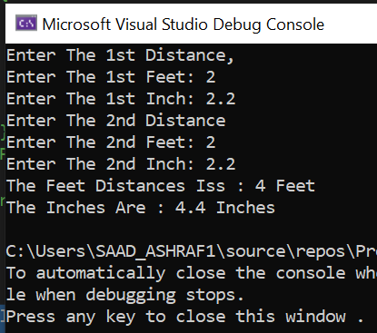

TASK 4:

#include <iostream>

using namespace std;

struct Marks {

int rollnumber[5];

string name[5];

float chemistry[5], physics[5], maths[5];

float percentage[5];

};

void Percentage(float chemistry[], float physics[], float maths[]) {

Marks student;

for (int i = 0; i < 5; i++) {

student.percentage[i] = ((chemistry[i] + physics[i] + maths[i]) / 300) * 100;

cout <<" Has the percentage "<< student.percentage[i] << endl;

}

}

int main() {

Marks student;

for (int i = 0; i < 5 ; i++)

{

cout << "Enter roll number : " << endl;

cin >> student.rollnumber[i];

cout << "Enter name : " << endl;

cin >> student.name[i];

cout << "Enter marks : " << endl;

cin >> student.chemistry[i];

cout << "Enter marks : " << endl;

cin >> student.physics[i];

cout << "Enter marks : " << endl;

cin >> student.maths[i];

}

Percentage(student.chemistry, student.physics, student.maths);

return 0;

}

