TASK 1:

PART A:

#include<iostream>

using namespace std;

int main()

{

char str[1000];

cout << "Enter The String : ";

cin >> str;

char\* ptr1, \* ptr2;

ptr1 = str;

while (\*ptr1 != '\0') {

++ptr1;

}

--ptr1;

for (ptr2 = str; ptr1 >= ptr2;) {

if (\*ptr1 != \*ptr2) {

break;

}

else

--ptr1;

ptr2++;

}

if (ptr2 < ptr1)

cout << str << " String is not a Palindrome" << endl;

else

cout << str << " String is Palindrome" << endl;

system("pause");

return 0;

}

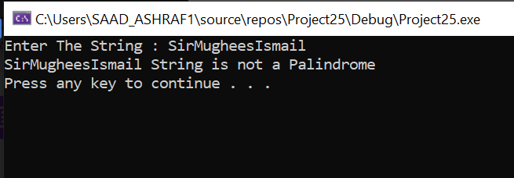

PART B:

#include<iostream>

#include <string>

using namespace std;

int main()

{

char str[100];

cout << "Enter a string : ";

cin >> str;

int l;

char\* ptr1, \* ptr2, x;

l = strlen(str); //predefined function to return lenght of a string and storing it in the variable "l"

ptr1 = str;

ptr2 = str;

int i = 0;

while (i < l - 1) {

ptr2++;

i++;

}

int k = 0;

while ( k < l / 2) {

x = \*ptr2;

\*ptr2 = \*ptr1;

\*ptr1 = x;

ptr2--;

ptr1++;

k++;

}

cout << "Reverse of the string is : " << str << endl;

system("pause");

return 0;

}

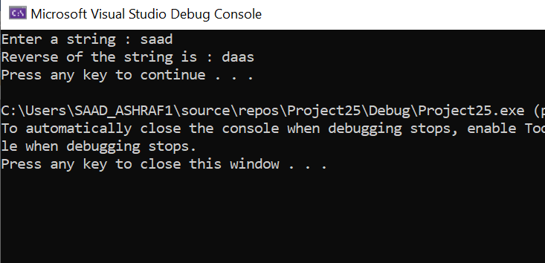

TASK 4:

#include <iostream>

using namespace std;

int main()

{

int rows, columns;

int a[100][100];

cout << "Enter Number Of Rows : ";

cin >> rows;

cout << "Enter Number Of Columns : ";

cin >> columns;

for (int i = 0; i < rows; ++i)

for (int j = 0; j < columns; ++j)

{

cout << "Enter element a" << i + 1 << j + 1 << " : ";

cin >> a[i][j];

}

int i, k = 0, z = 0;

while (k < rows && z < columns)

{

for (i = z; i < columns; ++i)

{

cout << a[k][i] << " ";

}

k++;

for (i = k; i < rows; ++i)

{

cout << a[i][columns - 1] << " ";

}

columns--;

if (k < rows)

{

for (i = columns - 1; i >= z; --i)

{

cout << a[rows - 1][i] << " ";

}

rows--;

}

if (z < columns)

{

for (i = rows - 1; i >= k; --i)

{

cout << a[i][z] << " ";

}

z++;

}

}

return 0;

}

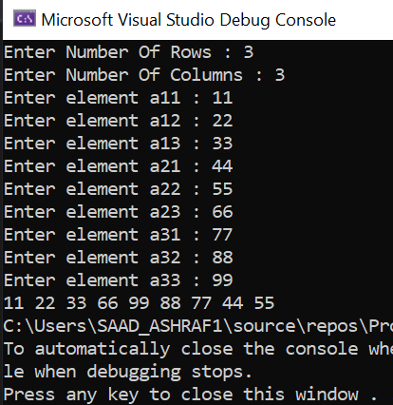

TASK 3:

#include<iostream>

using namespace std;

int main()

{

int arr[] = { 1, 2, 5, 7, 9, 5, 2, 3, 6 };

int n = sizeof(arr) / sizeof(arr[0]);

int k = 3, j, max;

for (int i = 0; i <= n - k; i++)

{

max = arr[i];

for (j = 1; j < k; j++)

{

if (arr[i + j] > max)

max = arr[i + j];

}

cout << max << " ";

}

return 0;

}

