TASK 1:

#include<iostream>

using namespace std;

int main() {

int number;

cout << "Enter a number";

cin >> number;

if (number > 0) {

cout << number << "is positive";

}

if (number < 0) {

cout << number << "is negative";

}

if (number == 0) {

cout << number << "is equal to zero";

}

system("pause");

return 0;

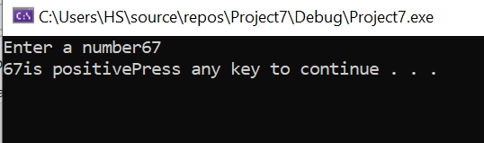}

TASK 2:

#include <iostream>

using namespace std;

int main()

{

int n, n1, n3, reverse = 0;

cout << "Enter a 5 digit number: ";

cin >> n1;

n = n1;

do

{

n3 = n1 % 10;

reverse = (reverse * 10) + n3;

n1 = n1 / 10;

} while (n1 != 0);

cout << " The reverse of the number is: " << reverse << endl;

if (n == reverse)

cout << " The number is palindrome";

else

cout << " The number is not palindrome";

system("pause");

return 0;

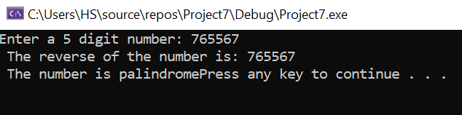}

TASK 3:

#include <iostream>

using namespace std;

int main()

{

int day;

cout << "Press 1 for Monday" << endl;

cout << "Press 2 for Tuesday" << endl;

cout << "Press 3 for Wednesday" << endl;

cout << "Press 4 for Thursday" << endl;

cout << "Press 5 for Friday" << endl;

cout << "Press 6 for Saturday" << endl;

cout << "Press 7 for Sunday" << endl;

cout << "Enter Day Number" << endl;

cin >> day;

if (day == 1) {

cout << "Today Is Monday";

}

if (day == 2) {

cout << "Today Is Tuesday";

}

if (day == 3) {

cout << "Today Is Wednesday";

}

if (day == 4) {

cout << "Today Is Thursday";

}

if (day == 5) {

cout << "Today Is Friday";

}

if (day == 6) {

cout << "Today Is Saturday";

}

if (day == 7) {

cout << "Today Is Sunday";

}

system("pause");

return 0;

}

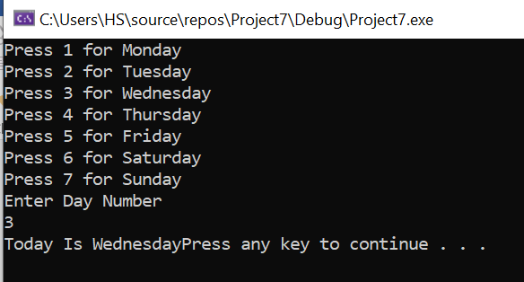

TASK 4:

BY IF ELSE STATEMENT:

#include<iostream>

using namespace std;

int main() {

int units;

float amount, totalbill, surcharge = 0;

cout << "Enter units :";

cin >> units;

if (units <= 50)

{

amount = units * 0.5;

}

else if (units > 50 && units <= 150) {

units = units - 50;

amount = (50 * 0.50) + (units * 0.75);

}

else if (units > 150 && units <= 250) {

units = units - 150;

amount = (50 * 0.50) + (100 * 0.75) + (units * 1.20);

}

else if (units > 250) {

units = units - 250;

amount = (50 * 0.50) + (100 * 0.75) + (100 * 1.20) + (units * 1.50);

}

surcharge = (0.20) * amount;

totalbill = amount + surcharge;

cout << "Total bill is :" << totalbill;

system("pause");

return 0;

}

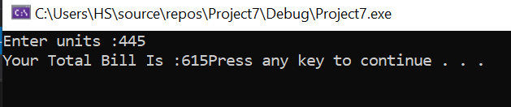

BY SWITCH:

#include<iostream>

using namespace std;

int main()

{

int unit;

float amount, total_amount, s_charge;

cout << "enter the number of units you consumed" << endl;

cin >> unit;

switch (unit <= 50)

{

case 1:

amount = unit * 0.50;

break;

case 0:

switch (unit <= 150)

{

case 1:

unit = unit - 50;

amount = (50 * 0.50) + (unit * 0.75);

break;

case 0:

switch (unit <= 250)

{

case 1:

unit = unit - 150;

amount = (50 * 0.50) + (100 * 0.75) + (unit * 1.20);

break;

case 0:

switch (unit > 250)

{

case 1:

unit = unit - 250;

amount = (50 * 0.50) + (100 * 0.75) + (100 * 1.20) + (unit * 1.50);

break;

}

}

}

}

s_charge = amount * 0.20;

total_amount = amount + s_charge;

cout << "your total bill is Rs" << total_amount;

system("pause");

return 0;

}

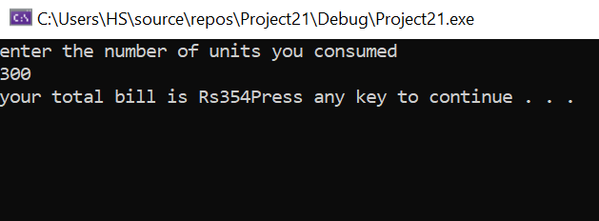

TASK 5:

#include<iostream>

using namespace std;

int main() {

int colonial, split_entry, single_story, area, price_colonial, price_split, price_single, minimum_price;

cout << "Enter per square unit price of split_entry :"<<endl;

cin >> split_entry;

cout << "Enter per square unit price of colonial :"<<endl;

cin >> colonial;

cout << "Enter per square unit price of single_story :"<<endl;

cin >> single_story;

cout << "Enter area in square feet :";

cin >> area;

price_single = area * single_story;

price_colonial = area * colonial;

minimum_price = price_colonial;

price_split = area * split_entry;

if (price_split < minimum_price)

minimum_price = price_split;

if (price_single < minimum_price)

minimum_price = price_single;

if (minimum_price == price_split)

cout << "spilt_entry has the least price and it is :" << minimum_price << "$"<<endl;

if (minimum_price == price_single)

cout << "single story has the least price and it is :" << minimum_price << "$" << endl;

if (minimum_price == price_colonial)

cout << "colonial story has the least price and it is :" << minimum_price << "$" << endl;

system("pause");

return 0;

}

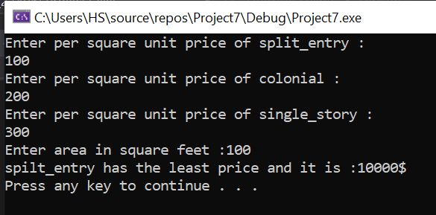

TASK 6:

#include<iostream>

using namespace std;

int main()

{

char ch;

cout << "Input any character: ";

cin >> ch;

if (ch <= 90 && ch >= 65)

cout << endl << "It Is An Uppercase Character";

else if (ch <= 122 && ch >= 97)

cout << endl << "You entered a lowercase character";

system("pause");

return 0;

}

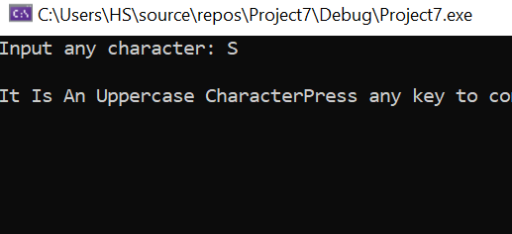

TASK 7:

#include<iostream>

using namespace std;

int main()

{

char grade;

cout << "Press a for M>=85 " << endl;

cout << "Press A for 80<=M<85 " << endl;

cout << "Press b for 70<=M<80 " << endl;

cout << "Press B for 60<=M<70 " << endl;

cout << "Press c for 50<=M<60 " << endl;

cout << "Press C for 40<=M<50 " << endl;

cout << "Press D for 35<=M<40 " << endl;

cout << "Press F for M<35 " << endl;

cout << "Enter any character";

cin >> grade;

if (grade == 'a') {

cout << "This Grade Lies In Range: M>=85";

}

if (grade == 'A') {

cout << "This Grade Lies In Range: 80<=M<85";

}

if (grade == 'b') {

cout << "This Grade Lies In Range: 70<=M<80";

}

if (grade == 'B') {

cout << "This Grade Lies In Range: 60<=M<70";

}

if (grade == 'c') {

cout << "This Grade Lies In Range: 50<=M<60";

}

if (grade == 'C') {

cout << "This Grade Lies In Range: 40<=M<50";

}

if (grade == 'D') {

cout << "This Grade Lies In Range: 35<=M<40";

}

if (grade == 'F') {

cout << "This Grade Lies In Range: M<35";

}

system("pause");

return 0;

}

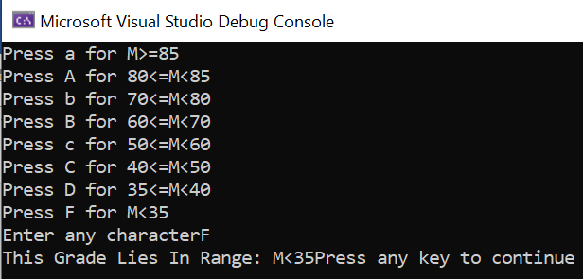

TASK 8:

#include<iostream>

using namespace std;

int main() {

int quantity, price1=0, price2=0, price3=0, price, total, number, change;

//Menu

cout << "Press \'1\' for Burger" << endl;

cout << "Press \'2\' for Fries" << endl;

cout << "Press \'3\' for Drinks" << endl;

cout << "If You want To Cancel Item Press \'0\'" << endl;

cout << "What Do You Want?" << endl;

cin >> number;

//Quantity

cout << "Enter quantity" << endl;

cin >> quantity;

if (number == 1)

price1 = 30 * quantity;

cout << "Do you want Fries?" << endl;

cin >> number;

if (number == 2) {

cout << "Enter quantity" << endl;

cin >> quantity;

price2 = 10 * quantity;

}

if (number == 0) {

}

cout << "Do you want Drinks" << endl;

cin >> number;

if (number == 3) {

cout << "Enter quantity" << endl;

cin >> quantity;

price3 = 5 * quantity;

}

if (number == 0) {

}

//Totall Bill

price = price1 + price2 + price3;

cout << "Total Amount is :" << price << endl;

cout << "Enter price =";

cin >> total;

//For Change

change = total - price;

if (change >= 0)

cout << "Remaining Amount is " << change << "$";

else

cout << "Invalid input";

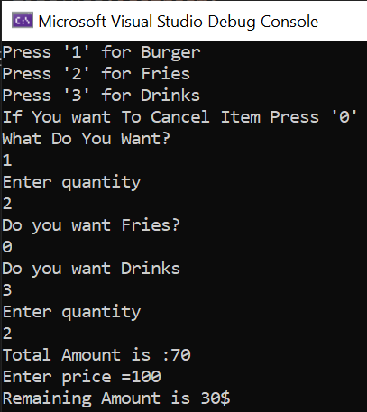 return 0;}