**TASK 2:**

#include<iostream>

using namespace std;

void bubblesprt(int size, int array[]) {

for (int i = 0; i <= size; i++) {

for (int j = 0; j <= size; j++) {

if (array[i] < array[j + 1]) {

int temp = array[i];

array[i] = array[j + 1];

array[j + 1] = temp;

}

}

}

}

int main() {

int size, array[100];

cout << "Enter size of array" << endl;

cin >> size;

for (int i = 0; i <= size; i++) {

cin >> array[i];

}

cout << "The array is" << endl;

for (int i = 0; i < size; i++) {

cout << array[i] << " " << endl;

}

cout << endl;

cout << "After sorting the array is: " << endl;

bubblesprt(size, array);

system("pause");

}

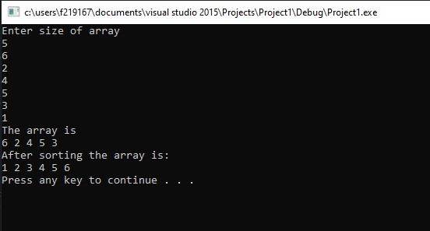

**TASK 1:**

#include<iostream>

using namespace std;

void candy(int candies[100], int result[100], int extracandies, int size) {

cout << "enter the size of the candies array" << endl;

cin >> size;

for (int i = 0; i <= size; i++) {

cin >> candies[i];

}

cout << "Enter the number of extra candies" << endl;

cin >> extracandies;

for (int i = 0; i <= size; i++) {

cout << "The kid will have " << candies[i] + extracandies << " candies which is greatest" << endl;

}

}

int main() {

int candies[100],

int result[100],

int extracandies,

int size;

candy(candies, result, extracandies, size);

system("pause");

}

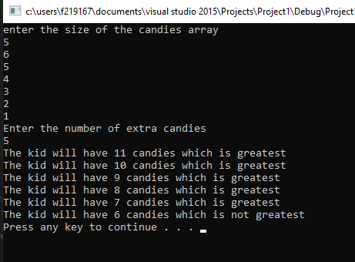

**TASK 5:**

#include<iostream>

#include<string>

using namespace std;

char arr[];

int size;

void conversionofalphapet(char arr[], int size) {

for (int i = 0; i <= size; i++) {

cout << arr[i] << " ";

}

for (int i = 0; i <= size; i++) {

if (arr[i] == 'a' || arr[i] == 'e' || arr[i] == 'i' || arr[i] == 'o' || arr[i] == 'u') {

}

if (arr[i] != 'a' || arr[i] != 'e' || arr[i] != 'i' || arr[i] != 'o' || arr[i] != 'u') {

}

}

system("pause");

}

int main() {

int size;

cin >> size;

char arr[100];

arr[100] = arr[size];

for (int i = 0; i <= size; i++) {

cin >> arr[i];

}

conversionofalphapet( arr, size);

system("pause");

}

**TASK 4:**

#include<iostream>

#include<fstream>

using namespace std;

int main() {

int shortest_height, number_of_classes, size, height_of_students[100];

ifstream fin("inputfile.txt");

ofstream fout("outputfile.txt");

if (!fin.is_open()) {

cout << "Error in opening file" << endl;

}

else

{

cout << "The file has been opened from the location" << endl;

}

cout << "Enter the total number of classes whose studnets height you want to compare: " << endl;

cin >> number_of_classes;

fout << number_of_classes;

cout << "How many students height do you want to enter: " << endl;

cin >> size;

cout << "Enter height of students: " << endl;

for (int i = 0; i <= (size-1); i++) {

cin >> height_of_students[i];

}

system("pause");

}