TASK 1:

#include <iostream>

using namespace std;

int main()

{

int n1, n2, n3, minimum, maximum;

cout << " Enter the three numbers : \n\n\n";

cin >> n1 >> n2 >> n3;

minimum = n1;

maximum = n2;

if (n2 < minimum)

{

minimum = n2;

}

if (n3 < minimum)

{

minimum = n3;

}

if (n3 > maximum)

{

maximum = n3;

}

if (n2 > maximum)

{

maximum = n2;

}

cout << "The Smallest number is : " << minimum;

cout << "The Largest number among is : " << maximum;

return 0;

}

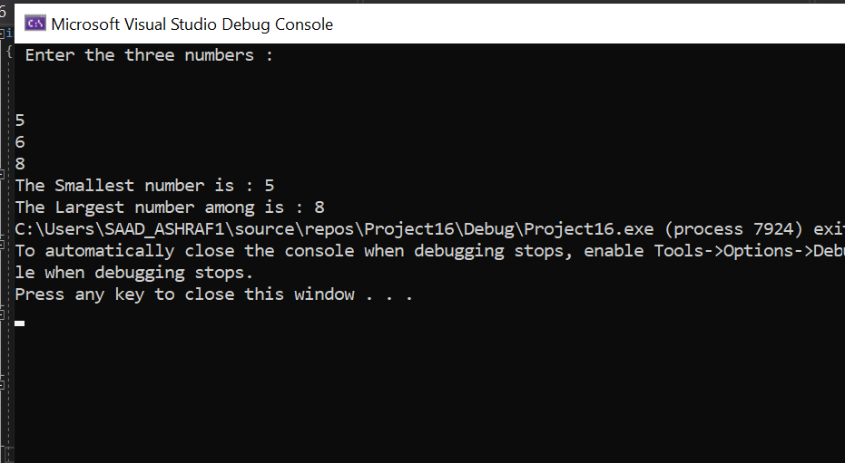

TASK 3:

#include<iostream>

using namespace std;

int main() {

int g_bill, step, elec_bill, f_bill, house_rent, salary;

cout << "Enter 1 for gas bill" << endl;

cout << "Enter 2 for electricity bill" << endl;

cout << "Enter 3 for fuel bill" << endl;

cout << "Enter 4 for house rent" << endl;

cin >> step;

cout << "salary of person:";

cin >> salary;

if (step == 1) {

g_bill = salary * 0.1;

cout << "The gas bill is " << g_bill << endl;

}

if (step == 2) {

elec_bill = salary * 0.05;

cout << "The Electricity bill is: " << elec_bill << endl;

}

if (step == 3) {

f_bill = salary * 0.1;

cout << "The Bill of fuel is:" << f_bill << endl;

}

if (step == 4) {

house_rent = salary * 0.15;

cout << "The House rent is:" << house_rent << endl;

}

return 0;

}

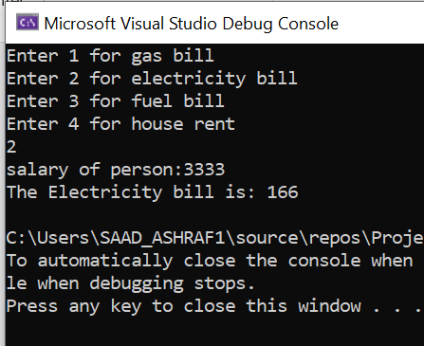

Task 4:

#include<iostream>

using namespace std;

int main() {

int n, hours, min, days;

cout << "press 1 for converting the number of days into hours" << endl;

cout << "press 2 for converting the number of days into minute" << endl;

cin >> n;

cout << "Enter number of Days :";

cin >> days;

if (n == 1) {

hours = days * 24;

cout << "The number of hours : " << hours << endl;

}

else if (n == 2) {

min = days * 24 * 60;

cout << "The number of minutes : " << min << endl;

}

return 0;

}

