TASK1:

#include<iostream>

using namespace std;

int main()

{

int base, exponent, count=1, i;

cout << "Input Base Number:" << endl;

cin >> base;

cout << "Input Exponent Number:" << endl;

cin >> exponent;

for (i = 1; i <= exponent; i++) {

count = count \* base;

}

cout <<base<< " ^ " << exponent << "=" << count << endl;

return 0;

}

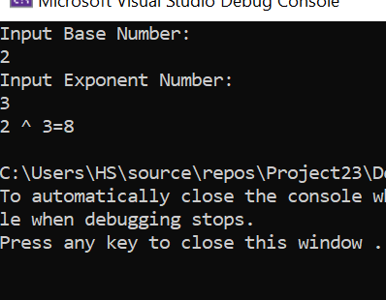

TASK 3:

#include<iostream>

using namespace std;

int main() {

int n1 = 1, n;

cout << "Enter A Number:" << endl;

cin >> n;

while (n >= 1) {

n1 = n1 \* n;

n--;

}

cout<<"The Factorial is:" << n1 << endl;

return 0;

}

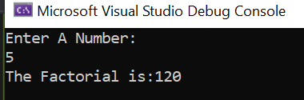

TASK 4:

#include <iostream>

using namespace std;

int main()

{

int n = 1;

double product = 1;

while (n <= 50)

{

if (n % 2 == 1)

{

cout << " " << n << endl;

product = product \* n;

}

n++;

}

cout << "The product of 1st 50 odd numbers is: " << product << endl;

return 0;

}

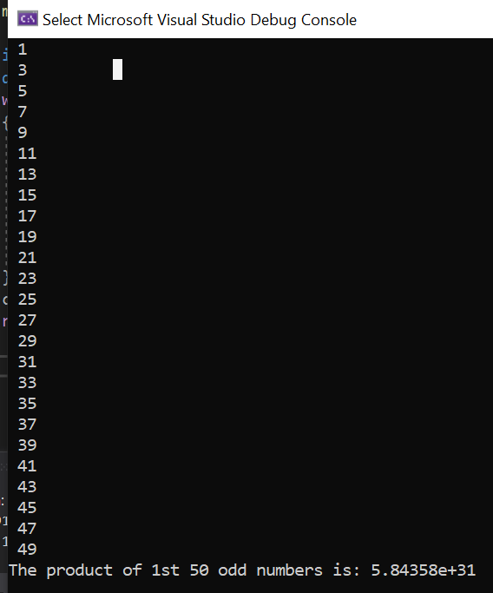

TASK 5:

#include<iostream>

using namespace std;

int main() {

int n1, n2, count = 1, n3;

cout << "Enter A Number :";

cin >> n1;

cout << "Enter A Limit :";

cin >> n2;

while (count <= n2) {

n3 = n1 \* count;

cout << n1 << " \* " << count << " = " << n3 << endl;

count++;

}

return 0;

}

