**NAME:SAAD ASHRAF ROLL NO:21F-9167**

**PRACTICE TASK 1:**

#include<iostream>

using namespace std;

int main() {

cout << "$$$$$$$$$$$$$$$$$$$$$$$$$$$$$\n $****************************$\n ***********\\\WELCOME to PF*******\n $$$$$$$$$$$$$$$$$$$$$$$$$$$$$\n";

system("pause");

return 0;

}

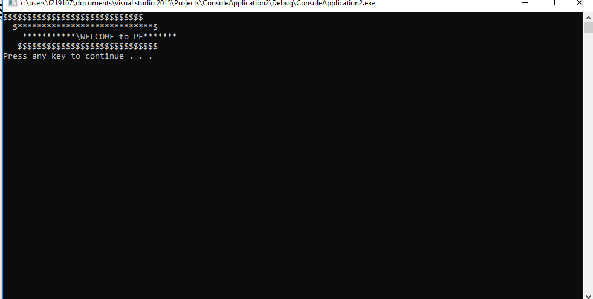

**PRACTICE TASK 2:**

#include<iostream>

using namespace std;

int main() {

cout << "*** My Introduction ***\n *Name: Saad Ashraf*\n *DOB: 17 december 2003 *\n *City: Lahore *\n *Prog: BSCS *\n * The End *\n";

system("pause");

return 0;}

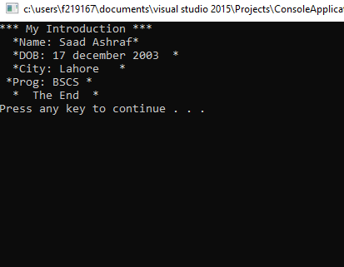**PRACTICE TASK 3:**

#include<iostream>

using namespace std;

int main() {

cout << "Course Code | Course Name | Credit Hour\n CS1114 | ITC | 4\n CS1234 | Computer Programming | 4\n CS1123 | Cal-I | 4\n CS1121 | Algebra | 3\n CS1124 | Discrete Maths | 3\n Total | 5 |18\n";

system("pause");

return 0;}

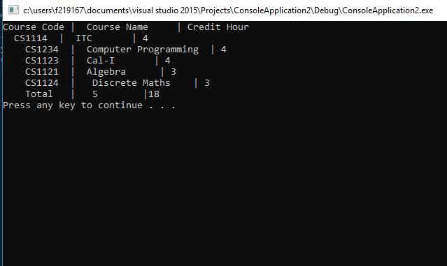

PRACTICE TASK 4:

}