**TASK 7.1:**

#include<iostream>

using namespace std;

int main() {

int n1, n2, n3, n4, n5, n6, n7, n8, n9, n10;

cout << "Enter number 1";

cin >> n1;

cout << "Enter number 2";

cin >> n2;

cout << "Enter number 3";

cin >> n3;

cout << "Enter number 4";

cin >> n4;

cout << "Enter number 5";

cin >> n5;

cout << "Enter number 6";

cin >> n6;

cout << "Enter number 7";

cin >> n7;

cout << "Enter number 8";

cin >> n8;

cout << "Enter number 9";

cin >> n9;

cout << "Enter number 10";

cin >> n10;

if (n1 % 3 == 0)

cout << n1 << "divisible by 3" << endl;

if (n2 % 3 == 0)

cout << n2 << "divisible by 3" << endl;

if (n3 % 3 == 0)

cout << n3 << "divisible by 3" << endl;

if (n4 % 3 == 0)

cout << n4 << "divisible by 3" << endl;

if (n5 % 3 == 0)

cout << n5 << "divisible by 3" << endl;

if (n6 % 3 == 0)

cout << n6 << "divisible by 3" << endl;

if (n7 % 3 == 0)

cout << n7 << "divisible by 3" << endl;

if (n8 % 3 == 0)

cout << n8 << "divisible by 3" << endl;

if (n9 % 3 == 0)

cout << n9 << "divisible by 3" << endl;

if (n10 % 3 == 0)

cout << n10 << "divisible by 3" << endl;

system("pause");

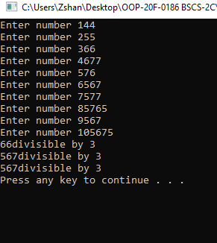 return 0;}

**TASK 7.2:**

#include<iostream>

using namespace std;

int main() {

int tax, price, product;

cout << "Press 3 for toothpaste" << endl;

cout << "Press 4 for shampoo" << endl;

cout << "What is the product?";

cin >> product;

if (product == 4) {

cout << "Price of product?";

cin >> price;

if (price > 100 && price < 999) {

tax = (5 / 100)*price;

cout << tax << endl;

}

}

}

else if (product == 3) {

cout << "Price of product?";

cin >> price;

if (price > 50 && price < 500) {

tax = (3 / 100)*price;

cout << tax << endl;

}

}

}

system("pause");

return 0;

}

**TASK 7.4:**

#include<iostream>

using namespace std;

int main() {

int son2, son1;

cout << "Enter the marks of son 1" << endl;

cin >> son1;

cout << "Enter the marks of son 2" << endl;

cin >> son2;

if (son1 > 90) {

cout << "Grade A and first son you get a treat From Father" << endl;

}

if (son2 > 90) {

cout << "Grade A and second son you get a treat From Father" << endl;

}

if (son1 > 90 && son2 > 90) {

cout << "Both Grade A and son 1 and son 2 you both get a treat From Father" << endl;

}

system("pause");

return 0;

}

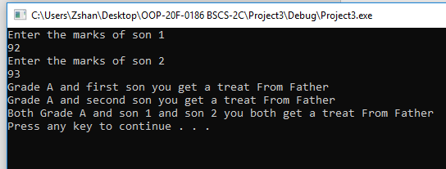

**TASK 7.5:**

#include<iostream>

using namespace std;

int main() {

int n1, n2, number;

cout << "input first number";

cin >> n1;

cout << "input second number";

cin >> n2;

cout << "Press 1 to check if the numbers are even or odd" << endl;

cout << "Press 2 to check if the numbers are divisible 5 or not" << endl;

cout << "Press 3 to add the numbers" << endl;

cout << "Press 4 to subtract the numbers" << endl;

cout << "Press 5 to multiply the numbers" << endl;

cout << "Press 6 to divide the numbers" << endl;

cin >> number;

if (number == 1) {

if (n1 % 2 == 0)

cout << n1 << "is even number" << endl;

else

cout << n1 << "is odd number" << endl;

if (n2%2==0)

cout << n2 << "is even number" << endl;

else

cout << n2 << "is odd number" << endl;

}

if (number == 2) {

if (n1%5==0)

cout << n1 << "is divisible by 5" << endl;

else

cout << n1 << "is not divisible by 5" << endl;

if (n2 % 5 == 0)

cout << n2 << "is divisible by 5" << endl;

else

cout << n2 << "is not divisible by 5" << endl;

}

if (number == 3) {

cout << "sum of two number is" << n1 + n2 << endl;

}

if (number == 4) {

cout << "subtraction of two number is" << n1 - n2 << endl;

}

if (number == 5) {

cout << "multiplication of two number is" << n1 * n2 << endl;

}

if (number == 6) {

cout << "divison of two number is" << n1 / n2 << endl;

}

system("pause");

return 0;

}

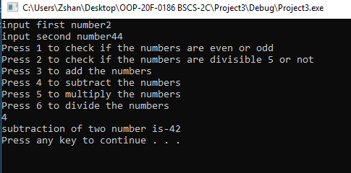

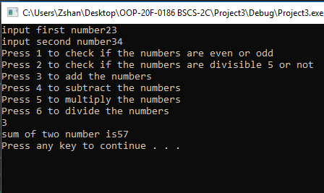

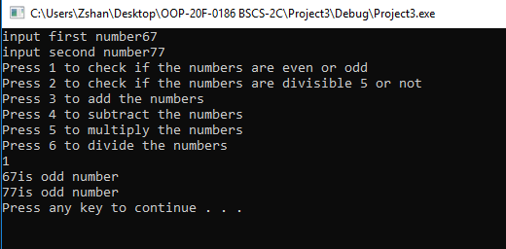

**TASK 7.6:**