

**NAME: SAAD ASHRAF**

**ROLL: 21F9167**

**SECTION: F**

**PF COURSE ASSIGNMENT 3:**

TASK 1;

#include <iostream>

using namespace std;

int main()

{

int X;

cout << "Enter number" << endl;

cin >> X;

int j = 0;

for (int i = 0; i <= X;)

{

if (j < i)

{

cout << " * ";

j++;

}

else {

cout << endl;

j = 0;

i++;

}

}

}

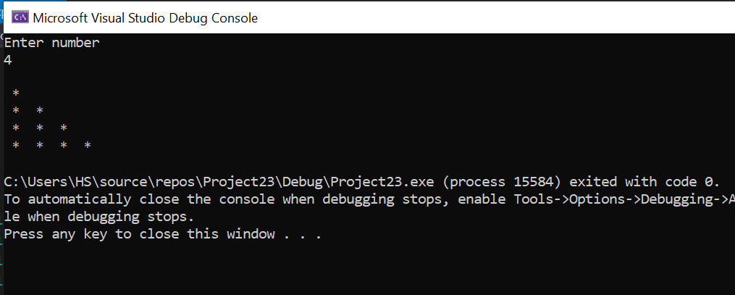

TASK 2:

#include <iostream>

using namespace std;

int main()

{

int Y;

cout << "Enter Number" << endl;

cin >> Y;

int x = Y;

for (int y = 0; y < Y;)

{

if (x > y)

{

cout << "*";

x--;

}

else

{

cout << endl;

x = Y;

y++;

}

}

return 0;

}

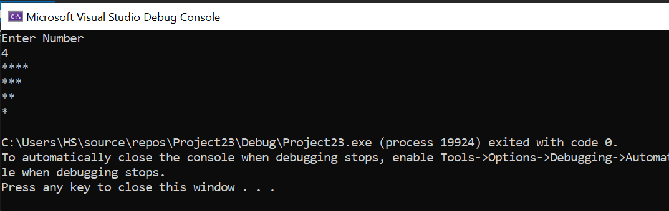

**TASK 3:**

#include<iostream>

using namespace std;

int main()

{

//creating desired suitable variables

int i, j, height, width;

//Asking user to input the height of rectangle

cout << "Enter the number of height lines" << endl;

//user enters the height of rectangle

cin >> height;

//Asking user to input the width of rectangle

cout << "Enter the number of width lines" << endl;

//user enters the width of rectangle

cin >> width;

//using for nested loop

for (i = 1; i <= height; i++) //increment i++

{

for (j = 1; j <= width; j++) //increment j++

{

if (i == 1 || i == height || j == 1 || j == width) //using check statement "=="

cout << "*"; //printing *

else

cout << " ";

}

cout << endl;

}

return 0;

}

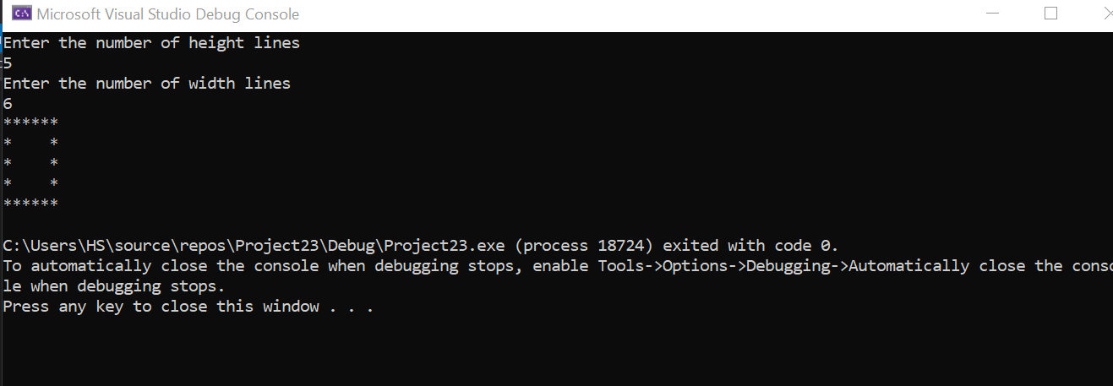

TASK 4:

#include<iostream>

#include<string>

using namespace std;

int main()

{

int x;

string y;

cout << "Enter a number." << endl;

cin >> x;

y = " ";

while (x > 0)

{

if (x % 2 != 0)

{

y = y + "x";

cout << y << endl;

x--;

}

else if (x % 2 == 0)

{

y =y + "+";

cout << y << endl;

x--;

}

}

return 0;

}

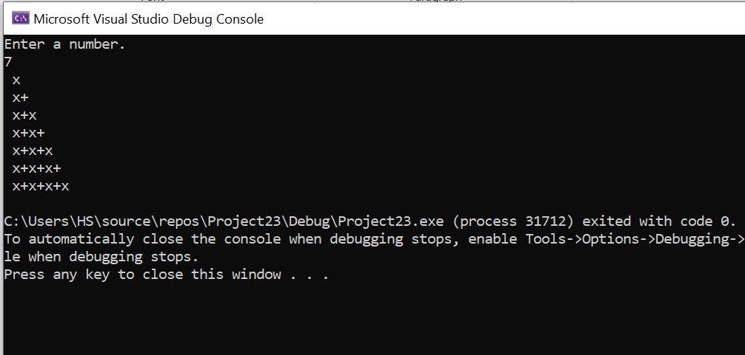

TASK 5:

#include <iostream>

using namespace std;

int main()

{

float price = 0;

int quantity = 0;

float temp_price;

float total = 0;

cout << "How many items do you want to purchase?"<<endl;

//Asking for the amount of items the user wants to purchase

cin >> quantity;

//Entering the amount of items the user wants to purchase

//Using while loop and setting statement according to given condition

while (quantity > 9) { //quantity of items to be purchased must not increase 9

cout << "Try again. The number of items you want to buy cannot exceed 9." << endl;

cout << "Reenter the quantity of items you want to purchase:" << endl;

cin >> quantity;

}

for (int i = 0; i < quantity; i++)

{

cout << "enter the price of the item Rupees:\n";

cin >> temp_price;

price = price + temp_price;

}

//Applying the condition that if the price is greater than 200 then shipping should be free

if (price >= 200)

{

cout << "Your shipping is free since your total bill is greater than 200\n";

total = price;

}

else

{

//Applying else conditon if bill is not greater than 200

cout << "the shipping fee is 10 rupees for one item so the total shipping fee is Rupees:" << quantity * 10 << endl;

//if bill is not greater than 200 then

total = price + (quantity * 10);

}

//Printing the total bill with/without the delievery fee

cout << "Your total fee is Rupees:" << total << endl;

system("pause");

return 0;

}

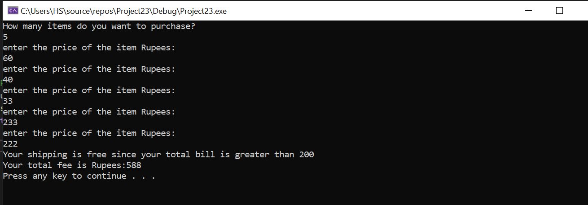

**TASK 6:**

#include<iostream>

using namespace std;

int main() {

int townA_population, townB_population, years = 1;

double rateA, rateB;

//Asking for population of town A

cout << "enter the population of town A" << endl;

//Entering the population of town A

cin >> townA_population;

//Asking for population of town B

cout << "enter the population of town B" << endl;

//Entering the population of town A

cin >> townB_population;

//Asking for growth rate of town A

cout << "enter the grothw rate of town A" << endl;

//Entering the growth rate of town A

cin >> rateA;

//Asking for growth rate of town B

cout << "enter the grothw rate of town B" << endl;

//Entering the growth rate of town A

cin >> rateB;

//Applying the while condition

while (townA_population < townB_population) {

townA_population = townA_population + (townA_population * (rateA / 100));

townB_population = (townB_population * (rateB / 100)) + townB_population;

//increment in years variable

years++;

}

cout << "In " << years << " years the population of Town A will become greater than that of town B" << endl;

return 0;

}

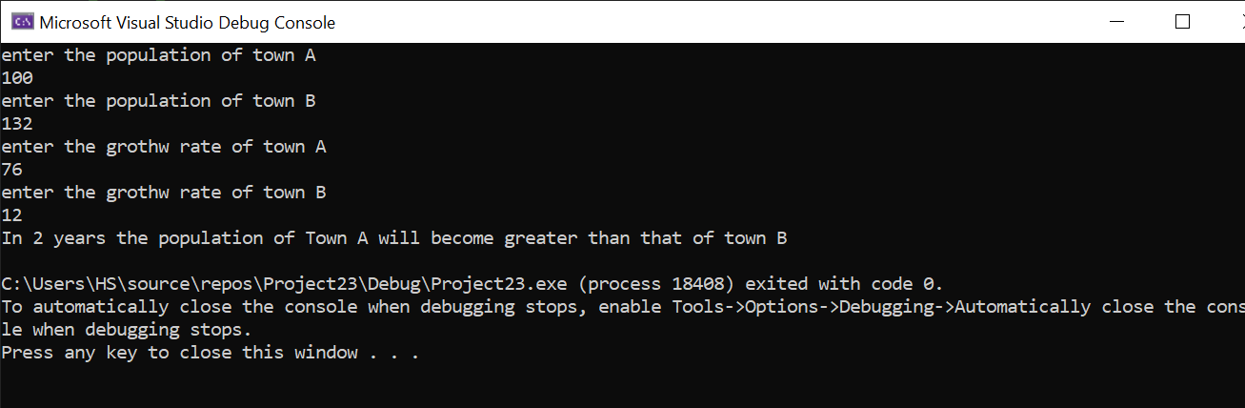

**TASK 7:**

#include <iostream>

#include <string>

using namespace std;

int main()

{

//Creating desired variables

int Number1, Number2, answer, sum = 0, sum2 = 0, square;

//creating desired characters

char letter1, letter2;

string letters;

//Asking the user for the first number

cout << " enter the first number" << endl;

//Entering the first number

cin >> Number1;

//Asking the user for the second number

cout << "enter the second number" << endl;

//Entering the second number

cin >> Number2;

//using while condition

while (Number1 > Number2)

{

//displaying error message if first number is greater than second number

cout << "ERROR!!" << endl;

//Asking the user to try again according to the given condition

cout << "Please try again becuase first number was greater than second number" << endl;

cout << "Reenter first number" << endl;

cin >> Number1;

cout << "Reenter second number" << endl;

cin >> Number2;

cout << endl;

}

//Printing all the possible odd numbers between the first number and second number that has been entered by the user

cout << "All the odd numbers between " << Number1 << " and " << Number2 << " are: " << endl;

answer = Number1;

while (answer != Number2)

{

answer++;

if (answer % 2 != 0)

{

cout << answer << endl;

}

}

answer = Number1 + 1;

while (answer < Number2)

{

answer++;

if (answer % 2 == 0)

{

sum = sum + answer;

}

}

//Printing the sum of all possible even numbers between user given first number and second number

cout << "sum of even integers between " << Number1 << " and " << Number2 << " = " << sum << endl;

//Printing the square of numbers from 1 to 10

answer = 1;

while (answer <= 10)

{

answer++;

square = answer * answer;

cout << "The square of " << answer << " is: " << square << endl;

}

answer = Number1;

while (answer < Number2)

{

answer++;

if (answer % 2 != 0)

{

sum2 = sum2 + (answer * answer);

}

}

cout << "The Sum of the squares of the odd integers between " << Number1 << " and " << Number2 << " is " << sum2 << endl;

//declaring letter1=65 and using given conditon to print all english lowercase alphabets

letter1 = 65;

while (letter1 < 91)

{

letter1++;

letters = letters + letter1;

}

//printing all lowercase english letters

cout << letters << endl;

system("pause");

return 0;

}

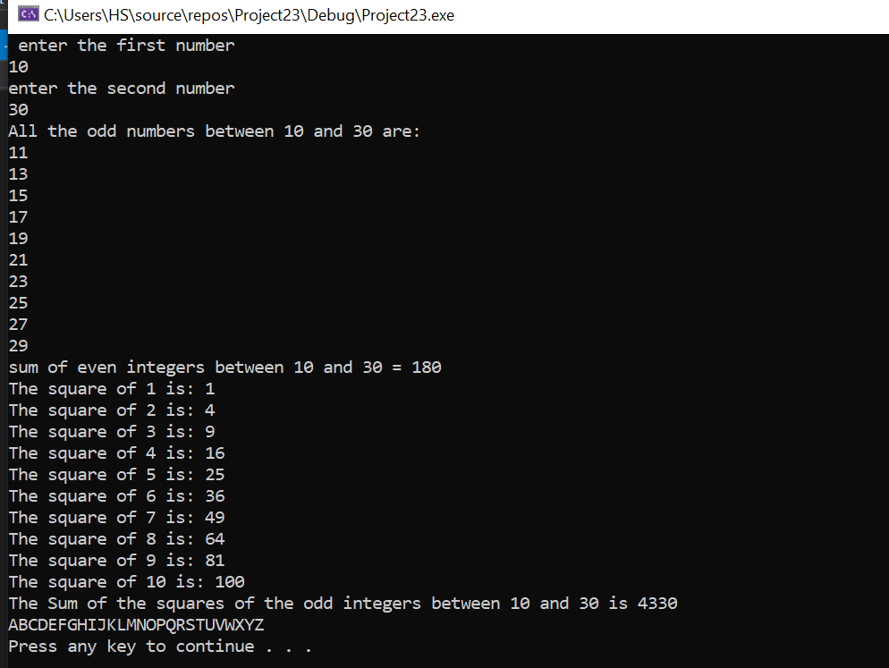

**TASK 8:**

#include <iostream>

#include <string>

using namespace std;

int main()

{

//Creating desired variables

int Number1, Number2, answer, sum = 0, sum2 = 0, square;

//creating desired characters

char letter1, letter2;

string letters;

//Asking the user for the first number

cout << " enter the first number" << endl;

//Entering the first number

cin >> Number1;

//Asking the user for the second number

cout << "enter the second number" << endl;

//Entering the second number

cin >> Number2;

//using while condition

while (Number1 > Number2)

{

//displaying error message if first number is greater than second number

cout << "ERROR!!" << endl;

//Asking the user to try again according to the given condition

cout << "Please try again becuase first number was greater than second number" << endl;

cout << "Reenter first number" << endl;

cin >> Number1;

cout << "Reenter second number" << endl;

cin >> Number2;

cout << endl;

}

//Printing all the possible odd numbers between the first number and second number that has been entered by the user

cout << "All the odd numbers between " << Number1 << " and " << Number2 << " are: " << endl;

for (answer = Number1; answer != Number2; answer++)

{

if (answer % 2 != 0)

{

cout << answer << endl;

}

}

for (answer = Number1 + 1; answer < Number2; answer++)

{

if (answer % 2 == 0)

{

sum = sum + answer;

}

}

//Printing the sum of all possible even numbers between user given first number and second number

cout << "sum of even integers between " << Number1 << " and " << Number2 << " = " << sum << endl;

//Printing the square of numbers from 1 to 10

for (answer = 1; answer <= 10; answer++)

{

square = answer * answer;

cout << "The square of " << answer << " is: " << square << endl;

}

for (answer = Number1; answer < Number2; answer++)

{

if (answer % 2 != 0)

{

sum2 = sum2 + (answer * answer);

}

}

cout << "The Sum of the squares of the odd integers between " << Number1 << " and " << Number2 << " is " << sum2 << endl;

//declaring letter1=65 and using given conditon to print all english lowercase alphabets

for (letter1 = 65; letter1 < 91; letter1++)

{

letters = letters + letter1;

}

//printing all lowercase english letters

cout << letters << endl;

system("pause");

return 0;

}



TASK 9:

#include <iostream>

#include <string>

using namespace std;

int main()

{

//Creating desired variables

int Number1, Number2, answer, sum = 0, sum2 = 0, square;

//creating desired characters

char letter1, letter2;

string letters;

//Asking the user for the first number

cout << " enter the first number" << endl;

//Entering the first number

cin >> Number1;

//Asking the user for the second number

cout << "enter the second number" << endl;

//Entering the second number

cin >> Number2;

//using while condition

while (Number1 > Number2)

{

//displaying error message if first number is greater than second number

cout << "ERROR!!" << endl;

//Asking the user to try again according to the given condition

cout << "Please try again becuase first number was greater than second number" << endl;

cout << "Reenter first number" << endl;

cin >> Number1;

cout << "Reenter second number" << endl;

cin >> Number2;

cout << endl;

}

//Printing all the possible odd numbers between the first number and second number that has been entered by the user

cout << "All the odd numbers between " << Number1 << " and " << Number2 << " are: " << endl;

answer = Number1;

do

{

answer++;

if (answer % 2 != 0)

{

cout << answer << endl;

}

} while (answer != Number2);

answer = Number1 + 1;

do

{

answer++;

if (answer % 2 == 0)

{

sum = sum + answer;

}

} while (answer < Number2);

//Printing the sum of all possible even numbers between user given first number and second number

cout << "sum of even integers between " << Number1 << " and " << Number2 << " = " << sum << endl;

//Printing the square of numbers from 1 to 10

answer = 1;

do

{

answer++;

square = answer * answer;

cout << "The square of " << answer << " is: " << square << endl;

} while (answer <= 10);

answer = Number1;

do

{

answer++;

if (answer % 2 != 0)

{

sum2 = sum2 + (answer * answer);

}

} while (answer < Number2);

cout << "The Sum of the squares of the odd integers between " << Number1 << " and " << Number2 << " is " << sum2 << endl;

//declaring letter1=65 and using given conditon to print all english lowercase alphabets

letter1 = 65;

do

{

letter1++;

letters = letters + letter1;

} while (letter1 < 91);

//printing all lowercase english letters

cout << letters << endl;

system("pause");

return 0;

}



TASK 12:

**USING IF ELSE:**

#include <iostream>

using namespace std;

int main()

{

//we declare grade

char grade;

//Asking user for the grade

cout << "Enter the Grade: " << endl;

//user inputs garde

cin >> grade;

//using if else condition

if (grade == 'A')

cout << "Excellent" << endl;

else

if (grade == 'B')

cout << "Good" << endl;

else

if (grade == 'C')

cout << "Average" << endl;

else

if (grade == 'D')

cout << "Poor" << endl;

else

if (grade == 'F')

cout << "Fail" << endl;

else

//if user enters character other than A, B, C, D, E, F then it will display an error message.

cout << "Invalid. Please input grade like A, B, C, D, F";

return 0;

}

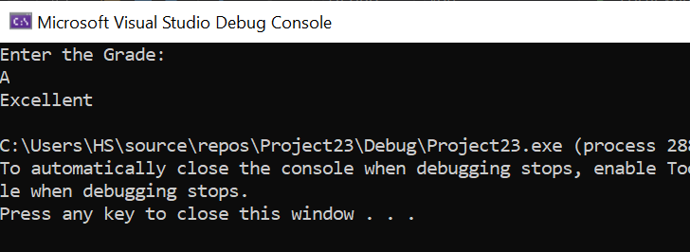

**USING SWITCH:**

#include <iostream>

using namespace std;

int main()

{

//we declare grade

char grade;

//Asking user for the grade

cout << "Enter the Grade: " << endl;

//user inputs garde

cin >> grade;

switch (grade)

{

case 'A': //if case is A then

cout << "Excellent" << endl;

break;

case 'B': //if case is B then

if (grade == 'B')

cout << "Good" << endl;

break;

case 'C': //if case is C then

if (grade == 'C')

cout << "Average" << endl;

break;

case 'D': //if case is D then

cout << "Poor" << endl;

break;

case 'F': //if case is F then

cout << "Fail" << endl;

break;

default: //if case is any other than A, B, C, D, F then

cout << "Invalid";

}

}

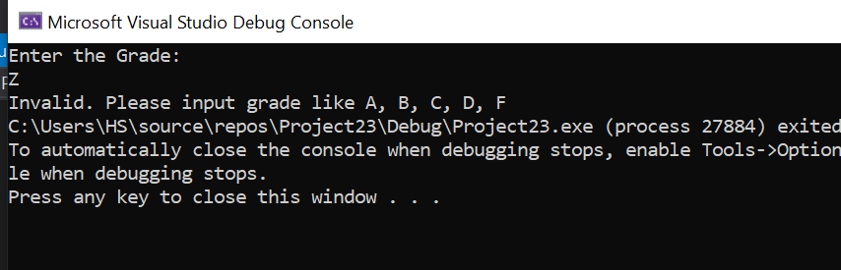

USING TERNARY OPERATOR:

#include<iostream>

using namespace std;

int main() {

char grade;

cout << "Enter grade"<<endl;

cin >> grade;

(grade == 'A') ? cout << "Excellent" << endl : (grade == 'B') ? cout << "Good" << endl : (grade == 'C') ? cout << "Average" << endl : (grade == 'D') ? cout << "Poor" << endl : (grade == 'F') ? cout << "Fail" << endl : cout << "invalid grade" << endl;

return 0;

}

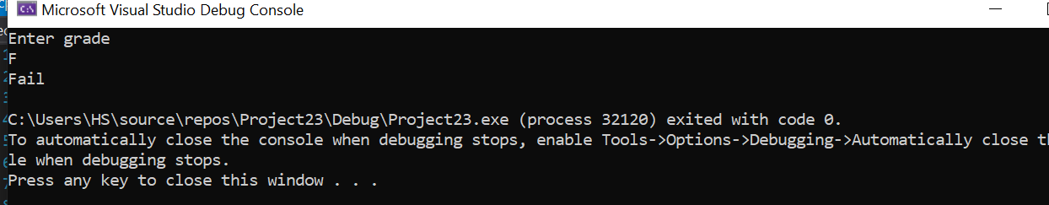

**TASK 13:**

#include <iostream>

using namespace std;

int main()

{

//Declaring and initilazing the suitable variables

int i, n, factorial = 1;

//Asking the user to enter a positive integer

cout << "Enter a positive integer: ";

//User inputs the positive integer

cin >> n;

for (i = 1; i <= n; ++i) { //in this case i=1 and we do preincrement in i

factorial = factorial * i;

}

cout << "Factorial of " << n << " = " << factorial;

return 0;

}

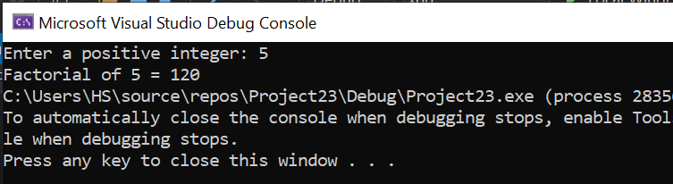

TASK 14:

#include<iostream>

using namespace std;

int main()

{

int x, k;

cout << "enter a number." << endl;

cin >> x;

cout << x << " ";

while (x > 2)

{

if (x % 2 == 0)

x = x / 2;

if (x % 2 != 0)

x = x * 3 + 1;

cout << x << " ";

}

cout << "1";

}

