Project Part1

Run Xie #47922054

If we assume all items have no weight and volume, and only one cart is used to collect the items, the warehouse problem is very similar to Travelling Salesman Problem (TSP), that is: “given a list of items and the positions of each in the warehouse, what is the shortest possible route that get all the items and returns to origin point.”

Note that TSP is a NP-hard problem, Dijkstra and DP cannot solve the problem efficiently especially when the order list is large. So, we choose 2-optimization algorithm to search the approximal-best route.

We assume each shelve has only one side. The length and width of the shelve are both 1 unit.

The three columns of the raw data represent item number, location X and location Y respectively. And the decimal part of location X represent the location in the shelve. As shown in fig.1. The minimum distance from one determined item to another determined item is:

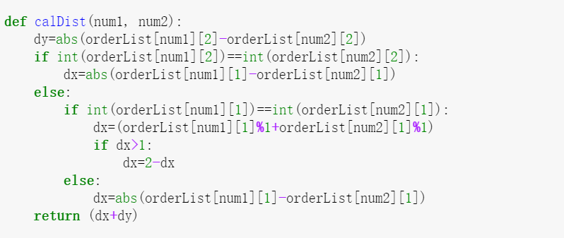

0

1

2

1

2

3

0.01

0.99

1.01

1.99

2.01

2.99

Case A

Case B

Fig.1 shelve-map definition

When we use the first 20 items as input, the result is shown in fig 2.

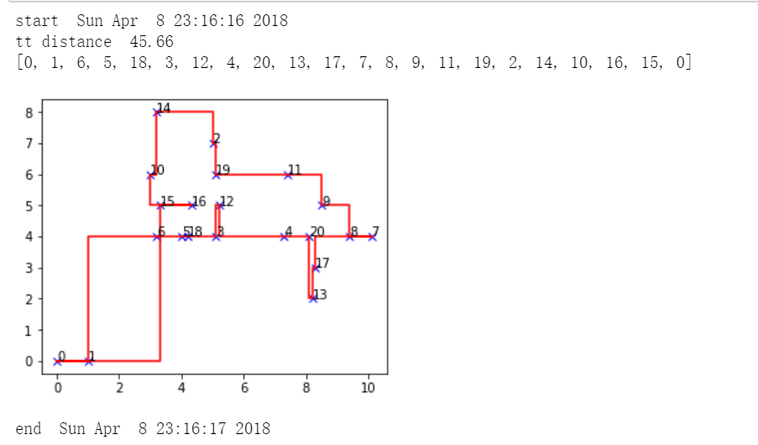

Fig.2 opt results for 20 items

For the first 100 items, the result is shown in fig.3.

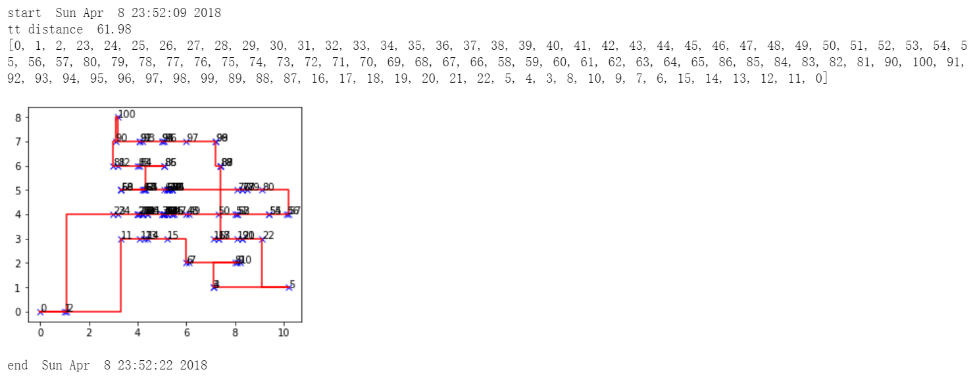

Fig.3 opt results for 100 items

For the first 1000 items, to speed up, sort the orderList by Yaxis first:

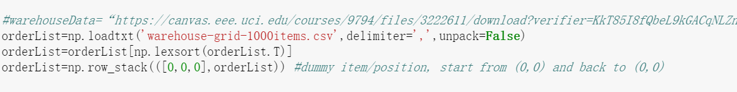

the result is shown in fig.4.

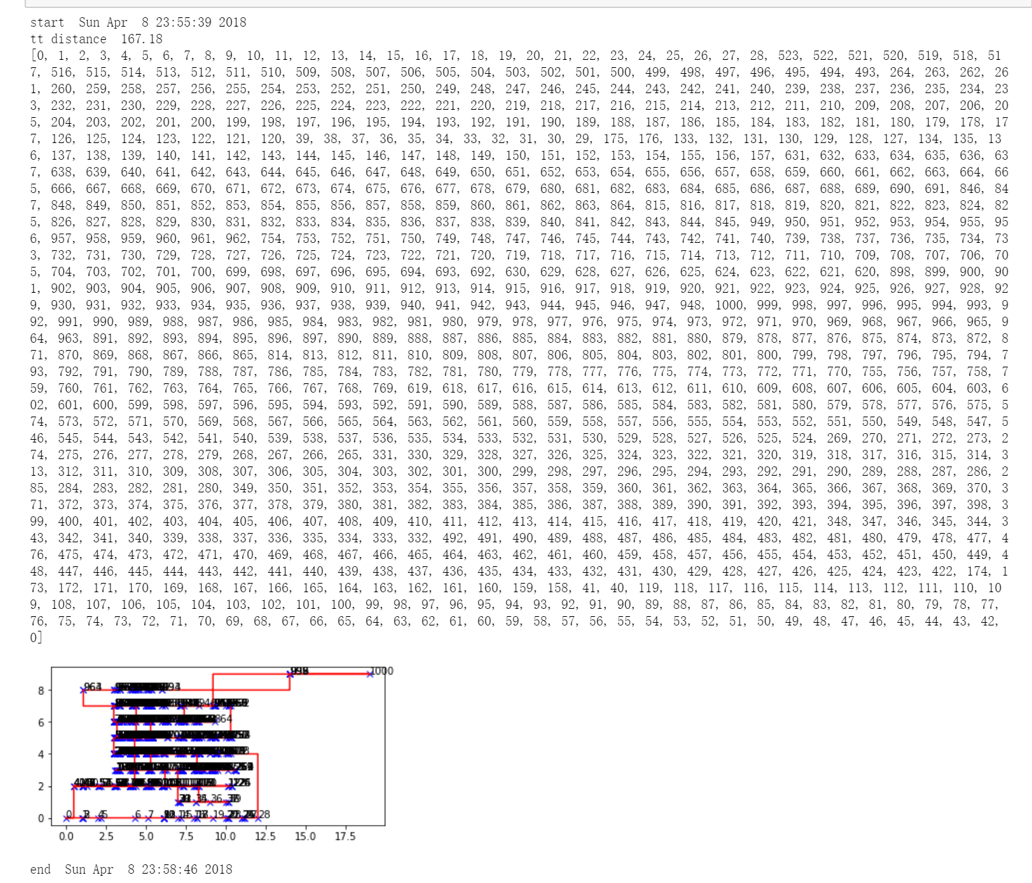

Fig.4 opt results for 1000 items

Future work:

1. Better GUI and plot function.
2. Multi-thread
3. Real physical dimension
4. Multiple carts parallel working
5. Real weight and volume of each items