Using 2-opt algorithm. Running result as following:

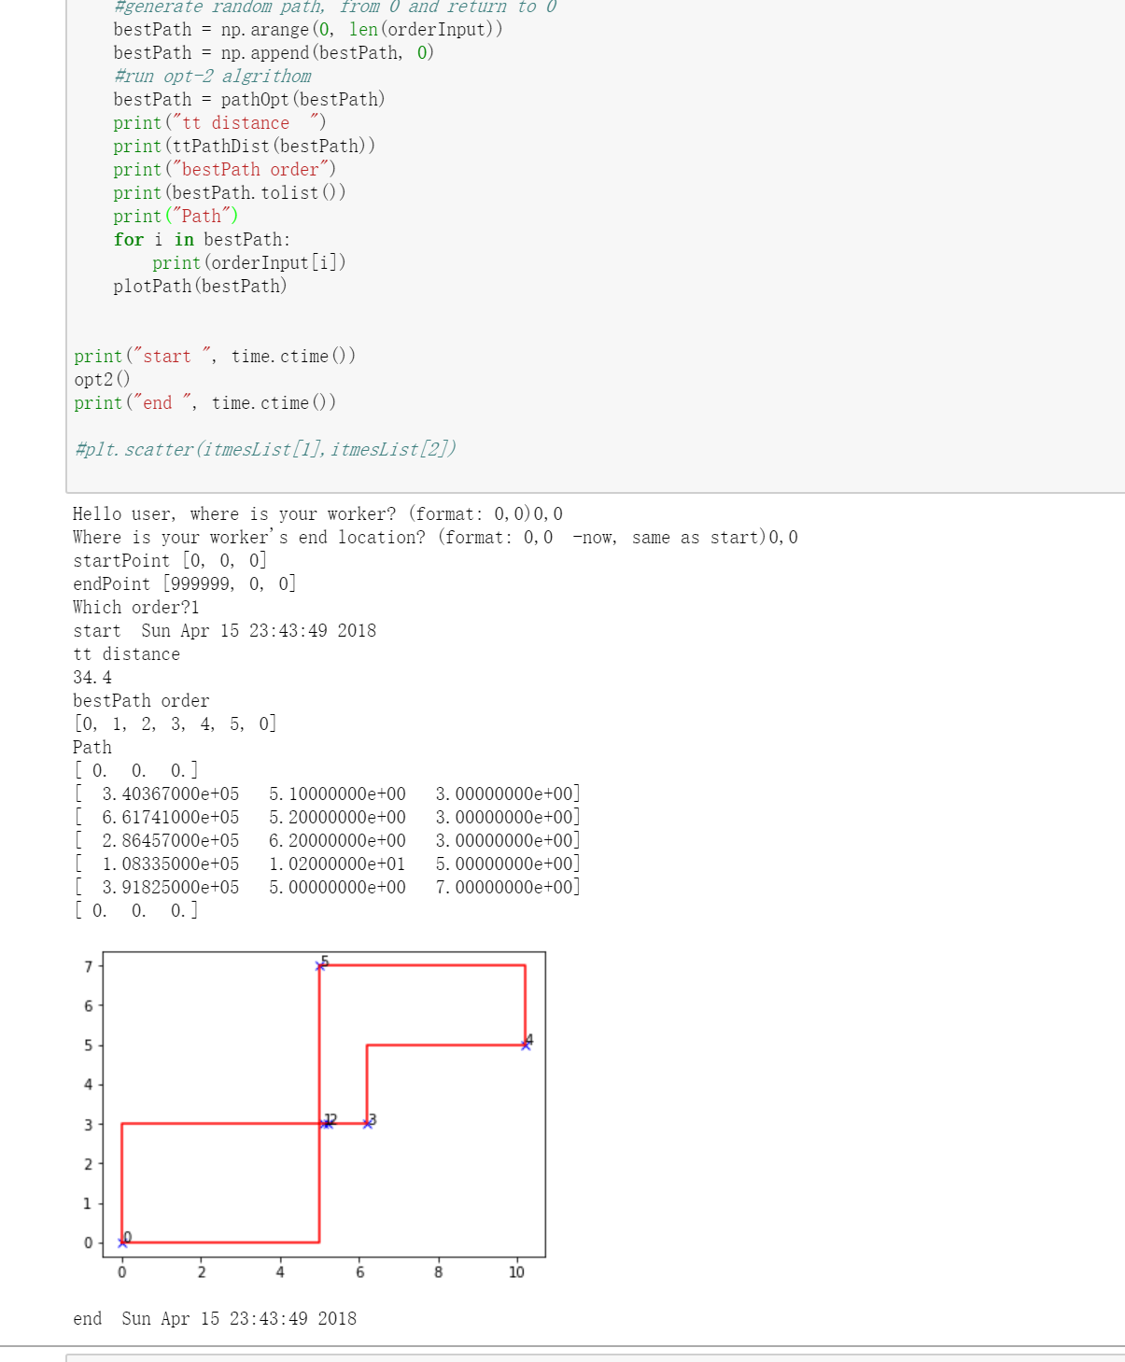

Compere SOMA with 2-opt:

For each step, 2-opt search for the crosses route total randomly, while individuals in SOMA are “jumping” towards the optimum position. It seems that the SOMA could convergence faster than the 2-opt. But, for the specific warehouse problem, my modified 2-opt could terminate faster (optimize 1000 items/nodes in 187sec). That is because, if the items number is large - that means the items density in the warehouse is high, there is an obvious optimized solution: “get the items one by one, row by row”. So, we can dramatically improve the 2-opt efficiency by pre-sorting the items by the row, as shown in following figure.

