1. Folder Structure Explanation
The final airflow_demo directory contains all components needed to run an end-to-end Airflow + dbt + Snowflake pipeline:

dags/
Contains all Airflow DAG definitions.
- weather_pipeline_dag.py — the main DAG orchestrating the pipeline (Extract → Transform → Verify).
- Other example DAGs (e.g., simple_dag.py) are unused but kept for reference.

include/
Stores all external assets used by operators in the DAG.
- profiles.yml — dbt Snowflake profile used during dbt run.
- rsa_key.pem — private key for Snowflake key-pair authentication.
- weather_dbt_project/ — full dbt project (models, schema tests, target/, dbt_project.yml).

weather_dbt_project/models/
- staging/ — staging models like stg_weather.sql
- marts/ — analytics models like fact_weather.sql, fact_weather_daily.sql
- schema.yml — tests and documentation for the models

Other auto-generated folders
- logs/ — Airflow task logs
- target/ inside dbt project — dbt compiled SQL & artifacts

2.

DAG Explanation
The weather_pipeline_dag.py file defines a 3-step Weather ETL pipeline:

DAG Setup
Defines metadata and settings:
- DAG name, schedule, start date, tags
- default_args controlling retries and ownership

Task 1: extract_weather_api (PythonOperator)
- Calls the Open-Meteo API
- Converts API JSON into a Pandas DataFrame
- Saves the data as a timestamped CSV file in /tmp/
- Returns the filename as XCom
This simulates the “Extract” part of ETL.

Task 2: transform_dbt (BashOperator)
Runs dbt inside the container:
cd $AIRFLOW_HOME/include/weather_dbt_project
dbt run --profiles-dir $AIRFLOW_HOME/include
This executes:
- staging model (stg_weather)
- fact models (fact_weather, fact_weather_daily)
This is the “Transform” step.

Task 3: verify_snowflake (SQLExecuteQueryOperator)
Executes a Snowflake query to confirm the dbt models were built:
SELECT COUNT(*), MIN(date), MAX(date)
FROM fact_weather_daily;
This ensures data landed correctly in Snowflake (“Load/Verify” step).

Task Ordering
extract >> transform >> verify
Defines the ETL sequence.

3. Screenshot:

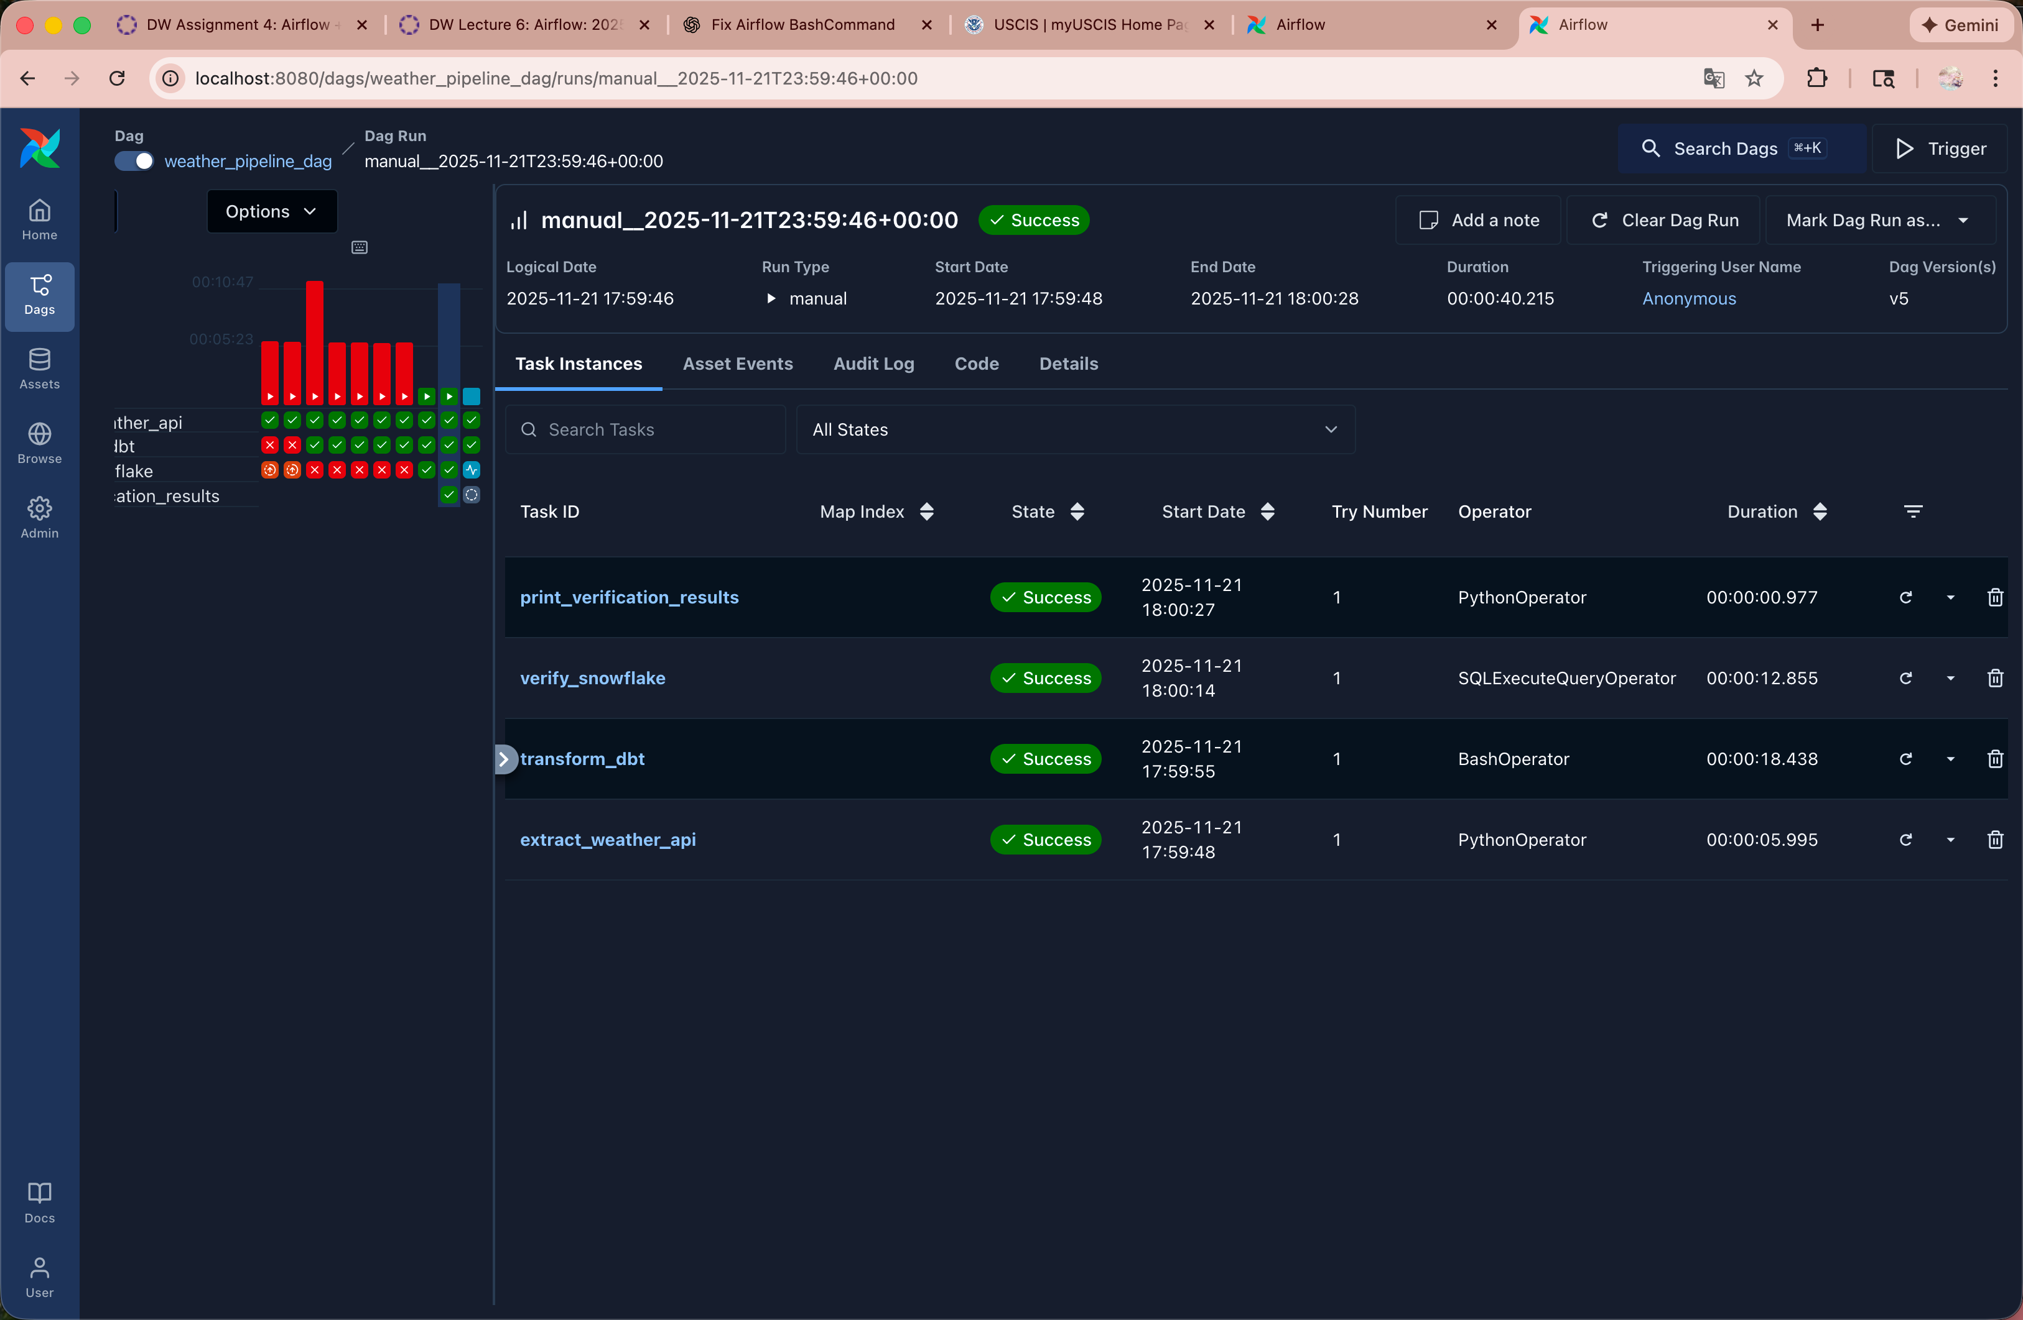

Project:

Q1: Topic & Data
Topic:
Analyze global earthquake patterns, identify high-risk regions, and examine magnitude/depth distributions.
Key Questions
- Which regions experience the most earthquakes?
- What magnitude ranges are most common?
- Are there any recent spikes in seismic activity?
Data Source
- USGS Earthquake API
  - Endpoint: https://earthquake.usgs.gov/earthquakes/feed/v1.0/summary/all_month.geojson
  - Access: Python requests → CSV → S3 → Snowflake

Q2: Pipeline Plan
USGS API → Python → CSV → S3 → Snowflake Raw → dbt → Tableau

Q3: dbt Models
- stg_earthquake_raw — parse GeoJSON, clean timestamp, convert coordinates
- dim_region — map coordinates → region/country
- fct_quakes — magnitude bins, depth bins, daily counts
- mart_quake_analysis — final model for visualizations

Q4: Visuals

1. Global Earthquake Map (Choropleth / Bubble Map)
Description:
A world map displaying all earthquakes within the selected timeframe (e.g., past 30 days). Each earthquake appears as a circle marker placed at its latitude/longitude, where:
- Size = magnitude (larger circle = stronger earthquake)
- Color = depth category (e.g., shallow = yellow, deep = red)
Insight / Purpose:
- Shows geographic concentration of seismic activity.
- Highlights global “hot zones” such as the Ring of Fire, Japan, Indonesia, Chile, and Alaska.
- Immediately reveals where the most powerful or deepest earthquakes occur.
This visual helps users understand spatial patterns that are not obvious from raw data.

2. Magnitude Histogram
Description:
A histogram displaying the distribution of magnitudes for all earthquakes in the dataset.
Typical x-axis bins:
- 0–2 (minor)
- 2–4 (light)
- 4–6 (moderate)
- 6–7 (strong)
- 7 (major)
Insight / Purpose:
- Shows what magnitude range is most common.
- Identifies whether recent seismic activity is mostly minor or if there are unusual spikes in moderate/strong events.
- Helps quantify whether the period was seismically “active” or “quiet.”
For example, most earthquakes are usually in the 2–4 range, and the histogram confirms or challenges that expectation.

3. Daily Earthquake Frequency Line Chart
Description:
A time-series line chart showing how many earthquakes occurred each day.
- X-axis: date
- Y-axis: count of earthquakes per day
- Optional: a second line for count of earthquakes above magnitude 4.0
Insight / Purpose:
- Reveals temporal patterns, such as days with unusually high activity.
- Helps identify trends, spikes, or clusters of seismic events.
- Useful for monitoring whether certain weeks had abnormal activity.

