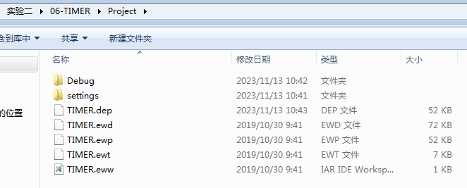

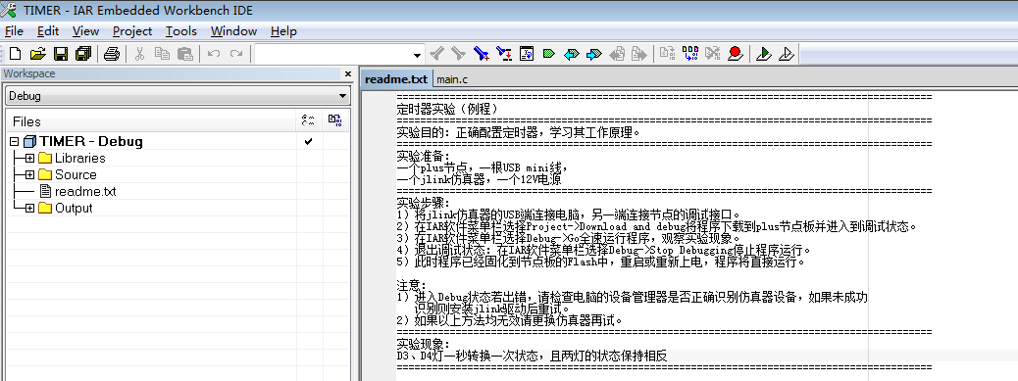

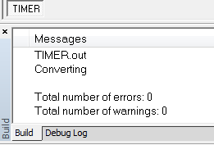

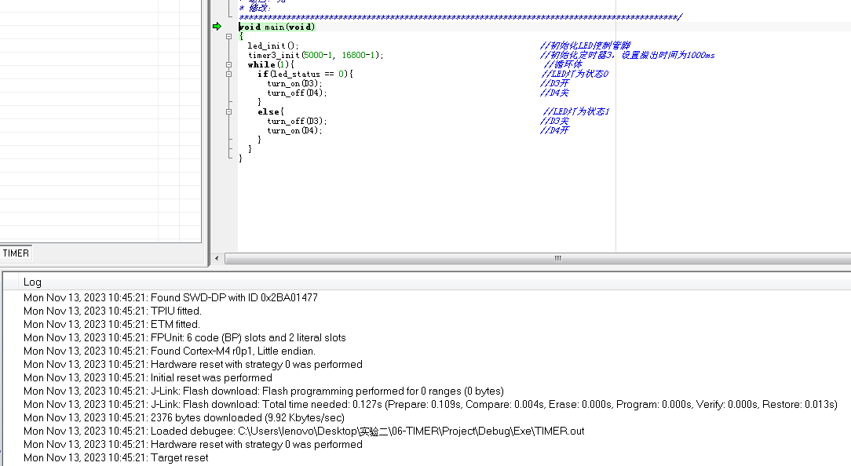

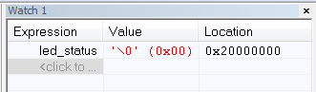

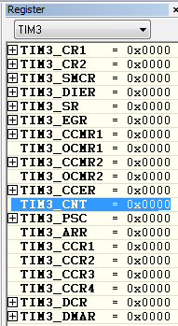

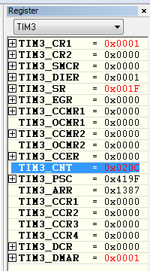

//timer.c

void TIM3_IRQHandler(void)

{

if (TIM_GetITStatus(TIM3, TIM_IT_Update ) != RESET) { //如果中断标志被设置

TIM_ClearITPendingBit(TIM3, TIM_IT_Update); //清除中断标志

led_status++;

led_status %= 3;

}

}

//main.c

void main(void)

{

led_init(); //初始化LED控制管脚

timer3_init(5000-1, 16800-1); //初始化定时器3，设置溢出时间为1000ms

while(1){ //循环体

if(led_status == 0){ //LED灯为状态0

turn_on(LEDR); // red on

turn_off(LEDG);

turn_off(LEDB);

}

else if(led_status == 1){

turn_on(LEDB); // blue on

turn_off(LEDR);

turn_off(LEDG);

}

else{

turn_on(LEDG); // green on

turn_off(LEDR);

turn_off(LEDB);

}

}

}