Name: Ruochen Liao

ID: 1533019693

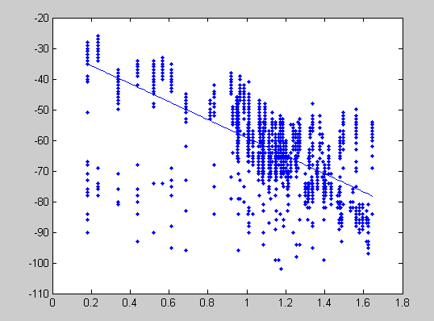

Eta = 2.9414, K = -2.7851, standard_diviation = 9.9298

clear all;

receiver=importdata('receiverXY.csv');

transmitter=importdata('transmitterXY.csv');

exp7=importdata('wifiExp7.csv');%1st experiment

exp8=importdata('wifiExp8.csv');%2st experiment

exp9=importdata('wifiExp9.csv');%3st experiment

exp10=importdata('wifiExp10.csv');%4st experiment

exp11=importdata('wifiExp11.csv');%5st experiment

exp12=importdata('wifiExp12.csv');%6st experiment

exp13=importdata('wifiExp13.csv');%7st experiment

exp14=importdata('wifiExp14.csv');%8st experiment

exp15=importdata('wifiExp15.csv');%9st experiment

exp16=importdata('wifiExp16.csv');%10st experiment

exp17=importdata('wifiExp17.csv');%11st experiment

exp18=importdata('wifiExp18.csv');%12st experiment

distance0=zeros(12,8);

for i=1:12

for j=1:8

%distance(i,j) = log(((transmitter(i,1)-receiver(j,1))^2+(transmitter(i,2)-receiver(j,2))^2)^0.5);

distance0(i,j)= sqrt((transmitter(i,1)-receiver(j,1))^2+(transmitter(i,2)-receiver(j,2))^2);

end

end

x0 = [];

x = [];

y = [];

length(exp8)

%exp 7

distance = log10(distance0);

for i=1:8

for j=1:length(exp7)

if( exp7(j,i+1)~=500 )

x0 = [x0,distance0(1,i)];

x = [x,distance(1,i)];

y = [y,-exp7(j,i+1)];

end

end

end

% exp 8

for i=1:8

for j=1:length(exp8)

if( exp8(j,i+1)~=500 )

x0 = [x0,distance0(2,i)];

x = [x,distance(2,i)];

y = [y,-exp8(j,i+1)];

end

end

end

%exp 9

for i=1:8

for j=1:length(exp9)

if( exp9(j,i+1)~=500 )

x0 = [x0,distance0(3,i)];

x = [x,distance(3,i)];

y = [y,-exp9(j,i+1)];

end

end

end

%exp 10

for i=1:8

for j=1:length(exp10)

if( exp10(j,i+1)~=500 )

x0 = [x0,distance0(4,i)];

x = [x,distance(4,i)];

y = [y,-exp10(j,i+1)];

end

end

end

%exp 11

for i=1:8

for j=1:length(exp11)

if( exp11(j,i+1)~=500 )

x0 = [x0,distance0(5,i)];

x = [x,distance(5,i)];

y = [y,-exp11(j,i+1)];

end

end

end

%exp 12

for i=1:8

for j=1:length(exp12)

if( exp12(j,i+1)~=500 )

x0 = [x0,distance0(6,i)];

x = [x,distance(6,i)];

y = [y,-exp12(j,i+1)];

end

end

end

%exp 13

for i=1:8

for j=1:length(exp13)

if( exp13(j,i+1)~=500 )

x0 = [x0,distance0(7,i)];

x = [x,distance(7,i)];

y = [y,-exp13(j,i+1)];

end

end

end

%exp 14

for i=1:8

for j=1:length(exp14)

if( exp14(j,i+1)~=500 )

x0 = [x0,distance0(8,i)];

x = [x,distance(8,i)];

y = [y,-exp14(j,i+1)];

end

end

end

%exp 15

for i=1:8

for j=1:length(exp15)

if( exp15(j,i+1)~=500 )

x0 = [x0,distance0(9,i)];

x = [x,distance(9,i)];

y = [y,-exp15(j,i+1)];

end

end

end

%exp 16

for i=1:8

for j=1:length(exp16)

if( exp16(j,i+1)~=500 )

x0 = [x0,distance0(10,i)];

x = [x,distance(10,i)];

y = [y,-exp16(j,i+1)];

end

end

end

%exp 17

for i=1:8

for j=1:length(exp17)

if( exp17(j,i+1)~=500 )

x0 = [x0,distance0(11,i)];

x = [x,distance(11,i)];

y = [y,-exp17(j,i+1)];

end

end

end

%exp 18

for i=1:8

for j=1:length(exp18)

if( exp18(j,i+1)~=500 )

x0 = [x0,distance0(12,i)];

x = [x,distance(12,i)];

y = [y,-exp18(j,i+1)];

end

end

end

p = polyfit(x,y,1);

x1 = linspace(min(x),max(x));

y1 = polyval(p,x1);

plot( x,y,'.');

hold on

plot(x1,y1);

hold off

eta = -p(1)/10

K = p(2) + 27

standard_diviation = std(x0)

output:

eta =

2.9414

K =

-2.7851

standard_diviation =

9.9298