2 X-axis is log scale distance for path loss exponents 2 and 4.

η= 2

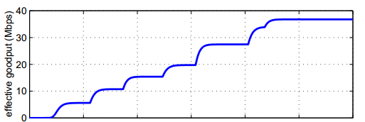

40 37.5 35 32.5 30 27.5 25

η= 4



20 18.7 17.5 16.25 15 13.75 12.5

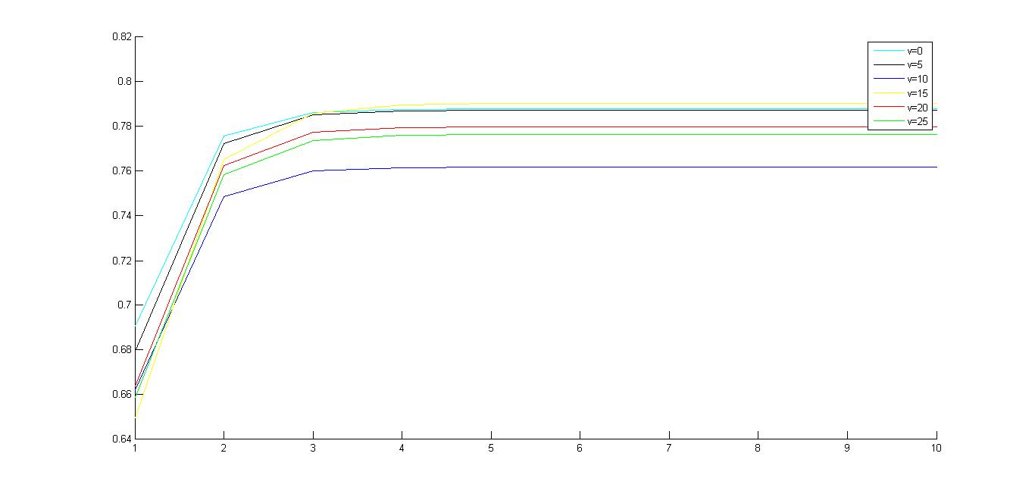

Y-axes is P(0,1 ), X-axes is k

4 My policy is transmit a packet, if it failed, then wait for k time slots and transmit again. If the packet is successful, transmit immediately at the next time slop.

Plot X-axes range from 0 to 10;

P01 = 0.1 and P11 = 0.2, k = 4

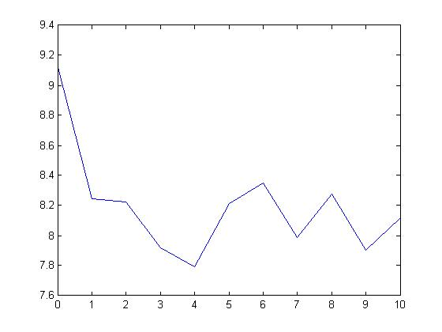

P01 = 0.1, P11 = 0.4, k = 6

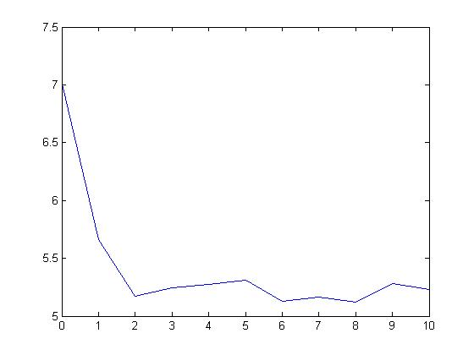

P01 = 0.1, P11 = 0.9, K = 10

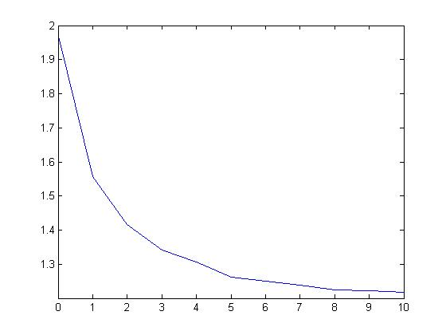

5

(1) hamming (7,4) original 4 bits code has 16 possible format from 0000 to 1111, so

A =

0 0 0 0

0 0 0 1

0 0 1 0

0 0 1 1

0 1 0 0

0 1 0 1

0 1 1 0

0 1 1 1

1 0 0 0

1 0 0 1

1 0 1 0

1 0 1 1

1 1 0 0

1 1 0 1

1 1 1 0

1 1 1 1

x = G' * A, x'=

0 0 0 0 0 0 0

1 0 0 1 1 0 0

1 1 1 0 0 0 0

2 1 1 1 1 0 0

0 1 0 1 0 1 0

1 1 0 2 1 1 0

1 2 1 1 0 1 0

2 2 1 2 1 1 0

1 1 0 1 0 0 1

2 1 0 2 1 0 1

2 2 1 1 0 0 1

3 2 1 2 1 0 1

1 2 0 2 0 1 1

2 2 0 3 1 1 1

2 3 1 2 0 1 1

3 3 1 3 1 1 1

so change odd number to 1 and change even number to 0 **codeword** =

0 0 0 0 0 0 0

1 0 0 1 1 0 0

1 1 1 0 0 0 0

0 1 1 1 1 0 0

0 1 0 1 0 1 0

1 1 0 0 1 1 0

1 0 1 1 0 1 0

0 0 1 0 1 1 0

1 1 0 1 0 0 1

0 1 0 0 1 0 1

0 0 1 1 0 0 1

1 0 1 0 1 0 1

1 0 0 0 0 1 1

0 0 0 1 1 1 1

0 1 1 0 0 1 1

1 1 1 1 1 1 1

(3 ) systematic form of G is [I P]

G =

1 0 0 0 1 1 1

0 1 0 0 1 1 0

0 0 1 0 0 1 1

0 0 0 1 1 0 1

G =[I(k)|P]; => H = [P'|I(n-k)]

H =

1 1 0 1 1 0 0

1 1 1 0 0 1 0

1 0 1 1 0 0 1

(4) suppose the original

data =

1 0 1 0

generater matrix

G =

1 0 0 0

0 1 0 0

0 0 1 0

0 0 0 1

1 1 0 1

1 1 1 0

1 0 1 1

transmit vector v = G * data

v =

1

0

1

0

1

0

0

erro occurs at the 6th bit and change the v to v_ = [1 1 1 0 1 0 0]'

then z is H*v

z =

3

3

2

z = [3 3 2]=[1 1 0] means the 6th bit was corrupted, so the error is detected and can be v_ can be changed back to v

(5) unable to detect error when 4 bits were corrupted

v = [1 0 1 0 1 0 0] is changed to v_ = [0 1 0 1 1 0 0]

z= H*v_

z =

3

1

1

z = [3 1 1]= [1 1 1], it can not point to the 4 errors because it is imppossible for hamming(7,4) to point out 4 positions error by only giving the matrix z

6

(1)

1 zero-forcing works well when channel is noiseless, but when channel is noisy, the zero forcing equalizer will amplify the noise greatly"

2 The Minimum Mean-Square Error Linear Equalizer (MMSE-LE) balances a reduction in ISI with noise enhancement.

Both Techniques need to find coefficient W.

Zero force: W = (H^H *H)^-1 * H^H

MMSE: W = [H^HH + N0*I]H^H.

The difference is the term N0*I which represent the noise.

Apart from the N0*I term both equations are compararble. In fact when the noise term is zero, the MMSE eqaulizer reduces to Zero forcing qualizer.

(2) It shows the CDF of SNR of weakest stream for ZF and MMSE. MMSE is a bit better compared to ZF

