AlloDesigner: An AI-Guided End-to-end Computational Framework Integrating Sequence, Conformation, and Function for Cryptic Allosteric Drug Design

Yangyang Zhang^{1,2}, Yuchen Zhu¹, Jihong Chen¹, Nanqi Lin¹, Hongbin Pei^{2,5*}, Tingjun Hou^{1,3,4}*, Chang-Yu Hsieh^{1,3,4*}

¹ College of Pharmaceutical Sciences, Zhejiang University, Hangzhou, 310058, Zhejiang, China
² Shenzhen Loop Area Institute (SLAI), China
³ The First Affiliated Hospital, College of Medicine, Zhejiang University, Hangzhou, 310058, China
⁴ Zhejiang Provincial Key Laboratory for Intelligent Drug Discovery and Development, Jinhua, 321016, Zhejiang, China
⁵ MOEKLINNS Lab, School of Cyber Science and Engineering, Xi’an Jiaotong University, China

*Corresponding authors:
Chang-Yu Hsieh
E-mail: kimhsieh@zju.edu.cn
Tingjun Hou
E-mail: tingjunhou@zju.edu.cn
Hongbin Pei
E-mail: peihongbin@xjtu.edu.cn

Dataset Construction and Preprocessing
The allosteric dataset for this study was curated from the latest release of the Allosteric Database (ASD 2023). To ensure robust model evaluation and high data quality, we implemented a stringent structural filtering pipeline. First, we retained only complex structures where Fpocket successfully identified a minimum of two potential ligand-binding pockets, stipulating a maximum spatial distance of 10 Å between the allosteric ligand and the designated protein pocket. To mitigate data leakage and enhance the model's generalization capabilities, we controlled sequence redundancy by clustering all protein sequences using MMseqs2 at a strict 30% sequence identity threshold, guaranteeing no significant sequence homology across the data splits. Crucially, to resolve the redundancy introduced by multiple PDB entries mapping to a single UniProt ID, we devised a binding-mode-centric optimization strategy. For the representative protein of each sequence cluster, we evaluated the overlap of annotated key binding residues across its corresponding PDB structures. Structures exhibiting >50% residue overlap were classified as sharing identical binding modes, and only the most comprehensively annotated entry was retained. Conversely, structures with ≤50% overlap were deemed to represent distinct binding modes and were concurrently preserved. Furthermore, we explicitly retained samples featuring subtle binding site variations induced by local amino acid mutations, thereby sensitizing the model to fine-grained structural perturbations. Ultimately, this curation pipeline yielded a structurally diverse, non-redundant dataset that broadly captures various allosteric binding modalities. The final dataset was partitioned into training (156 samples), validation (39 samples), and test (40 samples) sets, establishing a high-fidelity structural foundation for subsequent model training and benchmarking.

Conformational Evaluation of the Allosteric Pocket Dynamic Ensemble
To assess the physical plausibility of the HOLO-APO conformational ensembles generated via linear interpolation and subsequent energy minimization, we analyzed each simulated allosteric trajectory. Focusing on amino acid residues within a 10 Å radius of the allosteric ligand, we utilized the LIGSITE algorithm to calculate pocket grid points, thereby quantitatively characterizing relative volume changes during conformational evolution. As illustrated in Fig. S1, despite the mechanistic complexity and diversity of allosteric regulation across various target proteins, the dynamic progression of pocket volumes broadly converges into five prototypical paradigms. Trajectory analysis consistently revealed that as the system transitions from the HOLO to the APO state, grid point counts within the allosteric regions exhibit pronounced, continuous fluctuations. This clearly delineates the dynamic “opening and closing” motions of the allosteric pockets along the conformational pathway. These observations not only corroborate the inherent structural plasticity of allosteric pockets during functionally relevant transitions but also validate the efficacy of our “linear sampling coupled with energy minimization” strategy in capturing the dynamic signatures of these sites. Ultimately, the conformational ensembles constructed via this pipeline provide a robust, physics-informed structural prior for the subsequent deep learning-based prediction of cryptic allosteric sites.
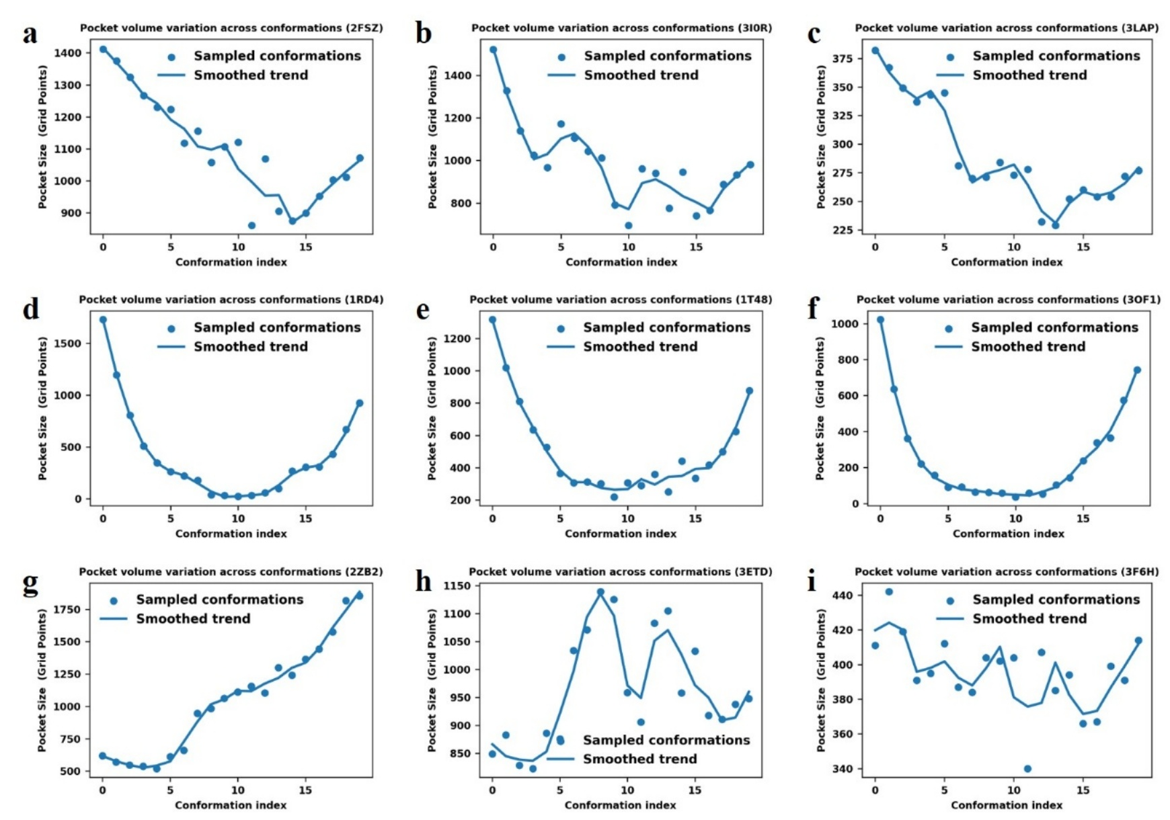

Figure S1. Dynamic transition patterns of allosteric pockets along linearly sampled conformational transition pathways. Quantitative analysis of allosteric pocket LIGSITE grid counts (y-axis, serving as a proxy for relative pocket volume) reveals that volumetric transition roughly converges into five distinct paradigms during the HOLO-to-APO conformational transition. a–c represent approximately linear decrease, where the HOLO state exhibits maximum volume and the APO state tends toward closure, effectively modeling gradual pocket contraction. d–f exhibit a U-shaped trend; while the initial HOLO volume exceeds the final APO volume, intermediate sampling conformations undergo transient volume collapse during energy minimization to resolve severe atomic steric clashes. g displays a linear increase, primarily attributed to structural alignment protocols and the pruning of residues missing in the initial HOLO state, resulting in a general volumetric increase along the optimized trajectory. h is characterized by an arched or parabolic pattern, where severe local atomic clashes in intermediate conformations necessitate significant pocket expansion during energy minimization to alleviate steric tension. i shows low-amplitude fluctuations, indicating high structural rigidity wherein pocket volume remains relatively static throughout the pathway. In summary, despite the structural diversity of allosteric proteins and the non-linearity of volumetric transitions, our generated pathway ensembles successfully capture the critical “opening and closing” dynamic processes of these pockets. Crucially, this establishes essential physics-informed structural priors enabling neural networks to identify potentially flexible residues and detect cryptic functional pockets that emerge during conformational transition.

Design rationale for supervised learning of cryptic pocket residues
Existing allosteric protein databases suffer from profound limitations in site annotation. Experimental records are notoriously sparse, incomplete, and predominantly biased toward static HOLO (ligand-bound) conformations. Consequently, they fail to capture the highly transient nature of cryptic allosteric pockets in the unbound state and the dynamic conformational landscape of allosteric signal transduction. Relying exclusively on a few hundred statically annotated samples for end-to-end supervised learning is thus inadequate for the complex task of pocket identification. Empirical benchmarking reveals that when a model is trained solely on HOLO conformations and known critical binding residues, and subsequently evaluated on an independent APO (unbound) ensemble (50 structures per target), it achieves only baseline ranking capability (AUROC = 0.71). More critically, the overall predicted probabilities are severely depressed, leading to a failure in effectively identifying key functional sites (AUPR = 0.13, Recall = 0.09). Furthermore, due to incomplete experimental coverage, numerous biophysically plausible functional sites lack explicit ground-truth annotations and are thus systematically penalized as false positives. Compounded by the background noise of intrinsic structural cavities, the current static, explicit annotation paradigm systematically underestimates the true predictive capacity of these models.
To overcome these critical data and methodological bottlenecks, we introduce a novel cryptic pocket residue supervised learning paradigm. We shift the supervisory signal from traditional static annotations to cryptic pocket residue labels (LIGSITE Labels) derived from conformational ensembles. These ensembles, generated via rapid linear sampling, effectively approximate the physical “opening and closing” dynamics of allosteric pockets. The resulting cryptic labels encapsulate not only established allosteric sites but also highly flexible regions with potential regulatory functions during conformational transitions, thereby endowing the model with robust prospective identification capabilities. By introducing LIGSITE Labels, we successfully translate dynamic conformational changes—acting as a biophysical form of data augmentation—into machine-readable supervisory signals. Compared to sparse explicit annotations, these cryptic labels provide vastly superior residue and spatial coverage, effectively mitigating the optimization challenges caused by extreme class imbalance. Concurrently, this paradigm deeply embeds the biophysical priors of conformational evolution into the learning process, strengthening the model's ability to capture statistical correlations between protein structure and function. Ultimately, this approach establishes a rigorous theoretical framework for future explorations of complex allosteric mechanisms utilizing multi-scale evaluation metrics and physics-enhanced sampling techniques.

Assessment of the validity and dynamic sensitivity of LIGSITE Labels
We systematically benchmarks the performance of the LIGSITE Label against classical pocket identification methods in the detection of cryptic allosteric pockets. While widely utilized generic pocket detection algorithms (e.g., Fpocket) boast high detection sensitivity, they suffer from a pronounced deficit in specificity. Specifically, these algorithms identify an average of roughly 20 candidate pockets per protein conformation, introducing a substantial amount of noise in the form of undersized or fragmented local surface depressions. Furthermore, when analyzing allosteric pockets, they frequently mischaracterize continuous functional cavities by erroneously segmenting them into isolated sub-regions. Compounding this issue, their associated druggability scores offer limited utility in discriminating true binding sites, thereby failing to effectively filter allosteric pockets even within established HOLO structures. In stark contrast, the LIGSITE Label demonstrates a significant advantage in curbing false positives while maximizing functional coverage. Under rigorous constraints where only ~20% of the total residues are classified as positive sites, the LIGSITE Label robustly captures 60% to 70% of the residues comprising known allosteric binding sites, achieving exceptional recall and specificity. Using the PDB 3OTU complex as a representative case (Fig. S2), the residue overlap ratio between the LIGSITE Label and Fpocket is a mere 0.25. This underscores the LIGSITE Label's ability to successfully filter out approximately 40% of poorly druggable surface cavity residues, drastically minimizing the interference of non-functional background noise in downstream modeling.
To further validate the LIGSITE Label's proficiency in capturing dynamic cavities, we applied this labeling scheme to conformational ensembles generated from multi-pathway allosteric trajectories. Intrinsically, allostery is governed by the dynamic evolution of protein conformations; its complex energy landscape, shaped by superimposed potential energy surfaces, dictates the emergence of transient or stable allosteric pockets along transition pathways. Statistical analysis of the ensemble reveals a distinct tripartite distribution: approximately 51% of residues remain unannotated across all sampled conformations, verifying their structural rigidity and non-participation in pocket formation during allosteric evolution. Conversely, roughly 27% of residues are persistently annotated as implicit sites across varying conformations, defining the structurally stable core of the allosteric pockets. Most critically, approximately 22% of residues exhibit pronounced, conformation-dependent fluctuations in their annotations. This dynamic subset accurately delineates the transient formation and disappearance of allosteric pockets during the dynamic process. This distinct labeling distribution not only corroborates the biophysical realism of our generated conformational ensembles but also conclusively demonstrates that the LIGSITE Label framework effectively tracks the "opening and closing" dynamics of pocket topologies. Consequently, this establishes a robust and reliable methodological foundation for the precise downstream identification of cryptic allosteric sites.

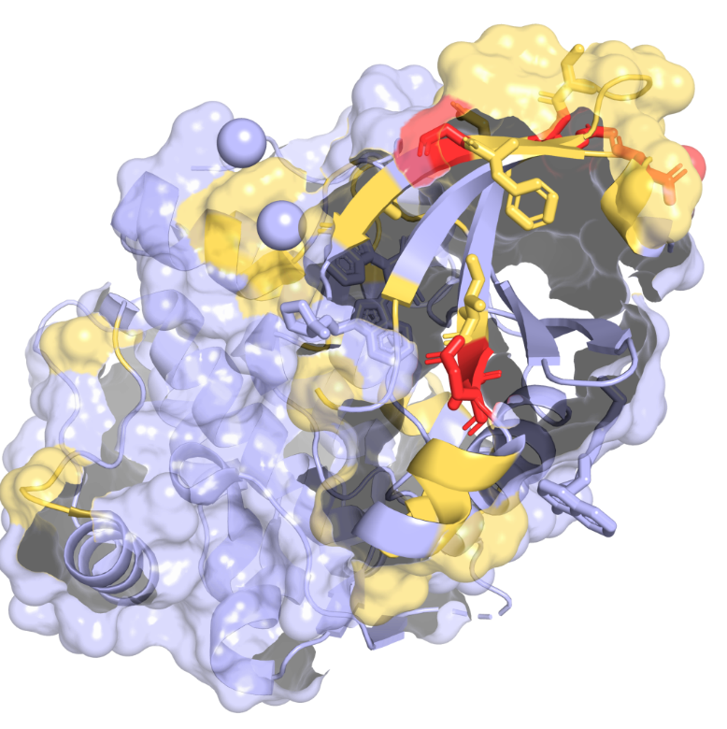
Figure S2. Visual comparison of allosteric pocket identification by Fpocket versus the LIGSITE Label in the PDB 3OTU complex. The light blue surface delineates the 20 potential candidate pockets predicted by the Fpocket algorithm. These predictions exhibit a highly diffuse and redundant spatial distribution, encompassing the majority of the target protein's surface area and incorporating numerous non-functional geometric depressions. Conversely, the yellow surface defines the implicit allosteric pocket labels generated by LIGSITE. This spatial footprint is significantly refined and precisely encapsulates the experimentally validated critical allosteric residues (depicted as red sticks). This direct spatial comparison visually underscores that, relative to conventional pocket detection tools, the LIGSITE labeling strategy achieves superior targeting and specificity for genuine allosteric functional sites while systematically eliminating substantial non-specific background noise.

Multi-Dimensional Evaluation of Model Generalization Performance
To systematically evaluate the model's generalization capabilities across unseen and complex scenarios, we conducted a multi-dimensional prospective validation. First, within the GPCR protein family, we examined the neurological pain target CB1R (Fig. S3b), which shares extremely low sequence identity (< 0.4) with the training set. Although known allosteric residues constitute merely 6% of this target, our model achieved a remarkable allosteric site recall of 52% at a positive prediction rate of 19%. This significantly outperforms the baseline model, PocketMiner, which achieved only a 17% recall at an equivalent prediction rate. Similarly, for the GLP-1 receptor (Fig. 1b)—a target harboring diverse allosteric pockets—we focused on the highly challenging lipid allosteric region located on the extracellular face of the transmembrane helices. Here, our model secured an excellent recall of 33% at a 24% positive prediction rate, surpassing the baseline's 26%. Given that the target pocket of CB1R is topologically more cryptic than that of the GLP-1 receptor, these results compellingly underscore our model's core advantage in detecting deeply cryptic allosteric sites.
Second, we assessed the model's cross-protein structural generalization (Fig. S3a) by leveraging prior features learned from the classical allosteric target KRAS (PDB: 4LUC) to predict sites on HRAS (PDB: 4DLV). While highly homologous, HRAS presents a distinctly different allosteric pocket distribution. Under the implicit label system, the initial recall rates for the two primary allosteric sites of HRAS were a mere 51% and 3%, highlighting the inherent difficulty of this transfer learning task. Nevertheless, constrained by a strict positive prediction rate of 14%, our model maintained an overall recall of 33% for HRAS allosteric sites, successfully anchoring the key functional pockets and confirming its robust capacity for cross-structural knowledge transfer.
Furthermore, to validate the model's zero-shot discovery capabilities, we evaluated it on PCSK9 (Fig. 1b), an extremely low-homology target with a sequence identity of < 0.1 compared to the training set. The model demonstrated precise prospective identification across all three of its literature-reported independent allosteric regions. It accurately pinpointed 20% and 9 out of 28 critical residues in the domain hinge and β-sheet regions, respectively. Most notably, within the flexible loop region, it successfully localized the key residues flanking a segment that remains incompletely resolved due to missing electron density.
In stark contrast, when processing complex targets such as KRAS and PCSK9, the residue prediction probabilities output by the baseline model, PocketMiner, are highly concentrated. This lack of statistical discriminative power prevents the effective isolation and identification of cryptic allosteric sites, revealing significant limitations in its generalization performance under complex biophysical scenarios.

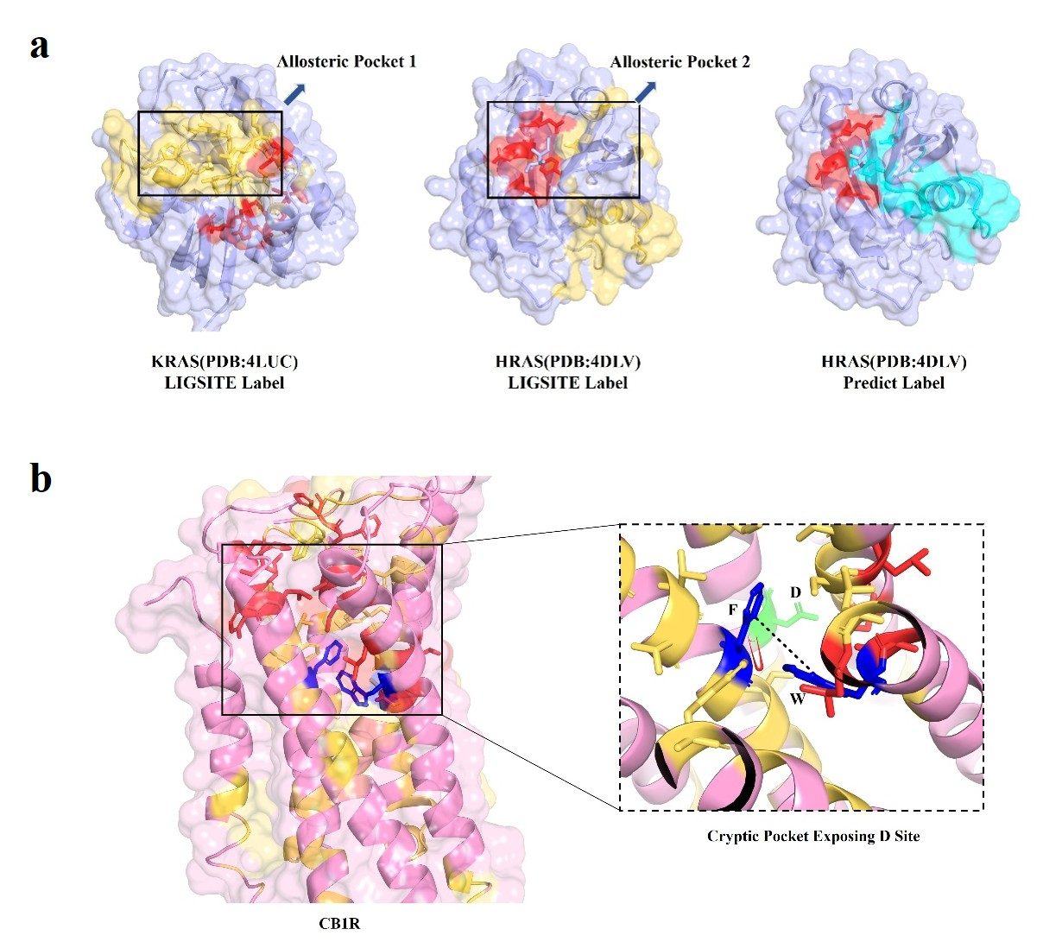

Figure S3. Evaluation of the model’s cross-protein generalization capability and the discovery of novel cryptic allosteric pockets. a. Validation of generalization across homologous targets (KRAS to HRAS). The left panel illustrates the KRAS protein structure (PDB: 4LUC) utilized during model training. The red and yellow stick models denote the known critical allosteric residues and the LIGSITE-annotated implicit pocket residues (training labels), respectively, exhibiting robust spatial overlap. The middle panel presents the homologous protein HRAS (PDB: 4DLV), an unseen target excluded from the training set. Here, the LIGSITE labels display significantly lower coverage of the known key residues, indicating that the ground-truth distribution of this test sample deviates from the original label space learned by the model. Nevertheless, the predictive results in the right panel demonstrate that our model (with cyan stick models representing predicted cryptic binding sites) successfully and accurately targets the known allosteric pockets of HRAS. This comparison substantiates the model's capacity to effectively transfer deep latent features learned from KRAS to homologous proteins, enabling the precise identification of spatially divergent allosteric pockets across similar targets. b. Discovery of a novel cryptic pocket in the CB1 receptor (CB1R). The newly detected cryptic allosteric pocket in CB1R is rendered as a red surface, with the model-predicted critical residues (yellow stick models) accurately encapsulating and delineating its core formation zone. Structural dynamics analysis reveals that the emergence of this pocket is fundamentally driven by an expansion in the spatial distance between specific phenylalanine (F) and tryptophan (W) residues. This conformational transition may effectively facilitate the recruitment of small-molecule ligands to the D site, thereby mediating essential allosteric regulatory functions.

Table S1. Data sources for case studies used in the evaluation of model generalization performance
Target gene | Pdb uniprot | Allosteric pdb | source
HRAS | P01112 | 4DLV | https://www.rcsb.org/structure/4DLV
CB1R | P63096 | 9B65 | https://www.nature.com/articles/s41586-025-08618-7#data-availability
GLP1 | P43220 | 5VEX | https://www.nature.com/articles/nature22378
PCSK9 | Q8NBP7 | 4NE9 | https://pubs.acs.org/doi/10.1021/acs.jcim.4c00294
PCSK9 | Q8NBP7 | 6U38 | https://www.sciencedirect.com/science/article/pii/S235294072400132X
PCSK9 | Q8NBP7 | / | https://patents.google.com/patent/US20230407285A1/en?oq=US20230407285

Limitations of AlphaFlow in sampling implicit allosteric pocket conformations
We further evaluate the limitations of flow-based generative algorithms, specifically AlphaFlow, in capturing cryptic allosteric pocket conformations. Although the protein conformational ensembles sampled by AlphaFlow theoretically approximate a Boltzmann distribution, conventional unbiased sampling strategies frequently fail to adequately explore the specific, metastable functional conformations that harbor cryptic allosteric pockets. To empirically validate this hypothesis, we conducted an in-depth analysis of two randomly selected target systems: 3KJF and 4EJN. Specifically, we generated 100 conformations for each system using AlphaFlow and rigorously screened them against our criteria for allosteric pocket identification—defined as a minimum spatial overlap of nine atoms between the surface cavity identified by Fpocket and the known allosteric binding site. Statistical analysis revealed that none of the 100 sampled conformations for the 3KJF system satisfied the conditions for cryptic allosteric pocket formation (0/100). Similarly, for the 4EJN system, only a single conformation successfully captured the target pocket (1/100). Furthermore, structural inspections revealed that the unliganded (APO) conformations directly generated by AlphaFlow suffer from pervasive, non-physical steric clashes. Consequently, these structures could not be correctly recognized or parameterized by the OPLS force field during the subsequent Glide protein preparation phase. These empirical findings robustly demonstrate that while state-of-the-art conformational generation models can recapitulate global protein dynamics to some extent, their sampling efficiency for specific, functional cryptic allosteric states remains exceedingly low. This sampling bottleneck severely limits the utility of relying exclusively on unbiased generative ensembles for allosteric site identification. Ultimately, it underscores the absolute necessity of integrating targeted enhanced sampling strategies or complementary physics-based force field constraints to effectively explore complex conformational landscapes.

Evaluating the Efficacy of Co-Folding Models in Predicting Allosteric Target Pockets
To further validate the practical performance of co-folding methodologies in allosteric ligand prediction tasks, this study conducted a systematic case-study evaluation of Boltz2, a widely recognized model in the current field. Existing literature suggests that the predictive performance of models like Boltz2 is heavily reliant on the memorization of training set data. Consequently, their generalization capability is often compromised when confronted with out-of-distribution (OOD) data. Empirical analysis demonstrates this phenomenon in the case of the GLP-1 receptor (Fig. S4c-f). Because the structural resolution of this target falls within the temporal cutoff of the Boltz2 training set, the co-folding method accurately identified the spatial coordinates of the allosteric pocket, yielding predicted ligand-binding poses that highly align with the experimentally resolved HOLO structure. Nevertheless, a subset of the predicted conformations still exhibited deviations from the expected distribution.
In stark contrast, when evaluating the PCSK9 target (Fig. S4a-b), although the model successfully predicted the known allosteric pocket located in the domain hinge region, it completely failed to identify the allosteric site within the flexible β-sheet region, which lacks support from static crystal structures. This comparative analysis compellingly illustrates that existing co-folding models suffer from significant limitations when tasked with identifying novel pockets unseen in the training corpus or flexible regions undergoing large-scale conformational transitions. In summary, while current co-folding methods exhibit situational applicability for specific allosteric prediction tasks, their conformational sampling depth and capacity for novel cryptic pocket discovery are insufficient to broadly address complex allosteric binding scenarios. This underscores a pressing need to further enhance the physical conformational exploration and OOD generalization capabilities of such models.

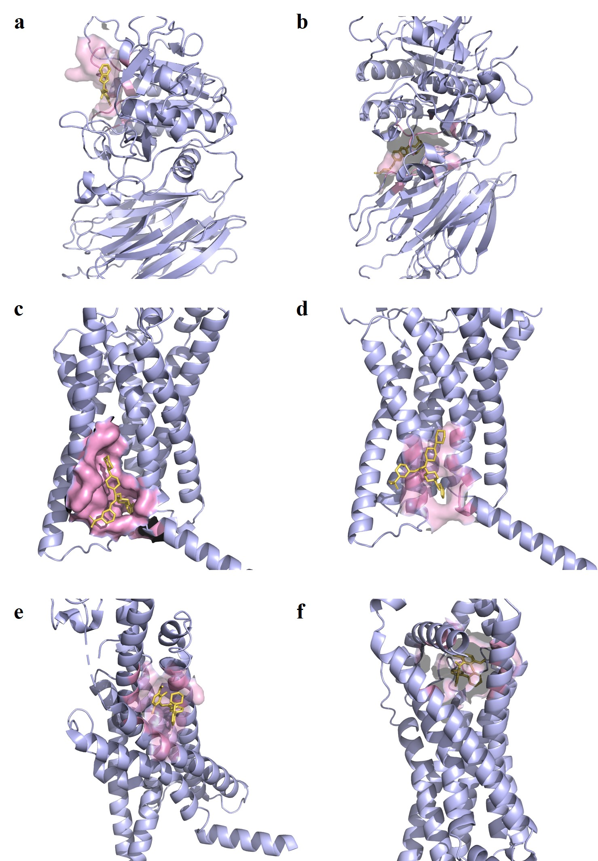

Figure S4. Visualization of protein-ligand co-folding conformations generated by the Boltz2 model. a, b Co-folding results for the PCSK9 target protein reveal two distinct categories of potential allosteric pockets: one situated adjacent to the upper loop region, and another located at the inter-domain hinge, exhibiting high structural similarity to a known allosteric site. c, d Co-folding conformations of allosteric ligands within the extra-helical lipid region adjacent to transmembrane helices TM5, TM6, and TM7 of the GLP-1 receptor. Panel d demonstrates favorable interactions between the ligand and helices TM6 and TM7. Panel c captures a distinct conformational feature wherein the N-terminal α-helix rotates downward to contribute to pocket formation. e, f Comparison of the experimental ground truth versus the predicted allosteric pocket apical to the helices of GLP-1R (PDB: 6VCB). Panel e shows the native reference structure of the pocket in the experimental HOLO conformation. The co-folding prediction in panel f indicates that the allosteric ligand is slightly shifted towards the middle of the helical bundle, yet successfully induces the formation of the binding pocket.

Integrated Computational Framework: Case Study on GLP-1 and PCSK9

GLP1
To address the challenges of discovering allosteric pockets and sampling conformations in transmembrane G protein-coupled receptors (GPCRs), this study utilizes the GLP-1 receptor as a validation system to systematically demonstrate a comprehensive computational framework: AI prior identification-guided physical biased simulation of preferred conformations. Given the high conformational flexibility of the channel formed by the seven transmembrane (TM) helices of GPCRs, and the presence of multiple cryptic allosteric pockets concealed within the extra-helical lipid regions, we constructed an end-to-end workflow mapping from sequences to conformational ensembles, and ultimately to functional pockets.
Initially, using the full-length sequence as input, AlphaFlow was employed to generate 50 APO conformations conforming to a Boltzmann distribution. A deep learning model then output the probability of each residue serving as a cryptic binding site. Benchmarked against the known HOLO structure (PDB: 5VEX), the model achieved a 33% recall rate (with a positive predictive value of 24%) in the extra-helical lipid region, successfully capturing allosteric signals at the sequence level. Subsequently, the predicted probabilities at identical positions were averaged, and a strict threshold of 0.7 was applied to filter and define the implicit residue pool.
To acquire high-fidelity evolutionary information, multiple sequence alignments (MSAs) were extracted using MMseqs2 integrated within ColabFold. Applying a 0.8 coverage threshold, 984 homologous sequences were purified from 7,483 raw sequences. Through randomized shuffling, partitioning, and repeated predictions, a structurally diverse ensemble comprising 620 conformations was systematically generated (Fig. S6). Building upon this, the predicted residues were mapped into three-dimensional space and subjected to spatial clustering using the DBSCAN algorithm (eps=6, min_samples=2), identifying 15 potential synergistic pocket modules. By integrating DeepAllo allosteric potential evaluations and PLB druggability scoring, the predicted residues within the TM7 helical region exhibited outstanding performance (Fig. S5b). Incorporating biophysical priors and masking confounding regions, this study precisely focused on the extra-helical lipid allosteric region of TM6. Ultimately, 14 critical residues—Ile354, Lys355, Arg357, Leu358, Leu365, Leu369, Leu410, Tyr411, Cys412, Phe413, Val414, Asn415, Asn416, and Glu417—were locked in as the candidate pocket core (achieving a target recall of 50%), conclusively validating the reliability of AI priors in localizing functional residues.
Because specific functional allosteric conformations frequently exist as highly underrepresented metastable states within an ensemble, we designed an iterative sequence screening and purification pipeline for the targeted enrichment of co-evolutionary signals (Fig. S5a). Over six consecutive screening rounds, the MSA was partitioned into subsets for structural prediction. To quantify conformational preference, the Euclidean distance between the cluster center of the key residues and the geometric center identified by Fpocket was calculated. The system strictly retained only the sequences corresponding to the top 20% of conformations (ranked by minimal distance) to advance to the next iteration. During the first five rounds, the average distance for the top 10% preferred conformations steadily decreased to within 5 Å, reaching saturation by the sixth round. Consequently, sequences corresponding to the ultra-low distance conformations from the first five rounds were aggregated to construct an enriched library of 759 sequences. To further disentangle structure-specific correlations, we introduced a "leave-one-group-out" cross-sampling and sequence voting mechanism. The enriched library was divided into 37 groups, iteratively generating 36 × 37 overlapping subsets for prediction. Based on the distance metric, predicted conformations were binned into 20 intervals, and the conformational preference distribution of each sequence was statistically mapped. The system ultimately extracted 5 sequences localized in the leftmost intervals (Bin 3 and Bin 4, representing the absolute minimal distance and closest proximity to the target pocket morphology) to serve as a highly purified, correlated sequence set. Validation results demonstrated that the 40 predicted conformations generated from these purified sequences flawlessly recapitulated the anticipated continuous pocket morphology. In stark contrast, a control group generated from randomly enriched sequences exhibited significant misalignment of the TM5 and TM6 helices, failing entirely to form a cavity (Fig. S5c). This robustly verifies the exceptional efficacy of the sequence voting and purification strategy in capturing exceedingly rare functional conformations.
To validate and optimize the biophysical plausibility and dynamic signatures of these preferred conformations, an all-atom simulation system embedded in a lipid bilayer was constructed (Fig. S5d). Following a 100 ns conventional molecular dynamics equilibration, metadynamics-based enhanced sampling (biased simulation) was introduced. Using the total solvent-accessible surface area (SASA) of the pocket—defined by the 14 established key residues and their 8 Å neighborhood—as the collective variable (CV), a 50 ns biased simulation was executed. Results indicated that critical regions, notably TM6–TM7, rapidly converged under the bias. The pocket volume frequently surpassed 500 Å³ during the mid-to-late stages, exhibiting a highly stable open state. This successfully achieved a dual optimization paradigm: evolutionary information guides the direction; physical force fields stabilize the conformation. To conclusively demonstrate the indispensability of each module within this framework, systematic ablation studies were performed. First, although the highest-confidence conformation predicted solely from the standard source MSA exhibited a tendency for TM6 outward rotation (Fig. S5e-f), it could not maintain an open pocket during equivalent biased simulations. This proves that raw co-evolutionary signals, devoid of iterative purification, are insufficient to anchor the functional state. Second, under identical simulation durations, the probability of sampling large-volume pockets (>500 Å³) via conventional MD was significantly lower than that of biased MD, highlighting the indispensable role of the SASA bias in surmounting conformational energy barriers. Finally, within the initial unbiased ensemble generated by AlphaFlow, a mere ~10% of the pockets breached the 400 Å³ volume threshold, falling drastically short of the final sampling depth achieved by our integrated framework.
In summary, the integrated multi-stage workflow proposed in this study—“AI prior identification, iterative sequence purification, and physical biased optimization”—demonstrates unparalleled advantages in targeting precision, biophysical plausibility, and functional accessibility. It establishes a highly promising computational paradigm for the systematic mining and dynamic validation of cryptic allosteric pockets.

Table S2. Iterative enrichment distance metrics for GLP-1–specific conformational sequences.
 | Iteration1 | Iteration2 | Iteration3 | Iteration4 | Iteration5 | Iteration6
10% Distance | 5.17 | 5.12 | 5.05 | 5.13 | 4.81 | 5.00

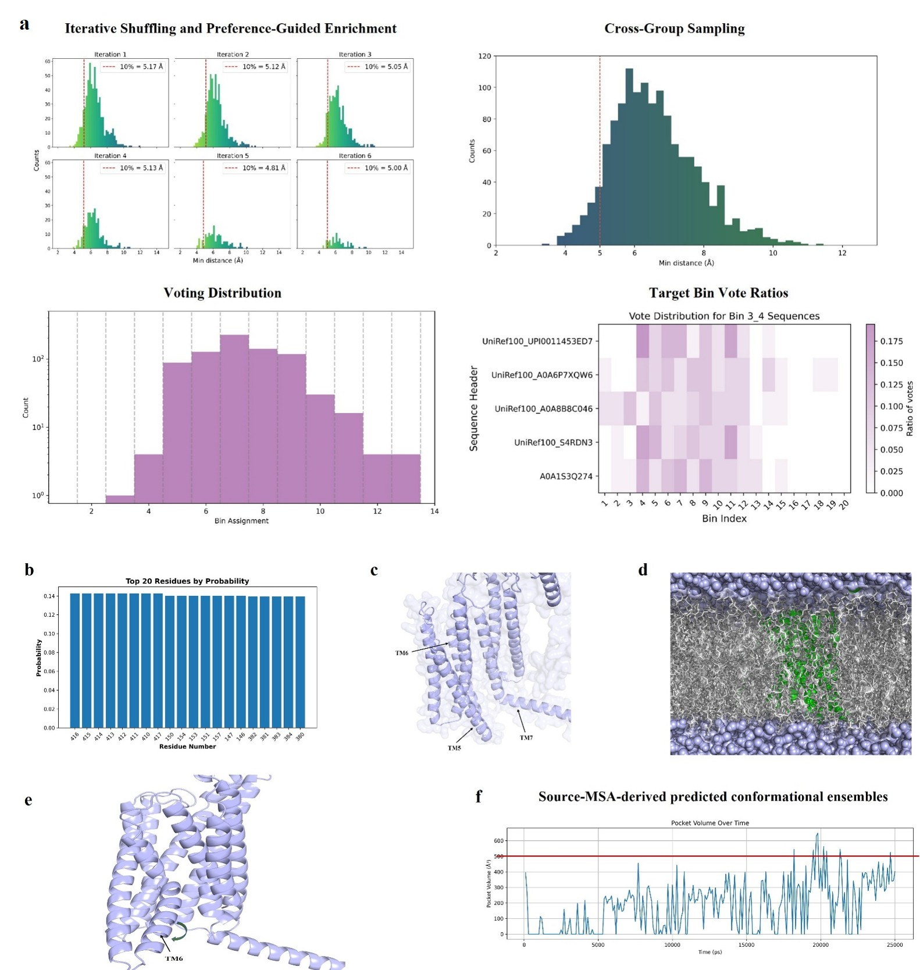

Figure. S5. Sequence enrichment and preference-guided conformational sampling analysis of the GLP-1 receptor system. (a) Iterative enrichment of allosteric pocket–preferred sequences and the corresponding conformational state evolution. In the upper-left panel, the six-round iterative curves show that, as the number of screening rounds increases, the distance-score threshold of the top 10% conformations decreases steadily, confirming effective enrichment of the sequence subset toward the target pocket. In the upper-right panel, the score distribution indicates that, after cross-group sampling, a large fraction of enriched sequences exhibit conformations with distance scores below 5 Å, thereby providing a foundation for identifying highly preferred conformational states. In the lower-left panel, consensus voting counts are shown for the optimal conformational state of each sequence based on distance-interval binning, where smaller bin values indicate closer resemblance to the target pocket geometry. The lower-right panel further presents the conformational state distribution of the high-purity subsets (Bin 3 and Bin 4). (b) Top 20 key amino acid residues ranked by the protein–ligand binding (PLB) score. (c) Control conformation predicted from randomly sampled sequences. The TM5–TM6–TM7 transmembrane helical region is severely distorted, with TM6 in particular exhibiting substantial spatial displacement and failing to form the characteristic receptor architecture, thereby inversely highlighting the necessity of the sequence enrichment strategy adopted in this study. (d) Schematic illustration of the all-atom molecular dynamics simulation system. The gray region represents the POPC lipid bilayer surrounding the receptor (shown in cartoon representation), and the light blue regions above and below correspond to the solvent water layers. (e) Highest-confidence conformation directly predicted from the source multiple sequence alignment (MSA). TM6 is displaced outward and exhibits a characteristic active-state feature. (f) Global statistical analysis of the conformational ensemble derived from the source MSA. Very few conformational frames in the original ensemble exhibit an allosteric pocket volume greater than 500 Å³, indicating that the unrefined evolutionary information alone is insufficient to effectively sample the target large-volume functional pocket.

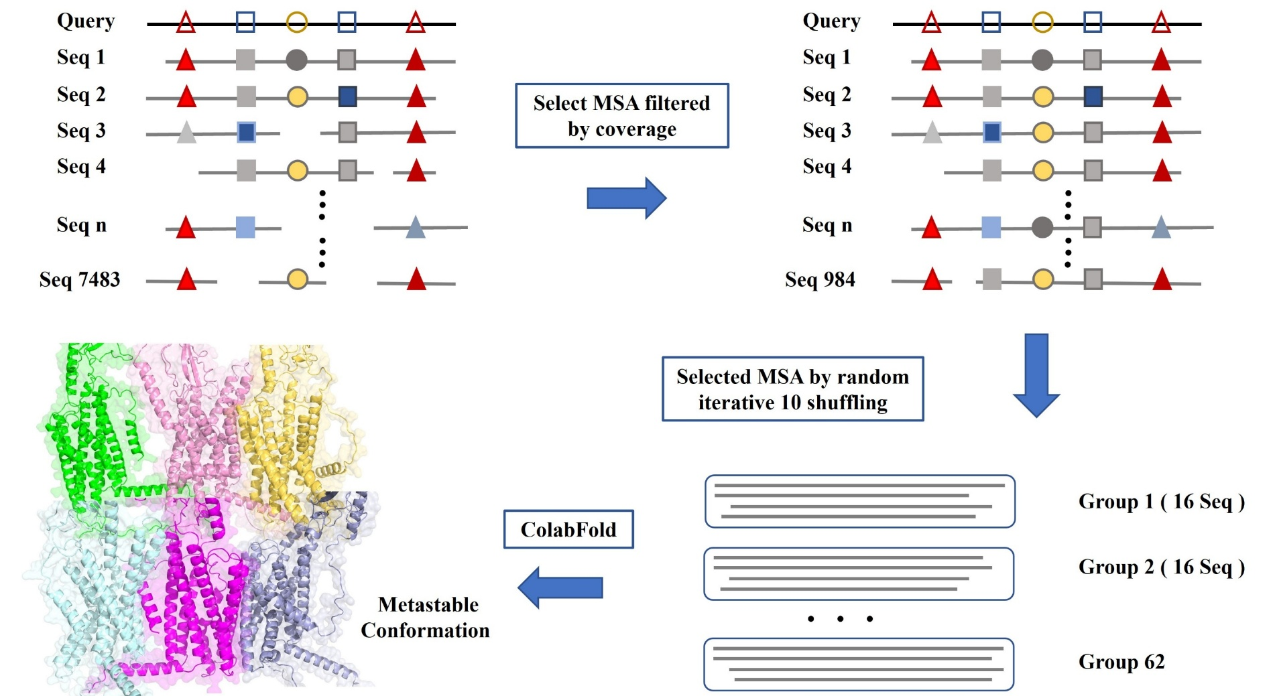

Figure. S6. Workflow and example of metastable conformational ensemble construction based on multiple sequence alignment. Using the GLP-1 receptor as an example, this figure illustrates the complete workflow for mapping sequence diversity to conformational diversity. First, the original multiple sequence alignment (MSA), containing 7,483 sequences, was filtered using a stringent coverage threshold (≥ 0.8), yielding 984 high-quality sequences. Next, this curated sequence set was subjected to 10 rounds of random resampling and grouping to generate multiple independent subsets, each containing 16 sequences. ColabFold was then used to perform independent structure prediction for all sequence subsets, and the resulting models were aggregated to construct the target metastable conformational ensemble. As shown in the conformational landscape analysis in the lower-left panel, the generated ensemble effectively reveals multiple potential functional states of the receptor. For example, by tracking whether the TM6 transmembrane helix undergoes outward rotation, heterogeneous conformational clusters corresponding to active and inactive states can be clearly identified and separated. These results directly demonstrate that the MSA-resampling-based ensemble construction strategy can efficiently and broadly cover the complex and heterogeneous dynamic conformational landscape of the target protein.

PCSK9
To evaluate the generalizability of the proposed framework across distinct targets and structural classes, we further applied it to PCSK9, a key regulator of lipid metabolism. The C-terminal β-sheet region of PCSK9 exhibits pronounced conformational flexibility and represents a potential hotspot for allosteric regulation; however, its “open” state has not yet been resolved experimentally, posing a major obstacle to structure-based drug design.
We first applied a deep learning model to the full-length PCSK9 sequence to predict potential cryptic allosteric sites. The predicted residues showed strong agreement with a previously reported patent-defined pocket, achieving 80% coverage of the known pocket residues and correctly identifying 9 of the 28 key residues. This biologically informed prior provided a clear spatial anchor for downstream conformational sampling. A large-scale conformational ensemble was then generated by random grouping based on the source multiple sequence alignment (MSA), and the predicted positive residues were projected into three-dimensional space and clustered into pocket modules using the DBSCAN algorithm (eps = 4.5, min_samples = 2). Functional evaluation by integrating DeepAllo and protein–ligand binding (PLB) scores revealed that high-scoring residues were significantly enriched in the β-sheet region and domain hinge area, with DeepAllo specifically highlighting residues 343–348 as a key allosteric segment. By combining prior knowledge of the known critical residue (residue 483) with a statistical summary of spatially recurrent high-frequency residues, we ultimately identified 20 key residues as spatial targets for conformational enrichment.
To extract sequence signals capable of stably forming the target pocket from the background evolutionary noise, we performed eight rounds of iterative sequence screening (Fig. S7a). In each round, structures were predicted from the MSA-derived sequence sets, and a distance metric was computed between the clustering center of the preferred residues and the geometric center of the pocket identified by Fpocket. The resulting ensemble exhibited a clear iterative shift toward lower distances, indicating progressive enrichment toward conformations more closely matching the target pocket geometry. All sequences corresponding to conformations with distances below 5 Å (372 sequences in total) were then collected for a leave-one-group-out cross-sampling purification stage (Fig. S7b). This set was divided into 37 groups, and 36 × 37 subsets were constructed for structure prediction, thereby systematically probing the pronounced flexibility of this region and the discriminative power of the proposed strategy. Through further sequence–conformation voting analysis (Fig. S7c), sequences falling into the optimal bins (Bin 3 and Bin 4) were selected to construct the final purified target-preferred MSA subset (Fig. S7d). Structural analysis showed that conformations predicted from this purified subset displayed a markedly increased separation between β-sheet 1 (residues 481–485) and β-sheet 2 (residues 408–413), consistent with a characteristic pocket-open state. By contrast, structures predicted directly from the source MSA retained a tightly packed arrangement in this region and failed to form a pocket (Fig. S7f and Fig. S8), thereby underscoring the decisive role of sequence purification in capturing functional conformations.
To further assess the dynamical stability and druggability of this open conformation, we constructed an all-atom molecular dynamics system using the highest-quality structure predicted from the purified MSA as the starting model. To compare the sampling efficiency of different reaction coordinates (CVs), we separately employed (i) the distance between key residue pairs across the two β-sheets and (ii) the total solvent-accessible surface area (SASA) of the pocket neighborhood defined by the key residues as biasing variables for enhanced sampling. After full equilibration and 100 ns of conventional molecular dynamics simulation, a 50 ns unbiased trajectory was extracted and used for low-dimensional reaction-coordinate learning with the State Predictive Information Bottleneck (SPIB) method, which then guided a subsequent 50 ns metadynamics simulation. Trajectory analysis showed that the SASA-based biased simulation (Fig. S7e) successfully drove a large number of conformational frames to pocket volumes exceeding 500 Å³, thereby capturing a persistent and highly stable open state. In contrast, simulations biased by residue-pair distance yielded very few large-volume pocket conformations. This comparison highlights the clear superiority of SASA as a dynamical order parameter for describing the opening–closing behavior of this allosteric pocket.
To evaluate the ligand-binding potential of this pocket, an allosteric small molecule reported in the patent literature was docked into representative open conformations using AutoDock Vina (Fig. S9). The best binding pose achieved a docking score of −7.425 kcal/mol, in good agreement with the experimentally measured micromolar (μM)-level bioactivity. This binding result directly demonstrates that the cryptic allosteric pocket captured by our computational framework is not only physically and structurally plausible, but also associated with clear biological function and substantial therapeutic potential.
Taken together, these results systematically validate the proposed end-to-end computational framework—AI prior identification, iterative sequence purification, and physics-based bias optimization—across two fundamentally different and highly challenging target classes: a transmembrane protein (GLP-1 receptor) and a multidomain soluble protein (PCSK9). By deeply integrating deep-learning-driven residue-level prior prediction, coevolution-guided conformational enrichment, and physics-based enhanced sampling, the framework achieves multiscale coverage of cryptic allosteric pockets, spanning microscopic residue identification, mesoscopic conformational steering, and macroscopic dynamical exploration. The results not only demonstrate its robust ability to anchor allosterically important residues across diverse systems, but also highlight its power to overcome sampling bottlenecks in highly flexible targets and efficiently enrich functional conformations with well-defined structural signatures and druggable open-pocket states. More broadly, this work establishes a rational, atomistically grounded computational paradigm for allosteric drug discovery against conventionally “undruggable” targets such as GPCRs and multidomain flexible proteins, with considerable promise for both methodological expansion and early-stage drug development pipelines.
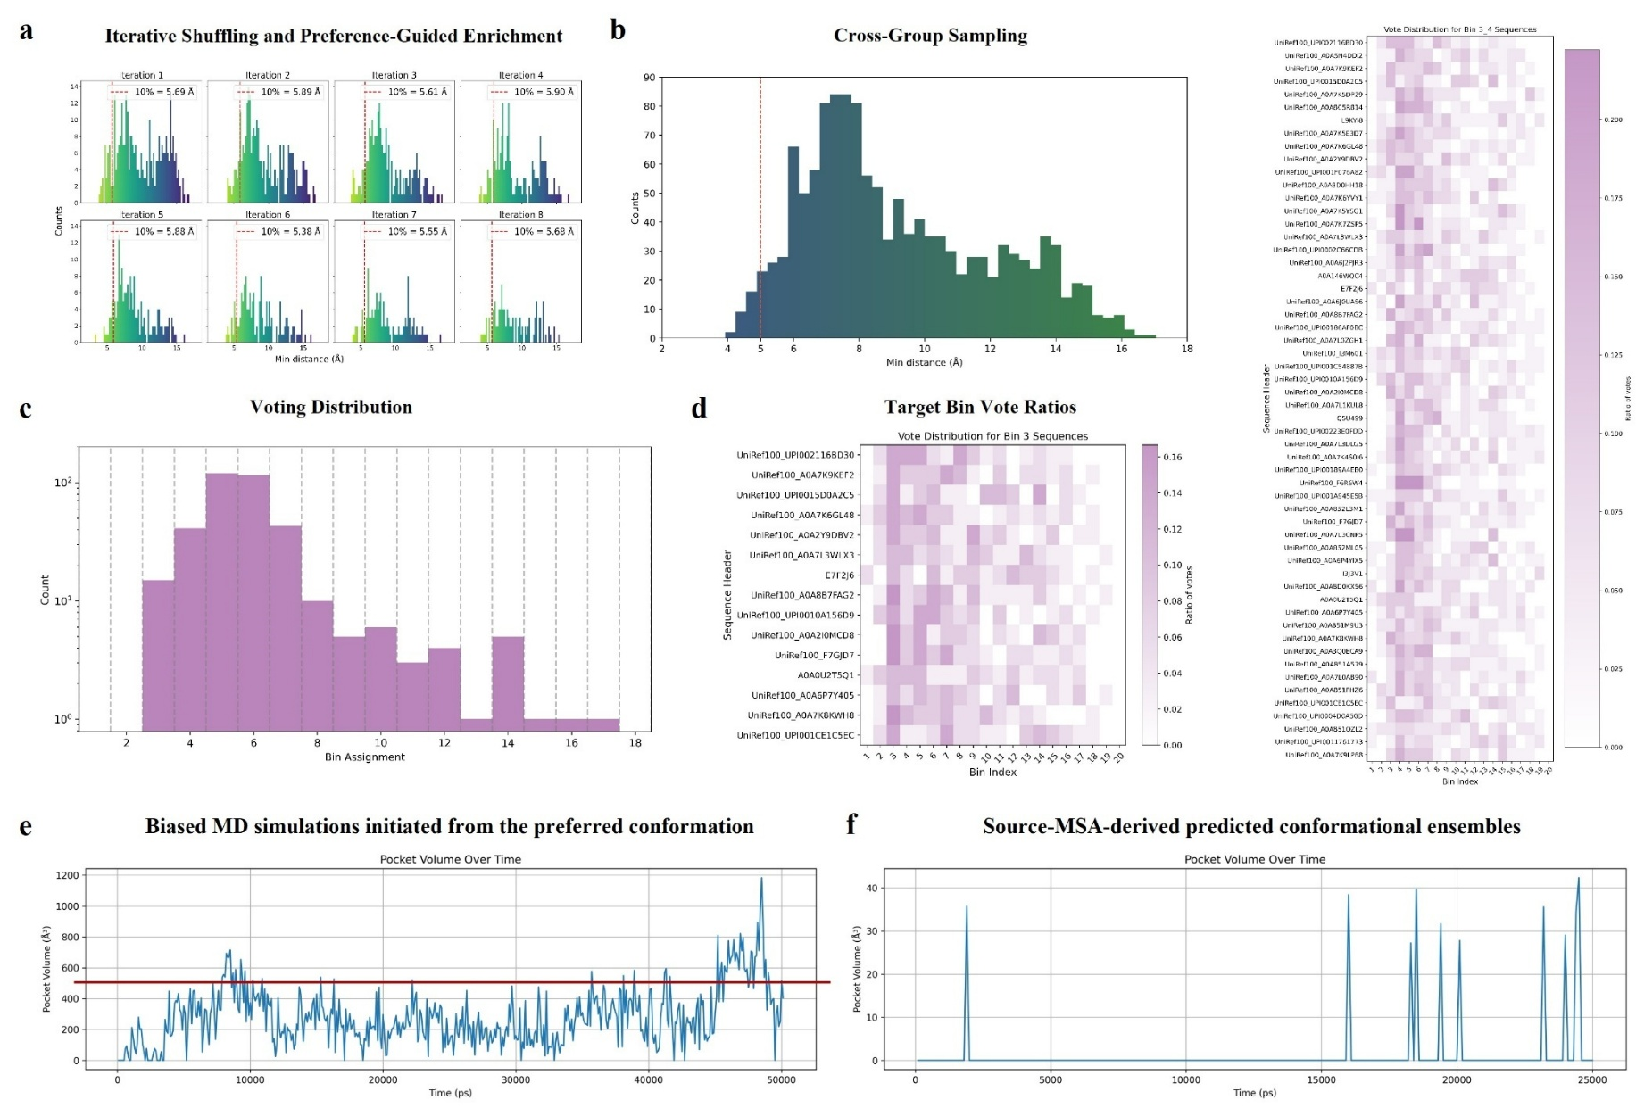

Figure. S7. Preference-guided conformational sampling of the PCSK9 target and monitoring of allosteric pocket volume. (a) Eight rounds of iterative sequence enrichment based on the source multiple sequence alignment (MSA). As the number of iterations increased, the overall distance-metric threshold of the conformational ensemble progressively decreased, indicating effective enrichment of the preferred conformations within the ensemble. (b) Distance-metric distributions of conformations predicted from different sequence subsets after cross-group sampling of the enriched sequences, directly illustrating the strong association between enriched sequences and the preferred conformations. (c) Voting distributions of sequences across different conformational states. The x-axis denotes multiple conformational intervals (bins) defined by the distance metric, where bins further to the left correspond to conformations closer to the target pocket, and the y-axis represents the sequence voting counts. (d) Overall voting distributions of conformational states for the high-purity sequence subsets, including Bin 3 alone and the combined Bin 3 + Bin 4 subsets. (e) Time evolution of the allosteric pocket volume during metadynamics simulation. The simulation was initialized from the preferred conformation, and the collective variable was defined as the total solvent-accessible surface area (SASA) of the pocket formed by the key residues and their neighboring residues. (f) Distribution of the volume of the corresponding allosteric pocket in the conformational ensemble predicted from the source MSA, serving as a baseline control for evaluating the outcome and enrichment efficiency of the preference-guided conformational sampling strategy.

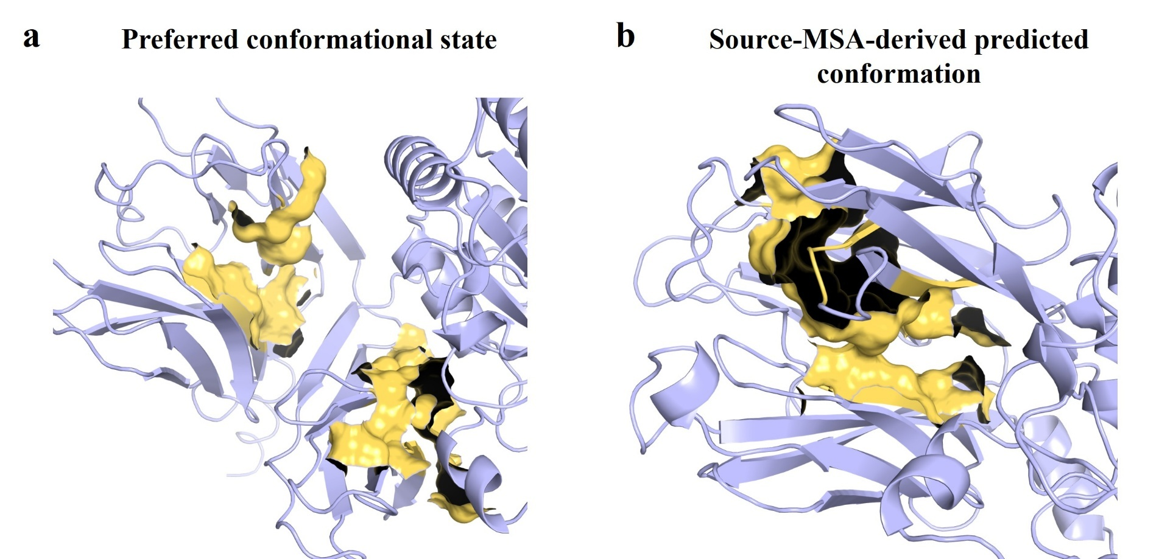

Figure. S8. Comparison of PCSK9 allosteric pocket conformational features before and after sequence purification. (A) Preferred conformation of the target allosteric pocket captured after iterative enrichment and consensus-voting-based purification of the multiple sequence alignment (MSA). (B) Conformation predicted directly from the untreated source MSA. The yellow surface highlights the key residues comprising the allosteric binding site. Structural analysis clearly shows that, in the preferred conformation, pronounced spatial separation and opening of adjacent β-sheet clusters expose a cryptic binding pocket. In contrast, in the conformation predicted from the source MSA, the β-sheet cluster remains in a tightly packed and closed arrangement, making it physically difficult to form an effective cavity capable of accommodating a ligand.

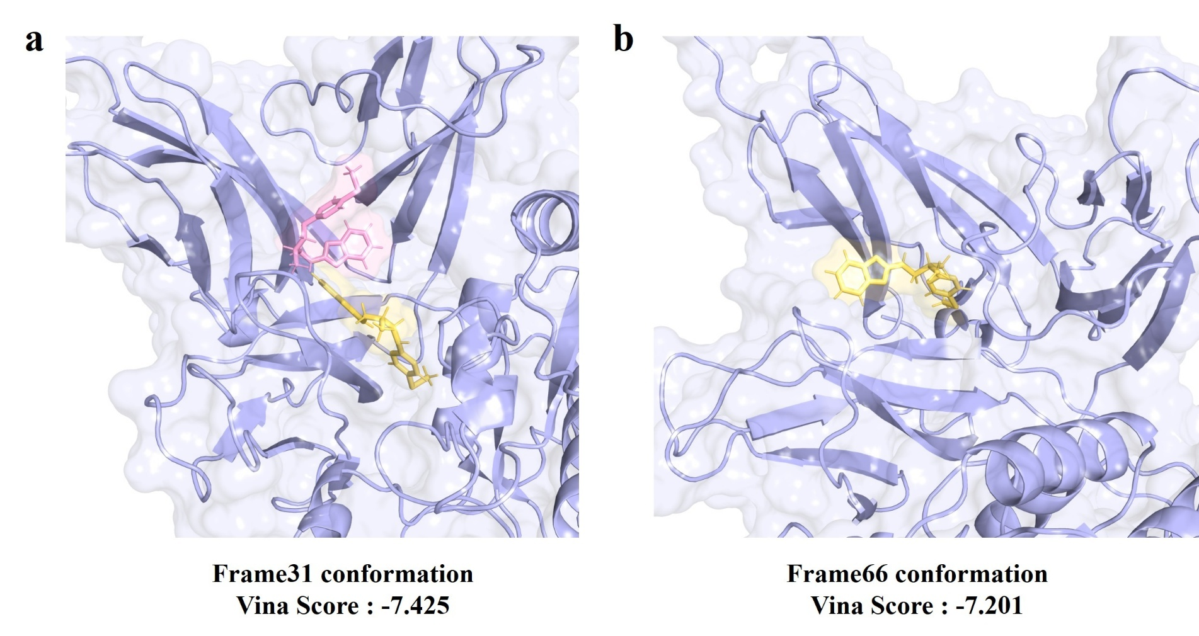
Figure. S9. Molecular docking and pose evaluation of the allosteric ligand in simulated conformational frames. Analysis of docking scores (Vina scores) obtained using AutoDock Vina on the dynamically sampled conformational ensemble showed that the target allosteric ligand can effectively anchor within the allosteric pocket region through diverse binding poses. Specifically, frame 31 exhibited the globally optimal docking affinity, with a binding energy of −7.425 kcal/mol. Although frame 66 yielded a slightly lower score (−7.201 kcal/mol), its ligand-binding pose displayed a high degree of spatial-topological consistency with the interaction pattern of the key residues predicted a priori by our computational framework, thereby providing strong support for the pharmacological relevance of the predicted pocket.

Structure-Based Virtual Screening and Ligand Discovery
After completion of the molecular dynamics simulations and acquisition of the equilibrated conformational ensemble, representative allosteric pocket conformations were systematically extracted for subsequent virtual screening. To evaluate the quality of the proposed conformational sampling paradigm, we used the GLP-1R system as an example and performed an in-depth comparison between the sampled allosteric conformations and a known HOLO (ligand-bound) reference structure. Specifically, a docking grid was defined based on the geometric center of the preidentified key allosteric residues, and AutoDock Vina was used to score docking poses of the known allosteric ligand against all trajectory frames. The results showed that frame 500 exhibited the globally optimal Vina score (−10.573 kcal/mol), indicating the highest theoretical binding affinity. However, structural superposition analysis revealed that the potential binding site in this conformation was markedly shifted downward relative to the reference HOLO structure. Such a geometric rearrangement would likely sterically hinder the outward rotational activation motion of TM6, suggesting that this conformation may predominantly confer an allosterically inhibitory functional property. For comparison, the known HOLO structure yielded a Vina score of −8.983 kcal/mol. By comprehensively considering the physicochemical microenvironment of the pocket, geometric shape, ligand accommodation, and consistency of docking scores, we ultimately selected frame 141 (Vina score = −9.636 kcal/mol) as the receptor model for virtual screening, as this conformation achieved the best balance between high-affinity binding characteristics and potential functional interpretability.
In addition, to emphasize the general applicability of this computational paradigm in realistic de novo design scenarios where no prior ligand information is available, we further proposed a completely ligand-independent conformation selection strategy. Specifically, one may directly extract trajectory frames in which the allosteric pocket volume reaches an extreme value during the equilibrated dynamical stage, or perform clustering analysis on the subset of conformations whose pocket volume exceeds 500 Å³, followed by extraction of the cluster centers for ensemble docking.
Based on the selection of frame 141 as the screening receptor, we designed and implemented an efficient hierarchical virtual screening workflow for the ChemDiv commercial library containing approximately 1.4 million compounds. First, the entire library was subjected to rapid preliminary screening using the KarmaDock docking engine, and the top 100,000 high-potential compounds were retained according to the docking-score ranking. Next, the Glide module in the Schrödinger Suite was used for cascaded refinement, in which standard precision (SP) docking further reduced the candidate pool to the top 10,000 molecules. Finally, extra precision (XP) docking was performed using a more stringent force-field evaluation and desolvation penalty scheme, leading to the identification of multiple candidate compounds with excellent predicted binding affinities (best Glide XP score = −9.32) and novel scaffolds. Detailed three-dimensional analysis of the binding modes of these hit compounds provides a solid theoretical basis and physical prior for subsequent experimental activity validation and rational lead optimization.

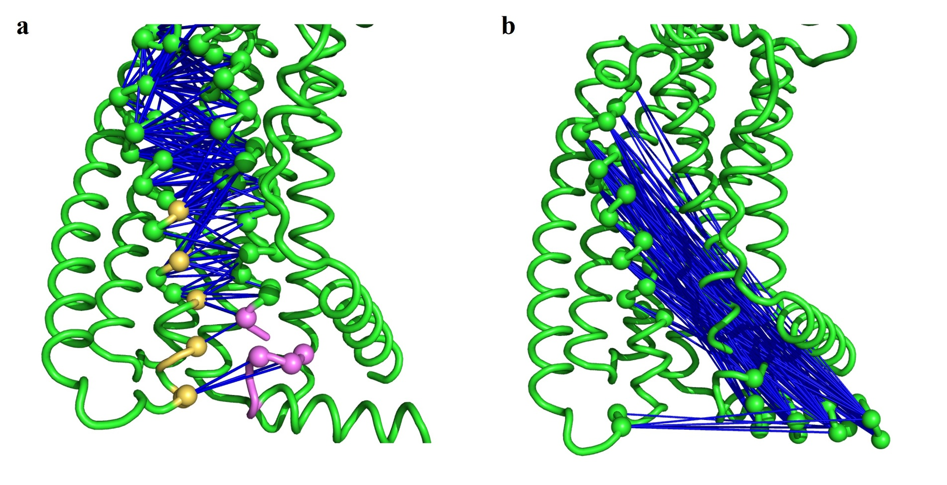
Figure. S10. Residue-residue dynamic correlation analysis based on Linear Mutual Information (LMI). (a) Analysis of highly correlated residue pairs at the TM6-TM7 interface. Key allosteric residues mediating local interactions are highlighted; residues located on TM6 are colored yellow, while those on TM7 are colored purple. (b) Map of the long-range interaction network between TM6 and TM7 helices. This network reveals potential allosteric communication pathways spanning TM6 and TM7, reflecting dynamical coupling relationships beyond direct physical contact.

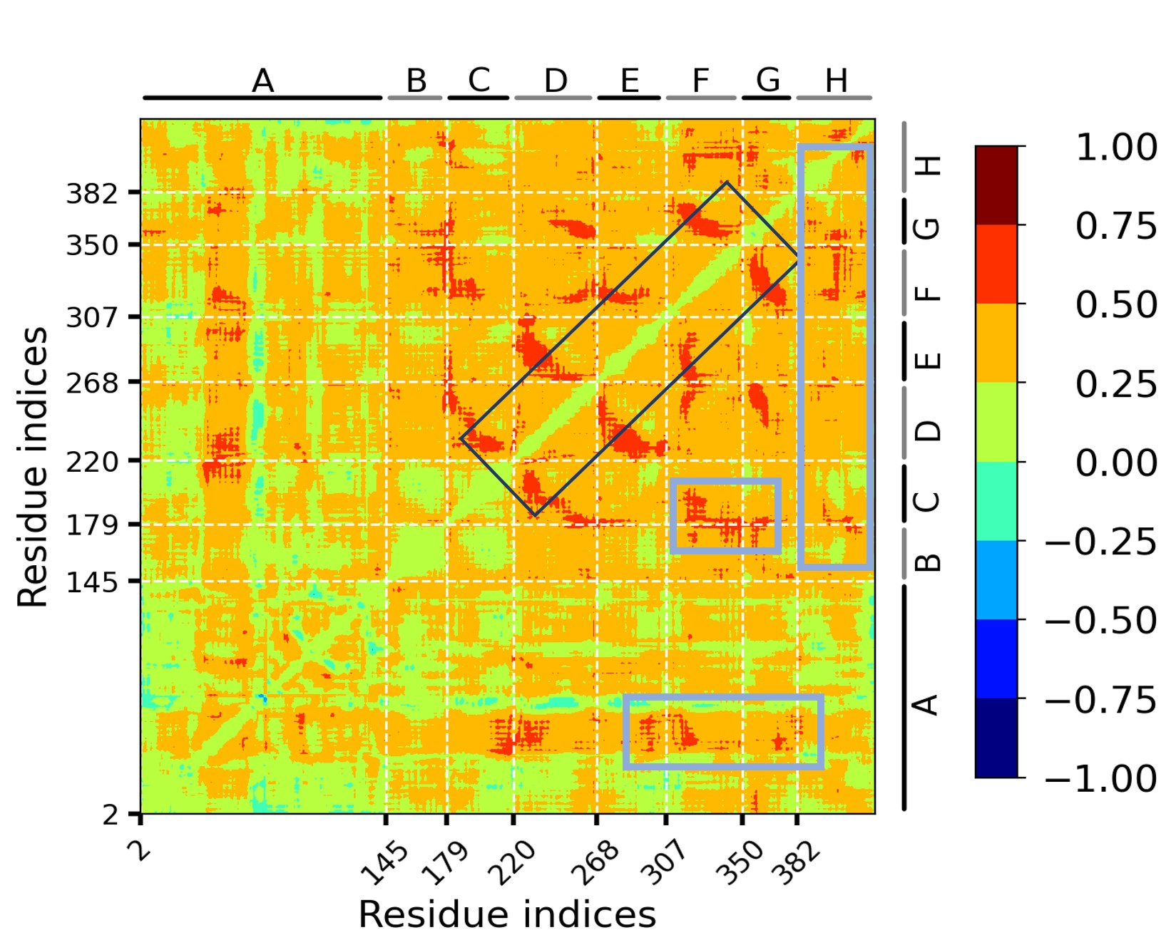
Figure. S11. Ligand-induced differential residue interaction map (HOLO vs. APO). The figure displays the difference matrix of inter-residue dynamical correlations between the ligand-bound (HOLO) and ligand-free (APO) states. Black solid boxes (Diagonal regions): Primarily correspond to short-range contacts within individual transmembrane helices or between spatially adjacent helices. Blue solid boxes (Off-diagonal regions): Highlight significant changes in long-range dynamical couplings. These off-diagonal signals reveal key signal communication events triggered by allosteric ligand binding, characterizing the conformational rearrangements and remote modulation mechanisms occurring between transmembrane helices (specifically between TM6/TM7 and TM5/TM1).

