AlloDesigner: An AI-Guided End-to-end Computational Framework Integrating Sequence, Conformation, and Function for Cryptic Allosteric Drug Design

Yangyang Zhang^{1,2}, Yuchen Zhu¹, Jihong Chen¹, Nanqi Lin¹, Hongbin Pei^{2,5*}, Tingjun Hou^{1,3,4}*, Chang-Yu Hsieh^{1,3,4*}

¹ College of Pharmaceutical Sciences, Zhejiang University, Hangzhou, 310058, Zhejiang, China
² Shenzhen Loop Area Institute (SLAI), China
³ The First Affiliated Hospital, College of Medicine, Zhejiang University, Hangzhou, 310058, China
⁴ Zhejiang Provincial Key Laboratory for Intelligent Drug Discovery and Development, Jinhua, 321016, Zhejiang, China
⁵ MOEKLINNS Lab, School of Cyber Science and Engineering, Xi’an Jiaotong University, China

*Corresponding authors:
Chang-Yu Hsieh
E-mail: kimhsieh@zju.edu.cn
Tingjun Hou
E-mail: tingjunhou@zju.edu.cn
Hongbin Pei
E-mail: peihongbin@xjtu.edu.cn

Abstract
Rare and transient conformational states play central roles in protein function and druggability but remain difficult to discover systematically. Cryptic allosteric pockets are often invisible in experimentally resolved structures and challenging to capture with conventional molecular dynamics due to the high cost of sampling rare events, while current generative models frequently struggle to predict conformations outside their training distributions. Here we introduce AlloDesigner, an end-to-end computational framework that, for the first time, integrates geometric deep learning with physics-based enhanced sampling to progress directly from protein sequence to physically realistic open cryptic allosteric states with minimal human intervention. The method generates low-cost conformational ensembles to train a geometric vector perceptron (GVP) network on dynamic labels that identifies residues associated with latent allosteric sites. These learned structural priors are then automatically translated into interpretable residue-level reaction coordinates that inform collective variables for metadynamics, enabling efficient sampling of rare functional conformations. On an independent benchmark of 40 diverse allosteric proteins, AlloDesigner achieves a PR-AUC of 0.701, significantly outperforming the leading structure-based baseline PocketMiner (0.582). The framework demonstrates robust generalization to challenging low-homology targets such as GPCRs and PCSK9, successfully sampling previously unresolved open states. As a demonstration of practical utility, the approach supports virtual screening against a newly identified extra-helical allosteric pocket in the GLP-1 receptor, yielding structurally novel candidate ligands. By coupling data-driven structural inference with automated, physically grounded sampling, AlloDesigner establishes a generalizable strategy for exploring the “dark” functional states of biomolecular systems.

Introduction
Proteins function through dynamic ensembles of conformational states rather than adopting single static structures. Many functionally critical binding sites, particularly cryptic allosteric pockets^{1–6}, remain invisible or only transiently populated in experimentally determined structures obtained by X-ray crystallography or cryo-EM¹⁸. These pockets, often absent in the apo state but induced or stabilized upon ligand binding, play central roles in the allosteric regulation of signaling pathways and enzyme activity^{3,4,7–17}. Their transient nature makes them promising yet underexplored targets for drug discovery, as they enable selective modulation of disease-associated proteins that are often difficult to address via conventional orthosteric approaches.
Despite their biological and therapeutic importance, systematic identification of cryptic allosteric pockets faces fundamental computational barriers¹⁹⁻²⁶. Conventional all-atom molecular dynamics simulations can, in principle, reveal rare conformational transitions, but high free-energy barriers render exhaustive sampling prohibitively expensive for proteome-scale applications^{27–35}. Recent advances in protein structure generations have improved prediction accuracy for conformations accessible via experimental probing (such as more dominant, stable conformations), yet these models frequently exhibit limited generalization to the low-probability tails of the conformational distribution. Because training data are dominated by stable experimentally resolved structures, generative approaches⁴⁸⁻⁵⁴ often fail to capture the rare transient states where cryptic pockets emerge³⁶⁻⁴⁵. Consequently, current computational^{46,47} strategies often face a trade-off between physical rigor at prohibitive cost and efficiency at the expense of reliable access to low-population functional states. No existing method has yet provided a seamless, end-to-end workflow that starts from sequence alone and automatically translates data-driven structural priors into physically interpretable collective variables for targeted sampling of cryptic allosteric states.
As a result, a gap remains between identifying potential allosteric regions and physically realizing the conformational states in which such pockets emerge. Bridging this gap requires a framework that can (i) infer functionally relevant structural signals from limited information, (ii) translate these signals into physically meaningful coordinates, and (iii) guide efficient exploration of high-dimensional conformational landscapes without extensive human intervention.
Here, we introduce AlloDesigner, an end-to-end computational framework that integrates geometric deep learning with physics-based enhanced sampling (Fig. 1a). The method first generates low-cost conformational ensembles along putative pocket opening–closing pathways, which serve as training data for a geometric vector perceptron (GVP) graph neural network. This network learns latent structural signatures associated with cryptic pocket formation and translates these biophysical priors into interpretable residue-level reaction coordinates. These coordinates define physically meaningful collective variables that guide metadynamics simulations, efficiently directing sampling toward rare functional conformations that harbor cryptic allosteric sites. This approach illustrates a broader computational paradigm in which machine learning extracts latent structural features from approximate ensembles and converts them into physically meaningful coordinates, enabling the efficient exploration of high-dimensional dynamical systems.
Extensive benchmarking on an independent set of 40 diverse allosteric proteins demonstrates that AlloDesigner substantially outperforms leading structure-based baselines in identifying functionally relevant cryptic pocket residues. The framework exhibits robust generalization to challenging, low-sequence-similarity targets including GPCRs and PCSK9, successfully recovering key allosteric regions and sampling previously unresolved open conformational states (Fig. 1b-c). As a practical demonstration, the approach supports structure-based virtual screening against a newly identified extra-helical allosteric pocket in the GLP-1 receptor, yielding structurally novel candidate ligands. Beyond allosteric drug design, this integrated strategy provides a generalizable paradigm for modeling rare events in high-dimensional biomolecular systems and highlights the potential of hybrid AI-simulation workflows for exploring complex conformational landscapes.
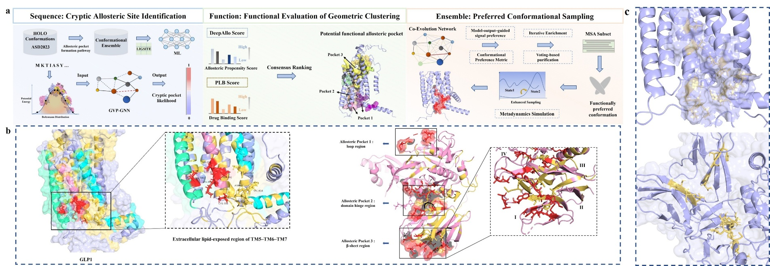
Figure 1. The AlloDesigner computational framework and application in cryptic allosteric pocket design. a. illustrates the framework’s three core mechanisms unifying geometric deep learning and physical enhanced sampling: at the sequence level, machine learning derives the probability of each residue forming a cryptic site; at the ensemble level, this probability signal acts as a physical collective variable (CV) guiding metadynamics to sample functionally preferred conformations; at the functional level, potential pockets are geometrically clustered and consensus-ranked using DeepAllo and PLB druggability scores. b. validates the model’s precision on multi-type targets with low sequence similarity. The left panel shows the successful identification of a cryptic lipid-facing pocket outside the transmembrane helices (TM5 cyan, TM6 pink, TM7 light blue) of the flexible GLP-1 receptor. The right panel demonstrates accurate coverage of three known allosteric pockets (loop, hinge, and β-sheet regions) in PCSK9⁵⁵⁻⁵⁸. The precise spatial overlap between known key residues (red sticks) and predicted sites (yellow sticks) confirms the paradigm’s accuracy. c. displays translucent 3D surface models to intuitively visualize the geometric spatial topologies of the targeted allosteric pockets for the GLP-1 receptor (top) and PCSK9 (bottom).

Results

Identification of Potential Implicit Allosteric Binding Sites
To address the computational demands of targeting cryptic allosteric proteins in real-world drug design scenarios, the field currently faces fundamental challenges, including the scarcity of structural data, the prohibitive costs of acquiring dynamic information, and the incomplete annotation of key functional sites. Constrained by these bottlenecks, traditional methods relying on static structures or explicit annotations suffer severe performance degradation in learning environments characterized by small sample sizes, high noise levels, and extreme class imbalance. For instance, models fine-tuned solely on limited static HOLO (ligand-bound) conformations and fragmentary annotations exhibit preliminary residue ranking capabilities (AUROC = 0.71) but fail to effectively identify critical functional sites (AUPR = 0.13, Recall = 0.09). To overcome this, we propose a novel Graph Neural Network (GNN)-based computational paradigm (Fig. 2a). By learning from conformational ensembles of allosteric pocket opening and closing events generated via rapid linear sampling, this approach enables the precise identification of potential cryptic binding sites.
Distinct from traditional strategies that rely on computationally expensive molecular dynamics (MD) simulations, we constructed conformational ensembles spanning putative pocket opening and closing configurations using a computationally efficient interpolation-based approach (see Methods). We emphasize that these ensembles are not intended to reproduce physically accurate transition pathways. Instead, they are designed to provide a diverse set of geometrically plausible intermediate states that expose the model to rare and transient structural patterns associated with cryptic pocket formation (see SI Data).
Specifically, linear interpolation between HOLO and APO conformations was combined with energy minimization to remove steric artifacts while preserving structural diversity. This strategy enables efficient exploration of a broad conformational space, including strained or high-energy states that may correspond to low-population functional configurations.
This design reflects the objective of the first-stage learning task, which is to identify structural determinants of cryptic pocket formation rather than to model the underlying kinetics. In contrast to short unbiased molecular dynamics simulations, which often fail to access such conformations within tractable timescales, this approach provides a practical mechanism to generate informative training data without introducing strong assumptions about transition pathways.
Using this ensemble, we then applied LIGSITE⁵⁹ to quantitatively monitor pocket dynamics (Fig. S1), this sampling strategy not only approximates rigorous physical dynamics but also leverages superior computational efficiency and conformational coverage. It effectively captures the geometric statistical signals of spatial residue distribution changes during the "open-close" transitions of allosteric pockets (Fig. 2b), thereby establishing a high-quality, physics-rich training data foundation for the neural network.
To effectively model allosteric dynamics and provide physically meaningful supervisory signals, we defined cryptic pocket residues (termed LIGSITE labels, Fig. 2c) based on the aforementioned ensembles. Specifically, we first extracted pocket grid points using the LIGSITE algorithm⁵⁹ and mapped them to surrounding residues based on spatial proximity (≤ 5 Å). Subsequently, residues exhibiting significant perturbations along the allosteric pathway (defined as a grid point fluctuation count > 20) were designated as cryptic allosteric sites (see Methods). Systematic comparisons with classical pocket recognition methods reveal that this labeling scheme offers three major advantages: (1) significantly reducing false positives caused by non-functional surface concavities; (2) improving the coverage of known key allosteric sites; and (3) effectively capturing the conformation-dependent dynamic transition of pockets (detailed in the SI section “Rationality and Dynamics Analysis of the LIGSITE Label”). Biologically, this label not only comprehensively explores potential allosteric regions but also provides crucial priors for extracting physical collective variables (CVs) to guide subsequent metadynamics simulations, thereby facilitating highly efficient, progressive sampling of complex allosteric processes.
Building upon this innovative paradigm, we employed a Graph Neural Network enhanced by Geometric Vector Perceptrons (GVP)⁶⁰ to conduct supervised fine-tuning on the LIGSITE labels. On an independent test set (Table 1), the model demonstrated outstanding predictive performance for implicit binding sites (PR-AUC = 0.701, Precision = 0.688, Recall = 0.572), achieving a 50% coverage rate for experimentally annotated allosteric sites. In contrast, the state-of-the-art general cryptic pocket prediction baseline, PocketMiner³⁷, not only exhibited weaker performance on the test set (PR-AUC = 0.582) but also revealed limitations in residue discriminability and recall when confronted with challenging targets such as GPCRs, KRAS, and PCSK9. The significant superiority of our model on allosteric targets provides compelling evidence that it has successfully captured allostery-specific prior knowledge (detailed in the SI sections “Design Philosophy of Supervised Learning for Implicit Pocket Residues” and “Evaluation of Model Generalization Performance”).
In summary, the computational paradigm proposed in this study demonstrates three prominent advantages that collectively advance the field of structure-based drug design. First, the method exhibits broader generalizability by operating completely independently of prior knowledge regarding HOLO conformations, rendering it highly applicable and seamlessly aligned with the practical constraints of real-world drug discovery scenarios. Furthermore, it achieves enhanced computational efficiency; in stark contrast to traditional molecular dynamics simulation paradigms, our approach requires significantly less computational overhead and facilitates the direct identification of binding sites without relying on subsequent, independent pocket detection algorithms. Finally, the framework provides profound mechanistic interpretability. Distinct from conventional protein language models (PLMs) that rely exclusively on one-dimensional sequence information, this approach deeply integrates the biophysical dynamics of the allosteric pocket “open-close” process with learnable biological mechanisms directly into the neural network architecture. This crucial integration ultimately endows the model with superior functional orientation and robust mechanistic transparency for the precise identification of cryptic allosteric sites.

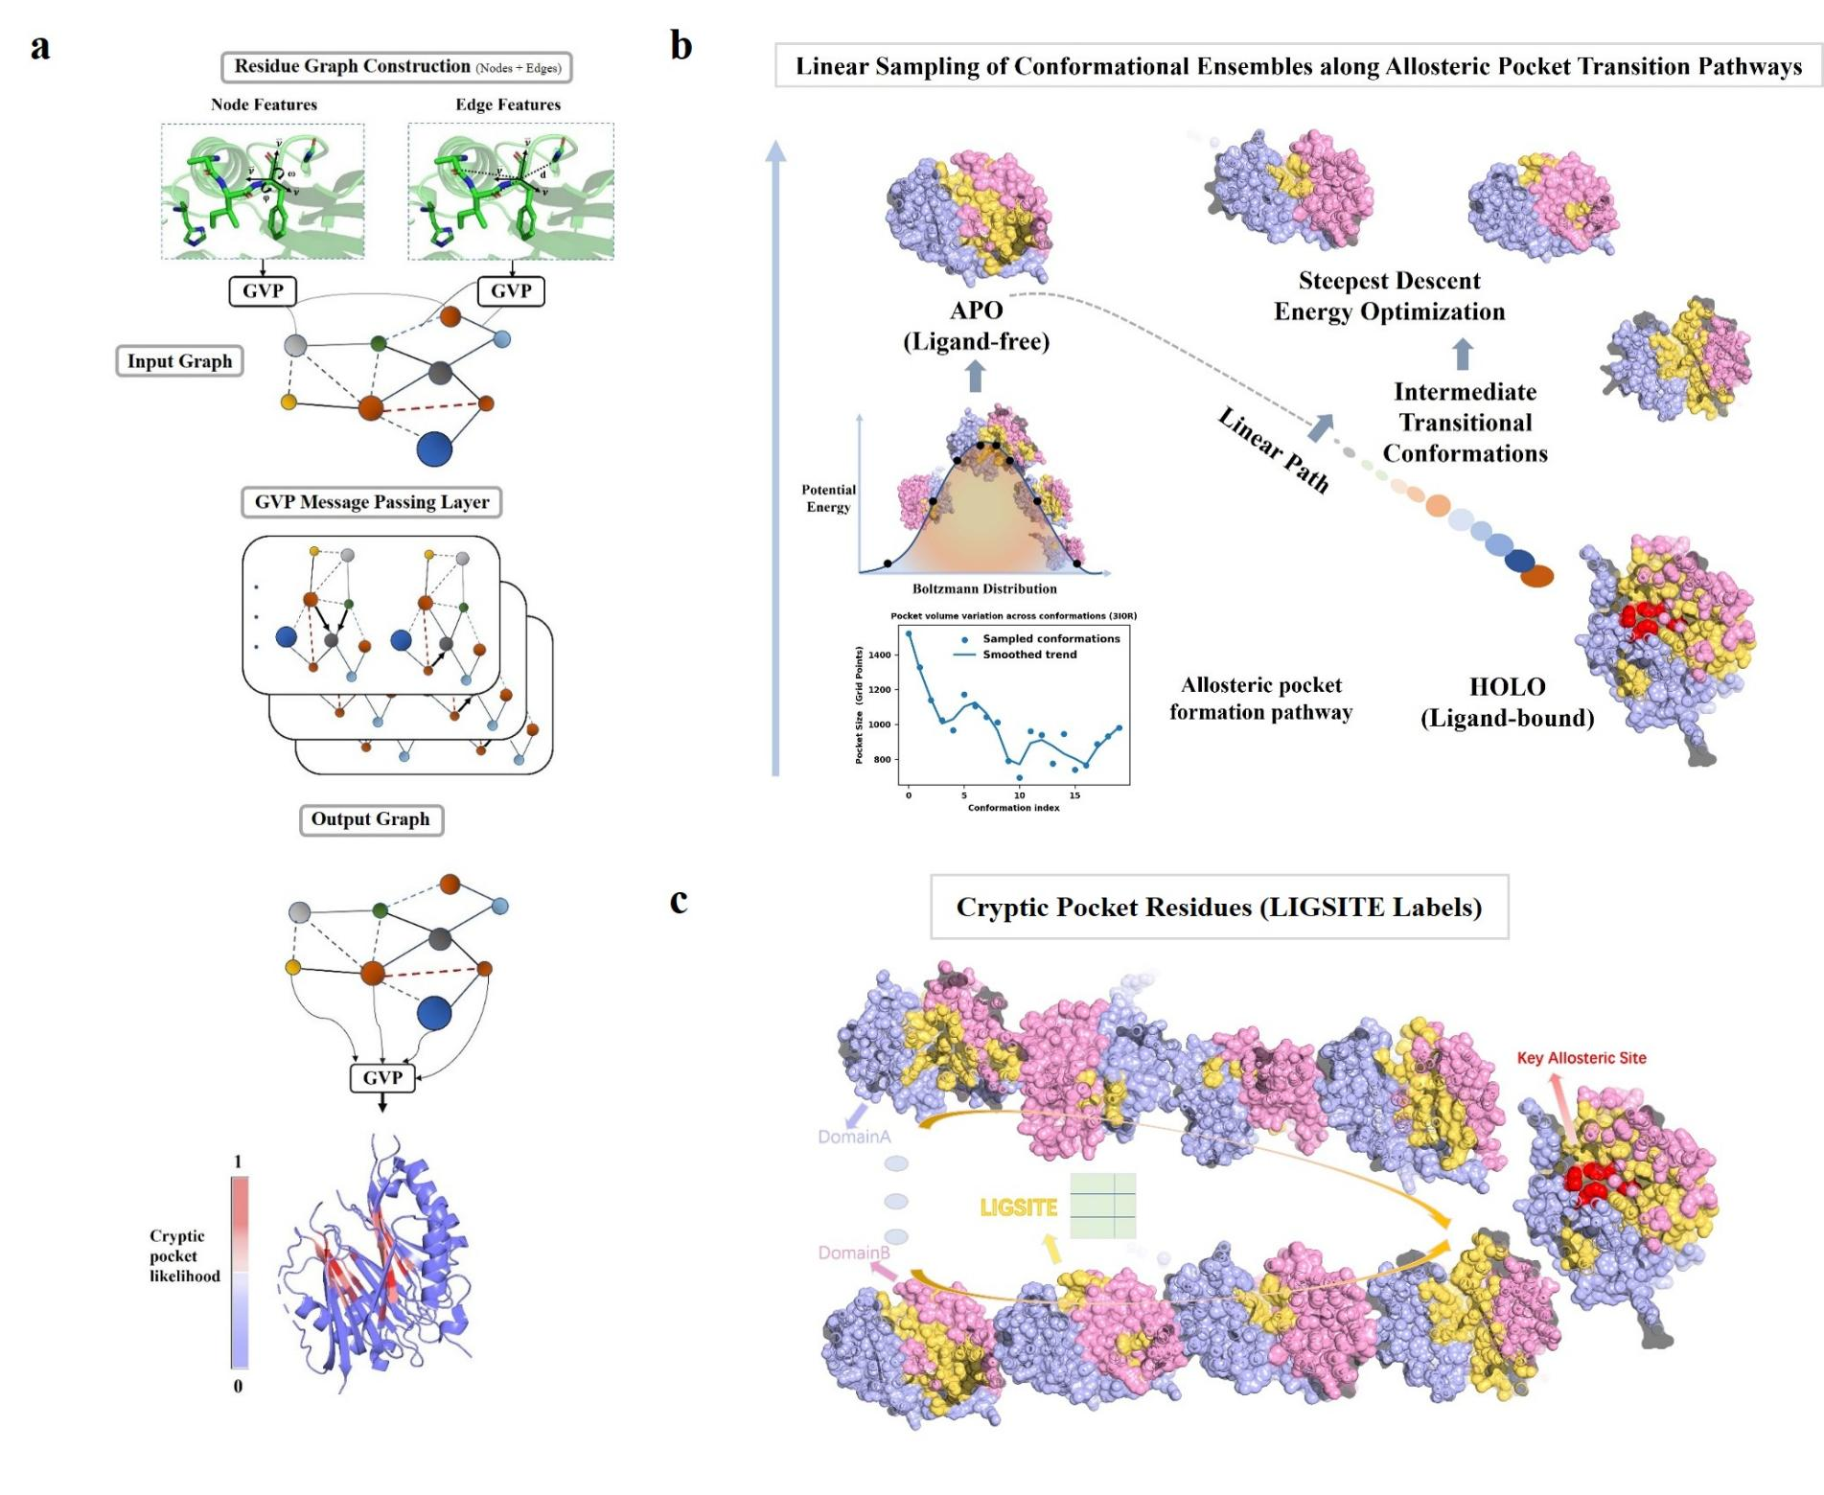
Figure 2. Architecture of the AlloDesigner model, construction of the allosteric dynamic conformational ensemble, and label generation strategy. a. illustrates the model architecture, which utilizes a series of Geometric Vector Perceptron (GVP) message-passing layers to exchange residue information, thereby generating encoded representations for the prediction of cryptic allosteric sites. Specifically, the input protein structure is transformed into a graph representation via GVPs, where node features encompass backbone dihedral angles and Cα reverse unit vectors, while edge features incorporate radial basis function (RBF) encodings of inter-residue distances alongside unit vectors between Cα atoms. During the message-passing phase, the model deeply aggregates neighborhood embeddings, which are ultimately processed by an output GVP layer to execute the precise prediction of potential allosteric sites. b. details the construction workflow for the dynamic conformational ensemble of the allosteric pocket. Based on the experimentally resolved ligand-bound (HOLO) structure, rapid sampling is first employed to acquire a cluster of ligand-free (APO) conformations that strictly adhere to the Boltzmann distribution. Subsequently, multiple linear interpolation pathways are established between the APO and HOLO states to uniformly sample intermediate conformations. To ensure physical plausibility, all sampled intermediates undergo rigorous energy minimization to effectively eliminate unphysical steric clashes potentially introduced by the linear interpolation, ultimately integrating them into a high-quality conformational ensemble that authentically reflects the dynamic opening and closing processes of the allosteric pocket. c. presents the dynamic annotation strategy for the conformational ensemble based on LIGSITE. To circumvent the reliance on existing static site annotations, this study leverages the LIGSITE algorithm to dynamically annotate every conformation along the transitionary trajectory, precisely defining cryptic pockets by calculating and assigning the number of associated grid points to each residue. Taking the allosteric pocket formed by a bifunctional domain (Domain A in light blue and Domain B in pink) as an illustrative example, the yellow surfaces indicate the potential cryptic pocket residues dynamically annotated by LIGSITE along the conformational transitionary path, whereas the red regions represent known key allosteric residues. The visual comparison clearly demonstrates that this dynamic annotation strategy not only effectively covers the known key residues and accurately captures the transient opening and closing dynamics of the pocket but also comprehensively reveals the deep topological features of the target protein’s ensemble across multiple HOLO-APO conformational transition pathways.

Table 1. Performance evaluation of the model for cryptic allosteric pocket prediction based on LIGSITE-derived labels.
 | AUC | PR-AUC | F1 | RECALL | PRECISION | FPR
AlloDesigner | 0.842 | 0.701 | 0.625 | 0.572 | 0.688 | 0.093
PocketMiner | 0.783 | 0.582 | 0.523 | 0.467 | 0.595 | 0.121

AI-Prior–Guided Metadynamics for Preference-Oriented Conformational Sampling
In capturing rare conformations such as cryptic allosteric pockets, the “AI-guided physical simulation” paradigm has garnered significant attention for its ability to balance atomic-level realism with efficient conformational sampling. However, its core computational bottleneck lies in the generation of high-quality, structurally diverse initial conformations. Although existing studies have attempted to expand conformational coverage through multiple sequence alignment (MSA) subsampling (e.g., AFCluster⁶¹, AFsample3⁶²), flow-based generative models (e.g., AlphaFlow⁶³), or ligand-induced co-folding^{53,54}, these methods are fundamentally constrained by their reliance on known structural or ligand priors. Consequently, their capacity for targeted sampling and rational design remains severely limited when addressing functionally specific cryptic allosteric pockets (for a detailed evaluation of these limitations, see SI and Fig. S4).
Inspired by co-evolutionary information purification strategies⁶⁴, we propose a novel computational paradigm that utilizes potential cryptic allosteric sites—predicted via deep learning—as spatial priors to guide the preference sampling of functionally specific pockets. Building upon the large-scale identification of potential allosteric residues, this paradigm first integrates a multi-metric consensus evaluation system (see Methods) with biological priors to precisely filter key residue combinations associated with specific allosteric functions (Fig. 3a-b). Subsequently, pocket-like distance metrics are constructed based on the spatial distance features of these key residues to perform iterative enrichment and cross-group sampling on the original MSA. By incorporating a sequence-conformation preference voting mechanism (see Methods), we ultimately purify a sequence subset with explicit functional tendencies, thereby acquiring preferred initial conformations strictly directed toward specific cryptic allosteric pockets (Fig. 3c-d). This pipeline successfully bridges the gap from broad prediction to functional focusing in an end-to-end manner, providing a highly directional structural starting point for downstream physical simulations.
To further enhance the physical reliability of the conformations and maximize sampling efficiency at the atomic scale, we employ metadynamics³⁹ to perform enhanced sampling on the aforementioned initial preferred conformations (Fig. 4a). Specifically, centered on the key site residues enriched by the machine learning module, we define their solvent-accessible surface area (SASA) or inter-residue pair distances as collective variables (CVs; see Methods). By applying bias potentials along these customized, physics-informed CVs, the simulation is effectively guided to evolve along functionally preferred structural pathways, enabling the highly efficient acquisition of allosteric pocket conformations that possess both atomic precision and explicit functional directionality.
To rigorously validate the necessity of each core component within this “AI-guided physical sampling” strategy, we conducted systematic ablation studies. This pipeline innovatively integrates GVP score-guided MSA enrichment, the automated definition of interpretable CVs, and SPIB-optimized metadynamics simulations, with empirical results proving that all these components are absolutely indispensable to the overall paradigm. For instance, unbiased MD simulations lacking CV guidance: when utilizing the preferred conformation as a starting point for conventional unbiased molecular dynamics simulations of identical duration, the sampling success rate for the target pocket is significantly lower compared to the CV-guided biased simulations (Fig. 4d). Furthermore, guidance utilizing high-dimensional random CVs: extracting the sine and cosine values of all 438 rotatable dihedral angles of a target (e.g., the GLP-1 protein) to serve as high-dimensional random CVs for SPIB-optimized biased simulations proves to be extremely computationally exhaustive; this approach yields a mere 1 to 2 ns/day, effectively reducing sampling efficiency by nearly 50-fold relative to our optimized method. The necessity of deriving an initial preferred conformation is also starkly evident: relying directly on conformations sampled from the source MSA almost completely fails to capture fully open pocket states (volume > 500 Å³; Fig. S5f). Similarly, employing the highest-confidence predicted conformation as the starting point for identical biased simulations restricts the resulting sampled pocket volumes to strictly below 250 Å³ (Fig. 4c). As an additional benchmark, utilizing general conformational generative models like AlphaFlow yields ensembles where only approximately 10% of the generated conformations achieve a pocket volume greater than 400 Å³. Comprehensive analyses of specific targets such as GLP-1 (Fig. S5) definitively show that all these comparative schemes are significantly inferior to our proposed computational framework—which sustains a sampling efficiency of 50 to 70 ns/day (Fig. 4b)—in terms of both the average sampled dimensions of the target cryptic pocket and overarching computational efficiency. These findings unequivocally establish that standard structure prediction, unbiased simulations, or general generative models alone are insufficient for capturing the precise structural nuances of rare events like functionally relevant cryptic allosteric pockets, powerfully highlighting the critical synergy between targeted preference guidance and physical enhanced sampling.
In summary, the end-to-end computational framework constructed in this study, AlloDesigner, realizes the integrated design of a “sequence-conformational ensemble-function” pipeline for cryptic allosteric proteins for the first time. Representing the first known method to directly translate machine learning sequence scores into interpretable residue-level collective variables (CVs) through automated MSA purification and conformational selection, this paradigm successfully achieves highly efficient, targeted exploration of rare cryptic states relying solely on a single primary sequence. By systematically unifying deep learning predictions, co-evolutionary preference sampling, and metadynamics simulations, this work not only provides a robust, physics-grounded computational solution for allosteric regulation research but also significantly broadens the methodological boundaries for the structural exploration and design of other complex, highly dynamic biomacromolecular systems.

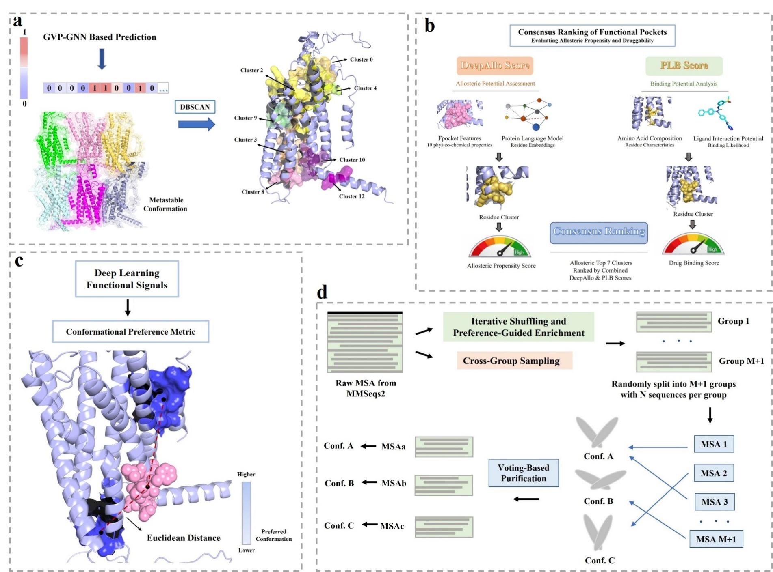

Figure 3. Functional preference-guided enhanced sampling directed by the prior of cryptic allosteric site predictions. a. illustrates the spatial clustering analysis of potential allosteric pockets. Leveraging a metastable conformational ensemble generated through random sub-sampling of the multiple sequence alignment (MSA) (Fig. S6), the DBSCAN algorithm⁶⁵ is employed to perform geometric spatial clustering on the deep learning-predicted cryptic allosteric residues, thereby identifying the spatial distribution patterns of potential pockets. b. presents a dual-dimensional functional evaluation system for these identified regions. By synergistically integrating the DeepAllo score⁶⁶, which measures allosteric regulatory characteristics, and the PLB score⁶⁷, which evaluates binding compatibility, the clustered pockets are quantitatively assessed to enable the precise screening of high-potential functional allosteric cavities. Building upon this, c. details the quantitative evaluation of conformational preference. Based on the key residues of the specifically screened functional pockets, the Euclidean distance (denoted as the distance score) between their geometric center and the pocket center identified by the Fpocket algorithm⁶⁸ is calculated. This metric rigorously quantifies the degree of preference of each conformation toward the target pocket, effectively tracking the conformational distribution shift towards the desired functional state. d. outlines the iterative enrichment and purification of functionally preferred sequences. A multi-round iterative enrichment and cross-group sampling strategy is applied to process the source MSA. In each iteration, sequences are rigorously filtered based on their conformational preference scores, and a cross-group voting mechanism is introduced to classify and purify the co-evolutionary signals. This systematic process ultimately extracts a subset of functionally preferred sequences explicitly directed toward the specific cryptic allosteric pocket.

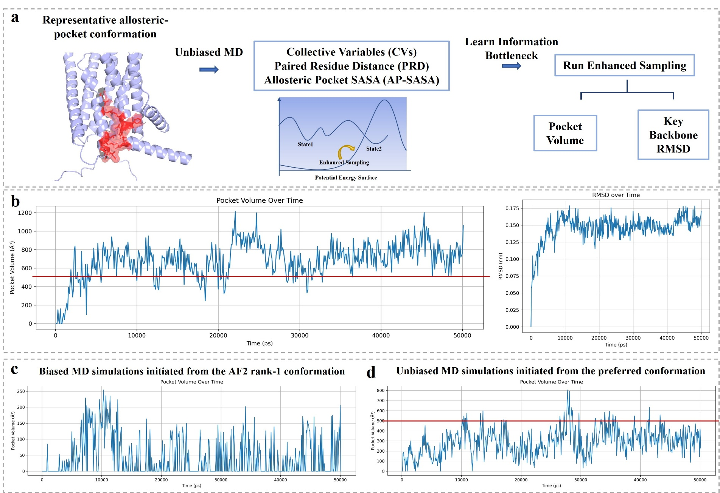

Figure 4. Pipeline for the acquisition of stable equilibrium conformations via preference-guided enhanced sampling and corresponding ablation studies. a. illustrates the workflow for State Predictive Information Bottleneck (SPIB)-optimized biased sampling. Initiated from the predicted structure derived from the purified, functionally preferred sequence, an initial trajectory is first generated via an unbiased molecular dynamics simulation. Subsequently, physical metrics such as key inter-residue distances or solvent-accessible surface areas (SASA) are extracted to formulate interpretable residue-level reaction coordinates. These coordinates then undergo dimensionality reduction utilizing the SPIB method, followed by the execution of biased molecular dynamics simulations to accelerate directed sampling and efficiently yield a stable, functionally preferred conformational ensemble. b. presents the trajectory analysis of this preference-guided enhanced sampling, utilizing the GLP-1 receptor as a representative system. The left subfigure displays the volume distribution of the target cryptic allosteric pocket, where a substantial number of conformational frames exhibit volumes exceeding 500 Å³, confirming the robust formation of a distinct and stable functional cavity; meanwhile, the right subfigure details the root-mean-square deviation (RMSD) analysis of backbone atoms within the critical transmembrane region (TM6-ECL3-TM7), demonstrating conformational convergence within a mere 50 ns and thereby validating the extreme efficiency of this sampling pipeline. To rigorously assess the indispensable nature of these core components, c. provides an ablation control regarding the initial conformation. Under identical biased simulation parameters, initiating the simulation from the highest-confidence predicted structure derived from the unpurified source MSA restricts the pocket volumes of the vast majority of sampled conformations to strictly below 250 Å³. This stark contrast underscores that selecting an initial structure imbued with an explicit functional preference is absolutely paramount for efficiently capturing the target cryptic pocket. d. delineates the ablation control for the sampling strategy itself. Even when utilizing the optimal preferred conformation as the structural starting point, conventional unbiased molecular dynamics simulations fundamentally fail to effectively drive the required conformational distribution shift, rendering the capture of large-volume pocket conformations (> 500 Å³) an exceedingly rare event. This outcome unequivocally highlights the critical necessity of deploying AI-customized, preference-guided enhanced sampling to successfully navigate and sample complex structural transitions within cryptic allosteric landscapes.

Computational Validation of Classical Allosteric Pocket Identification and Virtual Screening Applications
To rigorously validate the generalization performance of our computational framework, we conducted systematic retrospective testing across a diverse array of challenging targets (Fig. 1b and Fig. S3). The results demonstrate the model's exceptional generalizability across multiple scenarios. In cross-pocket evaluations of structurally similar proteins (e.g., 4DLV), the model achieved a positive predictive value (PPV) of 14.3% and a recall of 33%. When confronted with the CB1R, a G protein-coupled receptor (GPCR) target sharing a remarkably low sequence similarity of 0.38, the framework delivered precise recognition that significantly outperformed the baseline (PPV of 18.5% and recall of 51.7%). Most crucially, for the PCSK9 target, which exhibits an extremely low sequence similarity (<0.1) to the training set, the model successfully pinpointed key residues across three distinct, experimentally validated allosteric regions. This robustly confirms its strict zero-shot generalization capabilities, establishing that the proposed paradigm can effectively identify cryptic allosteric pockets under highly challenging conditions and possesses broad real-world applicability.
We subsequently applied this framework to a real-world drug design task targeting the GLP-1 receptor (GLP-1R). Focusing on the cryptic allosteric pocket situated on the extracellular face of the transmembrane helices, the model successfully enriched 14 key residues (see SI for GLP-1 details), achieving a 50% recall rate for previously annotated critical sites. Following a comprehensive multi-dimensional assessment of the pocket's physicochemical properties and ligand accommodation capacity, the optimal conformation selected by our framework yielded an AutoDock Vina score⁶⁹ of -9.636, significantly outperforming the HOLO reference conformation (-8.983) (Fig. 5a-b). Leveraging this preferred conformation, we executed a hierarchical virtual screening campaign against the 1.4 million-compound ChemDiv library (progressing from KarmaDock⁷⁰ to Glide^{71–73} SP and finally Glide XP), which successfully yielded multiple candidate molecules with outstanding predicted binding affinities (optimal XP score of -9.32, Fig. 5c). Furthermore, the top 50 hit compounds exhibited an extremely low average Tanimoto similarity (0.0924) to known allosteric modulators, indicating the discovery of entirely novel chemical scaffolds. As a strict negative control, we utilized static APO conformations generated by AlphaFlow; after energy minimization to eliminate steric clashes, these yielded an average Vina score of only -4.94. Performing an identical screening protocol on the median AlphaFlow conformation (-7.02) failed to identify a single compound with a Glide XP score of -8.0 or better. This control experiment compellingly demonstrates that relying solely on static APO structures is fundamentally inadequate for drug discovery targeting cryptic allosteric pockets, thereby underscoring the absolute indispensability of our preference-guided enhanced sampling strategy.
As a complementary evaluation, we deployed the ultra-high-throughput model DrugCLIP⁷⁴ to conduct virtual screening across a massive library of 500 million molecules. The results revealed that the optimal score for our sampled conformation (3.86) was significantly superior to that of the APO reference conformation (3.12). More importantly, within the top 10,000 high-scoring candidates, the screening hit overlap rate between the sampled conformation and the HOLO reference conformation reached a remarkable 17.5%. Evaluated across an ultra-large-scale chemical space, these findings further corroborate the high reliability of the conformations generated by our framework in preserving the core functional binding features essential for target modulation.
To deeply investigate the kinetic stability of the ligand-bound states, we clustered a 10 ns molecular dynamics trajectory of the GLP-1 system utilizing Vina scores as a guiding metric, extracting two structurally distinct representative conformations for comparative analysis. The first, a stable binding state (Frame 141), exhibited exceptional binding affinity (-9.6 kcal/mol); within this conformation, the ligand underwent only minor thermal fluctuations and rapidly relaxed into an optimal docking pose, demonstrating an extraordinarily high degree of structural complementarity. In stark contrast, the second, a conformationally deviated state (Frame 24), displayed a significantly reduced affinity (-6.1 kcal/mol); although the receptor backbone remained relatively stable, the ligand experienced a pronounced longitudinal spatial displacement downwards (detailed in the SI). The mutual corroboration between the stable residence of high-scoring conformations and the spatial deviation of low-scoring ones definitively proves that the cryptic allosteric pocket identified by our study possesses the specific geometric characteristics and physical stability required for robust ligand accommodation. This stable binding mode not only explicitly validates the druggability of the targeted site but also provides a highly reliable structural template for subsequent rational molecular optimization.
To elucidate the underlying signal transduction mechanisms within the receptor, we conducted a linear mutual information (LMI) and cross-correlation analysis on the GLP-1 system based on the biased simulation trajectories derived from our preference-guided enhanced sampling (detailed in Methods). By defining interpretable residue-level reaction coordinates, our analysis focused intensively on the interface between the TM6 and TM7 helices—where the cryptic allosteric pocket resides—and its adjacent structural extensions. As illustrated in Figure S10a, the high-correlation network preliminarily unveils a critical set of allosteric residues that mediate local interaction clusters. Furthermore, the long-range correlation analysis (Figure S10b) maps a comprehensive interaction network, strongly suggesting a potential communication pathway extending distally from the allosteric site. To investigate the remodeling effects of ligand binding on the receptor's dynamic network, we compared the residue interaction difference map before and after ligand binding (APO vs. HOLO, Figure S11). The diagonal regions of the difference map (indicated by black boxes) primarily reflect the relatively conserved contacts within individual transmembrane helices or between spatially adjacent ones, which are fundamental for maintaining the receptor's basal topology. Notably, the off-diagonal regions (indicated by blue boxes) exhibit profound dynamic changes, explicitly capturing a widespread conformational distribution shift. The simulation results suggest that, under the regulation of this key residue network, TM6 and TM7 undergo substantial relative displacement and conformational rearrangement; critically, these structural perturbations are not isolated but propagate through the helical contact interfaces to induce concerted conformational adjustments in TM5 and TM1. Ultimately, this concerted movement of the TM5-TM6-TM7-TM1 helical bundle, as observed through computational simulation, aligns perfectly with the established functional mechanism of allosteric inhibitors—specifically, preventing the outward rotation of the TM6 helix. This provides a compelling mechanistic pathway for allosteric signal transmission from the binding pocket to the intracellular effector domain (for detailed results, see the "Structure-Based Virtual Screening and Ligand Discovery" section in the SI). Recognizing that these allosteric networks and signal transduction mechanisms are primarily extrapolated from computational simulations, their precise molecular details and global structural implications await exhaustive validation through future biological mechanism experiments.

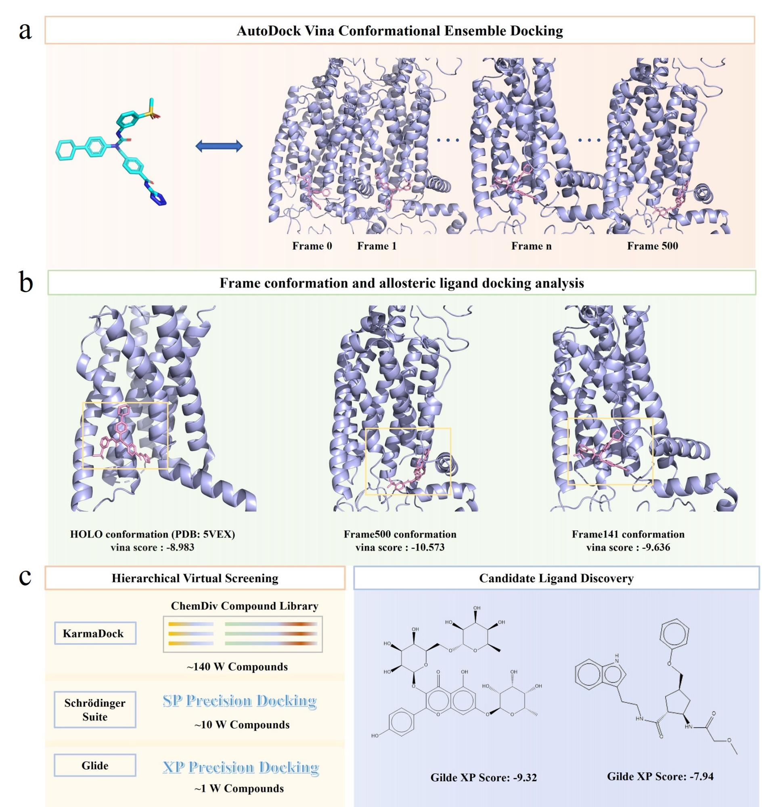

Figure 5. Hierarchical virtual screening and lead compound discovery based on generated conformations. a. illustrates the docking-based evaluation of conformational trajectories. Utilizing a known allosteric ligand as a structural probe, AutoDock Vina was employed to score molecular dynamics trajectory frames by performing localized spatial sampling around the geometric center of the allosteric pocket. b. compares the ligand binding modes and docking scores of representative conformations. The left panel displays the HOLO crystal reference conformation (Vina score = -8.983). The middle panel highlights the conformation with the optimal trajectory score (Frame 500, -10.573); however, its binding pose exhibits a pronounced bias toward the TM7 helix, and its overall pocket geometry deviates significantly from the reference state. The right panel demonstrates that, following a comprehensive assessment of pocket geometric features, ligand accommodation capacity, and docking score consistency, Frame 141 was strategically selected as the definitive receptor model for subsequent large-scale virtual screening. c. details the hierarchical virtual screening pipeline and the identification of high-scoring hit compounds. Targeting the 1.4-million-compound ChemDiv library, a sequential protocol was executed: an initial high-throughput screen via KarmaDock (retaining the top 100,000 candidates), followed by standard-precision (SP) Glide docking (retaining the top 10,000), and concluding with an extra-precision (XP) Glide final screen. The right section showcases a selection of high-affinity, structurally novel molecules successfully enriched through this rigorous computational workflow.

Discussion
The systematic discovery of cryptic allosteric pockets remains a major challenge in computational structural biology because functional conformational states are both high-dimensional and rarely populated. In this work, we introduced AlloDesigner, an end-to-end framework that integrates geometric deep learning with physics-based enhanced sampling to enable efficient exploration of such rare states. By linking data-driven structural inference with targeted molecular simulation, the framework addresses the longstanding trade-off between predictive efficiency and physical rigor in computational protein modeling.
The integrated design of the framework links data-driven structural inference with physically grounded sampling, enabling the identification and exploration of cryptic allosteric states within a unified workflow. Rather than relying on predefined collective variables or ligand priors, the approach leverages learned residue-level signals to guide enhanced sampling toward functionally relevant conformations. While the observed performance across diverse targets supports the effectiveness of this strategy, further validation will be required to fully establish the functional relevance of the sampled states and to assess performance across broader classes of proteins.
As a result, these models may have limited ability to capture the low-population conformational states in which cryptic pockets emerge. In contrast, AlloDesigner leverages low-cost, dynamics-informed ensembles to learn structural signatures associated with pocket formation and converts these learned representations into interpretable reaction coordinates that guide enhanced sampling simulations. This strategy allows the search for cryptic pockets to be constrained by physically meaningful variables, improving the efficiency of conformational exploration.
The end-to-end architecture of this framework effectively mitigates the error propagation commonly encountered in traditional sequential computational pipelines. Predictions generated by the deep learning module are systematically translated into interpretable residue-level reaction coordinates, which are immediately subjected to rigorous validation via preference-guided enhanced sampling. By introducing strict energetic and kinetic constraints to drive the required conformational distribution shift, this physical integration not only effectively filters out spurious structural signals but also fundamentally suppresses the memorization bias inherent to neural networks over-relying on static training data. This integrated strategy, which deeply fuses data-driven priors with rigorous physical laws, exhibits exceptional generalization capabilities and robustness when confronting challenging scenarios characterized by low sequence similarity or complex topological architectures. For instance, the framework successfully identified key allosteric regions within highly flexible targets such as PCSK9 and G protein-coupled receptors (GPCRs). Specifically, it recovered 33% and 52% of the annotated residues within the extra-helical pockets of GLP-1R and CB1R, respectively, at a positive predictive value of <25%, substantially outperforming the PocketMiner baseline in regimes where traditional homology-based methods routinely fail. Furthermore, the successful delineation of the extra-helical pocket in the GLP-1 receptor and the subsequent virtual screening campaign compellingly demonstrate how this framework facilitates the structural discovery and pharmacological targeting of previously uncharacterized cryptic allosteric sites.
Despite these advances, several limitations remain. The current framework relies on the availability of reasonable structural models and may be sensitive to inaccuracies in initial conformational ensembles. In particular, targets with shallow multiple sequence alignments or regions of high intrinsic disorder occasionally produced linear-interpolation pathways containing unphysical clashes that propagated noise into the GVP training. Although the incorporation of rigorous energy minimization effectively resolves these potential steric clashes, this heuristic strategy—fundamentally a structural compromise reliant on linear interpolation and subsequent minimization—may inherently constrain the model from achieving optimal predictive fidelity when navigating the complex conformational landscapes of highly flexible biomacromolecular systems. In addition, while enhanced sampling improves exploration of rare states, complete coverage of complex conformational landscapes remains computationally demanding. Future work may further improve the approach by incorporating adaptive sampling strategies or integrating experimental constraints such as hydrogen–deuterium exchange or cryo-EM ensemble data.
Beyond the specific problem of allosteric pocket discovery, this work highlights the broader potential of combining machine learning with physically grounded simulation to explore rare functional states in biomolecular systems. Extracting interpretable reaction coordinates from learned structural representations may provide a powerful approach for studying diverse phenomena including intrinsically disordered proteins, transient protein–protein interactions, and ligand-induced conformational transitions. More broadly, hybrid strategies that integrate data-driven models with mechanistic simulation—particularly those capable of deriving interpretable, physics-aligned reaction coordinates—may represent an important direction for advancing computational approaches in molecular science.

Methods

Construction of the Dynamic Conformational Ensemble for Cryptic Allosteric Pockets
To elucidate the opening and closing dynamics of cryptic allosteric pockets and to acquire physically plausible transition-state conformations of proteins, this study engineered a linear sampling workflow that seamlessly integrates deep learning-based conformational generation with physics-based energy minimization. This robust strategy systematically captures metastable and transient intermediate conformations through the following specific procedures.
Initial Structure Preparation and APO State Sampling: Drawing upon annotation data from the ASD2023 database⁷⁶, the biopolymer sequence of the target allosteric protein and its corresponding ligand-bound (HOLO) crystal structure were first extracted. PDBFixer was employed to automatically model any missing residues within the HOLO structure, thereby establishing a complete and rigorous atomic coordinate system. Subsequently, utilizing the full-length sequence of the target protein as input, the AlphaFlow generative model was deployed to conduct extensive conformational sampling. This rapid generation yielded a highly diverse set of stable, ligand-free (APO) conformations that strictly adhere to a Boltzmann distribution. This generative step effectively expands the breadth of the conformational space, providing a reliable and structurally diverse initial ensemble for the subsequent construction of transition pathways.

Construction of Allosteric Transition Pathways and Linear Interpolation: To generate training data rich in pocket opening–closing signals, all APO conformations were first structurally aligned to the corresponding HOLO reference structure using backbone atoms, placing all states in a common coordinate frame. For each aligned HOLO–APO pair, a linear transition trajectory was defined and 18 intermediate conformations were uniformly sampled using linear interpolation (Equation 1). These intermediates were then subjected to energy minimization to eliminate steric clashes while preserving geometric diversity.
Importantly, the resulting ensembles are not intended to represent physically accurate equilibrium or kinetic pathways. Rather, they serve as a computationally efficient data-augmentation strategy that exposes the downstream GVP network to a wide range of structurally plausible yet low-population conformations associated with cryptic pocket formation. By combining linear interpolation with energy minimization, we achieve local physical plausibility without sacrificing the conformational diversity required for learning subtle structural signatures of allosteric sites. This deliberate separation—using approximate ensembles for representation learning and rigorous physics-based enhanced sampling for functional-state exploration—forms a central design principle of the AlloDesigner framework.
Structural Repair and Energy Minimization: To explicitly eliminate unphysical atomic steric clashes inherently introduced by the linear interpolation process and to significantly enhance the physical validity of the intermediate states, rigorous post-processing was executed on all sampled transition conformations. Initially, PDBFixer was re-applied to refine the atomic coordinates of the intermediates. Following this, the steepest descent algorithm was employed to perform energy minimization on each interpolated conformation. The convergence criteria for this energetic optimization were strictly set to either a maximum system force below 500 kJ/(mol·nm) or a maximum limit of 5000 iteration steps. Through this exhaustive structural relaxation, the intermediate conformations were successfully driven to local energy minima, ensuring that the final generated ensemble possesses strict geometric topological rationality and robust physical stability. Ultimately, this high-fidelity dynamic ensemble provides highly reliable structural starting points for downstream preference-guided enhanced sampling.
$$φ_{intermediate state\left(α\right)}=\left(1-α\right)* φ_{apo}+ α* φ_{holo} \left(1\right)$$

LIGSITE-based annotation of potential cryptic pocket residues
To effectively translate the dynamic features of allosteric systems into biophysically meaningful supervision signals, this study systematically annotated cryptic allosteric residues across the constructed conformational ensembles utilizing the LIGSITE algorithm integrated within ENSPARA⁷⁷. The procedure initiated with rigorous parameter configuration and grid generation; through a systematic parameter search along a randomly selected HOLO-APO transitionary pathway for all target proteins, an optimal configuration was established comprising a minimum rank of 7, a grid spacing of 0.7 Å, a probe radius of 1.4 Å, and a minimum cluster size of 3 grid points. This precise parameter combination successfully maximized the coverage of experimentally known allosteric sites while maintaining a strictly reasonable proportion of positive labels. Subsequently, for residue mapping and dynamic determination, the algorithm assigns the computed pocket grid points to spatially adjacent amino acid residues within a proximity threshold of ≤ 5 Å for each distinct conformation. Crucially, if the fluctuation amplitude of the assigned grid points for a specific residue exceeds a variance threshold of 20 across the entire HOLO-APO structural trajectory, it is formally designated as a dynamic cryptic pocket residue for that specific pathway. To further eliminate the stochastic noise inherent to single-pathway sampling and guarantee the absolute robustness of the annotations, a multi-pathway consensus integration strategy was enforced for the terminal HOLO conformation labels. Under this rigorous statistical criterion, a residue is definitively confirmed as a key cryptic allosteric residue for the holistic HOLO system only if it is consistently identified as a cryptic binding site across more than 50% of the independent sampling pathways. Ultimately, the robust identification of these dynamic cryptic residues lays the essential structural groundwork for formulating interpretable residue-level reaction coordinates, which are fundamentally required to explicitly drive the downstream preference-guided enhanced sampling pipeline and comprehensively capture the functionally relevant conformational distribution shift.

Definition and Extraction of Allosteric Binding Sites
To construct a high-confidence benchmark dataset for rigorous model training and performance evaluation, this study systematically annotated allosteric binding sites utilizing experimentally resolved protein-ligand (HOLO) complex structures. The precise operational workflow commenced with the deployment of the Fpocket algorithm to conduct exhaustive global spatial probing across the target HOLO conformations, thereby identifying all potential surface cavities. Subsequently, these computationally delineated pockets were subjected to rigorous spatial cross-referencing against experimentally annotated allosteric sites cataloged within the ASD 2023 (AlloSteric Database). To ensure absolute labeling fidelity, this study established a strict spatial overlap threshold of nine atoms: if a detected potential pocket exhibited an overlap of nine or more atoms with a historically known allosteric site from the database, the cavity was definitively classified as an authentic allosteric pocket. Consequently, all amino acid residues spatially localized within this validated cavity were officially labeled as true allosteric binding sites, providing a highly reliable and clean structural ground truth for downstream machine learning tasks.

Model architecture
Geometric vector perceptron–based graph neural networks (GVP-GNNs)
Geometric Vector Perceptron–based graph neural networks (GVP-GNNs) were originally designed to learn protein-level representations. In this work, we adapted this architecture to learn residue-level representations, enabling the inference of the probability that each residue participates in the formation of cryptic pockets along conformational transition pathways.
GVP-GNNs learn representations of the chemical and topological environment of individual residues through information exchange between neighboring residues. The network input consists of node features and edge features, where node features describe intrinsic residue properties and edge features encode inter-residue relationships.
Node features include: (1) scalar features given by {sin, cos} ∘ {φ, ψ, ω}, where φ, ψ, and ω are backbone dihedral angles computed from atoms $C_{i-1}$, N, $C_{αi}$, $C_{i}$, $N_{i+1}$; (2) a unit vector along the $C_{βi}$-$C_{αi}$ direction, obtained by imputing the $C_{β}$ atom assuming tetrahedral geometry and normalizing the resulting vector; (3) forward and reverse unit vectors; and (4) a one-hot encoding of the amino acid type.
Edge features were computed for the 30 nearest neighbors of each residue and include: (1) a unit vector pointing from $C_{αj}$ - $C_{αi}$; (2) a Gaussian radial basis function (RBF) encoding of the Euclidean distance ${\left||C_{αj}-C_{αi}|\right|}_{2}$; and (3) a sinusoidal encoding of j - i to represent sequence separation along the backbone.
Here we provide an intuitive description of how the network learns residue representations through inter-residue information exchange; rigorous mathematical definitions and derivations can be found in the original GVP literature.
At each graph propagation step, the representation of residue i is updated based on the properties of its 30 nearest neighbors and the corresponding spatial and sequential relationships. Specifically, for each neighbor, its node features are concatenated with the associated edge features, resulting in 30 feature vectors that are processed by a Geometric Vector Perceptron (GVP) to perform nonlinear transformations. The outputs of the 30 GVPs are averaged and added to a self-representation derived from the node features of residue i, yielding an updated representation. This update is performed simultaneously for all residues in the protein and repeated for n propagation steps. Through this iterative message-passing process, the representation of residue i integrates information not only from its direct neighbors but also implicitly from more distant residues, as neighbor representations themselves already encode information from their respective neighborhoods. Ultimately, each residue acquires a high-level representation that captures both the global protein topology and its local chemical environment.
Based on this architecture, we trained the GVP-GNN model using the following hyperparameters: node features with 8-dimensional vector channels and 50-dimensional scalar channels; edge features with 1-dimensional vector channels and 32-dimensional scalar channels; GVP hidden layers with 16-dimensional vector channels and 100-dimensional scalar channels; 4 encoding layers; 30 nearest neighbors selected per residue during graph propagation; and a dropout rate of 0.1. Except for minor differences, these hyperparameters are consistent with those used by Jing et al.⁶⁰ in their model quality assessment framework.

Model Fine-Tuning and Hyperparameter Settings
In this study, we fine-tuned the pre-trained PocketMiner-GVP model architecture specifically for our curated allosteric dataset. The core architecture of the model comprises four message-passing layers. Regarding feature mapping, both node and edge features are embedded into hidden layers with a dimensionality configured to (16, 100). To effectively mitigate overfitting during the training phase, a Dropout mechanism was incorporated into the network with a dropout rate set to 0.1. Given the pronounced class imbalance between allosteric sites (positive samples) and non-allosteric sites (negative samples) within protein sequences, we formulated a customized composite loss function (Dice + BCE Loss) to guide model optimization. This loss function directly sums the traditional Binary Cross-Entropy (BCE) loss and the Dice Coefficient loss (with a smooth factor set to 1 × 10⁻⁶). While the BCE loss provides fundamental probabilistic classification supervision at the residue level, the Dice loss—evaluating from the perspective of global intersection over union—substantially amplifies the model’s attention toward the sparse positive samples (i.e., cryptic allosteric pocket residues) and sharpens the accuracy of the prediction boundaries. For the training configuration, the Adam optimizer was employed for gradient descent and parameter updating, with the initial learning rate strictly controlled at 2 × 10⁻⁵ to ensure the stability of the fine-tuning process. The training batch size was set to 16, and the entire training regimen spanned 20 epochs. To comprehensively evaluate model performance, the Area Under the Receiver Operating Characteristic Curve (ROC-AUC) and the Area Under the Precision-Recall Curve (PR-AUC) were calculated during the validation phase. Because allosteric site recognition is a quintessential machine learning task characterized by extreme positive-negative sample imbalance, this study ultimately selected the validation set PR-AUC as the primary monitoring metric for optimal model screening. The model checkpoint from the epoch achieving the highest PR-AUC score was saved as the definitive predictive model. Ultimately, this finely tuned network seamlessly informs downstream virtual screening and conformational analyses, providing the highly reliable structural priors needed to formulate interpretable residue-level reaction coordinates, which subsequently drive the preference-guided enhanced sampling pipeline to successfully capture the targeted conformational distribution shift.

Conformational ensemble generation based on MSA sequences
Multiple sequence alignment acquisition
All multiple sequence alignments (MSAs) used in this study were generated using the built-in MMseqs2 pipeline in ColabFold v1.5.5^{78,79}. Sequence searches were performed against the UniRef30_2302⁸⁰, colabfold_envdb_202108⁷⁹, pdb100_230517⁷⁹ , and pdb100_foldseek_230517⁷⁹ databases to ensure comprehensive coverage and high-quality evolutionary homologs.
Structure prediction and parameter settings
All protein structure predictions were carried out using the AlphaFold2⁸¹ implementation within the ColabFold platform. During the iterative enrichment and sampling of MSA sequences, a single structure was generated for each input MSA file. To ensure reproducibility, a fixed random seed of 42 was used throughout this process. For each final, purified MSA subcluster, additional structure predictions were performed to further assess prediction robustness and explore conformational diversity. Specifically, eight different random seeds were applied, and five structural models were generated per seed, yielding a total of 40 predicted conformations for downstream analyses. In all structure prediction tasks, the number of model recycles was fixed to three.
For predictions during sampling:
colabfold_batch input_dir_with_msas/ output_dir/ --num-models 1 --random-seed 42 --num-recycle 3
For predictions after sequence purification:
colabfold_batch input_dir_with_msas/ output_dir/ --num-models 5 --num-seeds 8 --num-recycle 3

Allosteric Pocket Evaluation and Ranking System Based on Multi-Metric Consensus
To systematically evaluate and prioritize the candidate allosteric pockets identified by our model, this study constructed a multi-metric consensus evaluation system that integrates both allosteric propensity and druggability. This framework conducts quantitative scoring and comprehensive ranking on spatially clustered candidate pockets by specifically integrating two core metrics. The first is the DeepAllo Score, utilized to quantify the allosteric regulatory potential of the pocket. Derived from the DeepAllo model, this score effectively fuses 19 physicochemical features extracted by Fpocket with deep residue representations learned by Protein Language Models (PLMs). Given that the output of Fpocket consists of discrete geometric cavities whereas our predictions manifest as residue clusters, we achieved precise score mapping by calculating the spatial Euclidean distance between the geometric center of each residue cluster and the geometric centers of all Fpocket cavities, subsequently assigning the physicochemical feature score of the nearest-neighbor Fpocket cavity to the corresponding residue cluster. The second metric is the Protein-Ligand Binding (PLB) Score, employed to directly assess the druggability and ligand-binding probability of the pocket using machine learning algorithms based primarily on features such as the amino acid composition of the clustered residues. During the consensus ranking and residue scoring phase, we calculated the respective DeepAllo and PLB scores for each predicted cryptic binding site residue cluster within the conformational ensemble. Subsequently, the evaluation results across all conformations were aggregated, and the top seven high-scoring clusters based on this comprehensive ranking were extracted. For each individual residue, the score of the highest-rated cluster to which it belongs was assigned as its definitive score. Ultimately, by fusing these two categories of scores, a rigorous consensus ranking list was constructed to serve as the quantitative decision-making basis for screening high-confidence, druggable combinations of allosteric pocket residues. The robust identification of these optimal residue combinations serves as a critical prerequisite for defining interpretable residue-level reaction coordinates. These coordinates are, in turn, absolutely essential to accurately characterize the functional conformational distribution shift and to efficiently drive the downstream preference-guided enhanced sampling pipeline.

Quantitative Evaluation and Measurement of Conformational Quality
To quantitatively evaluate the formation propensity and structural integrity of candidate cryptic allosteric pockets within specific conformations, this study proposes a rigorous conformational quality scoring method predicated on the spatial compactness of key residues. Specifically, known key allosteric residues are first mapped onto the target conformation, enabling the precise calculation of the geometric center of this functional residue cluster following spatial clustering. Simultaneously, the Fpocket algorithm is employed to execute global pocket detection across the full-protein conformation, extracting the geometric center of the computationally identified pocket most proximal to this targeted residue cluster. Subsequently, the Euclidean distance between these two geometric centers is calculated to serve as the definitive quality score for the given conformation. A lower Euclidean distance unequivocally indicates that the key functional residues converge to form a compact, morphologically objective, and continuous cavity, thereby signifying a substantially higher probability that the conformation supports the robust formation of a functional binding pocket. Structural states exhibiting these low distance values are explicitly defined as preferred conformations, successfully capturing the functionally critical conformational distribution shift. Crucially, this geometric distance metric effectively functions as interpretable residue-level reaction coordinates, establishing the core evaluation criterion for subsequent sequence enrichment and conformational screening. This rigorous quantification not only ensures that the selected conformational models possess profound allosteric binding potential but also provides the high-fidelity structural foundation required to seamlessly drive the downstream preference-guided enhanced sampling pipeline.

Iterative shuffling and enrichment of conformation-preferred sequences in MSA
To mitigate noise introduced by alignment gaps and ensure the utmost quality of input information, this study initially subjected the raw multiple sequence alignment (MSA) to rigorous preprocessing, utilizing a strict coverage threshold of 0.8. Subsequently, to definitively extract a sequence subset highly prone to adopting the target functional state, we implemented a sophisticated, structure-guided iterative sequence enrichment workflow. In each round of this iterative purification, the system first randomly shuffles the current MSA sequence pool and partitions it into multiple fixed-size subsets, a strategy explicitly designed to exhaustively explore the evolutionary combinatorial space. ColabFold is then deployed to execute high-throughput structure prediction across these discrete subsets. All generated conformations are subsequently subjected to rigorous quantitative evaluation and sorted in descending order based on the previously established metric for conformational quality, a step crucial for actively tracking the desired conformational distribution shift. Following this evaluation, the raw sequences corresponding to the top 20% of high-quality conformations are precisely extracted; post-deduplication, these sequences are seamlessly merged and recombined to constitute the enriched sequence pool entering the next iteration. This robust feedback loop, strictly driven by structural predictions, is executed for a pre-defined number of cycles. Ultimately, by aggregating the optimally recovered sequences across all iterations, we successfully construct a highly purified MSA set that exhibits a pronounced propensity to form the target cryptic allosteric conformation. Serving as a high-fidelity structural prior, this purified ensemble provides the essential topological foundation required to accurately formulate interpretable residue-level reaction coordinates, which subsequently and directly drive the downstream preference-guided enhanced sampling to achieve optimal deep conformational exploration and physical simulation.

Cross-Group Sampling and Sequence Voting–Based Purification
To further elucidate the correlation between specific sequences within the enriched multiple sequence alignment (MSA) and distinct conformational states, and to meticulously purify sequence subsets exhibiting high conformational specificity, this study adopted a sophisticated purification mechanism integrating leave-one-group-out cross-sampling with sequence consensus voting. Specifically, the enriched MSA sequences are initially partitioned into M + 1 mutually exclusive, non-overlapping groups. By systematically excluding one group while combinatorially assembling the remaining M groups, the system constructs M × (M + 1) overlapping MSA subsets, rigorously ensuring that each original sequence appears exactly M times across the newly generated subsets. By deconstructing the massive global MSA into smaller, overlapping subsets, this resampling architecture effectively amplifies the contribution weight of individual sequences toward the final structural prediction, thereby unmasking weak sequence-conformation associations that are typically obscured within the macroscopic global alignment. Subsequently, ColabFold is deployed to execute independent structure predictions for each discrete MSA subset. All resulting predictions are then systematically binned based on the conformational quality scores of the target residues, definitively establishing the statistical distribution of distinct conformational states. Building upon this structural landscape, the study introduces a rigorous sequence voting mechanism for precise sequence categorization. For any given original sequence, the system comprehensively tracks and tallies the conformational bins corresponding to all MSA subsets in which that sequence participates; the bin with the highest frequency of occurrence is subsequently defined as the definitive preferred conformational state for that specific sequence. This consensus voting process, strictly anchored in statistical frequency, effectively filters out prediction fluctuations induced by evolutionary noise or contextual dependencies, thereby cleanly stratifying the initial sequence pool into several high-purity, conformation-specific MSA subsets. Ultimately, the purified MSA subset perfectly representing the target functional conformation—specifically, the bin achieving the optimal conformational quality score—is extracted. This highly refined subset provides exceptionally reliable, statistically significant sequence priors that are fundamentally critical for defining interpretable residue-level reaction coordinates, actively tracking the targeted conformational distribution shift, and ultimately driving the downstream preference-guided enhanced sampling and rigorous physical simulations of the allosteric system.

Biased Metadynamics Simulations
System Preparation, Equilibration, and Preference-Guided Enhanced Sampling
All-atom simulation systems were constructed from the target conformations using CHARMM-GUI with the AMBER20 force field and the TIP3P water model. For membrane proteins such as GPCRs, the protein was embedded in a POPC bilayer, whereas this step was omitted for soluble proteins. A 10 Å water layer was added on both sides of the system, followed by the addition of 0.15 mol L⁻¹ KCl and neutralizing counterions. All simulations were performed in GROMACS. Each system was energy-minimized using the steepest descent algorithm until the maximum force was below 1000 kJ mol⁻¹ nm⁻¹ or 5000 steps were reached. During minimization, positional restraints were applied to the backbone, side chains, and lipids with force constants of 4000, 2000, and 1000 kJ mol⁻¹ nm⁻², respectively, together with backbone dihedral restraints of 1000 kJ mol⁻¹ rad⁻². Electrostatic and van der Waals interactions were truncated at 0.9 nm, and long-range electrostatics were treated using PME. After minimization, the systems were equilibrated at 310.15 K through a multistep restrained protocol. Two 125 ps NVT stages were first performed with a 1 fs timestep, using restraint sets of 4000/2000/1000 and 2000/1000/400 kJ mol⁻¹ nm⁻² for backbone/side chains/lipids, respectively. This was followed by three NPT stages under the v-rescale thermostat (τ = 1.0 ps) and semi-isotropic C-rescale barostat (τ = 5.0 ps): 125 ps at 1 fs with restraints of 1000/500/400 kJ mol⁻¹ nm⁻², 500 ps at 2 fs with restraints of 500/200/200 kJ mol⁻¹ nm⁻², and 500 ps at 2 fs with restraints of 200/50/40 kJ mol⁻¹ nm⁻² while maintaining a backbone dihedral restraint of 100 kJ mol⁻¹ rad⁻². A final 500 ps weakly restrained NPT equilibration was then performed with only a 50 kJ mol⁻¹ nm⁻² positional restraint on the backbone. Bonds involving hydrogen atoms were constrained using LINCS throughout equilibration.
Production simulations were subsequently carried out for 100 ns in the unrestrained NPT ensemble at 310.15 K and 1 bar with a 2 fs timestep. Trajectories were collected for downstream conformational analysis. To enhance exploration of the conformational landscape associated with cryptic allosteric pockets, metadynamics-based sampling was combined with SPIB to iteratively optimize the reaction coordinates. The initial collective variables included the total solvent-accessible surface area of allosteric residues and distances between selected residue pairs. Biased simulations were run for 50 ns using a Gaussian width of 1.0, a hill height of 0.72 kJ mol⁻¹, a bias factor of 25, and hill deposition every 500 steps, while COLVAR and HILLS files were recorded. For SPIB training, a 50 ns unbiased trajectory was used with a time delay of 145 steps to learn a two-dimensional reaction-coordinate space. The model consisted of a linear encoder and a nonlinear decoder with 32 hidden neurons, and was trained using Adam with an initial learning rate of 0.01 and a batch size of 300. Convergence was defined by a state-distribution change threshold of 0.0001. After eight rounds of iterative refinement with dynamic state-label updates, SPIB identified the most discriminative CV combinations, yielding interpretable residue-level reaction coordinates that capture the conformational distribution shift underlying cryptic pocket formation and support subsequent preference-guided enhanced sampling.

Residue-Residue Dynamic Correlation Analysis Using CorrelationPlus
We employed the CorrelationPlus package⁸² to perform network-based dynamic correlation and allosteric communication analyses. This approach allows for the calculation, visualization, and analysis of pairwise residue correlations within the simulation trajectories, thereby precisely identifying key residues associated with protein structural conformational changes. The analysis utilized the normalized Linear Mutual Information (nLMI) metric. To calculate the LMI between any two residues, i and j, the determination of their respective covariance matrices is required first. The covariance matrix of residue i is defined as $C_{i} = 〈{x_{i}}^{T}x_{i}〉$, where $x_{i}$ denotes the atomic position deviation vector from the mean conformation (i.e., $x_{i}=R_{i} - 〈R_{i}〉$). The joint covariance matrix for the residue pair (i, j) is given by $C_{ij}= 〈{\left(x_{i}, x_{j}\right)}^{T}\left(x_{i}, x_{j}\right)〉$. Subsequently, these matrices are used to compute the LMI value according to the following equation:
$${LMI}_{i,j}=0.5\left[\ln\left(detC_{i}\right)+ \ln\left(detC_{j}\right)- \ln\left(detC_{ij}\right)\right]$$
The computed LMI values were subsequently normalized, mapping them to the [0, 1] numerical interval. On this scale, 0 corresponds to completely independent motions between residues, while 1 represents fully correlated motions.

Code availability
AlloDesigner is publicly available via GitHub (https://github.com/TriYangZhang/AlloDesigner).

References
1. Colombo G. Computing allostery: from the understanding of biomolecular regulation and the discovery of cryptic sites to molecular design. Current Opinion in Structural Biology. 2023;83:102702. doi:10.1016/j.sbi.2023.102702
2. Szilagyi A, Nussinov R, Csermely P. Allo-Network Drugs: Extension of the Allosteric Drug Concept to Protein- Protein Interaction and Signaling Networks. CTMC. 2013;13(1):64-77. doi:10.2174/1568026611313010007
3. Nussinov R, Zhang M, Maloney R, Liu Y, Tsai CJ, Jang H. Allostery: Allosteric Cancer Drivers and Innovative Allosteric Drugs. Journal of Molecular Biology. 2022;434(17):167569. doi:10.1016/j.jmb.2022.167569
4. Han B, Salituro FG, Blanco MJ. Impact of Allosteric Modulation in Drug Discovery: Innovation in Emerging Chemical Modalities. ACS Med Chem Lett. 2020;11(10):1810-1819. doi:10.1021/acsmedchemlett.9b00655
5. Spradlin JN, Zhang E, Nomura DK. Reimagining Druggability Using Chemoproteomic Platforms. Acc Chem Res. 2021;54(7):1801-1813. doi:10.1021/acs.accounts.1c00065
6. Beglov D, Hall DR, Wakefield AE, et al. Exploring the structural origins of cryptic sites on proteins. Proc Natl Acad Sci USA. 2018;115(15). doi:10.1073/pnas.1711490115
7. Wyman J, Changeux JP. On the Nature of Allosteric Transitions: A Plausible Model.
8. Nussinov R, Tsai CJ, Liu J. Principles of Allosteric Interactions in Cell Signaling. J Am Chem Soc. 2014;136(51):17692-17701. doi:10.1021/ja510028c
9. Liu J, Nussinov R. Allostery: An Overview of Its History, Concepts, Methods, and Applications. PLoS Comput Biol. 2016;12(6):e1004966. doi:10.1371/journal.pcbi.1004966
10. Dokholyan NV. Controlling Allosteric Networks in Proteins. Chem Rev. 2016;116(11):6463-6487. doi:10.1021/acs.chemrev.5b00544
11. Fenton AW. Allostery: an illustrated definition for the ‘second secret of life.’ Trends in Biochemical Sciences. 2008;33(9):420-425. doi:10.1016/j.tibs.2008.05.009
12. Changeux JP, Christopoulos A. Allosteric Modulation as a Unifying Mechanism for Receptor Function and Regulation. Cell. 2016;166(5):1084-1102. doi:10.1016/j.cell.2016.08.015
13. Wootten D, Christopoulos A, Sexton PM. Emerging paradigms in GPCR allostery: implications for drug discovery. Nat Rev Drug Discov. 2013;12(8):630-644. doi:10.1038/nrd4052
14. Attwood MM, Fabbro D, Sokolov AV, Knapp S, Schiöth HB. Trends in kinase drug discovery: targets, indications and inhibitor design. Nat Rev Drug Discov. 2021;20(11):839-861. doi:10.1038/s41573-021-00252-y
15. Lu S, He X, Ni D, Zhang J. Allosteric Modulator Discovery: From Serendipity to Structure-Based Design. J Med Chem. 2019;62(14):6405-6421. doi:10.1021/acs.jmedchem.8b01749
16. Nussinov R, Tsai CJ. The Different Ways through Which Specificity Works in Orthosteric and Allosteric Drugs. CPD. 2012;18(9):1311-1316. doi:10.2174/138161212799436377
17. Guarnera E, Berezovsky IN. Allosteric drugs and mutations: chances, challenges, and necessity. Current Opinion in Structural Biology. 2020;62:149-157. doi:10.1016/j.sbi.2020.01.010
18. Mendes V, Green SR, Evans JC, et al. Inhibiting Mycobacterium tuberculosis CoaBC by targeting an allosteric site. Nat Commun. 2021;12(1):143. doi:10.1038/s41467-020-20224-x
19. Wagner JR, Lee CT, Durrant JD, Malmstrom RD, Feher VA, Amaro RE. Emerging Computational Methods for the Rational Discovery of Allosteric Drugs. Chem Rev. 2016;116(11):6370-6390. doi:10.1021/acs.chemrev.5b00631
20. Meng H, McClendon CL, Dai Z, et al. Discovery of Novel 15-Lipoxygenase Activators To Shift the Human Arachidonic Acid Metabolic Network toward Inflammation Resolution. J Med Chem. 2016;59(9):4202-4209. doi:10.1021/acs.jmedchem.5b01011
21. Huang Z, Zhao J, Deng W, et al. Identification of a cellularly active SIRT6 allosteric activator. Nat Chem Biol. 2018;14(12):1118-1126. doi:10.1038/s41589-018-0150-0
22. Li C, Deng X, Zhang W, et al. Novel Allosteric Activators for Ferroptosis Regulator Glutathione Peroxidase 4. J Med Chem. 2019;62(1):266-275. doi:10.1021/acs.jmedchem.8b00315
23. Ni D, Wei J, He X, et al. Discovery of cryptic allosteric sites using reversed allosteric communication by a combined computational and experimental strategy. Chem Sci. 2021;12(1):464-476. doi:10.1039/D0SC05131D
24. Wenthur CJ, Gentry PR, Mathews TP, Lindsley CW. Drugs for Allosteric Sites on Receptors. Annu Rev Pharmacol Toxicol. 2014;54(1):165-184. doi:10.1146/annurev-pharmtox-010611-134525
25. Scarabelli G, Morra G, Colombo G. Predicting Interaction Sites from the Energetics of Isolated Proteins: A New Approach to Epitope Mapping. Biophysical Journal. 2010;98(9):1966-1975. doi:10.1016/j.bpj.2010.01.014
26. Riedlová K, Škrhák V, Gatlin W, et al. Protein Language Models and Structure-Based Machine Learning for Prediction of Allosteric Binding Sites in Protein Kinases: An Explainable AI Framework Grounded in Energy Landscape-Encoded Frustration.
27. Bowman GR, Bolin ER, Hart KM, Maguire BC, Marqusee S. Discovery of multiple hidden allosteric sites by combining Markov state models and experiments. Proc Natl Acad Sci USA. 2015;112(9):2734-2739. doi:10.1073/pnas.1417811112
28. Oleinikovas V, Saladino G, Cossins BP, Gervasio FL. Understanding Cryptic Pocket Formation in Protein Targets by Enhanced Sampling Simulations. J Am Chem Soc. 2016;138(43):14257-14263. doi:10.1021/jacs.6b05425
29. Bowman GR, Geissler PL. Equilibrium fluctuations of a single folded protein reveal a multitude of potential cryptic allosteric sites. Proc Natl Acad Sci USA. 2012;109(29):11681-11686. doi:10.1073/pnas.1209309109
30. Sztain T, Amaro R, McCammon JA. Elucidation of Cryptic and Allosteric Pockets within the SARS-CoV-2 Main Protease. J Chem Inf Model. 2021;61(7):3495-3501. doi:10.1021/acs.jcim.1c00140
31. Ghanakota P, Carlson HA. Driving Structure-Based Drug Discovery through Cosolvent Molecular Dynamics: Miniperspective. J Med Chem. 2016;59(23):10383-10399. doi:10.1021/acs.jmedchem.6b00399
32. Smith RD, Carlson HA. Identification of Cryptic Binding Sites Using MixMD with Standard and Accelerated Molecular Dynamics. J Chem Inf Model. 2021;61(3):1287-1299. doi:10.1021/acs.jcim.0c01002
33. Martinez-Rosell G, Lovera S, Sands ZA, De Fabritiis G. PlayMolecule CrypticScout: Predicting Protein Cryptic Sites Using Mixed-Solvent Molecular Simulations. J Chem Inf Model. 2020;60(4):2314-2324. doi:10.1021/acs.jcim.9b01209
34. Lal Gupta P, Carlson HA. Cosolvent Simulations with Fragment-Bound Proteins Identify Hot Spots to Direct Lead Growth. J Chem Theory Comput. 2022;18(6):3829-3844. doi:10.1021/acs.jctc.1c01054
35. Kalenkiewicz A, Grant B, Yang CY. Enrichment of Druggable Conformations from Apo Protein Structures Using Cosolvent-Accelerated Molecular Dynamics. Biology. 2015;4(2):344-366. doi:10.3390/biology4020344
36. Meller A, Bhakat S, Solieva S, Bowman GR. Accelerating Cryptic Pocket Discovery Using AlphaFold. J Chem Theory Comput. 2023;19(14):4355-4363. doi:10.1021/acs.jctc.2c01189
37. Meller A, Ward M, Borowsky J, et al. Predicting locations of cryptic pockets from single protein structures using the PocketMiner graph neural network. Nat Commun. 2023;14(1):1177. doi:10.1038/s41467-023-36699-3
38. Abi Hussein H, Geneix C, Petitjean M, Borrel A, Flatters D, Camproux AC. Global vision of druggability issues: applications and perspectives. Drug Discovery Today. 2017;22(2):404-415. doi:10.1016/j.drudis.2016.11.021
39. Vani BP, Aranganathan A, Wang D, Tiwary P. AlphaFold2-RAVE: From Sequence to Boltzmann Ranking. J Chem Theory Comput. 2023;19(14):4351-4354. doi:10.1021/acs.jctc.3c00290
40. Evangelista Falcon W, Ellingson SR, Smith JC, Baudry J. Ensemble Docking in Drug Discovery: How Many Protein Configurations from Molecular Dynamics Simulations are Needed To Reproduce Known Ligand Binding? J Phys Chem B. 2019;123(25):5189-5195. doi:10.1021/acs.jpcb.8b11491
41. Amaro RE, Mulholland AJ. Multiscale methods in drug design bridge chemical and biological complexity in the search for cures. Nat Rev Chem. 2018;2(4):0148. doi:10.1038/s41570-018-0148
42. Comitani F, Gervasio FL. Exploring Cryptic Pockets Formation in Targets of Pharmaceutical Interest with SWISH. J Chem Theory Comput. 2018;14(6):3321-3331. doi:10.1021/acs.jctc.8b00263
43. Guvench O, MacKerell AD. Computational Fragment-Based Binding Site Identification by Ligand Competitive Saturation. Jacobson MP, ed. PLoS Comput Biol. 2009;5(7):e1000435. doi:10.1371/journal.pcbi.1000435
44. Vats S, Bobrovs R, Söderhjelm P, Bhakat S. AlphaFold-SFA: Accelerated sampling of cryptic pocket opening, protein-ligand binding and allostery by AlphaFold, slow feature analysis and metadynamics. Chu X, ed. PLoS ONE. 2024;19(8):e0307226. doi:10.1371/journal.pone.0307226
45. Li Y, Song L, Dong Y, Hao GF. Comparative study of innovative computational methods for identifying cryptic pockets. Drug Discovery Today. 2025;30(8):104430. doi:10.1016/j.drudis.2025.104430
46. Knoverek CR, Amarasinghe GK, Bowman GR. Advanced Methods for Accessing Protein Shape-Shifting Present New Therapeutic Opportunities. Trends in Biochemical Sciences. 2019;44(4):351-364. doi:10.1016/j.tibs.2018.11.007
47. Haldar S, Comitani F, Saladino G, et al. A Multiscale Simulation Approach to Modeling Drug–Protein Binding Kinetics. J Chem Theory Comput. 2018;14(11):6093-6101. doi:10.1021/acs.jctc.8b00687
48. Nittinger E, Yoluk Ö, Tibo A, Olanders G, Tyrchan C. Co-folding, the future of docking – prediction of allosteric and orthosteric ligands. Artificial Intelligence in the Life Sciences. 2025;8:100136. doi:10.1016/j.ailsci.2025.100136
49. Zheng H, Lin H, Alade AA, Chen J, Monroy EY, Wang J. AlphaFold3 in Drug Discovery: A Comprehensive Assessment of Capabilities, Limitations, and Applications.
50. Lin G, Zhang X, Ren Z, et al. TAPB: an interventional debiasing framework for alleviating target prior bias in drug-target interaction prediction. Nat Commun. 2025;16(1):10867. doi:10.1038/s41467-025-66915-1
51. Masters MR, Mahmoud AH, Lill MA. Investigating whether deep learning models for co-folding learn the physics of protein-ligand interactions. Nat Commun. 2025;16(1):8854. doi:10.1038/s41467-025-63947-5
52. Škrinjar P, Eberhardt J, Tauriello G, Schwede T, Durairaj J. Have protein-ligand cofolding methods moved beyond memorisation? Bioinformatics. Preprint posted online February 7, 2025. doi:10.1101/2025.02.03.636309
53. Abramson J, Adler J, Dunger J, et al. Accurate structure prediction of biomolecular interactions with AlphaFold 3. Nature. 2024;630(8016):493-500. doi:10.1038/s41586-024-07487-w
54. Boltz-2: Towards Accurate and Efficient Binding Affinity Prediction.
55. Sinha K, Basu I, Shah Z, Shah S, Chakrabarty S. Leveraging Bidirectional Nature of Allostery To Inhibit Protein–Protein Interactions (PPIs): A Case Study of PCSK9–LDLR Interaction. J Chem Inf Model. 2024;64(9):3923-3932. doi:10.1021/acs.jcim.4c00294
56. Bhardwaj VK, Purohit R. Potential acridinedione derivatives for the development of a heterobifunctional PROTAC for targeted degradation of PCSK9 protein. Applied Materials Today. 2024;38:102186. doi:10.1016/j.apmt.2024.102186
57. Https://patents.google.com/patent/US20230407285A1/en?oq=US20230407285
58. Mukhopadhyay S, Chakrabarty S. Mixed-Solvent Molecular Dynamics Simulation Reveals a Druggable Allosteric Pocket in the PCSK9 C-Terminal Domain. J Phys Chem B. 2025;129(45):11737-11744. doi:10.1021/acs.jpcb.5c05530
59. Hendlich M, Rippmann F, Barnickel G. LIGSITE: automatic and efficient detection of potential small molecule-binding sites in proteins. Journal of Molecular Graphics and Modelling. 1997;15(6):359-363. doi:10.1016/S1093-3263(98)00002-3
60. Jing B, Eismann S, Suriana P, Townshend RJL, Dror R. Learning from Protein Structure with Geometric Vector Perceptrons. arXiv. Preprint posted online May 16, 2021:arXiv:2009.01411. doi:10.48550/arXiv.2009.01411
61. Wayment-Steele HK, Ojoawo A, Otten R, et al. Predicting multiple conformations via sequence clustering and AlphaFold2. Nature. 2024;625(7996):832-839. doi:10.1038/s41586-023-06832-9
62. Kalakoti Y, Wallner B. AFsample3: Generating and selecting multiple conformational states with Alphafold3.
63. Jing B, Berger B, Jaakkola T. AlphaFold Meets Flow Matching for Generating Protein Ensembles. arXiv. Preprint posted online September 2, 2024:arXiv:2402.04845. doi:10.48550/arXiv.2402.04845
64. Cheng X, Xing E, Zhang J, Wang S. Leveraging Sequence Purification for Accurate Prediction of Multiple Conformational States with AlphaFold2. In Review. Preprint posted online March 4, 2025. doi:10.21203/rs.3.rs-6087969/v1
65. Schubert E, Sander J, Ester M, Kriegel HP, Xu X. DBSCAN Revisited, Revisited: Why and How You Should (Still) Use DBSCAN. ACM Trans Database Syst. 2017;42(3):1-21. doi:10.1145/3068335
66. Khokhar M, Keskin O, Gursoy A. DeepAllo: Allosteric Site Prediction using Protein Language Model (pLM) with Multitask Learning. Bioinformatics. Preprint posted online October 13, 2024. doi:10.1101/2024.10.09.617427
67. Soga S, Shirai H, Kobori M, Hirayama N. Use of Amino Acid Composition to Predict Ligand-Binding Sites. J Chem Inf Model. 2007;47(2):400-406. doi:10.1021/ci6002202
68. Le Guilloux V, Schmidtke P, Tuffery P. Fpocket: An open source platform for ligand pocket detection. BMC Bioinformatics. 2009;10(1):168. doi:10.1186/1471-2105-10-168
69. Trott O, Olson AJ. AutoDock Vina: Improving the speed and accuracy of docking with a new scoring function, efficient optimization, and multithreading. J Comput Chem. 2010;31(2):455-461. doi:10.1002/jcc.21334
70. Zhang X, Zhang O, Shen C, et al. Efficient and accurate large library ligand docking with KarmaDock. Nat Comput Sci. 2023;3(9):789-804. doi:10.1038/s43588-023-00511-5
71. Friesner RA, Banks JL, Murphy RB, et al. Glide: A New Approach for Rapid, Accurate Docking and Scoring. 1. Method and Assessment of Docking Accuracy. J Med Chem. 2004;47(7):1739-1749. doi:10.1021/jm0306430
72. Halgren TA, Murphy RB, Friesner RA, et al. Glide: A New Approach for Rapid, Accurate Docking and Scoring. 2. Enrichment Factors in Database Screening. J Med Chem. 2004;47(7):1750-1759. doi:10.1021/jm030644s
73. Friesner RA, Murphy RB, Repasky MP, et al. Extra Precision Glide: Docking and Scoring Incorporating a Model of Hydrophobic Enclosure for Protein−Ligand Complexes. J Med Chem. 2006;49(21):6177-6196. doi:10.1021/jm051256o
74. Jia Y, Gao B, Tan J, et al. Deep contrastive learning enables genome-wide virtual screening. Bioinformatics. Preprint posted online September 3, 2024. doi:10.1101/2024.09.02.610777
75. isodde_technical_report.
76. He J, Liu X, Zhu C, et al. ASD2023: towards the integrating landscapes of allosteric knowledgebase. Nucleic Acids Research. 2024;52(D1):D376-D383. doi:10.1093/nar/gkad915
77. Porter JR, Zimmerman MI, Bowman GR. Enspara : Modeling molecular ensembles with scalable data structures and parallel computing. The Journal of Chemical Physics. 2019;150(4):044108. doi:10.1063/1.5063794
78. Mirdita M, Schütze K, Moriwaki Y, Heo L, Ovchinnikov S, Steinegger M. ColabFold: making protein folding accessible to all. Nat Methods. 2022;19(6):679-682. doi:10.1038/s41592-022-01488-1
79. Kim G, Lee S, Levy Karin E, et al. Easy and accurate protein structure prediction using ColabFold. Nat Protoc. 2025;20(3):620-642. doi:10.1038/s41596-024-01060-5
80. Mirdita M, von den Driesch L, Galiez C, Martin MJ, Söding J, Steinegger M. Uniclust databases of clustered and deeply annotated protein sequences and alignments. Nucleic Acids Res. 2017;45(D1):D170-D176. doi:10.1093/nar/gkw1081
81. Jumper J, Evans R, Pritzel A, et al. Highly accurate protein structure prediction with AlphaFold. Nature. 2021;596(7873):583-589. doi:10.1038/s41586-021-03819-2
82. Tekpinar M, Neron B, Delarue M. Extracting Dynamical Correlations and Identifying Key Residues for Allosteric Communication in Proteins by correlationplus. J Chem Inf Model. 2021;61(10):4832-4838. doi:10.1021/acs.jcim.1c00742

