SHEET1

**Descriptive Statistics: CPI, Unemployment Rate, Cargo Volume, Wheat Market Price**

**Statistics**

|  |  |  |  |  |  |  |  |  |  |  |  |  |
| --- | --- | --- | --- | --- | --- | --- | --- | --- | --- | --- | --- | --- |
| **Variable** | **N** | | **N\*** | **Mean** | | **SE Mean** | **StDev** | **Minimum** | **Q1** | **Median** | **Q3** | **Maximum** |
| CPI | 48 | | 0 | 102.07 | | 0.195 | 1.35 | 99.50 | 101.03 | 102.10 | 102.70 | 105.40 |
| Unemployment Rate | 48 | | 0 | 5.3667 | | 0.0473 | 0.3277 | 4.9000 | 5.1000 | 5.3000 | 5.5000 | 6.2000 |
| Cargo Volume | 48 | | 0 | 4.44 | | 2.05 | 14.19 | -29.90 | -2.05 | 4.35 | 7.13 | 69.00 |
| Wheat Market Price | 48 | | 0 | 5.554 | | 0.767 | 5.314 | -0.800 | 0.200 | 5.350 | 7.575 | 16.900 |
| **Variable** | | **Skewness** | | |
| CPI | | 0.43 | | |
| Unemployment Rate | | 0.80 | | |
| Cargo Volume | | 2.09 | | |
| Wheat Market Price | | 0.61 | | |

SHEET1

**Histogram of CPI, Unemployment Rate, Cargo Volume, Wheat Market Price**

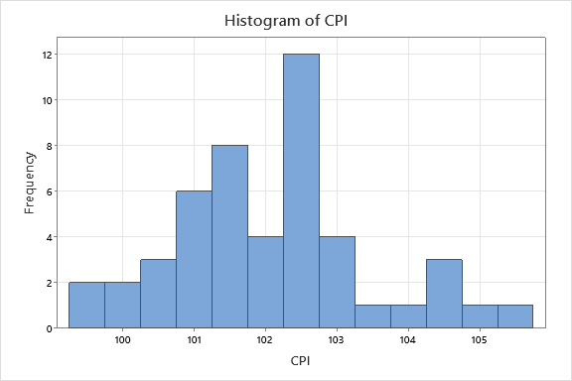

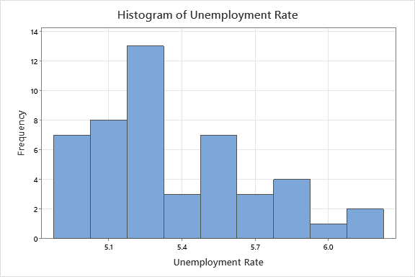

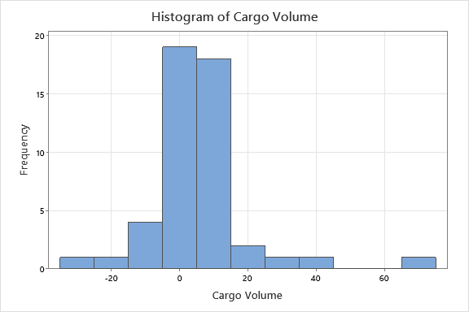

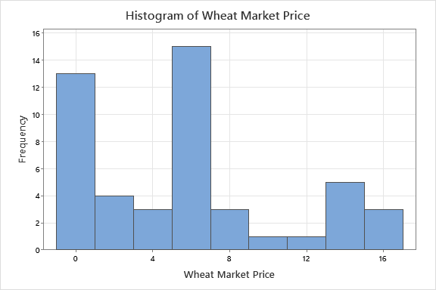

SHEET1

**Scatterplot of CPI vs Unemployment Rate, Cargo Volume, Wheat Market Price**

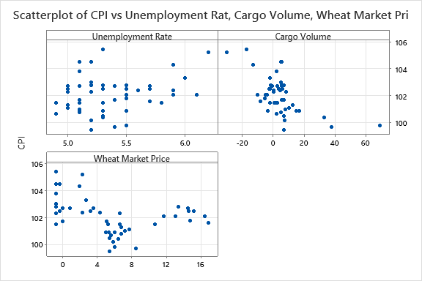

SHEET1

**Regression Analysis: CPI versus Unemployment Rate, Cargo Volume, Wheat Market Price**

**Regression Equation**

|  |  |  |
| --- | --- | --- |
| CPI | = | 98.52 + 0.821 Unemployment Rate - 0.0545 Cargo Volume - 0.1103 Wheat Market Price |

**Coefficients**

|  |  |  |  |  |  |
| --- | --- | --- | --- | --- | --- |
| **Term** | **Coef** | **SE Coef** | **T-Value** | **P-Value** | **VIF** |
| Constant | 98.52 | 2.44 | 40.38 | 0.000 |  |
| Unemployment Rate | 0.821 | 0.458 | 1.79 | 0.080 | 1.19 |
| Cargo Volume | -0.0545 | 0.0102 | -5.34 | 0.000 | 1.11 |
| Wheat Market Price | -0.1103 | 0.0269 | -4.11 | 0.000 | 1.08 |

**Model Summary**

|  |  |  |  |
| --- | --- | --- | --- |
| **S** | **R-sq** | **R-sq(adj)** | **R-sq(pred)** |
| 0.941353 | 54.43% | 51.32% | 42.63% |

**Analysis of Variance**

|  |  |  |  |  |  |
| --- | --- | --- | --- | --- | --- |
| **Source** | **DF** | **Adj SS** | **Adj MS** | **F-Value** | **P-Value** |
| Regression | 3 | 46.569 | 15.5229 | 17.52 | 0.000 |
| Unemployment Rate | 1 | 2.852 | 2.8519 | 3.22 | 0.080 |
| Cargo Volume | 1 | 25.283 | 25.2827 | 28.53 | 0.000 |
| Wheat Market Price | 1 | 14.951 | 14.9511 | 16.87 | 0.000 |
| Error | 44 | 38.990 | 0.8861 |  |  |
| Total | 47 | 85.559 |  |  |  |

**Fits and Diagnostics for Unusual Observations**

|  |  |  |  |  |  |  |
| --- | --- | --- | --- | --- | --- | --- |
| **Obs** | **CPI** | **Fit** | **Resid** | **Std Resid** |  |  |
| 11 | 104.500 | 102.446 | 2.054 | 2.24 | R |  |
| 12 | 104.500 | 102.599 | 1.901 | 2.07 | R |  |
| 14 | 105.200 | 104.985 | 0.215 | 0.27 |  | X |
| 23 | 99.500 | 101.801 | -2.301 | -2.48 | R |  |
| 26 | 99.800 | 98.615 | 1.185 | 1.86 |  | X |

*R  Large residual  
X  Unusual X*

**Durbin-Watson Statistic**

|  |  |
| --- | --- |
| Durbin-Watson Statistic = | 0.557007 |

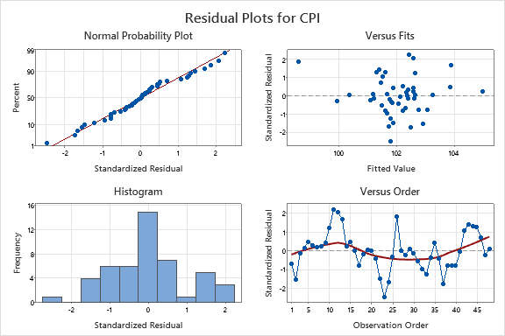

SHEET1

**Autocorrelation Function: SRES**

**Autocorrelations**

|  |  |  |  |
| --- | --- | --- | --- |
| **Lag** | **ACF** | **T** | **LBQ** |
| 1 | 0.687496 | 4.76 | 24.14 |
| 2 | 0.303953 | 1.51 | 28.96 |
| 3 | 0.080365 | 0.38 | 29.30 |
| 4 | -0.005358 | -0.03 | 29.30 |
| 5 | -0.030171 | -0.14 | 29.35 |
| 6 | -0.031640 | -0.15 | 29.41 |
| 7 | -0.039914 | -0.19 | 29.50 |
| 8 | -0.059330 | -0.28 | 29.71 |
| 9 | -0.129238 | -0.61 | 30.74 |
| 10 | -0.238933 | -1.12 | 34.35 |
| 11 | -0.402639 | -1.84 | 44.86 |
| 12 | -0.361925 | -1.55 | 53.60 |

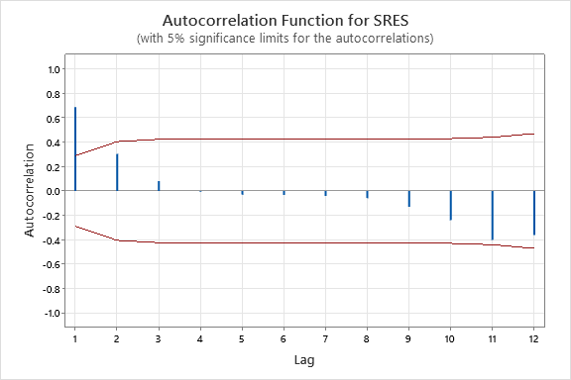

SHEET1

**Runs Test: SRES**

**Descriptive Statistics**

|  |  |  |  |
| --- | --- | --- | --- |
|  |  | **Number of Observations** | |
|  |  |
| **N** | **K** | **≤ K** | **> K** |
| 48 | 0 | 23 | 25 |

**Test**

|  |  |  |  |  |
| --- | --- | --- | --- | --- |
| Null hypothesis | | H₀: The order of the data is random | | |
| Alternative hypothesis | | H₁: The order of the data is not random | | |
| **Number of Runs** | | |  |
| **Observed** | **Expected** | | **P-Value** |
| 14 | 24.96 | | 0.001 |

SHEET1

**Best Subsets Regression: CPI versus Unemployment Rate, Cargo Volume, Wheat Market Price, Time_1, Time_2**

**Response is CPI**

|  |  |  |  |  |  |  |  |  |  |  |  |  |  |  |  |
| --- | --- | --- | --- | --- | --- | --- | --- | --- | --- | --- | --- | --- | --- | --- | --- |
| **Vars** | **R-Sq** | | | **R-Sq (adj)** | | | | **PRESS** | **R-Sq (pred)** | **Mallows Cp** | **S** | **AICc** | **BIC** | **Cond No** | **U n e m p l o y m e n t  R a t e** |
| 1 | 36.4 | | | 35.0 | | | | 63.0 | 26.4 | 18.2 | 1.0878 | 148.796 | 153.864 | 1.000 |  |
| 1 | 12.8 | | | 10.9 | | | | 80.1 | 6.4 | 41.3 | 1.2736 | 163.939 | 169.007 | 1.000 |  |
| 2 | 52.8 | | | 50.7 | | | | 51.3 | 40.1 | 4.2 | 0.94769 | 136.893 | 143.447 | 1.165 |  |
| 2 | 51.1 | | | 48.9 | | | | 52.6 | 38.5 | 5.8 | 0.96428 | 138.558 | 145.113 | 1.163 |  |
| 3 | 55.0 | | | 51.9 | | | | 49.3 | 42.4 | 4.0 | 0.93528 | 137.047 | 144.974 | 2.130 | X |
| 3 | 54.4 | | | 51.3 | | | | 49.1 | 42.6 | 4.6 | 0.94135 | 137.668 | 145.596 | 2.354 | X |
| 4 | 55.6 | | | 51.4 | | | | 51.1 | 40.3 | 5.5 | 0.94039 | 139.087 | 148.265 | 77.265 | X |
| 4 | 55.4 | | | 51.3 | | | | 50.6 | 40.8 | 5.6 | 0.94188 | 139.239 | 148.417 | 30.802 | X |
| 5 | 57.1 | | | 51.9 | | | | 51.5 | 39.8 | 6.0 | 0.93530 | 140.188 | 150.486 | 125.814 | X |
| **Vars** | | **C a r g o  V o l u m e** | **W h e a t  M a r k e t  P r i c e** | | **T i m e _ 1** | **T i m e _ 2** |
| 1 | | X |  | |  |  |
| 1 | |  |  | | X |  |
| 2 | | X |  | | X |  |
| 2 | | X | X | |  |  |
| 3 | | X |  | | X |  |
| 3 | | X | X | |  |  |
| 4 | | X |  | | X | X |
| 4 | | X | X | | X |  |
| 5 | | X | X | | X | X |

SHEET1

**Regression Analysis: CPI versus Unemployment Rate, Cargo Volume, Time_1**

**Regression Equation**

|  |  |  |
| --- | --- | --- |
| CPI | = | 99.79 + 0.662 Unemployment Rate - 0.0557 Cargo Volume - 0.04175 Time_1 |

**Coefficients**

|  |  |  |  |  |  |
| --- | --- | --- | --- | --- | --- |
| **Term** | **Coef** | **SE Coef** | **T-Value** | **P-Value** | **VIF** |
| Constant | 99.79 | 2.38 | 41.92 | 0.000 |  |
| Unemployment Rate | 0.662 | 0.446 | 1.48 | 0.145 | 1.15 |
| Cargo Volume | -0.0557 | 0.0101 | -5.49 | 0.000 | 1.11 |
| Time_1 | -0.04175 | 0.00993 | -4.20 | 0.000 | 1.04 |

**Model Summary**

|  |  |  |  |
| --- | --- | --- | --- |
| **S** | **R-sq** | **R-sq(adj)** | **R-sq(pred)** |
| 0.935278 | 55.02% | 51.95% | 42.35% |

**Analysis of Variance**

|  |  |  |  |  |  |
| --- | --- | --- | --- | --- | --- |
| **Source** | **DF** | **Adj SS** | **Adj MS** | **F-Value** | **P-Value** |
| Regression | 3 | 47.070 | 15.6901 | 17.94 | 0.000 |
| Unemployment Rate | 1 | 1.927 | 1.9266 | 2.20 | 0.145 |
| Cargo Volume | 1 | 26.394 | 26.3937 | 30.17 | 0.000 |
| Time_1 | 1 | 15.453 | 15.4528 | 17.67 | 0.000 |
| Error | 44 | 38.489 | 0.8747 |  |  |
| Total | 47 | 85.559 |  |  |  |

**Fits and Diagnostics for Unusual Observations**

|  |  |  |  |  |  |  |
| --- | --- | --- | --- | --- | --- | --- |
| **Obs** | **CPI** | **Fit** | **Resid** | **Std Resid** |  |  |
| 11 | 104.500 | 102.394 | 2.106 | 2.31 | R |  |
| 12 | 104.500 | 102.446 | 2.054 | 2.24 | R |  |
| 14 | 105.200 | 104.972 | 0.228 | 0.28 |  | X |
| 23 | 99.500 | 101.870 | -2.370 | -2.57 | R |  |
| 26 | 99.800 | 98.504 | 1.296 | 2.05 | R | X |

*R  Large residual  
X  Unusual X*

**Durbin-Watson Statistic**

|  |  |
| --- | --- |
| Durbin-Watson Statistic = | 0.585986 |

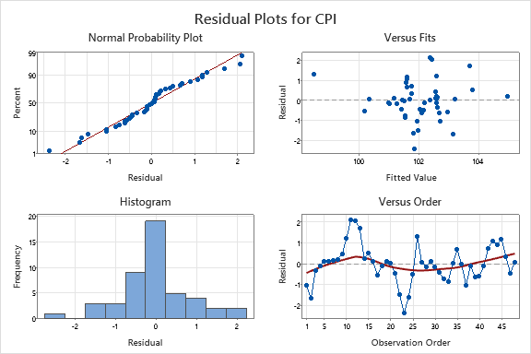

SHEET1

**Autocorrelation Function: SRES_2**

**Autocorrelations**

|  |  |  |  |
| --- | --- | --- | --- |
| **Lag** | **ACF** | **T** | **LBQ** |
| 1 | 0.653769 | 4.53 | 21.83 |
| 2 | 0.280949 | 1.43 | 25.94 |
| 3 | 0.053530 | 0.26 | 26.10 |
| 4 | -0.049753 | -0.24 | 26.23 |
| 5 | -0.064401 | -0.31 | 26.46 |
| 6 | -0.046386 | -0.23 | 26.59 |
| 7 | -0.029657 | -0.14 | 26.64 |
| 8 | -0.053941 | -0.26 | 26.81 |
| 9 | -0.156726 | -0.76 | 28.32 |
| 10 | -0.300379 | -1.44 | 34.02 |
| 11 | -0.462129 | -2.12 | 47.87 |
| 12 | -0.408518 | -1.72 | 59.00 |

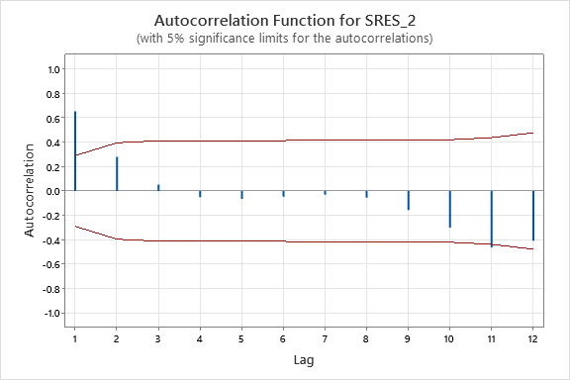

SHEET1

**Runs Test: SRES_2**

**Descriptive Statistics**

|  |  |  |  |
| --- | --- | --- | --- |
|  |  | **Number of Observations** | |
|  |  |
| **N** | **K** | **≤ K** | **> K** |
| 48 | 0 | 23 | 25 |

**Test**

|  |  |  |  |  |
| --- | --- | --- | --- | --- |
| Null hypothesis | | H₀: The order of the data is random | | |
| Alternative hypothesis | | H₁: The order of the data is not random | | |
| **Number of Runs** | | |  |
| **Observed** | **Expected** | | **P-Value** |
| 14 | 24.96 | | 0.001 |