SHEET1

**Descriptive Statistics: Health Expenditure, Supply per capita, Emissions per capita**

**Statistics**

|  |  |  |  |  |  |  |  |  |  |  |
| --- | --- | --- | --- | --- | --- | --- | --- | --- | --- | --- |
| **Variable** | **Developed / Developing** | **N** | **Mean** | **SE Mean** | **StDev** | **Minimum** | **Q1** | **Median** | **Q3** | **Maximum** |
| Health Expenditure | Developed | 15 | 10.927 | 0.451 | 1.748 | 9.200 | 10.000 | 10.700 | 11.100 | 16.800 |
|  | Developing | 15 | 5.627 | 0.765 | 2.963 | 2.100 | 3.000 | 4.600 | 9.300 | 11.100 |
|  |  |  |  |  |  |  |  |  |  |  |
| Supply per capita | Developed | 15 | 18.89 | 1.71 | 6.64 | 10.60 | 13.70 | 19.80 | 21.60 | 34.20 |
|  | Developing | 15 | 4.273 | 0.573 | 2.218 | 1.500 | 2.500 | 4.000 | 5.800 | 9.100 |
|  |  |  |  |  |  |  |  |  |  |  |
| Emissions per capita | Developed | 15 | 7.88 | 1.01 | 3.91 | 3.30 | 4.90 | 7.10 | 8.40 | 15.20 |
|  | Developing | 15 | 2.113 | 0.352 | 1.364 | 0.400 | 0.700 | 2.200 | 2.900 | 4.800 |

SHEET1

**Boxplot of Health Expenditure, Supply per capita, Emissions per capita**

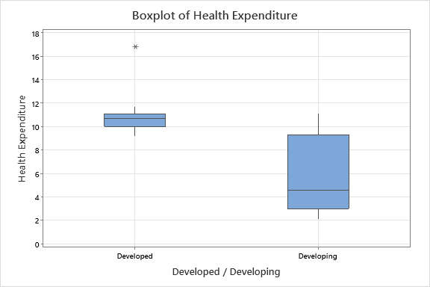

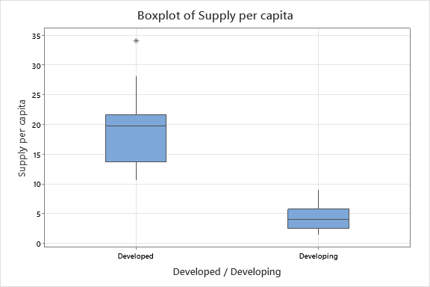

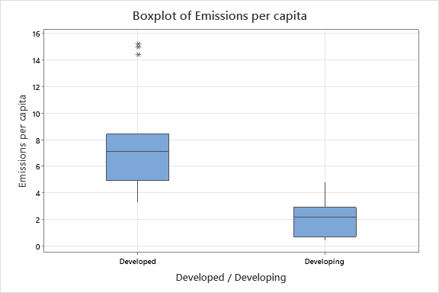

SHEET1

**Binary Logistic Regression: Development versus Health Expenditure, Supply per capita, Emissions per capita**

* WARNING * When the data are in the Response/Frequency format, the Residuals versus fits  
plot is unavailable.

* WARNING * The model could not be fit properly. Maximum likelihood estimates of parameters  
do not exist due to complete separation of data points. The results are not reliable. Please  
refer to help for more information about complete separation.

**Method**

|  |  |
| --- | --- |
| Link function | Logit |
| Residuals for diagnostics | Pearson |
| Rows used | 30 |

**Response Information**

|  |  |  |  |
| --- | --- | --- | --- |
| **Variable** | **Value** | **Count** |  |
| Development | 1 | 15 | (Event) |
|  | 0 | 15 |  |
|  | Total | 30 |  |

**Regression Equation**

|  |  |  |  |  |
| --- | --- | --- | --- | --- |
| P(1) | | = | | exp(Y')/(1 + exp(Y')) |
| Y' | = | | -81 + 6.0 Health Expenditure + 3.66 Supply per capita - 2.8 Emissions per capita | | |

**Coefficients**

|  |  |  |  |  |  |
| --- | --- | --- | --- | --- | --- |
| **Term** | **Coef** | **SE Coef** | **Z-Value** | **P-Value** | **VIF** |
| Constant | -81 | 127 | -0.64 | 0.521 |  |
| Health Expenditure | 6.0 | 14.7 | 0.41 | 0.681 | 1.70 |
| Supply per capita | 3.66 | 9.50 | 0.39 | 0.700 | 7.87 |
| Emissions per capita | -2.8 | 15.5 | -0.18 | 0.855 | 6.30 |

**Odds Ratios for Continuous Predictors**

|  |  |  |
| --- | --- | --- |
|  | **Odds Ratio** | **95% CI** |
| Health Expenditure | 422.4281 | (0.0000, 1.40443E+15) |
| Supply per capita | 38.7600 | (0.0000, 4.70876E+09) |
| Emissions per capita | 0.0596 | (0.0000, 8.61676E+11) |

**Model Summary**

|  |  |  |  |  |  |
| --- | --- | --- | --- | --- | --- |
| **Deviance R-Sq** | **Deviance R-Sq(adj)** | **AIC** | **AICc** | **BIC** | **Area Under ROC Curve** |
| 99.93% | 92.71% | 8.03 | 9.63 | 13.64 | 1.0000 |

**Goodness-of-Fit Tests**

|  |  |  |  |
| --- | --- | --- | --- |
| **Test** | **DF** | **Chi-Square** | **P-Value** |
| Deviance | 26 | 0.03 | 1.000 |
| Pearson | 26 | 0.02 | 1.000 |
| Hosmer-Lemeshow | 8 | 0.02 | 1.000 |

**Analysis of Variance**

|  |  |  |  |  |  |
| --- | --- | --- | --- | --- | --- |
|  |  |  |  | **Likelihood Ratio** | |
| **Source** | **DF** | **Adj Dev** | **Adj Mean** | **Chi-Square** | **P-Value** |
| Regression | 3 | 41.5579 | 13.8526 | 41.56 | 0.000 |
| Health Expenditure | 1 | * | * | * | * |
| Supply per capita | 1 | * | * | * | * |
| Emissions per capita | 1 | * | * | * | * |
| Error | 26 | 0.0309 | 0.0012 |  |  |
| Total | 29 | 41.5888 |  |  |  |

**Measures of Association**

|  |  |  |  |  |
| --- | --- | --- | --- | --- |
| **Pairs** | **Number** | **Percent** | **Summary Measures** | **Value** |
| Concordant | 225 | 100.0 | Somers’ D | 1.00 |
| Discordant | 0 | 0.0 | Goodman-Kruskal Gamma | 1.00 |
| Ties | 0 | 0.0 | Kendall’s Tau-a | 0.52 |
| Total | 225 | 100.0 |  |  |

*Association is between the response variable and predicted probabilities*

**Fits and Diagnostics for Unusual Observations**

|  |  |  |  |  |  |
| --- | --- | --- | --- | --- | --- |
| **Obs** | **Observed Probability** | **Fit** | **Resid** | **Std Resid** |  |
| 5 | 0.0000 | 0.0007 | -0.0259 | -0.04 | X |
| 7 | 0.0000 | 0.0053 | -0.0733 | -0.26 | X |
| 9 | 0.0000 | 0.0002 | -0.0136 | -0.02 | X |
| 28 | 1.0000 | 0.9923 | 0.0882 | 0.26 | X |

*X  Unusual X*

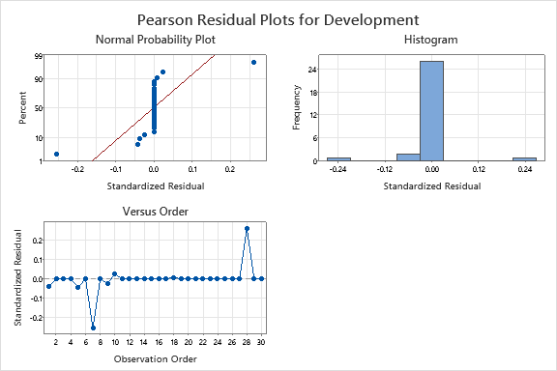

SHEET1

**Best Subsets Regression: Development versus Health Expenditure, Supply per capita, Emissions per capita**

**Response is Development**

|  |  |  |  |  |  |  |  |  |
| --- | --- | --- | --- | --- | --- | --- | --- | --- |
| **Vars** | **R-Sq** | **R-Sq (adj)** | **R-Sq (pred)** | **Mallows Cp** | **S** | **Health Expenditure** | **Supply per capita** | **Emissions per capita** |
| 1 | 70.1 | 69.0 | 63.9 | 4.8 | 0.28323 |  | X |  |
| 1 | 56.0 | 54.4 | 50.5 | 19.3 | 0.34341 | X |  |  |
| 2 | 74.1 | 72.2 | 65.4 | 2.6 | 0.26801 | X | X |  |
| 2 | 70.3 | 68.1 | 62.8 | 6.6 | 0.28721 |  | X | X |
| 3 | 74.7 | 71.8 | 64.4 | 4.0 | 0.26990 | X | X | X |

SHEET1

**Binary Logistic Regression: Development versus Health Expenditure, Supply per capita**

* WARNING * When the data are in the Response/Frequency format, the Residuals versus fits  
plot is unavailable.

* WARNING * The model could not be fit properly. Maximum likelihood estimates of parameters  
do not exist due to complete separation of data points. The results are not reliable. Please  
refer to help for more information about complete separation.

**Method**

|  |  |
| --- | --- |
| Link function | Logit |
| Residuals for diagnostics | Pearson |
| Rows used | 30 |

**Response Information**

|  |  |  |  |
| --- | --- | --- | --- |
| **Variable** | **Value** | **Count** |  |
| Development | 1 | 15 | (Event) |
|  | 0 | 15 |  |
|  | Total | 30 |  |

**Regression Equation**

|  |  |  |  |  |
| --- | --- | --- | --- | --- |
| P(1) | | = | | exp(Y')/(1 + exp(Y')) |
| Y' | = | | -89.9 + 6.7 Health Expenditure + 2.53 Supply per capita | | |

**Coefficients**

|  |  |  |  |  |  |
| --- | --- | --- | --- | --- | --- |
| **Term** | **Coef** | **SE Coef** | **Z-Value** | **P-Value** | **VIF** |
| Constant | -89.9 | 99.1 | -0.91 | 0.364 |  |
| Health Expenditure | 6.7 | 10.6 | 0.63 | 0.531 | 1.11 |
| Supply per capita | 2.53 | 3.52 | 0.72 | 0.472 | 1.11 |

**Odds Ratios for Continuous Predictors**

|  |  |  |
| --- | --- | --- |
|  | **Odds Ratio** | **95% CI** |
| Health Expenditure | 787.8398 | (0.0000, 9.11468E+11) |
| Supply per capita | 12.5704 | (0.0126, 12507.3489) |

**Model Summary**

|  |  |  |  |  |  |
| --- | --- | --- | --- | --- | --- |
| **Deviance R-Sq** | **Deviance R-Sq(adj)** | **AIC** | **AICc** | **BIC** | **Area Under ROC Curve** |
| 99.91% | 95.11% | 6.04 | 6.96 | 10.24 | 1.0000 |

**Goodness-of-Fit Tests**

|  |  |  |  |
| --- | --- | --- | --- |
| **Test** | **DF** | **Chi-Square** | **P-Value** |
| Deviance | 27 | 0.04 | 1.000 |
| Pearson | 27 | 0.02 | 1.000 |
| Hosmer-Lemeshow | 8 | 0.02 | 1.000 |

**Analysis of Variance**

|  |  |  |  |  |  |
| --- | --- | --- | --- | --- | --- |
|  |  |  |  | **Likelihood Ratio** | |
| **Source** | **DF** | **Adj Dev** | **Adj Mean** | **Chi-Square** | **P-Value** |
| Regression | 2 | 41.5532 | 20.7766 | 41.55 | 0.000 |
| Health Expenditure | 1 | * | * | * | * |
| Supply per capita | 1 | 16.5428 | 16.5428 | 16.54 | 0.000 |
| Error | 27 | 0.0357 | 0.0013 |  |  |
| Total | 29 | 41.5888 |  |  |  |

**Measures of Association**

|  |  |  |  |  |
| --- | --- | --- | --- | --- |
| **Pairs** | **Number** | **Percent** | **Summary Measures** | **Value** |
| Concordant | 225 | 100.0 | Somers’ D | 1.00 |
| Discordant | 0 | 0.0 | Goodman-Kruskal Gamma | 1.00 |
| Ties | 0 | 0.0 | Kendall’s Tau-a | 0.52 |
| Total | 225 | 100.0 |  |  |

*Association is between the response variable and predicted probabilities*

**Fits and Diagnostics for Unusual Observations**

|  |  |  |  |  |  |
| --- | --- | --- | --- | --- | --- |
| **Obs** | **Observed Probability** | **Fit** | **Resid** | **Std Resid** |  |
| 7 | 0.0000 | 0.0078 | -0.0885 | -0.32 | X |
| 9 | 0.0000 | 0.0004 | -0.0204 | -0.05 | X |
| 10 | 1.0000 | 0.9979 | 0.0462 | 0.06 | X |
| 28 | 1.0000 | 0.9930 | 0.0842 | 0.17 | X |

*X  Unusual X*

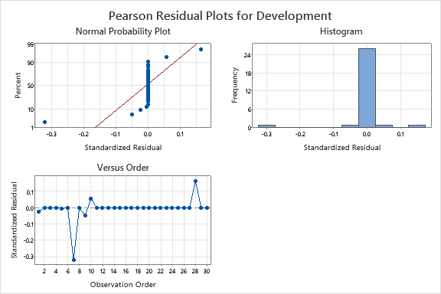

SHEET1

**Binary Logistic Regression: Development versus Supply per capita**

* WARNING * When the data are in the Response/Frequency format, the Residuals versus fits  
plot is unavailable.

* WARNING * The model could not be fit properly. Maximum likelihood estimates of parameters  
do not exist due to complete separation of data points. The results are not reliable. Please  
refer to help for more information about complete separation.

**Method**

|  |  |
| --- | --- |
| Link function | Logit |
| Residuals for diagnostics | Pearson |
| Rows used | 30 |

**Response Information**

|  |  |  |  |
| --- | --- | --- | --- |
| **Variable** | **Value** | **Count** |  |
| Development | 1 | 15 | (Event) |
|  | 0 | 15 |  |
|  | Total | 30 |  |

**Regression Equation**

|  |  |  |  |  |
| --- | --- | --- | --- | --- |
| P(1) | | = | | exp(Y')/(1 + exp(Y')) |
| Y' | = | | -53.8 + 5.46 Supply per capita | | |

**Coefficients**

|  |  |  |  |  |  |
| --- | --- | --- | --- | --- | --- |
| **Term** | **Coef** | **SE Coef** | **Z-Value** | **P-Value** | **VIF** |
| Constant | -53.8 | 44.2 | -1.22 | 0.224 |  |
| Supply per capita | 5.46 | 4.47 | 1.22 | 0.222 | 1.00 |

**Odds Ratios for Continuous Predictors**

|  |  |  |
| --- | --- | --- |
|  | **Odds Ratio** | **95% CI** |
| Supply per capita | 235.7216 | (0.0369, 1.50668E+06) |

**Model Summary**

|  |  |  |  |  |  |
| --- | --- | --- | --- | --- | --- |
| **Deviance R-Sq** | **Deviance R-Sq(adj)** | **AIC** | **AICc** | **BIC** | **Area Under ROC Curve** |
| 99.84% | 97.44% | 4.07 | 4.51 | 6.87 | 1.0000 |

**Goodness-of-Fit Tests**

|  |  |  |  |
| --- | --- | --- | --- |
| **Test** | **DF** | **Chi-Square** | **P-Value** |
| Deviance | 28 | 0.07 | 1.000 |
| Pearson | 28 | 0.03 | 1.000 |
| Hosmer-Lemeshow | 8 | 0.00 | 1.000 |

**Analysis of Variance**

|  |  |  |  |  |  |
| --- | --- | --- | --- | --- | --- |
|  |  |  |  | **Likelihood Ratio** | |
| **Source** | **DF** | **Adj Dev** | **Adj Mean** | **Chi-Square** | **P-Value** |
| Regression | 1 | 41.5227 | 41.5227 | 41.52 | 0.000 |
| Supply per capita | 1 | 41.5227 | 41.5227 | 41.52 | 0.000 |
| Error | 28 | 0.0661 | 0.0024 |  |  |
| Total | 29 | 41.5888 |  |  |  |

**Measures of Association**

|  |  |  |  |  |
| --- | --- | --- | --- | --- |
| **Pairs** | **Number** | **Percent** | **Summary Measures** | **Value** |
| Concordant | 225 | 100.0 | Somers’ D | 1.00 |
| Discordant | 0 | 0.0 | Goodman-Kruskal Gamma | 1.00 |
| Ties | 0 | 0.0 | Kendall’s Tau-a | 0.52 |
| Total | 225 | 100.0 |  |  |

*Association is between the response variable and predicted probabilities*

**Fits and Diagnostics for Unusual Observations**

|  |  |  |  |  |  |
| --- | --- | --- | --- | --- | --- |
| **Obs** | **Observed Probability** | **Fit** | **Resid** | **Std Resid** |  |
| 7 | 0.0000 | 0.0162 | -0.1282 | -0.96 | X |
| 28 | 1.0000 | 0.9835 | 0.1297 | 0.51 | X |

*X  Unusual X*

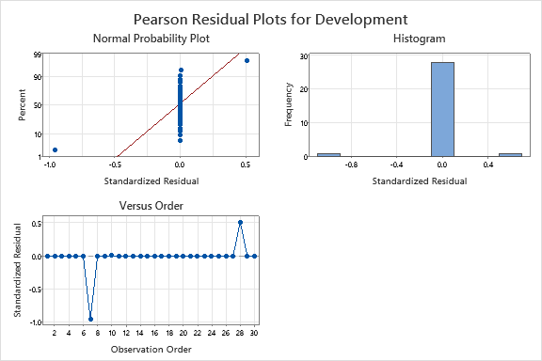

SHEET1

**Time Series Plot of HI, COOK, HI_1, COOK_1, HI_2, COOK_2**

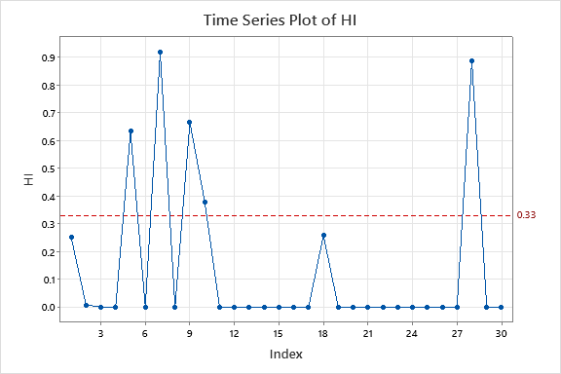

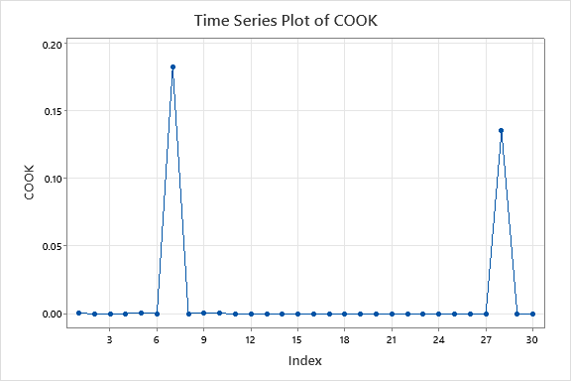

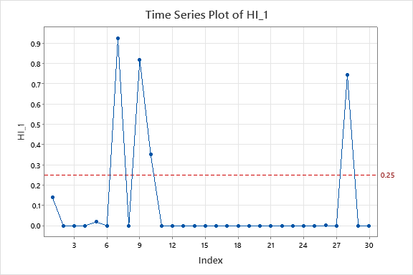

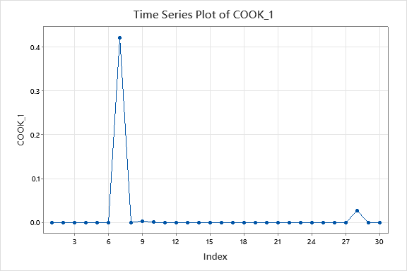

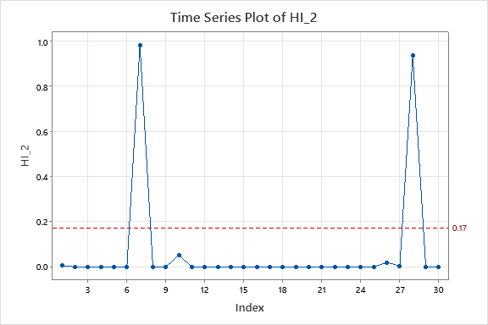

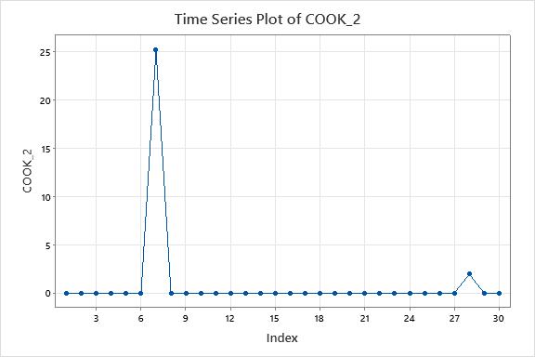

SHEET1

**Tabulated Statistics: Development, Predict**

**Rows: Development   Columns: Predict**

|  |  |  |  |
| --- | --- | --- | --- |
|  | **0** | **1** | **All** |
|  |  |  |  |
| 0 | 15 | 0 | 15 |
|  | 50 | 0 | 50 |
|  |  |  |  |
| 1 | 0 | 15 | 15 |
|  | 0 | 50 | 50 |
|  |  |  |  |
| All | 15 | 15 | 30 |
|  | 50 | 50 | 100 |

*Cell Contents  
      Count  
      % of Total*