SHEET1

**Descriptive Statistics: CPI, Unemployment Rate, Cargo Volume, Wheat Market Price**

**Statistics**

|  |  |  |  |  |  |  |  |  |  |  |
| --- | --- | --- | --- | --- | --- | --- | --- | --- | --- | --- |
| **Variable** | **N** | **Mean** | **SE Mean** | **StDev** | **Minimum** | **Q1** | **Median** | **Q3** | **Maximum** | **Skewness** |
| CPI | 48 | 102.07 | 0.195 | 1.35 | 99.50 | 101.03 | 102.10 | 102.70 | 105.40 | 0.43 |
| Unemployment Rate | 48 | 5.3667 | 0.0473 | 0.3277 | 4.9000 | 5.1000 | 5.3000 | 5.5000 | 6.2000 | 0.80 |
| Cargo Volume | 48 | 4.44 | 2.05 | 14.19 | -29.90 | -2.05 | 4.35 | 7.13 | 69.00 | 2.09 |
| Wheat Market Price | 48 | 5.554 | 0.767 | 5.314 | -0.800 | 0.200 | 5.350 | 7.575 | 16.900 | 0.61 |

SHEET1

**Histogram of CPI, Unemployment Rate, Cargo Volume, Wheat Market Price**

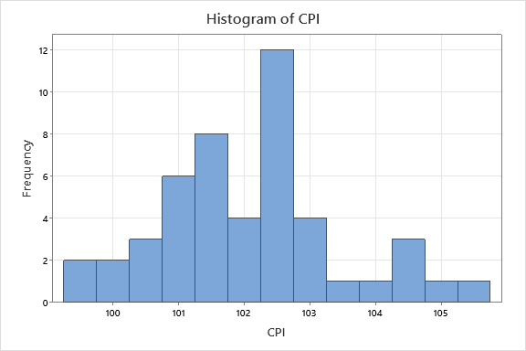

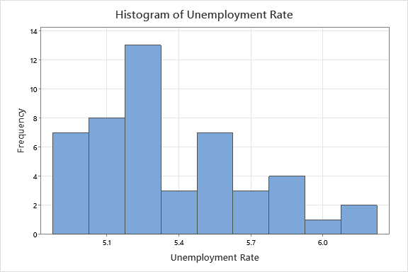

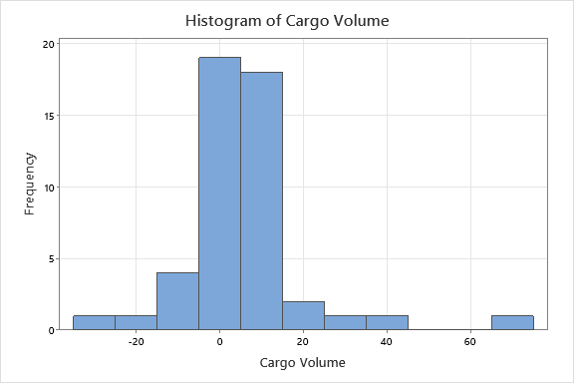

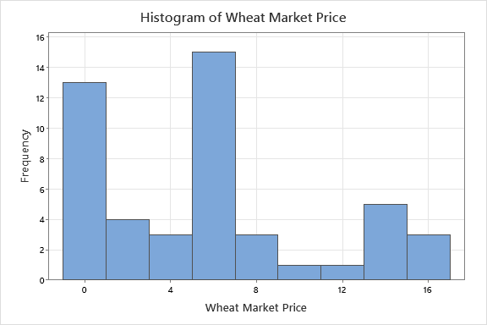

SHEET1

**Scatterplot of CPI vs Unemployment Rate, Cargo Volume, Wheat Market Price**

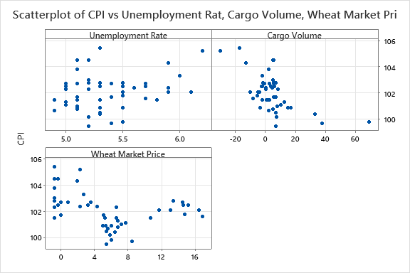

SHEET1

**Regression Analysis: CPI versus Unemployment Rate, Cargo Volume, Wheat Market Price**

**Regression Equation**

|  |  |  |
| --- | --- | --- |
| CPI | = | 98.52 + 0.821 Unemployment Rate - 0.0545 Cargo Volume - 0.1103 Wheat Market Price |

**Coefficients**

|  |  |  |  |  |  |
| --- | --- | --- | --- | --- | --- |
| **Term** | **Coef** | **SE Coef** | **T-Value** | **P-Value** | **VIF** |
| Constant | 98.52 | 2.44 | 40.38 | 0.000 |  |
| Unemployment Rate | 0.821 | 0.458 | 1.79 | 0.080 | 1.19 |
| Cargo Volume | -0.0545 | 0.0102 | -5.34 | 0.000 | 1.11 |
| Wheat Market Price | -0.1103 | 0.0269 | -4.11 | 0.000 | 1.08 |

**Model Summary**

|  |  |  |  |
| --- | --- | --- | --- |
| **S** | **R-sq** | **R-sq(adj)** | **R-sq(pred)** |
| 0.941353 | 54.43% | 51.32% | 42.63% |

**Analysis of Variance**

|  |  |  |  |  |  |
| --- | --- | --- | --- | --- | --- |
| **Source** | **DF** | **Adj SS** | **Adj MS** | **F-Value** | **P-Value** |
| Regression | 3 | 46.569 | 15.5229 | 17.52 | 0.000 |
| Unemployment Rate | 1 | 2.852 | 2.8519 | 3.22 | 0.080 |
| Cargo Volume | 1 | 25.283 | 25.2827 | 28.53 | 0.000 |
| Wheat Market Price | 1 | 14.951 | 14.9511 | 16.87 | 0.000 |
| Error | 44 | 38.990 | 0.8861 |  |  |
| Total | 47 | 85.559 |  |  |  |

**Fits and Diagnostics for Unusual Observations**

|  |  |  |  |  |  |  |
| --- | --- | --- | --- | --- | --- | --- |
| **Obs** | **CPI** | **Fit** | **Resid** | **Std Resid** |  |  |
| 11 | 104.500 | 102.446 | 2.054 | 2.24 | R |  |
| 12 | 104.500 | 102.599 | 1.901 | 2.07 | R |  |
| 14 | 105.200 | 104.985 | 0.215 | 0.27 |  | X |
| 23 | 99.500 | 101.801 | -2.301 | -2.48 | R |  |
| 26 | 99.800 | 98.615 | 1.185 | 1.86 |  | X |

*R  Large residual  
X  Unusual X*

**Durbin-Watson Statistic**

|  |  |
| --- | --- |
| Durbin-Watson Statistic = | 0.557007 |

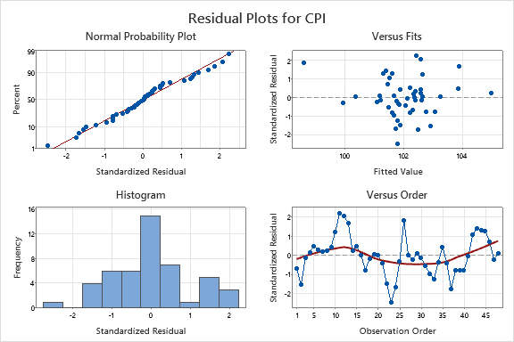

SHEET1

**Autocorrelation Function: SRES**

**Autocorrelations**

|  |  |  |  |
| --- | --- | --- | --- |
| **Lag** | **ACF** | **T** | **LBQ** |
| 1 | 0.687496 | 4.76 | 24.14 |
| 2 | 0.303953 | 1.51 | 28.96 |
| 3 | 0.080365 | 0.38 | 29.30 |
| 4 | -0.005358 | -0.03 | 29.30 |
| 5 | -0.030171 | -0.14 | 29.35 |
| 6 | -0.031640 | -0.15 | 29.41 |
| 7 | -0.039914 | -0.19 | 29.50 |
| 8 | -0.059330 | -0.28 | 29.71 |
| 9 | -0.129238 | -0.61 | 30.74 |
| 10 | -0.238933 | -1.12 | 34.35 |
| 11 | -0.402639 | -1.84 | 44.86 |
| 12 | -0.361925 | -1.55 | 53.60 |

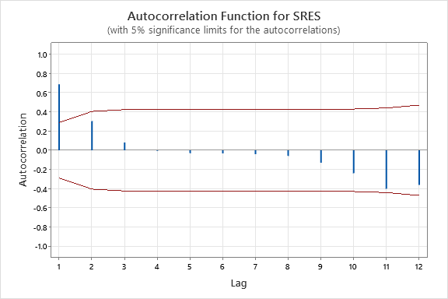

SHEET1

**Runs Test: SRES**

**Descriptive Statistics**

|  |  |  |  |
| --- | --- | --- | --- |
|  |  | **Number of Observations** | |
|  |  |
| **N** | **K** | **≤ K** | **> K** |
| 48 | 0 | 23 | 25 |

**Test**

|  |  |  |  |  |
| --- | --- | --- | --- | --- |
| Null hypothesis | | H₀: The order of the data is random | | |
| Alternative hypothesis | | H₁: The order of the data is not random | | |
| **Number of Runs** | | |  |
| **Observed** | **Expected** | | **P-Value** |
| 14 | 24.96 | | 0.001 |

SHEET1

**Best Subsets Regression: CPI versus Unemployment Rate, Cargo Volume, Wheat Market Price, Time_1, Time_2**

**Response is CPI**

|  |  |  |  |  |  |  |  |  |  |  |  |  |  |  |
| --- | --- | --- | --- | --- | --- | --- | --- | --- | --- | --- | --- | --- | --- | --- |
| **Vars** | **R-Sq** | **R-Sq (adj)** | **PRESS** | **R-Sq (pred)** | **Mallows Cp** | **S** | **AICc** | **BIC** | **Cond No** | **Unemployment Rate** | **Cargo Volume** | **Wheat Market Price** | **Time_1** | **Time_2** |
| 1 | 36.4 | 35.0 | 63.0 | 26.4 | 18.2 | 1.0878 | 148.796 | 153.864 | 1.000 |  | X |  |  |  |
| 1 | 12.8 | 10.9 | 80.1 | 6.4 | 41.3 | 1.2736 | 163.939 | 169.007 | 1.000 |  |  |  | X |  |
| 2 | 52.8 | 50.7 | 51.3 | 40.1 | 4.2 | 0.94769 | 136.893 | 143.447 | 1.165 |  | X |  | X |  |
| 2 | 51.1 | 48.9 | 52.6 | 38.5 | 5.8 | 0.96428 | 138.558 | 145.113 | 1.163 |  | X | X |  |  |
| 3 | 55.0 | 51.9 | 49.3 | 42.4 | 4.0 | 0.93528 | 137.047 | 144.974 | 2.130 | X | X |  | X |  |
| 3 | 54.4 | 51.3 | 49.1 | 42.6 | 4.6 | 0.94135 | 137.668 | 145.596 | 2.354 | X | X | X |  |  |
| 4 | 55.6 | 51.4 | 51.1 | 40.3 | 5.5 | 0.94039 | 139.087 | 148.265 | 77.265 | X | X |  | X | X |
| 4 | 55.4 | 51.3 | 50.6 | 40.8 | 5.6 | 0.94188 | 139.239 | 148.417 | 30.802 | X | X | X | X |  |
| 5 | 57.1 | 51.9 | 51.5 | 39.8 | 6.0 | 0.93530 | 140.188 | 150.486 | 125.814 | X | X | X | X | X |

SHEET1

**Regression Analysis: CPI versus Unemployment Rate, Cargo Volume, Time_1**

**Regression Equation**

|  |  |  |
| --- | --- | --- |
| CPI | = | 99.79 + 0.662 Unemployment Rate - 0.0557 Cargo Volume - 0.04175 Time_1 |

**Coefficients**

|  |  |  |  |  |  |  |
| --- | --- | --- | --- | --- | --- | --- |
| **Term** | **Coef** | | **SE Coef** | **T-Value** | **P-Value** | **VIF** |
| Constant | 99.79 | | 2.38 | 41.92 | 0.000 |  |
| Unemployment Rate | | 0.662 | 0.446 | 1.48 | 0.145 | 1.15 |
| Cargo Volume | -0.0557 | | 0.0101 | -5.49 | 0.000 | 1.11 |
| Time_1 | -0.04175 | | 0.00993 | -4.20 | 0.000 | 1.04 |

**Model Summary**

|  |  |  |  |
| --- | --- | --- | --- |
| **S** | **R-sq** | **R-sq(adj)** | **R-sq(pred)** |
| 0.935278 | 55.02% | 51.95% | 42.35% |

**Analysis of Variance**

|  |  |  |  |  |  |
| --- | --- | --- | --- | --- | --- |
| **Source** | **DF** | **Adj SS** | **Adj MS** | **F-Value** | **P-Value** |
| Regression | 3 | 47.070 | 15.6901 | 17.94 | 0.000 |
| Unemployment Rate | 1 | 1.927 | 1.9266 | 2.20 | 0.145 |
| Cargo Volume | 1 | 26.394 | 26.3937 | 30.17 | 0.000 |
| Time_1 | 1 | 15.453 | 15.4528 | 17.67 | 0.000 |
| Error | 44 | 38.489 | 0.8747 |  |  |
| Total | 47 | 85.559 |  |  |  |

**Fits and Diagnostics for Unusual Observations**

|  |  |  |  |  |  |  |
| --- | --- | --- | --- | --- | --- | --- |
| **Obs** | **CPI** | **Fit** | **Resid** | **Std Resid** |  |  |
| 11 | 104.500 | 102.394 | 2.106 | 2.31 | R |  |
| 12 | 104.500 | 102.446 | 2.054 | 2.24 | R |  |
| 14 | 105.200 | 104.972 | 0.228 | 0.28 |  | X |
| 23 | 99.500 | 101.870 | -2.370 | -2.57 | R |  |
| 26 | 99.800 | 98.504 | 1.296 | 2.05 | R | X |

*R  Large residual  
X  Unusual X*

**Durbin-Watson Statistic**

|  |  |
| --- | --- |
| Durbin-Watson Statistic = | 0.585986 |

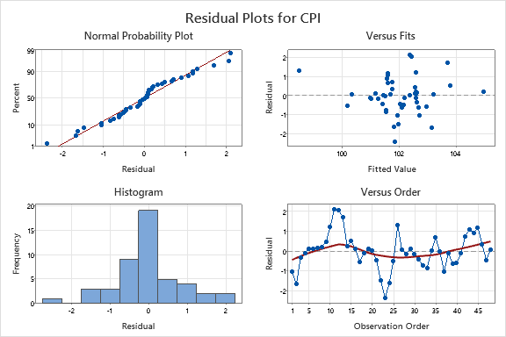

SHEET1

**Autocorrelation Function: SRES_2**

**Autocorrelations**

|  |  |  |  |
| --- | --- | --- | --- |
| **Lag** | **ACF** | **T** | **LBQ** |
| 1 | 0.653769 | 4.53 | 21.83 |
| 2 | 0.280949 | 1.43 | 25.94 |
| 3 | 0.053530 | 0.26 | 26.10 |
| 4 | -0.049753 | -0.24 | 26.23 |
| 5 | -0.064401 | -0.31 | 26.46 |
| 6 | -0.046386 | -0.23 | 26.59 |
| 7 | -0.029657 | -0.14 | 26.64 |
| 8 | -0.053941 | -0.26 | 26.81 |
| 9 | -0.156726 | -0.76 | 28.32 |
| 10 | -0.300379 | -1.44 | 34.02 |
| 11 | -0.462129 | -2.12 | 47.87 |
| 12 | -0.408518 | -1.72 | 59.00 |

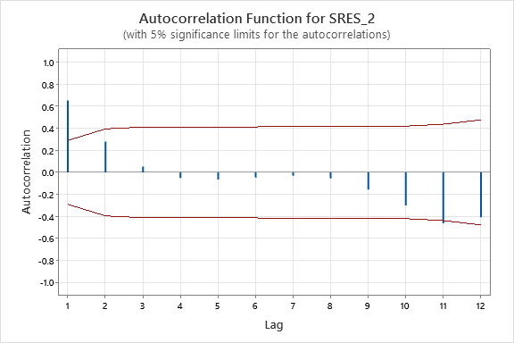

SHEET1

**Runs Test: SRES_2**

**Descriptive Statistics**

|  |  |  |  |
| --- | --- | --- | --- |
|  |  | **Number of Observations** | |
|  |  |
| **N** | **K** | **≤ K** | **> K** |
| 48 | 0 | 23 | 25 |

**Test**

|  |  |  |  |  |
| --- | --- | --- | --- | --- |
| Null hypothesis | | H₀: The order of the data is random | | |
| Alternative hypothesis | | H₁: The order of the data is not random | | |
| **Number of Runs** | | |  |
| **Observed** | **Expected** | | **P-Value** |
| 14 | 24.96 | | 0.001 |

SHEET1

**Scatterplot of CPI vs CPI_Lag1, CPI_Lag11**

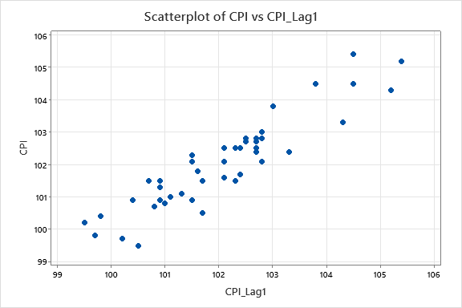

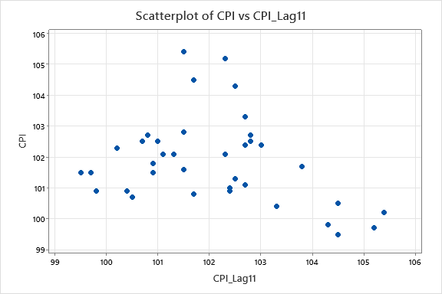

SHEET1

**Best Subsets Regression: CPI versus Unemployment Rate, Cargo Volume, Wheat Market Price, Time_1, Time_2, CPI_Lag1, CPI_Lag11**

**Response is CPI**

37 cases used, 11 cases contain missing values

|  |  |  |  |  |  |  |  |  |  |  |  |  |  |  |  |  |
| --- | --- | --- | --- | --- | --- | --- | --- | --- | --- | --- | --- | --- | --- | --- | --- | --- |
| **Vars** | **R-Sq** | **R-Sq (adj)** | **PRESS** | **R-Sq (pred)** | **Mallows Cp** | **S** | **AICc** | **BIC** | **Cond No** | **Unemploy**  **ment**  **Rate** | **Cargo Volume** | **Wheat Market Price** | **Time_1** | **Time_2** | **CPI_Lag1** | **CPI_**  **Lag11** |
| 1 | 84.7 | 84.3 | 12.4 | 82.7 | 13.9 | 0.55925 | 66.667 | 70.772 | 1.000 |  |  |  |  |  | X |  |
| 1 | 45.1 | 43.5 | 50.7 | 29.3 | 135.6 | 1.0605 | 114.022 | 118.127 | 1.000 |  | X |  |  |  |  |  |
| 2 | 86.7 | 85.9 | 11.9 | 83.5 | 9.9 | 0.52998 | 64.139 | 69.333 | 1.453 |  |  |  |  |  | X | X |
| 2 | 85.4 | 84.5 | 12.7 | 82.3 | 13.8 | 0.55483 | 67.530 | 72.724 | 4.937 |  | X |  |  |  | X |  |
| 3 | 87.2 | 86.0 | 12.0 | 83.3 | 10.4 | 0.52811 | 65.459 | 71.578 | 6.238 |  |  |  | X |  | X | X |
| 3 | 87.0 | 85.8 | 12.1 | 83.1 | 11.0 | 0.53201 | 66.003 | 72.122 | 5.078 |  |  |  |  | X | X | X |
| 4 | 89.0 | 87.6 | 10.9 | 84.8 | 6.9 | 0.49708 | 62.703 | 69.569 | 778.030 |  |  |  | X | X | X | X |
| 4 | 88.7 | 87.2 | 11.6 | 83.9 | 7.8 | 0.50417 | 63.751 | 70.616 | 148.098 |  |  | X | X |  | X | X |
| 5 | 90.4 | 88.8 | 10.4 | 85.5 | 4.5 | 0.47150 | 60.681 | 68.096 | 1079.419 |  |  | X | X | X | X | X |
| 5 | 89.1 | 87.4 | 11.5 | 83.9 | 8.3 | 0.50109 | 65.185 | 72.599 | 793.289 |  | X |  | X | X | X | X |
| 6 | 90.6 | 88.7 | 11.4 | 84.0 | 6.0 | 0.47523 | 63.332 | 71.076 | 1087.753 |  | X | X | X | X | X | X |
| 6 | 90.4 | 88.5 | 11.0 | 84.6 | 6.5 | 0.47916 | 63.941 | 71.686 | 1091.706 | X |  | X | X | X | X | X |
| 7 | 90.6 | 88.3 | 12.1 | 83.1 | 8.0 | 0.48326 | 66.842 | 74.674 | 1098.233 | X | X | X | X | X | X | X |

SHEET1

**Regression Analysis: CPI versus Wheat Market Price, Time_1, Time_2, CPI_Lag1, CPI_Lag11**

**Method**

|  |  |
| --- | --- |
| Rows unused | 11 |

**Regression Equation**

|  |  |  |
| --- | --- | --- |
| CPI | = | 118.1 + 0.1628 Wheat Market Price - 0.325 Time_1 + 0.00339 Time_2 + 0.410 CPI_Lag1- 0.519 CPI_Lag11 |

**Coefficients**

|  |  |  |  |  |  |
| --- | --- | --- | --- | --- | --- |
| **Term** | **Coef** | **SE Coef** | **T-Value** | **P-Value** | **VIF** |
| Constant | 118.1 | 27.8 | 4.25 | 0.000 |  |
| Wheat Market Price | 0.1628 | 0.0762 | 2.14 | 0.041 | 21.21 |
| Time_1 | -0.325 | 0.102 | -3.18 | 0.003 | 198.67 |
| Time_2 | 0.00339 | 0.00143 | 2.36 | 0.025 | 143.80 |
| CPI_Lag1 | 0.410 | 0.141 | 2.92 | 0.007 | 6.98 |
| CPI_Lag11 | -0.519 | 0.141 | -3.67 | 0.001 | 7.38 |

**Model Summary**

|  |  |  |  |
| --- | --- | --- | --- |
| **S** | **R-sq** | **R-sq(adj)** | **R-sq(pred)** |
| 0.471500 | 90.39% | 88.84% | 85.47% |

**Analysis of Variance**

|  |  |  |  |  |  |
| --- | --- | --- | --- | --- | --- |
| **Source** | **DF** | **Adj SS** | **Adj MS** | **F-Value** | **P-Value** |
| Regression | 5 | 64.829 | 12.9659 | 58.32 | 0.000 |
| Wheat Market Price | 1 | 1.015 | 1.0151 | 4.57 | 0.041 |
| Time_1 | 1 | 2.247 | 2.2466 | 10.11 | 0.003 |
| Time_2 | 1 | 1.242 | 1.2422 | 5.59 | 0.025 |
| CPI_Lag1 | 1 | 1.891 | 1.8908 | 8.50 | 0.007 |
| CPI_Lag11 | 1 | 2.999 | 2.9987 | 13.49 | 0.001 |
| Error | 31 | 6.892 | 0.2223 |  |  |
| Total | 36 | 71.721 |  |  |  |

**Fits and Diagnostics for Unusual Observations**

|  |  |  |  |  |  |
| --- | --- | --- | --- | --- | --- |
| **Obs** | **CPI** | **Fit** | **Resid** | **Std Resid** |  |
| 13 | 105.400 | 104.559 | 0.841 | 2.06 | R |
| 24 | 100.200 | 99.360 | 0.840 | 2.07 | R |
| 45 | 102.800 | 101.928 | 0.872 | 2.12 | R |

*R  Large residual*

**Durbin-Watson Statistic**

|  |  |
| --- | --- |
| Durbin-Watson Statistic = | 1.93607 |

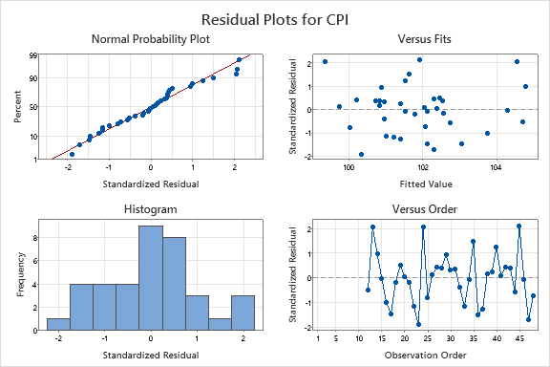

SHEET1

**Autocorrelation Function: SRES_4**

**Autocorrelations**

|  |  |  |  |
| --- | --- | --- | --- |
| **Lag** | **ACF** | **T** | **LBQ** |
| 1 | 0.014561 | 0.09 | 0.01 |
| 2 | -0.227429 | -1.38 | 2.14 |
| 3 | -0.099683 | -0.58 | 2.56 |
| 4 | -0.119130 | -0.68 | 3.18 |
| 5 | 0.178561 | 1.01 | 4.62 |
| 6 | 0.019040 | 0.11 | 4.64 |
| 7 | -0.152910 | -0.84 | 5.76 |
| 8 | -0.199312 | -1.08 | 7.74 |
| 9 | -0.281981 | -1.48 | 11.84 |

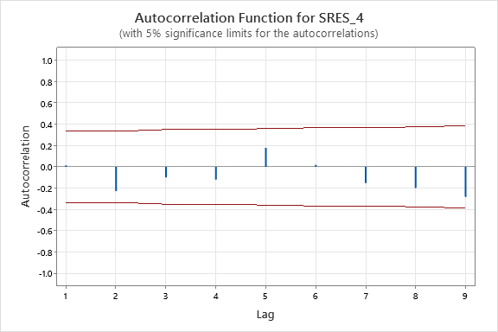

SHEET1

**Runs Test: SRES_4**

**Descriptive Statistics**

|  |  |  |  |
| --- | --- | --- | --- |
|  |  | **Number of Observations** | |
|  |  |
| **N** | **K** | **≤ K** | **> K** |
| 37 | 0 | 18 | 19 |

**Test**

|  |  |  |  |  |
| --- | --- | --- | --- | --- |
| Null hypothesis | | H₀: The order of the data is random | | |
| Alternative hypothesis | | H₁: The order of the data is not random | | |
| **Number of Runs** | | |  |
| **Observed** | **Expected** | | **P-Value** |
| 15 | 19.49 | | 0.134 |

SHEET1

**Time Series Plot of HI_4, COOK_4**

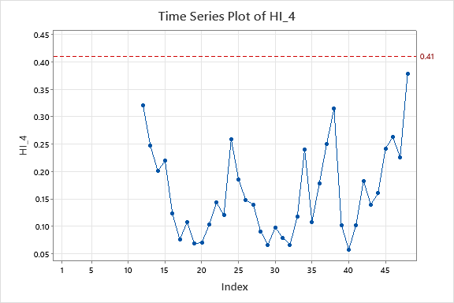

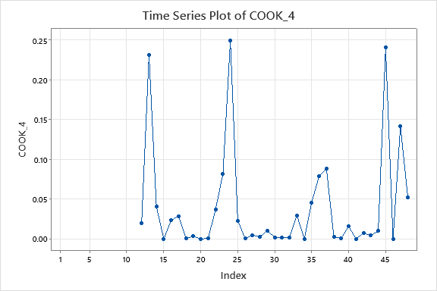

SHEET2 FOR #24

**Best Subsets Regression: CPI versus Unemployment Rate, Cargo Volume, Wheat Market Price, Time_1, Time_2, CPI_Lag1, CPI_Lag11, Dec20**

**Response is CPI**

37 cases used, 11 cases contain missing values

|  |  |  |  |  |  |  |  |  |  |  |  |  |  |  |
| --- | --- | --- | --- | --- | --- | --- | --- | --- | --- | --- | --- | --- | --- | --- |
| **Total Vars** | **R-Sq** | **R-Sq (adj)** | **Mallows Cp** | **S** | **AICc** | **BIC** | **Cond No** | **Unemployment Rate** | **Cargo Volume** | **Wheat Market Price** | **Time_1** | **Time_2** | **CPI_Lag1** | **CPI_Lag11** |
| 2 | 85.1 | 84.2 | 19.6 | 0.56070 | 68.309 | 73.502 | 1.775 |  |  |  |  |  | X |  |
| 2 | 48.2 | 45.2 | 144.9 | 1.0449 | 114.370 | 119.563 | 1.070 |  | X |  |  |  |  |  |
| 3 | 88.0 | 86.9 | 11.8 | 0.51104 | 63.027 | 69.146 | 2.562 |  |  |  |  |  | X | X |
| 3 | 85.6 | 84.3 | 19.9 | 0.55949 | 69.729 | 75.848 | 5.931 |  | X |  |  |  | X |  |
| 4 | 88.5 | 87.0 | 12.1 | 0.50806 | 64.320 | 71.185 | 6.785 |  |  |  | X |  | X | X |
| 4 | 88.3 | 86.9 | 12.7 | 0.51173 | 64.853 | 71.719 | 5.783 |  |  |  |  | X | X | X |
| 5 | 90.6 | 89.1 | 7.0 | 0.46703 | 59.977 | 67.391 | 154.864 |  |  | X | X |  | X | X |
| 5 | 89.8 | 88.2 | 9.6 | 0.48550 | 62.846 | 70.260 | 818.572 |  |  |  | X | X | X | X |
| 6 | 91.7 | 90.1 | 5.1 | 0.44497 | 58.463 | 66.207 | 1106.428 |  |  | X | X | X | X | X |
| 6 | 90.7 | 88.8 | 8.7 | 0.47258 | 62.917 | 70.662 | 157.287 |  | X | X | X |  | X | X |
| 7 | 91.7 | 89.7 | 7.1 | 0.45195 | 61.884 | 69.716 | 1131.224 |  | X | X | X | X | X | X |
| 7 | 91.7 | 89.7 | 7.1 | 0.45211 | 61.911 | 69.742 | 1119.084 | X |  | X | X | X | X | X |
| 8 | 91.8 | 89.4 | 9.0 | 0.45939 | 65.590 | 73.237 | 1143.504 | X | X | X | X | X | X | X |

*At your request, the best subsets procedure included these variables in every model: Dec20*

SHEET2 FOR #24

**Regression Analysis: CPI versus Wheat Market Price, Time_1, Time_2, CPI_Lag1, CPI_Lag11, Dec20**

**Method**

|  |  |
| --- | --- |
| Rows unused | 11 |

**Regression Equation**

|  |  |  |
| --- | --- | --- |
| CPI | = | 121.5 + 0.1922 Wheat Market Price - 0.3043 Time_1 + 0.00281 Time_2 + 0.449 CPI_Lag1- 0.594 CPI_Lag11 + 1.133 Dec20 |

**Coefficients**

|  |  |  |  |  |  |
| --- | --- | --- | --- | --- | --- |
| **Term** | **Coef** | **SE Coef** | **T-Value** | **P-Value** | **VIF** |
| Constant | 121.5 | 26.3 | 4.62 | 0.000 |  |
| Wheat Market Price | 0.1922 | 0.0731 | 2.63 | 0.013 | 21.95 |
| Time_1 | -0.3043 | 0.0970 | -3.14 | 0.004 | 200.63 |
| Time_2 | 0.00281 | 0.00138 | 2.04 | 0.051 | 149.30 |
| CPI_Lag1 | 0.449 | 0.134 | 3.35 | 0.002 | 7.11 |
| CPI_Lag11 | -0.594 | 0.138 | -4.32 | 0.000 | 7.87 |
| Dec20 | 1.133 | 0.517 | 2.19 | 0.036 | 1.31 |

**Model Summary**

|  |  |  |  |
| --- | --- | --- | --- |
| **S** | **R-sq** | **R-sq(adj)** | **R-sq(pred)** |
| 0.444968 | 91.72% | 90.06% | * |

**Analysis of Variance**

|  |  |  |  |  |  |
| --- | --- | --- | --- | --- | --- |
| **Source** | **DF** | **Adj SS** | **Adj MS** | **F-Value** | **P-Value** |
| Regression | 6 | 65.7812 | 10.9635 | 55.37 | 0.000 |
| Wheat Market Price | 1 | 1.3670 | 1.3670 | 6.90 | 0.013 |
| Time_1 | 1 | 1.9465 | 1.9465 | 9.83 | 0.004 |
| Time_2 | 1 | 0.8219 | 0.8219 | 4.15 | 0.051 |
| CPI_Lag1 | 1 | 2.2286 | 2.2286 | 11.26 | 0.002 |
| CPI_Lag11 | 1 | 3.6872 | 3.6872 | 18.62 | 0.000 |
| Dec20 | 1 | 0.9518 | 0.9518 | 4.81 | 0.036 |
| Error | 30 | 5.9399 | 0.1980 |  |  |
| Total | 36 | 71.7211 |  |  |  |

**Fits and Diagnostics for Unusual Observations**

|  |  |  |  |  |  |  |
| --- | --- | --- | --- | --- | --- | --- |
| **Obs** | **CPI** | **Fit** | **Resid** | **Std Resid** |  |  |
| 13 | 105.400 | 104.566 | 0.834 | 2.16 | R |  |
| 24 | 100.200 | 100.200 | -0.000 | * |  | X |
| 45 | 102.800 | 101.870 | 0.930 | 2.41 | R |  |

*R  Large residual  
X  Unusual X*

**Durbin-Watson Statistic**

|  |  |
| --- | --- |
| Durbin-Watson Statistic = | 1.73101 |

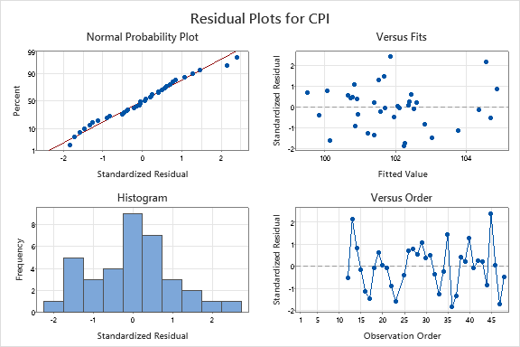

SHEET2 FOR #24

**Scatterplot of SRES_1 vs Wheat Market Price, Time_1, Time_2, CPI_Lag1, CPI_Lag11**

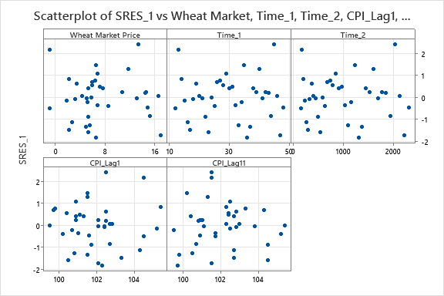

SHEET2 FOR #24

**Autocorrelation Function: SRES_1**

**Autocorrelations**

|  |  |  |  |
| --- | --- | --- | --- |
| **Lag** | **ACF** | **T** | **LBQ** |
| 1 | 0.122092 | 0.74 | 0.60 |
| 2 | -0.224747 | -1.35 | 2.68 |
| 3 | -0.106739 | -0.61 | 3.16 |
| 4 | -0.190071 | -1.08 | 4.74 |
| 5 | 0.097555 | 0.54 | 5.17 |
| 6 | -0.007718 | -0.04 | 5.18 |
| 7 | -0.097362 | -0.53 | 5.63 |
| 8 | -0.118184 | -0.64 | 6.33 |
| 9 | -0.276786 | -1.48 | 10.27 |

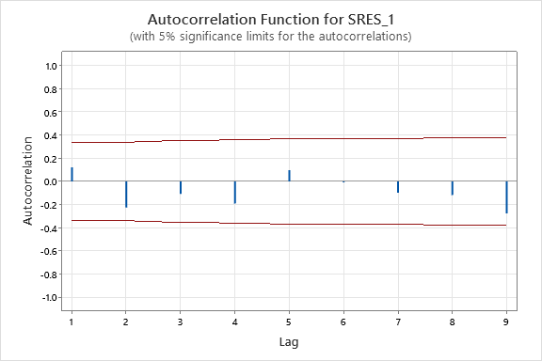

SHEET2 FOR #24

**Runs Test: SRES_1**

**Descriptive Statistics**

|  |  |  |  |
| --- | --- | --- | --- |
|  |  | **Number of Observations** | |
|  |  |
| **N** | **K** | **≤ K** | **> K** |
| 37 | 0 | 19 | 18 |

**Test**

|  |  |  |  |  |
| --- | --- | --- | --- | --- |
| Null hypothesis | | H₀: The order of the data is random | | |
| Alternative hypothesis | | H₁: The order of the data is not random | | |
| **Number of Runs** | | |  |
| **Observed** | **Expected** | | **P-Value** |
| 15 | 19.49 | | 0.134 |

SHEET2 FOR #24

**Time Series Plot of HI_1, COOK_1**

