SHEET1

**Descriptive Statistics: Health Expenditure, GDP per Capita**

**Statistics**

|  |  |  |  |  |  |  |  |  |  |  |
| --- | --- | --- | --- | --- | --- | --- | --- | --- | --- | --- |
| **Variable** | **N** | **Mean** | **SE Mean** | **StDev** | **Minimum** | **Q1** | **Median** | **Q3** | **Maximum** | **Skewness** |
| Health Expenditure | 187 | 6.583 | 0.222 | 3.029 | 1.500 | 4.400 | 6.200 | 8.300 | 24.000 | 1.57 |
| GDP per Capita | 187 | 15.43 | 1.71 | 23.35 | 0.29 | 2.12 | 6.18 | 17.99 | 189.51 | 3.43 |

SHEET1

**Histogram of Health Expenditure, GDP per Capita**

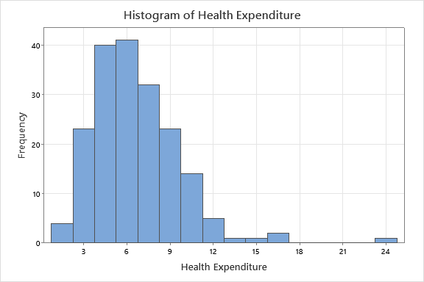

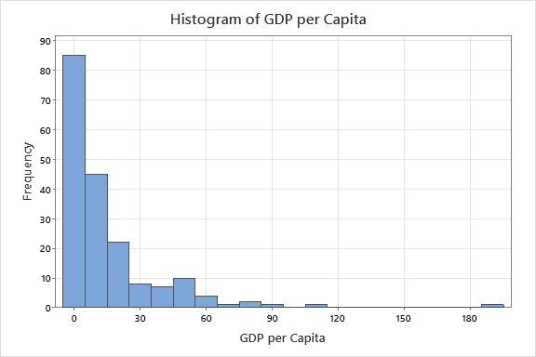

SHEET1

**Descriptive Statistics: Logged Health Expenditure, Logged GDP per Capita**

**Statistics**

|  |  |  |  |  |  |  |  |  |  |  |
| --- | --- | --- | --- | --- | --- | --- | --- | --- | --- | --- |
| **Variable** | **N** | **Mean** | **SE Mean** | **StDev** | **Minimum** | **Q1** | **Median** | **Q3** | **Maximum** | **Skewness** |
| Logged Health Expenditure | 187 | 1.7853 | 0.0332 | 0.4535 | 0.4055 | 1.4816 | 1.8245 | 2.1163 | 3.1781 | -0.23 |
| Logged GDP per Capita | 187 | 1.831 | 0.104 | 1.417 | -1.231 | 0.749 | 1.821 | 2.890 | 5.244 | 0.03 |

SHEET1

**Histogram of Logged Health Expenditure, Logged GDP per Capita**

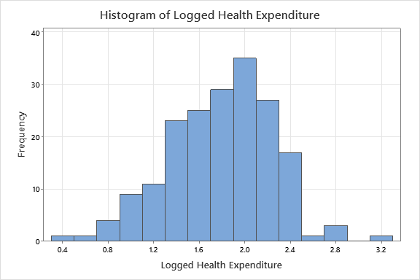

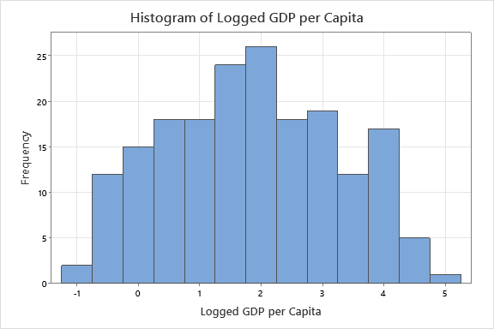

SHEET1

**Scatterplot of Logged Health Expenditure vs Logged GDP per Capita**

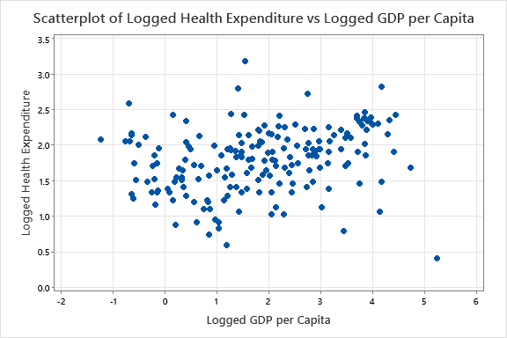

SHEET1

**Boxplot of Logged Health Expenditure**

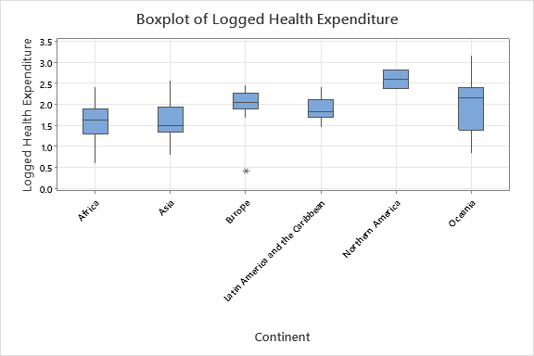

SHEET1

**Descriptive Statistics: Logged Health Expenditure**

**Statistics**

|  |  |  |  |  |  |  |  |  |  |  |  |  |
| --- | --- | --- | --- | --- | --- | --- | --- | --- | --- | --- | --- | --- |
| **Variable** | | **Continent** | | **N** | **N\*** | | **Mean** | **SE Mean** | | **StDev** | **Minimum** | |
| Logged Health Expenditure | | Africa | | 52 | 0 | | 1.5814 | 0.0571 | | 0.4116 | 0.5878 | |
|  | | Asia | | 44 | 0 | | 1.6055 | 0.0635 | | 0.4215 | 0.7885 | |
|  | | Europe | | 41 | 0 | | 2.0390 | 0.0530 | | 0.3394 | 0.4055 | |
|  | | Latin America and the Caribbean | | 32 | 0 | | 1.8841 | 0.0463 | | 0.2622 | 1.4586 | |
|  | | Northern America | | 2 | 0 | | 2.600 | 0.221 | | 0.312 | 2.380 | |
|  | | Oceania | | 16 | 0 | | 1.993 | 0.166 | | 0.663 | 0.833 | |
| **Variable** | **Continent** | | **Q1** | | | **Median** | | **Q3** | **Maximum** | | | **Skewness** | |
| Logged Health Expenditure | Africa | | 1.2878 | | | 1.6189 | | 1.9018 | 2.4248 | | | -0.22 | |
|  | Asia | | 1.3350 | | | 1.5041 | | 1.9459 | 2.5802 | | | 0.24 | |
|  | Europe | | 1.8946 | | | 2.0541 | | 2.2769 | 2.4596 | | | -2.76 | |
|  | Latin America and the Caribbean | | 1.6864 | | | 1.8325 | | 2.1097 | 2.4069 | | | 0.24 | |
|  | Northern America | | * | | | 2.600 | | * | 2.821 | | | * | |
|  | Oceania | | 1.393 | | | 2.150 | | 2.408 | 3.178 | | | -0.08 | |

SHEET1

**Descriptive Statistics: Logged GDP per Capita**

**Statistics**

|  |  |  |  |  |  |  |  |  |  |  |  |
| --- | --- | --- | --- | --- | --- | --- | --- | --- | --- | --- | --- |
| **Variable** | **Continent** | **N** | **N\*** | | **Mean** | **SE Mean** | | | **StDev** | **Minimum** | |
| Logged GDP per Capita | Africa | 52 | 0 | | 0.449 | 0.130 | | | 0.934 | -1.231 | |
|  | Asia | 44 | 0 | | 1.857 | 0.191 | | | 1.270 | -0.699 | |
|  | Europe | 41 | 0 | | 3.235 | 0.149 | | | 0.951 | 1.086 | |
|  | Latin America and the Caribbean | 32 | 0 | | 2.043 | 0.125 | | | 0.706 | 0.218 | |
|  | Northern America | 2 | 0 | | 4.007 | 0.167 | | | 0.236 | 3.841 | |
|  | Oceania | 16 | 0 | | 1.959 | 0.264 | | | 1.056 | 0.414 | |
| **Variable** | **Continent** | **Q1** | | **Median** | | | **Q3** | **Maximum** | | | **Skewness** | |
| Logged GDP per Capita | Africa | -0.257 | | 0.348 | | | 1.172 | 2.785 | | | 0.55 | |
|  | Asia | 0.802 | | 1.678 | | | 3.039 | 4.167 | | | 0.15 | |
|  | Europe | 2.635 | | 3.261 | | | 3.895 | 5.244 | | | -0.32 | |
|  | Latin America and the Caribbean | 1.666 | | 2.062 | | | 2.517 | 3.520 | | | -0.42 | |
|  | Northern America | * | | 4.007 | | | * | 4.174 | | | * | |
|  | Oceania | 1.171 | | 1.560 | | | 2.753 | 4.003 | | | 0.64 | |

SHEET1

**General Linear Model: Logged Health Expenditure versus Logged GDP per Capita, Continent**

**Method**

|  |  |
| --- | --- |
| Factor coding | (-1, 0, +1) |

**Factor Information**

|  |  |  |  |
| --- | --- | --- | --- |
| **Factor** | **Type** | **Levels** | **Values** |
| Continent | Fixed | 6 | Africa, Asia, Europe, Latin America and the Caribbean, Northern America, Oceania |

**Analysis of Variance**

|  |  |  |  |  |  |
| --- | --- | --- | --- | --- | --- |
| **Source** | **DF** | **Adj SS** | **Adj MS** | **F-Value** | **P-Value** |
| Logged GDP per Capita | 1 | 0.0283 | 0.02827 | 0.17 | 0.679 |
| Continent | 5 | 5.9395 | 1.18791 | 7.20 | 0.000 |
| Error | 180 | 29.6784 | 0.16488 |  |  |
| Lack-of-Fit | 179 | 29.3325 | 0.16387 | 0.47 | 0.852 |
| Pure Error | 1 | 0.3459 | 0.34589 |  |  |
| Total | 186 | 38.2608 |  |  |  |

**Model Summary**

|  |  |  |  |
| --- | --- | --- | --- |
| **S** | **R-sq** | **R-sq(adj)** | **R-sq(pred)** |
| 0.406054 | 22.43% | 19.85% | 15.16% |

**Coefficients**

|  |  |  |  |  |  |
| --- | --- | --- | --- | --- | --- |
| **Term** | **Coef** | **SE Coef** | **T-Value** | **P-Value** | **VIF** |
| Constant | 1.9787 | 0.0874 | 22.64 | 0.000 |  |
| Logged GDP per Capita | -0.0125 | 0.0301 | -0.41 | 0.679 | 2.05 |
| Continent |  |  |  |  |  |
| Africa | -0.3917 | 0.0900 | -4.35 | 0.000 | 3.00 |
| Asia | -0.3501 | 0.0753 | -4.65 | 0.000 | 1.92 |
| Europe | 0.1006 | 0.0810 | 1.24 | 0.216 | 2.14 |
| Latin America and the Caribbean | -0.0692 | 0.0806 | -0.86 | 0.392 | 1.84 |
| Northern America | 0.672 | 0.246 | 2.73 | 0.007 | 6.25 |

**Regression Equation**

|  |  |  |  |
| --- | --- | --- | --- |
| **Continent** |  |  |  |
| Africa | Logged Health Expenditure | = | 1.5870- 0.0125 Logged GDP per Capita |
|  |  |  |  |
| Asia | Logged Health Expenditure | = | 1.6287- 0.0125 Logged GDP per Capita |
|  |  |  |  |
| Europe | Logged Health Expenditure | = | 2.079- 0.0125 Logged GDP per Capita |
|  |  |  |  |
| Latin America and the Caribbean | Logged Health Expenditure | = | 1.9096- 0.0125 Logged GDP per Capita |
|  |  |  |  |
| Northern America | Logged Health Expenditure | = | 2.650- 0.0125 Logged GDP per Capita |
|  |  |  |  |
| Oceania | Logged Health Expenditure | = | 2.017- 0.0125 Logged GDP per Capita |

**Fits and Diagnostics for Unusual Observations**

|  |  |  |  |  |  |  |
| --- | --- | --- | --- | --- | --- | --- |
| **Obs** | **Logged Health Expenditure** | **Fit** | **Resid** | **Std Resid** |  |  |
| 1 | 2.580 | 1.637 | 0.943 | 2.39 | R |  |
| 7 | 2.425 | 1.610 | 0.815 | 2.03 | R |  |
| 24 | 0.788 | 1.586 | -0.797 | -2.00 | R |  |
| 31 | 2.380 | 2.603 | -0.223 | -0.78 |  | X |
| 38 | 0.742 | 1.576 | -0.835 | -2.08 | R |  |
| 39 | 1.131 | 1.980 | -0.849 | -2.17 | R |  |
| 48 | 0.588 | 1.572 | -0.985 | -2.45 | R |  |
| 95 | 2.425 | 1.585 | 0.840 | 2.09 | R |  |
| 105 | 2.791 | 2.000 | 0.791 | 2.01 | R |  |
| 110 | 0.405 | 2.014 | -1.608 | -4.06 | R |  |
| 130 | 0.833 | 2.005 | -1.172 | -2.99 | R |  |
| 174 | 3.178 | 1.998 | 1.180 | 3.00 | R |  |
| 180 | 2.821 | 2.598 | 0.223 | 0.78 |  | X |

*R  Large residual  
X  Unusual X*

**Means**

|  |  |  |
| --- | --- | --- |
| **Term** | **Fitted Mean** | **SE Mean** |
| Continent |  |  |
| Africa | 1.5642 | 0.0700 |
| Asia | 1.6058 | 0.0612 |
| Europe | 2.0565 | 0.0762 |
| Latin America and the Caribbean | 1.8867 | 0.0721 |
| Northern America | 2.628 | 0.294 |
| Oceania | 1.995 | 0.102 |

**Means for Covariates**

|  |  |  |
| --- | --- | --- |
| **Covariate** | **Data Mean** | **StDev** |
| Logged GDP per Capita | 1.83 | 1.42 |

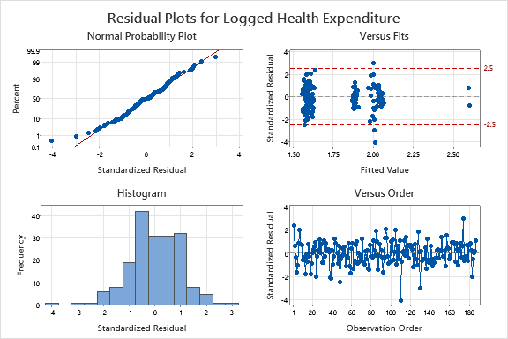

SHEET1

**Comparisons for Logged Health Expenditure**

**Tukey Pairwise Comparisons: Continent**

**Grouping Information Using the Tukey Method and 95% Confidence**

|  |  |  |  |  |
| --- | --- | --- | --- | --- |
| **Continent** | **N** | **Mean** | **Grouping** | |
| Northern America | 2 | 2.62756 | A |  |
| Europe | 41 | 2.05647 | A |  |
| Oceania | 16 | 1.99465 | A |  |
| Latin America and the Caribbean | 32 | 1.88674 | A |  |
| Asia | 44 | 1.60585 |  | B |
| Africa | 52 | 1.56421 |  | B |

*Means that do not share a letter are significantly different.*

**Tukey Simultaneous Tests for Differences of Means**

|  |  |  |  |  |  |
| --- | --- | --- | --- | --- | --- |
| **Difference of Continent Levels** | **Difference of Means** | | **SE of Difference** | | **Simultaneous 95% CI** |
| Asia - Africa | 0.0416 | | 0.0933 | | (-0.2269, 0.3102) |
| Europe - Africa | 0.492 | | 0.119 | | (0.149, 0.835) |
| Latin America and the Caribbean - Africa | 0.323 | | 0.103 | | (0.026, 0.619) |
| Northern America - Africa | 1.063 | | 0.312 | | (0.167, 1.960) |
| Oceania - Africa | 0.430 | | 0.125 | | (0.072, 0.789) |
| Europe - Asia | 0.4506 | | 0.0974 | | (0.1703, 0.7309) |
| Latin America and the Caribbean - Asia | 0.2809 | | 0.0945 | | (0.0089, 0.5529) |
| Northern America - Asia | 1.022 | | 0.301 | | (0.157, 1.887) |
| Oceania - Asia | 0.389 | | 0.119 | | (0.048, 0.730) |
| Latin America and the Caribbean - Europe | -0.170 | | 0.102 | | (-0.464, 0.125) |
| Northern America - Europe | 0.571 | | 0.295 | | (-0.278, 1.420) |
| Oceania - Europe | -0.062 | | 0.126 | | (-0.424, 0.300) |
| Northern America - Latin America and the Caribbean | 0.741 | | 0.302 | | (-0.128, 1.609) |
| Oceania - Latin America and the Caribbean | 0.108 | | 0.124 | | (-0.250, 0.466) |
| Oceania - Northern America | -0.633 | | 0.311 | | (-1.527, 0.261) |
| **Difference of Continent Levels** | **T-Value** | **Adjusted P-Value** | |
| Asia - Africa | 0.45 | 0.998 | |
| Europe - Africa | 4.13 | 0.001 | |
| Latin America and the Caribbean - Africa | 3.13 | 0.025 | |
| Northern America - Africa | 3.41 | 0.010 | |
| Oceania - Africa | 3.45 | 0.009 | |
| Europe - Asia | 4.63 | 0.000 | |
| Latin America and the Caribbean - Asia | 2.97 | 0.039 | |
| Northern America - Asia | 3.40 | 0.011 | |
| Oceania - Asia | 3.28 | 0.016 | |
| Latin America and the Caribbean - Europe | -1.66 | 0.560 | |
| Northern America - Europe | 1.94 | 0.384 | |
| Oceania - Europe | -0.49 | 0.996 | |
| Northern America - Latin America and the Caribbean | 2.45 | 0.144 | |
| Oceania - Latin America and the Caribbean | 0.87 | 0.954 | |
| Oceania - Northern America | -2.04 | 0.326 | |

*Individual confidence level = 99.55%*

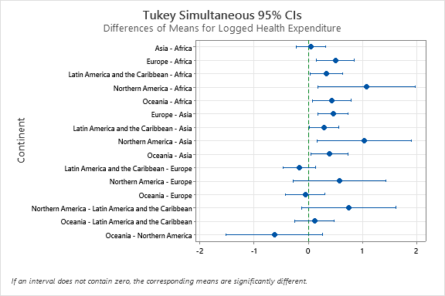

SHEET1

**Time Series Plot of HI, COOK**

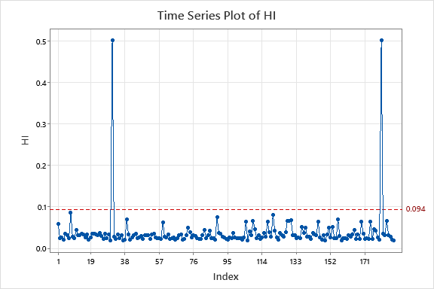

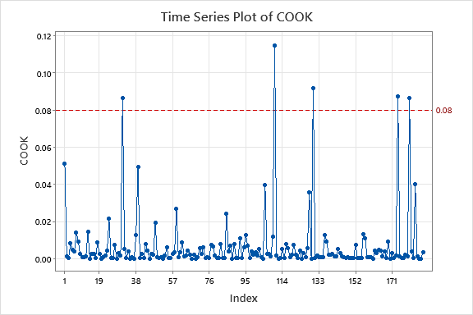

SHEET1

**General Linear Model: absres versus Continent**

**Method**

|  |  |
| --- | --- |
| Factor coding | (-1, 0, +1) |

**Factor Information**

|  |  |  |  |
| --- | --- | --- | --- |
| **Factor** | **Type** | **Levels** | **Values** |
| Continent | Fixed | 6 | Africa, Asia, Europe, Latin America and the Caribbean, Northern America, Oceania |

**Analysis of Variance**

|  |  |  |  |  |  |
| --- | --- | --- | --- | --- | --- |
| **Source** | **DF** | **Adj SS** | **Adj MS** | **F-Value** | **P-Value** |
| Continent | 5 | 10.24 | 2.0471 | 6.11 | 0.000 |
| Error | 181 | 60.67 | 0.3352 |  |  |
| Total | 186 | 70.91 |  |  |  |

**Model Summary**

|  |  |  |  |
| --- | --- | --- | --- |
| **S** | **R-sq** | **R-sq(adj)** | **R-sq(pred)** |
| 0.578976 | 14.43% | 12.07% | 8.98% |

**Coefficients**

|  |  |  |  |  |  |
| --- | --- | --- | --- | --- | --- |
| **Term** | **Coef** | **SE Coef** | **T-Value** | **P-Value** | **VIF** |
| Constant | 0.8400 | 0.0784 | 10.71 | 0.000 |  |
| Continent |  |  |  |  |  |
| Africa | 0.004 | 0.102 | 0.04 | 0.969 | 1.90 |
| Asia | 0.033 | 0.106 | 0.31 | 0.753 | 1.87 |
| Europe | -0.264 | 0.108 | -2.45 | 0.015 | 1.86 |
| Latin America and the Caribbean | -0.282 | 0.115 | -2.46 | 0.015 | 1.83 |
| Northern America | -0.063 | 0.343 | -0.18 | 0.854 | 5.96 |

**Regression Equation**

|  |  |  |
| --- | --- | --- |
| absres | = | 0.8400 + 0.004 Continent_Africa + 0.033 Continent_Asia - 0.264 Continent_Europe - 0.282 Continent_Latin America and the Caribbean - 0.063 Continent_Northern America + 0.572 Continent_Oceania |

**Fits and Diagnostics for Unusual Observations**

|  |  |  |  |  |  |  |
| --- | --- | --- | --- | --- | --- | --- |
| **Obs** | **absres** | **Fit** | **Resid** | **Std Resid** |  |  |
| 1 | 2.393 | 0.873 | 1.520 | 2.66 | R |  |
| 7 | 2.031 | 0.873 | 1.158 | 2.02 | R |  |
| 31 | 0.777 | 0.777 | 0.000 | 0.00 |  | X |
| 38 | 2.076 | 0.844 | 1.232 | 2.15 | R |  |
| 48 | 2.452 | 0.844 | 1.608 | 2.80 | R |  |
| 95 | 2.088 | 0.844 | 1.244 | 2.17 | R |  |
| 110 | 4.057 | 0.576 | 3.481 | 6.09 | R |  |
| 129 | 0.115 | 1.412 | -1.297 | -2.31 | R |  |
| 130 | 2.987 | 1.412 | 1.576 | 2.81 | R |  |
| 174 | 3.002 | 1.412 | 1.591 | 2.84 | R |  |
| 180 | 0.777 | 0.777 | -0.000 | -0.00 |  | X |

*R  Large residual  
X  Unusual X*

**Means**

|  |  |  |
| --- | --- | --- |
| **Term** | **Fitted Mean** | **SE Mean** |
| Continent |  |  |
| Africa | 0.8441 | 0.0803 |
| Asia | 0.8734 | 0.0873 |
| Europe | 0.5763 | 0.0904 |
| Latin America and the Caribbean | 0.558 | 0.102 |
| Northern America | 0.777 | 0.409 |
| Oceania | 1.412 | 0.145 |

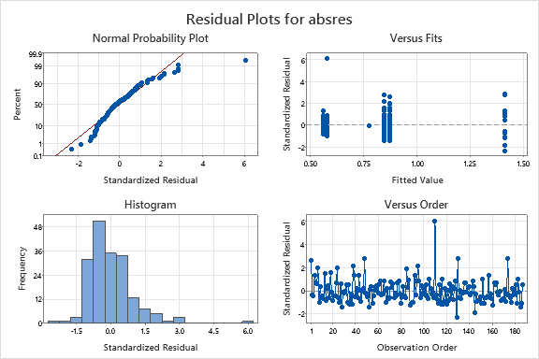

OMITTING 3 OUTLIERS

**General Linear Model: Logged Health Expenditure versus Logged GDP per Capita, Continent**

**Method**

|  |  |
| --- | --- |
| Factor coding | (-1, 0, +1) |

**Factor Information**

|  |  |  |  |
| --- | --- | --- | --- |
| **Factor** | **Type** | **Levels** | **Values** |
| Continent | Fixed | 6 | Africa, Asia, Europe, Latin America and the Caribbean, Northern America, Oceania |

**Analysis of Variance**

|  |  |  |  |  |  |
| --- | --- | --- | --- | --- | --- |
| **Source** | **DF** | **Adj SS** | **Adj MS** | **F-Value** | **P-Value** |
| Logged GDP per Capita | 1 | 0.0016 | 0.00159 | 0.01 | 0.914 |
| Continent | 5 | 5.7372 | 1.14745 | 8.39 | 0.000 |
| Error | 177 | 24.2198 | 0.13683 |  |  |
| Lack-of-Fit | 176 | 23.8739 | 0.13565 | 0.39 | 0.888 |
| Pure Error | 1 | 0.3459 | 0.34589 |  |  |
| Total | 183 | 33.5052 |  |  |  |

**Model Summary**

|  |  |  |  |
| --- | --- | --- | --- |
| **S** | **R-sq** | **R-sq(adj)** | **R-sq(pred)** |
| 0.369912 | 27.71% | 25.26% | 21.11% |

**Coefficients**

|  |  |  |  |  |  |
| --- | --- | --- | --- | --- | --- |
| **Term** | **Coef** | **SE Coef** | **T-Value** | **P-Value** | **VIF** |
| Constant | 1.9503 | 0.0807 | 24.16 | 0.000 |  |
| Logged GDP per Capita | 0.0030 | 0.0278 | 0.11 | 0.914 | 2.04 |
| Continent |  |  |  |  |  |
| Africa | -0.3702 | 0.0828 | -4.47 | 0.000 | 2.91 |
| Asia | -0.3503 | 0.0689 | -5.08 | 0.000 | 1.84 |
| Europe | 0.1200 | 0.0740 | 1.62 | 0.107 | 2.01 |
| Latin America and the Caribbean | -0.0723 | 0.0737 | -0.98 | 0.328 | 1.76 |
| Northern America | 0.638 | 0.225 | 2.84 | 0.005 | 5.62 |

**Regression Equation**

|  |  |  |  |
| --- | --- | --- | --- |
| **Continent** |  |  |  |
| Africa | Logged Health Expenditure | = | 1.5801 + 0.0030 Logged GDP per Capita |
|  |  |  |  |
| Asia | Logged Health Expenditure | = | 1.6000 + 0.0030 Logged GDP per Capita |
|  |  |  |  |
| Europe | Logged Health Expenditure | = | 2.070 + 0.0030 Logged GDP per Capita |
|  |  |  |  |
| Latin America and the Caribbean | Logged Health Expenditure | = | 1.8780 + 0.0030 Logged GDP per Capita |
|  |  |  |  |
| Northern America | Logged Health Expenditure | = | 2.588 + 0.0030 Logged GDP per Capita |
|  |  |  |  |
| Oceania | Logged Health Expenditure | = | 1.985 + 0.0030 Logged GDP per Capita |

**Fits and Diagnostics for Unusual Observations**

|  |  |  |  |  |  |  |
| --- | --- | --- | --- | --- | --- | --- |
| **Obs** | **Logged Health Expenditure** | **Fit** | **Resid** | **Std Resid** |  |  |
| 1 | 2.580 | 1.598 | 0.982 | 2.74 | R |  |
| 7 | 2.425 | 1.605 | 0.820 | 2.24 | R |  |
| 24 | 0.788 | 1.610 | -0.822 | -2.26 | R |  |
| 31 | 2.380 | 2.600 | -0.220 | -0.84 |  | X |
| 38 | 0.742 | 1.583 | -0.841 | -2.30 | R |  |
| 39 | 1.131 | 1.994 | -0.863 | -2.43 | R |  |
| 48 | 0.588 | 1.584 | -0.996 | -2.72 | R |  |
| 85 | 2.370 | 1.611 | 0.759 | 2.10 | R |  |
| 95 | 2.425 | 1.581 | 0.844 | 2.31 | R |  |
| 105 | 2.791 | 1.989 | 0.802 | 2.25 | R |  |
| 127 | 2.721 | 1.993 | 0.728 | 2.05 | R |  |
| 177 | 2.821 | 2.601 | 0.220 | 0.84 |  | X |
| 180 | 1.224 | 1.989 | -0.765 | -2.15 | R |  |

*R  Large residual  
X  Unusual X*

**Means**

|  |  |  |
| --- | --- | --- |
| **Term** | **Fitted Mean** | **SE Mean** |
| Continent |  |  |
| Africa | 1.5855 | 0.0639 |
| Asia | 1.6054 | 0.0558 |
| Europe | 2.0757 | 0.0697 |
| Latin America and the Caribbean | 1.8834 | 0.0657 |
| Northern America | 2.594 | 0.269 |
| Oceania | 1.9906 | 0.0991 |

**Means for Covariates**

|  |  |  |
| --- | --- | --- |
| **Covariate** | **Data Mean** | **StDev** |
| Logged GDP per Capita | 1.82 | 1.40 |

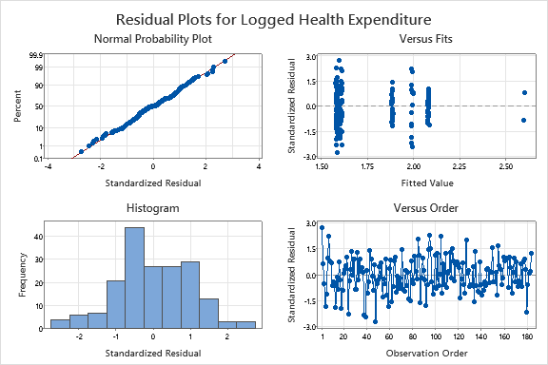

OMITTING 3 OUTLIERS

**Comparisons for Logged Health Expenditure**

**Tukey Pairwise Comparisons: Continent**

**Grouping Information Using the Tukey Method and 95% Confidence**

|  |  |  |  |  |
| --- | --- | --- | --- | --- |
| **Continent** | **N** | **Mean** | **Grouping** | |
| Northern America | 2 | 2.59391 | A |  |
| Europe | 40 | 2.07574 | A |  |
| Oceania | 14 | 1.99057 | A |  |
| Latin America and the Caribbean | 32 | 1.88343 | A |  |
| Asia | 44 | 1.60542 |  | B |
| Africa | 52 | 1.58552 |  | B |

*Means that do not share a letter are significantly different.*

**Tukey Simultaneous Tests for Differences of Means**

|  |  |  |  |  |  |
| --- | --- | --- | --- | --- | --- |
| **Difference of Continent Levels** | **Difference of Means** | | **SE of Difference** | | **Simultaneous 95% CI** |
| Asia - Africa | 0.0199 | | 0.0853 | | (-0.2255, 0.2653) |
| Europe - Africa | 0.490 | | 0.109 | | (0.177, 0.803) |
| Latin America and the Caribbean - Africa | 0.2979 | | 0.0942 | | (0.0268, 0.5690) |
| Northern America - Africa | 1.008 | | 0.284 | | (0.190, 1.827) |
| Oceania - Africa | 0.405 | | 0.120 | | (0.060, 0.750) |
| Europe - Asia | 0.4703 | | 0.0888 | | (0.2146, 0.7260) |
| Latin America and the Caribbean - Asia | 0.2780 | | 0.0861 | | (0.0302, 0.5258) |
| Northern America - Asia | 0.988 | | 0.274 | | (0.200, 1.777) |
| Oceania - Asia | 0.385 | | 0.114 | | (0.058, 0.712) |
| Latin America and the Caribbean - Europe | -0.1923 | | 0.0933 | | (-0.4608, 0.0762) |
| Northern America - Europe | 0.518 | | 0.269 | | (-0.256, 1.292) |
| Oceania - Europe | -0.085 | | 0.119 | | (-0.428, 0.258) |
| Northern America - Latin America and the Caribbean | 0.710 | | 0.275 | | (-0.081, 1.502) |
| Oceania - Latin America and the Caribbean | 0.107 | | 0.119 | | (-0.234, 0.448) |
| Oceania - Northern America | -0.603 | | 0.285 | | (-1.423, 0.216) |
| **Difference of Continent Levels** | **T-Value** | **Adjusted P-Value** | |
| Asia - Africa | 0.23 | 1.000 | |
| Europe - Africa | 4.51 | 0.000 | |
| Latin America and the Caribbean - Africa | 3.16 | 0.022 | |
| Northern America - Africa | 3.55 | 0.007 | |
| Oceania - Africa | 3.38 | 0.012 | |
| Europe - Asia | 5.29 | 0.000 | |
| Latin America and the Caribbean - Asia | 3.23 | 0.018 | |
| Northern America - Asia | 3.61 | 0.005 | |
| Oceania - Asia | 3.39 | 0.011 | |
| Latin America and the Caribbean - Europe | -2.06 | 0.313 | |
| Northern America - Europe | 1.93 | 0.390 | |
| Oceania - Europe | -0.72 | 0.980 | |
| Northern America - Latin America and the Caribbean | 2.58 | 0.107 | |
| Oceania - Latin America and the Caribbean | 0.90 | 0.945 | |
| Oceania - Northern America | -2.12 | 0.283 | |

*Individual confidence level = 99.55%*

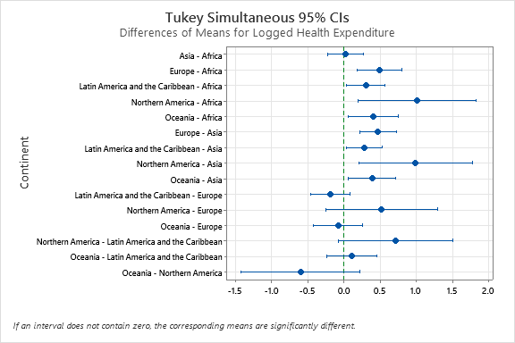

OMITTING 3 OUTLIERS

**Time Series Plot of HI, COOK**

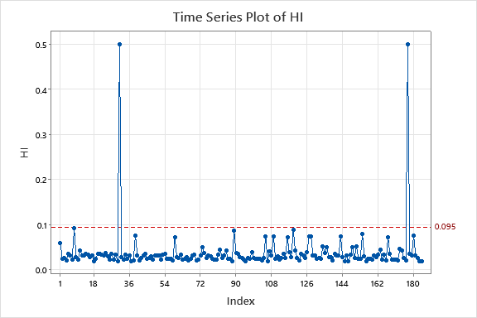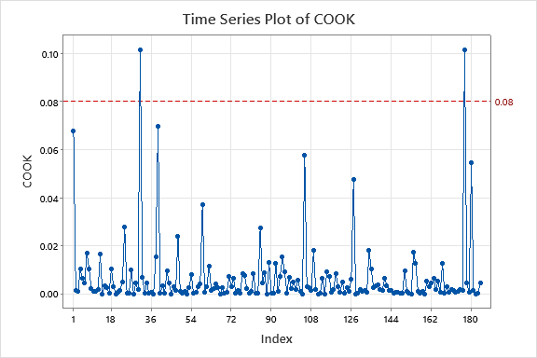

OMITTING 3 OUTLIERS

**General Linear Model: absres versus Continent**

**Method**

|  |  |
| --- | --- |
| Factor coding | (-1, 0, +1) |

**Factor Information**

|  |  |  |  |
| --- | --- | --- | --- |
| **Factor** | **Type** | **Levels** | **Values** |
| Continent | Fixed | 6 | Africa, Asia, Europe, Latin America and the Caribbean, Northern America, Oceania |

**Analysis of Variance**

|  |  |  |  |  |  |
| --- | --- | --- | --- | --- | --- |
| **Source** | **DF** | **Adj SS** | **Adj MS** | **F-Value** | **P-Value** |
| Continent | 5 | 9.490 | 1.8980 | 6.49 | 0.000 |
| Error | 178 | 52.056 | 0.2924 |  |  |
| Total | 183 | 61.546 |  |  |  |

**Model Summary**

|  |  |  |  |
| --- | --- | --- | --- |
| **S** | **R-sq** | **R-sq(adj)** | **R-sq(pred)** |
| 0.540785 | 15.42% | 13.04% | 10.27% |

**Coefficients**

|  |  |  |  |  |  |
| --- | --- | --- | --- | --- | --- |
| **Term** | **Coef** | **SE Coef** | **T-Value** | **P-Value** | **VIF** |
| Constant | 0.8587 | 0.0738 | 11.64 | 0.000 |  |
| Continent |  |  |  |  |  |
| Africa | 0.0660 | 0.0959 | 0.69 | 0.492 | 1.83 |
| Asia | 0.0986 | 0.0994 | 0.99 | 0.322 | 1.79 |
| Europe | -0.340 | 0.102 | -3.35 | 0.001 | 1.77 |
| Latin America and the Caribbean | -0.242 | 0.107 | -2.26 | 0.025 | 1.74 |
| Northern America | -0.016 | 0.321 | -0.05 | 0.961 | 5.36 |

**Regression Equation**

|  |  |  |
| --- | --- | --- |
| absres | = | 0.8587 + 0.0660 Continent_Africa + 0.0986 Continent_Asia - 0.340 Continent_Europe - 0.242 Continent_Latin America and the Caribbean - 0.016 Continent_Northern America + 0.434 Continent_Oceania |

**Fits and Diagnostics for Unusual Observations**

|  |  |  |  |  |  |  |
| --- | --- | --- | --- | --- | --- | --- |
| **Obs** | **absres** | **Fit** | **Resid** | **Std Resid** |  |  |
| 1 | 2.739 | 0.957 | 1.781 | 3.33 | R |  |
| 7 | 2.244 | 0.957 | 1.286 | 2.41 | R |  |
| 24 | 2.264 | 0.957 | 1.306 | 2.44 | R |  |
| 31 | 0.843 | 0.843 | -0.000 | -0.00 |  | X |
| 38 | 2.296 | 0.925 | 1.371 | 2.56 | R |  |
| 39 | 2.427 | 1.293 | 1.135 | 2.18 | R |  |
| 48 | 2.722 | 0.925 | 1.798 | 3.36 | R |  |
| 85 | 2.097 | 0.957 | 1.140 | 2.13 | R |  |
| 95 | 2.305 | 0.925 | 1.381 | 2.58 | R |  |
| 128 | 0.098 | 1.293 | -1.195 | -2.29 | R |  |
| 177 | 0.843 | 0.843 | 0.000 | 0.00 |  | X |

*R  Large residual  
X  Unusual X*

**Means**

|  |  |  |
| --- | --- | --- |
| **Term** | **Fitted Mean** | **SE Mean** |
| Continent |  |  |
| Africa | 0.9247 | 0.0750 |
| Asia | 0.9573 | 0.0815 |
| Europe | 0.5184 | 0.0855 |
| Latin America and the Caribbean | 0.6164 | 0.0956 |
| Northern America | 0.843 | 0.382 |
| Oceania | 1.293 | 0.145 |

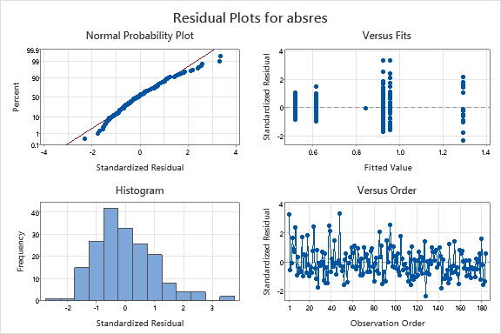

OMITTING 3 OUTLIERS

**Descriptive Statistics: SRES**

**Statistics**

|  |  |  |  |  |  |  |  |  |  |  |  |
| --- | --- | --- | --- | --- | --- | --- | --- | --- | --- | --- | --- |
| **Variable** | **Continent** | **N** | **N\*** | **Mean** | | **SE Mean** | | **StDev** | | **Minimum** | **Q1** |
| SRES | Africa | 52 | 0 | 0.001 | | 0.156 | | 1.127 | | -2.722 | -0.800 |
|  | Asia | 44 | 0 | 0.001 | | 0.175 | | 1.160 | | -2.264 | -0.740 |
|  | Europe | 40 | 0 | -0.0003 | | 0.0946 | | 0.5984 | | -1.0975 | -0.4968 |
|  | Latin America and the Caribbean | 32 | 0 | -0.000 | | 0.127 | | 0.721 | | -1.173 | -0.550 |
|  | Northern America | 2 | 0 | 0.000 | | 0.843 | | 1.192 | | -0.843 | * |
|  | Oceania | 14 | 0 | 0.001 | | 0.408 | | 1.528 | | -2.427 | -1.346 |
| **Variable** | **Continent** | **Median** | | | **Q3** | | **Maximum** | |
| SRES | Africa | 0.091 | | | 0.872 | | 2.305 | |
|  | Asia | -0.272 | | | 0.941 | | 2.739 | |
|  | Europe | -0.0026 | | | 0.5703 | | 1.0356 | |
|  | Latin America and the Caribbean | -0.143 | | | 0.632 | | 1.435 | |
|  | Northern America | 0.000 | | | * | | 0.843 | |
|  | Oceania | 0.439 | | | 1.046 | | 2.252 | |

OMITTING 3 OUTLIERS

**General Linear Model: Logged Health Expenditure versus Logged GDP per Capita, Continent**

**Method**

|  |  |
| --- | --- |
| Factor coding | (-1, 0, +1) |
| Weights | wt |

**Factor Information**

|  |  |  |  |
| --- | --- | --- | --- |
| **Factor** | **Type** | **Levels** | **Values** |
| Continent | Fixed | 6 | Africa, Asia, Europe, Latin America and the Caribbean, Northern America, Oceania |

**Analysis of Variance**

|  |  |  |  |  |  |
| --- | --- | --- | --- | --- | --- |
| **Source** | **DF** | **Adj SS** | **Adj MS** | **F-Value** | **P-Value** |
| Logged GDP per Capita | 1 | 0.2007 | 0.2007 | 1.52 | 0.219 |
| Continent | 5 | 5.0254 | 1.0051 | 7.63 | 0.000 |
| Error | 177 | 23.3217 | 0.1318 |  |  |
| Lack-of-Fit | 176 | 23.0493 | 0.1310 | 0.48 | 0.849 |
| Pure Error | 1 | 0.2723 | 0.2723 |  |  |
| Total | 183 | 34.8653 |  |  |  |

**Model Summary**

|  |  |  |  |
| --- | --- | --- | --- |
| **S** | **R-sq** | **R-sq(adj)** | **R-sq(pred)** |
| 0.362989 | 33.11% | 30.84% | 27.84% |

**Coefficients**

|  |  |  |  |  |  |
| --- | --- | --- | --- | --- | --- |
| **Term** | **Coef** | **SE Coef** | **T-Value** | **P-Value** | **VIF** |
| Constant | 1.8875 | 0.0818 | 23.08 | 0.000 |  |
| Logged GDP per Capita | 0.0307 | 0.0249 | 1.23 | 0.219 | 2.14 |
| Continent |  |  |  |  |  |
| Africa | -0.3199 | 0.0877 | -3.65 | 0.000 | 2.46 |
| Asia | -0.3390 | 0.0793 | -4.27 | 0.000 | 1.71 |
| Europe | 0.0945 | 0.0694 | 1.36 | 0.175 | 2.69 |
| Latin America and the Caribbean | -0.0662 | 0.0704 | -0.94 | 0.349 | 2.09 |
| Northern America | 0.590 | 0.260 | 2.27 | 0.025 | 3.77 |

**Regression Equation**

|  |  |  |  |
| --- | --- | --- | --- |
| **Continent** |  |  |  |
| Africa | Logged Health Expenditure | = | 1.5676 + 0.0307 Logged GDP per Capita |
|  |  |  |  |
| Asia | Logged Health Expenditure | = | 1.5485 + 0.0307 Logged GDP per Capita |
|  |  |  |  |
| Europe | Logged Health Expenditure | = | 1.9820 + 0.0307 Logged GDP per Capita |
|  |  |  |  |
| Latin America and the Caribbean | Logged Health Expenditure | = | 1.8213 + 0.0307 Logged GDP per Capita |
|  |  |  |  |
| Northern America | Logged Health Expenditure | = | 2.477 + 0.0307 Logged GDP per Capita |
|  |  |  |  |
| Oceania | Logged Health Expenditure | = | 1.928 + 0.0307 Logged GDP per Capita |

**Fits and Diagnostics for Unusual Observations**

|  |  |  |  |  |  |  |
| --- | --- | --- | --- | --- | --- | --- |
| **Obs** | **Logged Health Expenditure** | **Fit** | **Resid** | **Std Resid** |  |  |
| 1 | 2.580 | 1.527 | 1.053 | 2.56 | R |  |
| 24 | 0.788 | 1.654 | -0.866 | -2.09 | R |  |
| 31 | 2.380 | 2.595 | -0.216 | -0.71 |  | X |
| 38 | 0.742 | 1.594 | -0.852 | -2.10 | R |  |
| 43 | 2.407 | 1.889 | 0.518 | 2.01 | R |  |
| 48 | 0.588 | 1.604 | -1.016 | -2.51 | R |  |
| 95 | 2.425 | 1.572 | 0.853 | 2.11 | R |  |
| 98 | 1.686 | 2.128 | -0.441 | -2.09 | R |  |
| 177 | 2.821 | 2.606 | 0.216 | 0.71 |  | X |

*R  Large residual  
X  Unusual X*

**Means**

|  |  |  |
| --- | --- | --- |
| **Term** | **Fitted Mean** | **SE Mean** |
| Continent |  |  |
| Africa | 1.6235 | 0.0662 |
| Asia | 1.6044 | 0.0635 |
| Europe | 2.0378 | 0.0483 |
| Latin America and the Caribbean | 1.8772 | 0.0466 |
| Northern America | 2.533 | 0.311 |
| Oceania | 1.984 | 0.148 |

**Means for Covariates**

|  |  |  |
| --- | --- | --- |
| **Covariate** | **Data Mean** | **StDev** |
| Logged GDP per Capita | 1.82 | 1.40 |

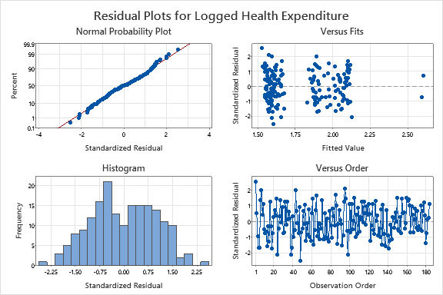

OMITTING 3 OUTLIERS

**Comparisons for Logged Health Expenditure**

**Tukey Pairwise Comparisons: Continent**

**Grouping Information Using the Tukey Method and 95% Confidence**

|  |  |  |  |  |  |
| --- | --- | --- | --- | --- | --- |
| **Continent** | **N** | **Mean** | **Grouping** | | |
| Northern America | 2 | 2.53322 | A | B |  |
| Europe | 40 | 2.03785 | A |  |  |
| Oceania | 14 | 1.98401 | A | B | C |
| Latin America and the Caribbean | 32 | 1.87720 | A |  |  |
| Africa | 52 | 1.62349 |  | B | C |
| Asia | 44 | 1.60436 |  |  | C |

*Means that do not share a letter are significantly different.*

**Tukey Simultaneous Tests for Differences of Means**

|  |  |  |  |  |  |
| --- | --- | --- | --- | --- | --- |
| **Difference of Continent Levels** | **Difference of Means** | | **SE of Difference** | | **Simultaneous 95% CI** |
| Asia - Africa | -0.0191 | | 0.0921 | | (-0.2841, 0.2458) |
| Europe - Africa | 0.4144 | | 0.0951 | | (0.1408, 0.6879) |
| Latin America and the Caribbean - Africa | 0.2537 | | 0.0833 | | (0.0141, 0.4933) |
| Northern America - Africa | 0.910 | | 0.324 | | (-0.021, 1.841) |
| Oceania - Africa | 0.361 | | 0.164 | | (-0.111, 0.832) |
| Europe - Asia | 0.4335 | | 0.0794 | | (0.2050, 0.6620) |
| Latin America and the Caribbean - Asia | 0.2728 | | 0.0787 | | (0.0464, 0.4993) |
| Northern America - Asia | 0.929 | | 0.317 | | (0.016, 1.841) |
| Oceania - Asia | 0.380 | | 0.161 | | (-0.085, 0.844) |
| Latin America and the Caribbean - Europe | -0.1606 | | 0.0642 | | (-0.3455, 0.0242) |
| Northern America - Europe | 0.495 | | 0.309 | | (-0.393, 1.383) |
| Oceania - Europe | -0.054 | | 0.155 | | (-0.499, 0.391) |
| Northern America - Latin America and the Caribbean | 0.656 | | 0.313 | | (-0.246, 1.558) |
| Oceania - Latin America and the Caribbean | 0.107 | | 0.155 | | (-0.340, 0.554) |
| Oceania - Northern America | -0.549 | | 0.343 | | (-1.538, 0.439) |
| **Difference of Continent Levels** | **T-Value** | **Adjusted P-Value** | |
| Asia - Africa | -0.21 | 1.000 | |
| Europe - Africa | 4.36 | 0.000 | |
| Latin America and the Caribbean - Africa | 3.05 | 0.031 | |
| Northern America - Africa | 2.81 | 0.060 | |
| Oceania - Africa | 2.20 | 0.242 | |
| Europe - Asia | 5.46 | 0.000 | |
| Latin America and the Caribbean - Asia | 3.47 | 0.009 | |
| Northern America - Asia | 2.93 | 0.044 | |
| Oceania - Asia | 2.35 | 0.179 | |
| Latin America and the Caribbean - Europe | -2.50 | 0.130 | |
| Northern America - Europe | 1.61 | 0.596 | |
| Oceania - Europe | -0.35 | 0.999 | |
| Northern America - Latin America and the Caribbean | 2.09 | 0.295 | |
| Oceania - Latin America and the Caribbean | 0.69 | 0.983 | |
| Oceania - Northern America | -1.60 | 0.600 | |

*Individual confidence level = 99.55%*

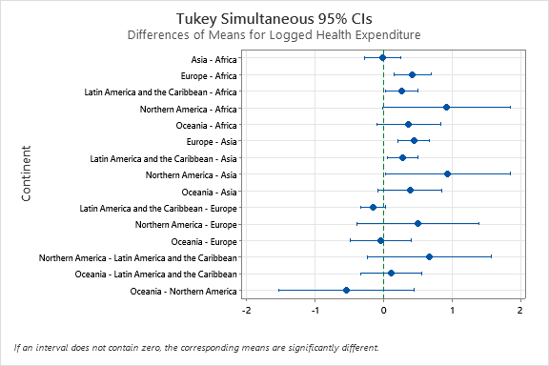

OMITTING 3 OUTLIERS

**General Linear Model: absres_1 versus Continent**

**Method**

|  |  |
| --- | --- |
| Factor coding | (-1, 0, +1) |

**Factor Information**

|  |  |  |  |
| --- | --- | --- | --- |
| **Factor** | **Type** | **Levels** | **Values** |
| Continent | Fixed | 6 | Africa, Asia, Europe, Latin America and the Caribbean, Northern America, Oceania |

**Analysis of Variance**

|  |  |  |  |  |  |  |  |
| --- | --- | --- | --- | --- | --- | --- | --- |
| **Source** | **DF** | **Seq SS** | **Contribution** | **Adj SS** | **Adj MS** | **F-Value** | **P-Value** |
| Continent | 5 | 0.0915 | 0.17% | 0.0915 | 0.01831 | 0.06 | 0.997 |
| Error | 178 | 52.6408 | 99.83% | 52.6408 | 0.29573 |  |  |
| Total | 183 | 52.7324 | 100.00% |  |  |  |  |

**Model Summary**

|  |  |  |  |  |  |  |
| --- | --- | --- | --- | --- | --- | --- |
| **S** | **R-sq** | **R-sq(adj)** | **PRESS** | **R-sq(pred)** | **AICc** | **BIC** |
| 0.543815 | 0.17% | 0.00% | 55.5500 | 0.00% | 306.54 | 328.41 |

**Coefficients**

|  |  |  |  |  |  |  |
| --- | --- | --- | --- | --- | --- | --- |
| **Term** | **Coef** | **SE Coef** | **95% CI** | **T-Value** | **P-Value** | **VIF** |
| Constant | 0.8232 | 0.0742 | (0.6768, 0.9695) | 11.10 | 0.000 |  |
| Continent |  |  |  |  |  |  |
| Africa | 0.0112 | 0.0964 | (-0.1790, 0.2015) | 0.12 | 0.907 | 1.83 |
| Asia | 0.0136 | 0.0999 | (-0.1835, 0.2108) | 0.14 | 0.892 | 1.79 |
| Europe | 0.016 | 0.102 | (-0.186, 0.217) | 0.15 | 0.878 | 1.77 |
| Latin America and the Caribbean | 0.058 | 0.108 | (-0.155, 0.271) | 0.54 | 0.590 | 1.74 |
| Northern America | -0.118 | 0.323 | (-0.754, 0.519) | -0.37 | 0.715 | 5.36 |

**Regression Equation**

|  |  |  |
| --- | --- | --- |
| absres_1 | = | 0.8232 + 0.0112 Continent_Africa + 0.0136 Continent_Asia + 0.016 Continent_Europe + 0.058 Continent_Latin America and the Caribbean - 0.118 Continent_Northern America + 0.019 Continent_Oceania |

**Fits and Diagnostics for Unusual Observations**

|  |  |  |  |  |  |  |  |  |  |  |  |  |
| --- | --- | --- | --- | --- | --- | --- | --- | --- | --- | --- | --- | --- |
| **Obs** | **absres_1** | **Fit** | | **SE Fit** | | | **95% CI** | | **Resid** | **Std Resid** | **Del Resid** | **HI** |
| 1 | 2.560 | 0.837 | | 0.082 | | | (0.675, 0.999) | | 1.724 | 3.21 | 3.29 | 0.022727 |
| 7 | 1.993 | 0.837 | | 0.082 | | | (0.675, 0.999) | | 1.156 | 2.15 | 2.17 | 0.022727 |
| 24 | 2.089 | 0.837 | | 0.082 | | | (0.675, 0.999) | | 1.252 | 2.33 | 2.36 | 0.022727 |
| 31 | 0.705 | 0.705 | | 0.385 | | | (-0.053, 1.464) | | 0.000 | 0.00 | 0.00 | 0.500000 |
| 38 | 2.103 | 0.834 | | 0.075 | | | (0.686, 0.983) | | 1.268 | 2.36 | 2.39 | 0.019231 |
| 43 | 2.010 | 0.882 | | 0.096 | | | (0.692, 1.071) | | 1.128 | 2.11 | 2.13 | 0.031250 |
| 48 | 2.510 | 0.834 | | 0.075 | | | (0.686, 0.983) | | 1.676 | 3.11 | 3.19 | 0.019231 |
| 95 | 2.105 | 0.834 | | 0.075 | | | (0.686, 0.983) | | 1.271 | 2.36 | 2.39 | 0.019231 |
| 98 | 2.091 | 0.839 | | 0.086 | | | (0.669, 1.009) | | 1.252 | 2.33 | 2.36 | 0.025000 |
| 177 | 0.705 | 0.705 | | 0.385 | | | (-0.053, 1.464) | | -0.000 | -0.00 | -0.00 | 0.500000 |
| **Obs** | **Cook’s D** | | **DFITS** | |  |  | |
| 1 | 0.04 | | 0.502255 | | R |  | |
| 7 | 0.02 | | 0.331365 | | R |  | |
| 24 | 0.02 | | 0.359703 | | R |  | |
| 31 | 0.00 | | 0.000000 | |  | X | |
| 38 | 0.02 | | 0.334084 | | R |  | |
| 43 | 0.02 | | 0.382395 | | R |  | |
| 48 | 0.03 | | 0.446885 | | R |  | |
| 95 | 0.02 | | 0.334775 | | R |  | |
| 98 | 0.02 | | 0.378110 | | R |  | |
| 177 | 0.00 | | -0.000000 | |  | X | |

*R  Large residual  
X  Unusual X*

**Means**

|  |  |  |
| --- | --- | --- |
| **Term** | **Fitted Mean** | **SE Mean** |
| Continent |  |  |
| Africa | 0.8344 | 0.0754 |
| Asia | 0.8368 | 0.0820 |
| Europe | 0.8388 | 0.0860 |
| Latin America and the Caribbean | 0.8815 | 0.0961 |
| Northern America | 0.705 | 0.385 |
| Oceania | 0.842 | 0.145 |

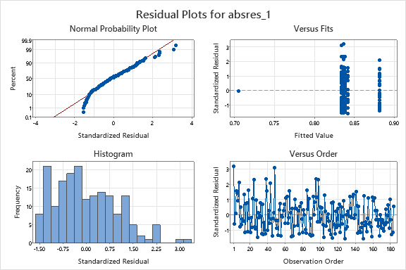

OMITTING 3 OUTLIERS

**Scatterplot of SRES_1 vs Logged GDP per Capita**

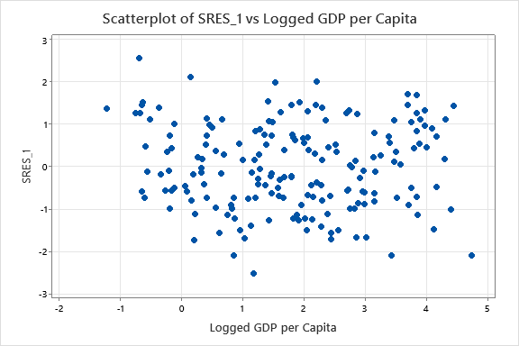

OMITTING 3 OUTLIERS

**Boxplot of SRES_1**

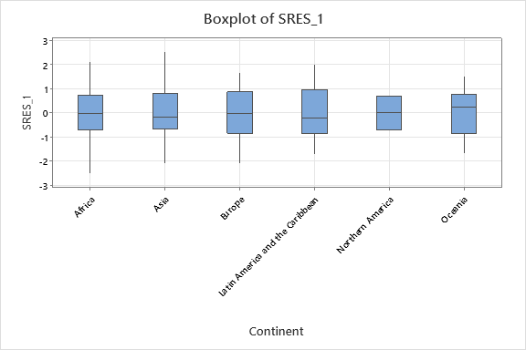

OMITTING 3 OUTLIERS

**General Linear Model: Logged Health Expenditure versus Logged GDP per Capita, Continent**

**Method**

|  |  |
| --- | --- |
| Factor coding | (-1, 0, +1) |
| Weights | wt |

**Factor Information**

|  |  |  |  |
| --- | --- | --- | --- |
| **Factor** | **Type** | **Levels** | **Values** |
| Continent | Fixed | 6 | Africa, Asia, Europe, Latin America and the Caribbean, Northern America, Oceania |

**Analysis of Variance**

|  |  |  |  |  |  |  |  |
| --- | --- | --- | --- | --- | --- | --- | --- |
| **Source** | **DF** | **Seq SS** | **Contribution** | **Adj SS** | **Adj MS** | **F-Value** | **P-Value** |
| Logged GDP per Capita | 1 | 6.5183 | 18.70% | 0.0769 | 0.07691 | 0.59 | 0.442 |
| Continent | 5 | 5.0254 | 14.41% | 0.6228 | 0.12457 | 0.96 | 0.442 |
| Logged GDP per Capita*Continent | 5 | 1.0627 | 3.05% | 1.0627 | 0.21255 | 1.64 | 0.151 |
| Error | 172 | 22.2589 | 63.84% | 22.2589 | 0.12941 |  |  |
| Lack-of-Fit | 171 | 21.9866 | 63.06% | 21.9866 | 0.12858 | 0.47 | 0.853 |
| Pure Error | 1 | 0.2723 | 0.78% | 0.2723 | 0.27233 |  |  |
| Total | 183 | 34.8653 | 100.00% |  |  |  |  |

**Model Summary**

|  |  |  |  |  |  |  |
| --- | --- | --- | --- | --- | --- | --- |
| **S** | **R-sq** | **R-sq(adj)** | **PRESS** | **R-sq(pred)** | **AICc** | **BIC** |
| 0.359739 | 36.16% | 32.07% | * | * | 137.72 | 177.37 |

**Coefficients**

|  |  |  |  |  |  |  |
| --- | --- | --- | --- | --- | --- | --- |
| **Term** | **Coef** | **SE Coef** | **95% CI** | **T-Value** | **P-Value** | **VIF** |
| Constant | 1.00 | 1.22 | (-1.40, 3.41) | 0.82 | 0.411 |  |
| Logged GDP per Capita | 0.235 | 0.305 | (-0.367, 0.837) | 0.77 | 0.442 | 326.80 |
| Continent |  |  |  |  |  |  |
| Africa | 0.61 | 1.22 | (-1.80, 3.02) | 0.50 | 0.618 | 484.48 |
| Asia | 0.62 | 1.22 | (-1.79, 3.03) | 0.51 | 0.613 | 414.30 |
| Europe | 0.74 | 1.22 | (-1.67, 3.16) | 0.61 | 0.543 | 852.64 |
| Latin America and the Caribbean | 0.90 | 1.22 | (-1.51, 3.32) | 0.74 | 0.461 | 641.84 |
| Northern America | -3.72 | 6.09 | (-15.73, 8.29) | -0.61 | 0.542 | 2094.90 |
| Logged GDP per Capita*Continent |  |  |  |  |  |  |
| Africa | -0.307 | 0.309 | (-0.916, 0.303) | -0.99 | 0.322 | 55.42 |
| Asia | -0.244 | 0.308 | (-0.851, 0.363) | -0.79 | 0.428 | 136.79 |
| Europe | -0.131 | 0.306 | (-0.736, 0.474) | -0.43 | 0.670 | 573.87 |
| Latin America and the Caribbean | -0.247 | 0.310 | (-0.858, 0.365) | -0.80 | 0.427 | 198.58 |
| Northern America | 1.09 | 1.52 | (-1.90, 4.09) | 0.72 | 0.473 | 969.18 |

**Regression Equation**

|  |  |  |  |
| --- | --- | --- | --- |
| **Continent** |  |  |  |
| Africa | Logged Health Expenditure | = | 1.6137 - 0.0717 Logged GDP per Capita |
|  |  |  |  |
| Asia | Logged Health Expenditure | = | 1.623 - 0.0092 Logged GDP per Capita |
|  |  |  |  |
| Europe | Logged Health Expenditure | = | 1.748 + 0.1042 Logged GDP per Capita |
|  |  |  |  |
| Latin America and the Caribbean | Logged Health Expenditure | = | 1.908 - 0.0116 Logged GDP per Capita |
|  |  |  |  |
| Northern America | Logged Health Expenditure | = | -2.72 + 1.33 Logged GDP per Capita |
|  |  |  |  |
| Oceania | Logged Health Expenditure | = | 1.843 + 0.072 Logged GDP per Capita |

**Fits and Diagnostics for Unusual Observations**

|  |  |  |  |  |  |  |  |  |  |  |  |  |
| --- | --- | --- | --- | --- | --- | --- | --- | --- | --- | --- | --- | --- |
| **Obs** | **Logged Health Expenditure** | | **Fit** | | **SE Fit** | | | **95% CI** | **Resid** | **Std Resid** | **Del Resid** | **HI** |
| 1 | 2.580 | | 1.629 | | 0.143 | | | (1.347, 1.911) | 0.951 | 2.43 | 2.46 | 0.11691 |
| 8 | 2.293 | | 2.132 | | 0.309 | | | (1.523, 2.741) | 0.161 | 0.35 | 0.35 | 0.31502 |
| 31 | 2.380 | | 2.380 | | 0.429 | | | (1.533, 3.226) | -0.000 | * | * | 1.00000 |
| 38 | 0.742 | | 1.553 | | 0.061 | | | (1.432, 1.674) | -0.811 | -2.02 | -2.04 | 0.02275 |
| 43 | 2.407 | | 1.882 | | 0.047 | | | (1.789, 1.975) | 0.525 | 2.06 | 2.08 | 0.03307 |
| 48 | 0.588 | | 1.529 | | 0.072 | | | (1.388, 1.670) | -0.941 | -2.36 | -2.39 | 0.03120 |
| 73 | 1.548 | | 1.905 | | 0.129 | | | (1.651, 2.160) | -0.358 | -1.59 | -1.60 | 0.24696 |
| 89 | 2.332 | | 1.873 | | 0.272 | | | (1.337, 2.409) | 0.459 | 0.96 | 0.96 | 0.24436 |
| 95 | 2.425 | | 1.603 | | 0.059 | | | (1.486, 1.720) | 0.821 | 2.05 | 2.07 | 0.02133 |
| 98 | 1.686 | | 2.241 | | 0.068 | | | (2.107, 2.376) | -0.555 | -2.72 | -2.77 | 0.10006 |
| 119 | 2.272 | | 2.117 | | 0.284 | | | (1.557, 2.677) | 0.155 | 0.33 | 0.33 | 0.26650 |
| 177 | 2.821 | | 2.821 | | 0.429 | | | (1.975, 3.668) | 0.000 | * | * | 1.00000 |
| **Obs** | **Cook’s D** | **DFITS** | |  | |  |
| 1 | 0.06 | 0.895522 | | R | |  |
| 8 | 0.00 | 0.239301 | |  | | X |
| 31 | * | * | |  | | X |
| 38 | 0.01 | -0.311589 | | R | |  |
| 43 | 0.01 | 0.384200 | | R | |  |
| 48 | 0.01 | -0.429058 | | R | |  |
| 73 | 0.07 | -0.914113 | |  | | X |
| 89 | 0.02 | 0.546241 | |  | | X |
| 95 | 0.01 | 0.305213 | | R | |  |
| 98 | 0.07 | -0.923689 | | R | |  |
| 119 | 0.00 | 0.198304 | |  | | X |
| 177 | * | * | |  | | X |

*R  Large residual  
X  Unusual X*

**Means**

|  |  |  |
| --- | --- | --- |
| **Term** | **Fitted Mean** | **SE Mean** |
| Continent |  |  |
| Africa | 1.483 | 0.100 |
| Asia | 1.6059 | 0.0629 |
| Europe | 1.9375 | 0.0621 |
| Latin America and the Caribbean | 1.8867 | 0.0482 |
| Northern America | -0.30 | 4.00 |
| Oceania | 1.974 | 0.151 |

**Means for Covariates**

|  |  |  |
| --- | --- | --- |
| **Covariate** | **Data Mean** | **StDev** |
| Logged GDP per Capita | 1.82 | 1.40 |

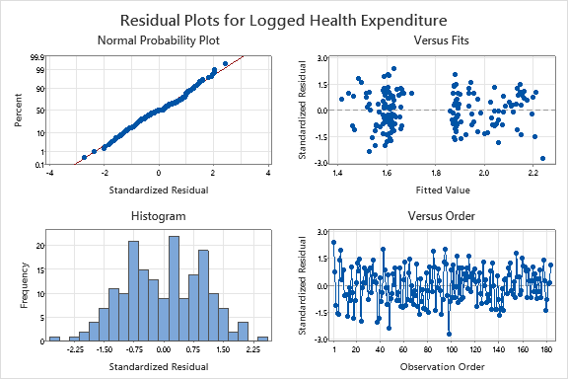

OMITTING 3 OUTLIERS

**General Linear Model: Logged Health Expenditure versus Logged GDP per Capita, Continent**

**Method**

|  |  |
| --- | --- |
| Factor coding | (-1, 0, +1) |
| Weights | wt |

**Factor Information**

|  |  |  |  |
| --- | --- | --- | --- |
| **Factor** | **Type** | **Levels** | **Values** |
| Continent | Fixed | 6 | Africa, Asia, Europe, Latin America and the Caribbean, Northern America, Oceania |

**Analysis of Variance**

|  |  |  |  |  |  |  |  |
| --- | --- | --- | --- | --- | --- | --- | --- |
| **Source** | **DF** | **Seq SS** | **Contribution** | **Adj SS** | **Adj MS** | **F-Value** | **P-Value** |
| Logged GDP per Capita | 1 | 6.5183 | 18.70% | 0.2007 | 0.2007 | 1.52 | 0.219 |
| Continent | 5 | 5.0254 | 14.41% | 5.0254 | 1.0051 | 7.63 | 0.000 |
| Error | 177 | 23.3217 | 66.89% | 23.3217 | 0.1318 |  |  |
| Lack-of-Fit | 176 | 23.0493 | 66.11% | 23.0493 | 0.1310 | 0.48 | 0.849 |
| Pure Error | 1 | 0.2723 | 0.78% | 0.2723 | 0.2723 |  |  |
| Total | 183 | 34.8653 | 100.00% |  |  |  |  |

**Model Summary**

|  |  |  |  |  |  |  |
| --- | --- | --- | --- | --- | --- | --- |
| **S** | **R-sq** | **R-sq(adj)** | **PRESS** | **R-sq(pred)** | **AICc** | **BIC** |
| 0.362989 | 33.11% | 30.84% | 25.1573 | 27.84% | 134.98 | 159.88 |

**Coefficients**

|  |  |  |  |  |  |  |
| --- | --- | --- | --- | --- | --- | --- |
| **Term** | **Coef** | **SE Coef** | **95% CI** | **T-Value** | **P-Value** | **VIF** |
| Constant | 1.8875 | 0.0818 | (1.7261, 2.0489) | 23.08 | 0.000 |  |
| Logged GDP per Capita | 0.0307 | 0.0249 | (-0.0184, 0.0799) | 1.23 | 0.219 | 2.14 |
| Continent |  |  |  |  |  |  |
| Africa | -0.3199 | 0.0877 | (-0.4930, -0.1467) | -3.65 | 0.000 | 2.46 |
| Asia | -0.3390 | 0.0793 | (-0.4956, -0.1824) | -4.27 | 0.000 | 1.71 |
| Europe | 0.0945 | 0.0694 | (-0.0424, 0.2314) | 1.36 | 0.175 | 2.69 |
| Latin America and the Caribbean | -0.0662 | 0.0704 | (-0.2052, 0.0729) | -0.94 | 0.349 | 2.09 |
| Northern America | 0.590 | 0.260 | (0.076, 1.104) | 2.27 | 0.025 | 3.77 |

**Regression Equation**

|  |  |  |  |
| --- | --- | --- | --- |
| **Continent** |  |  |  |
| Africa | Logged Health Expenditure | = | 1.5676 + 0.0307 Logged GDP per Capita |
|  |  |  |  |
| Asia | Logged Health Expenditure | = | 1.5485 + 0.0307 Logged GDP per Capita |
|  |  |  |  |
| Europe | Logged Health Expenditure | = | 1.9820 + 0.0307 Logged GDP per Capita |
|  |  |  |  |
| Latin America and the Caribbean | Logged Health Expenditure | = | 1.8213 + 0.0307 Logged GDP per Capita |
|  |  |  |  |
| Northern America | Logged Health Expenditure | = | 2.477 + 0.0307 Logged GDP per Capita |
|  |  |  |  |
| Oceania | Logged Health Expenditure | = | 1.928 + 0.0307 Logged GDP per Capita |

**Fits and Diagnostics for Unusual Observations**

|  |  |  |  |  |  |  |  |  |  |  |  |  |
| --- | --- | --- | --- | --- | --- | --- | --- | --- | --- | --- | --- | --- |
| **Obs** | **Logged Health Expenditure** | | **Fit** | | **SE Fit** | | | **95% CI** | **Resid** | **Std Resid** | **Del Resid** | **HI** |
| 1 | 2.580 | | 1.527 | | 0.090 | | | (1.350, 1.704) | 1.053 | 2.56 | 2.60 | 0.045569 |
| 24 | 0.788 | | 1.654 | | 0.075 | | | (1.507, 1.801) | -0.866 | -2.09 | -2.11 | 0.031455 |
| 31 | 2.380 | | 2.595 | | 0.306 | | | (1.992, 3.199) | -0.216 | -0.71 | -0.70 | 0.500092 |
| 38 | 0.742 | | 1.594 | | 0.058 | | | (1.480, 1.707) | -0.852 | -2.10 | -2.12 | 0.019810 |
| 43 | 2.407 | | 1.889 | | 0.046 | | | (1.798, 1.981) | 0.518 | 2.01 | 2.03 | 0.031505 |
| 48 | 0.588 | | 1.604 | | 0.060 | | | (1.486, 1.721) | -1.016 | -2.51 | -2.55 | 0.021203 |
| 95 | 2.425 | | 1.572 | | 0.057 | | | (1.459, 1.685) | 0.853 | 2.11 | 2.13 | 0.019576 |
| 98 | 1.686 | | 2.128 | | 0.052 | | | (2.025, 2.230) | -0.441 | -2.09 | -2.11 | 0.056626 |
| 177 | 2.821 | | 2.606 | | 0.306 | | | (2.002, 3.209) | 0.216 | 0.71 | 0.70 | 0.500092 |
| **Obs** | **Cook’s D** | **DFITS** | |  | |  |
| 1 | 0.04 | 0.568496 | | R | |  |
| 24 | 0.02 | -0.380096 | | R | |  |
| 31 | 0.07 | -0.704523 | |  | | X |
| 38 | 0.01 | -0.301880 | | R | |  |
| 43 | 0.02 | 0.365689 | | R | |  |
| 48 | 0.02 | -0.375194 | | R | |  |
| 95 | 0.01 | 0.300428 | | R | |  |
| 98 | 0.04 | -0.517226 | | R | |  |
| 177 | 0.07 | 0.704523 | |  | | X |

*R  Large residual  
X  Unusual X*

**Means**

|  |  |  |
| --- | --- | --- |
| **Term** | **Fitted Mean** | **SE Mean** |
| Continent |  |  |
| Africa | 1.6235 | 0.0662 |
| Asia | 1.6044 | 0.0635 |
| Europe | 2.0378 | 0.0483 |
| Latin America and the Caribbean | 1.8772 | 0.0466 |
| Northern America | 2.533 | 0.311 |
| Oceania | 1.984 | 0.148 |

**Means for Covariates**

|  |  |  |
| --- | --- | --- |
| **Covariate** | **Data Mean** | **StDev** |
| Logged GDP per Capita | 1.82 | 1.40 |

