conda create -n llama3 python=3.10

conda activate llama3

conda install pytorch==2.1.2 torchvision==0.16.2 torchaudio==2.1.2 pytorch-cuda=12.1 -c pytorch -c nvidia

conda activate agent

cd ~/xtuner/

git clone -b v0.1.18 https://github.com/InternLM/XTuner

cd XTuner

pip install -e .

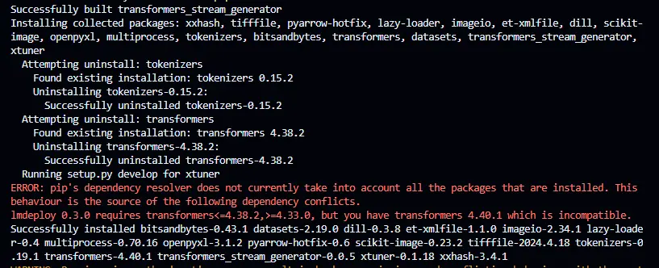

cd ~

ln -s /root/share/new_models/meta-llama/Meta-Llama-3-8B-Instruct /root/models/Meta-Llama-3-8B-Instruct

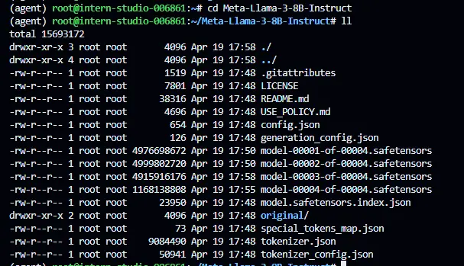

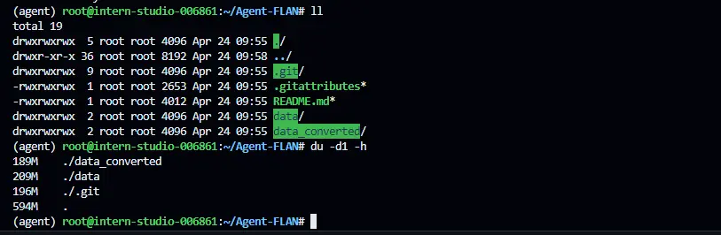

# pretrained_model_name_or_path = '~/Meta-Llama-3-8B-Instruct'

pretrained_model_name_or_path = '/root/share/new_models/meta-llama/Meta-Llama-3-8B-Instruct'

use_varlen_attn = True

# Data

agent_flan_path = '~/Agent-FLAN/data_converted'

prompt_template = PROMPT_TEMPLATE.llama3_chat

max_length = 8192

pack_to_max_length = True

# parallel

sequence_parallel_size = 1

# Scheduler & Optimizer

batch_size = 1 # per_device

accumulative_counts = 8

accumulative_counts *= sequence_parallel_size

dataloader_num_workers = 0

max_epochs = 1

model = dict(

type=SupervisedFinetune,

use_varlen_attn=use_varlen_attn,

llm=dict(

type=AutoModelForCausalLM.from_pretrained,

pretrained_model_name_or_path=pretrained_model_name_or_path,

trust_remote_code=True,

torch_dtype=torch.float16,

quantization_config=dict(

type=BitsAndBytesConfig,

load_in_4bit=True,

load_in_8bit=False,

llm_int8_threshold=6.0,

llm_int8_has_fp16_weight=False,

bnb_4bit_compute_dtype=torch.float16,

bnb_4bit_use_double_quant=True,

bnb_4bit_quant_type='nf4')),

lora=dict(

type=LoraConfig,

r=32,

lora_alpha=64,

lora_dropout=0.1,

bias='none',

task_type='CAUSAL_LM'))

MAX_JOBS=4 pip install flash-attn

pip install deepspeed

export MKL_SERVICE_FORCE_INTEL=1

export MKL_THREADING_LAYER=GNU

微调指令如下

NPROC_PER_NODE=1 xtuner train \

~/Llama3-Tutorial/configs/llama3-agentflan/llama3_8b_instruct_qlora_agentflan_3e.py \

--deepspeed deepspeed_zero2 \

--work-dir ~/project/llama3-ft/agent-flan

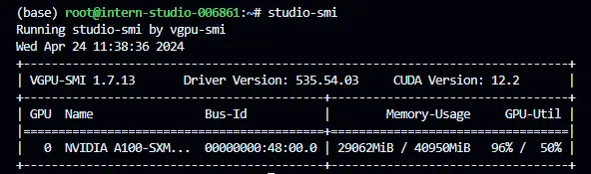

# 转换权重

xtuner convert pth_to_hf \

~/Llama3-Tutorial/configs/llama3-agentflan/llama3_8b_instruct_qlora_agentflan_3e.py \

~/project/llama3-ft/agent-flan/iter_500.pth \

~/project/llama3-ft/agent-flan/iter_500_hf

# 合并权重

export MKL_THREADING_LAYER=GNU

export MKL_SERVICE_FORCE_INTEL=1

xtuner convert merge ~/Meta-Llama-3-8B-Instruct \

~/project/llama3-ft/agent-flan/iter_500_hf \

~/project/llama3-ft/agent-flan/merged_500

