**Analysis about the trend changes in March**

In order to analyze the users’ activity, we have crawled the number of questions and answers per day in March. Then we tried to visualize it as line chart by applying Matlab.

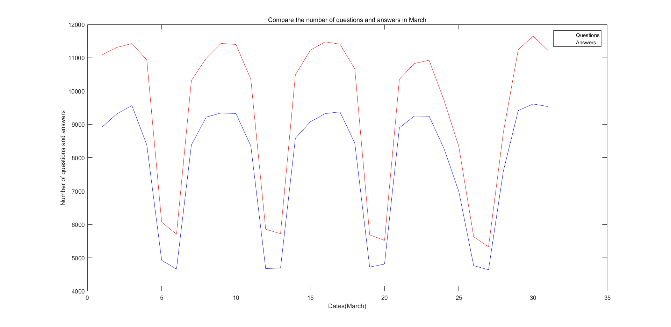

*Figure 1*

As shown in figure 1, the red line represent the number of answers and the blue line represent the number of questions. The x-axis shows the date from 1st March to 31st March and the y-axis shows the total number of questions and answers per day.

We plot the graph using discrete points but the result seems like an irregular sinusoidal which is very interesting. We have compared the date of trough points to the calendar and found out that the date of trough points are all weekend. We then draw the conclusion that the reduction of activities of users is due to the weekend. After all, nobody will be willing to work in weekend.

Meanwhile, the number of answers are always larger than the number of questions. Because each question always has several answers.