Data Visualization Assignment 1

Report on Analysing and Visualizing

Player Behaviour in DOTA

Group Number: 11 Date: 16/12/2015

## 1. Introduction and Objectives

This report aims to conduct the result of the analysing the player behaviour, especially the spatio-temporal information of each sill tier. Discussion will be provided at the end regarding the insights of the strategy behaviour of each tier. The objective of this report is to provide extra behaviour analysis by analysing and visualizing the result from spatio-temporal data.

In this paper, we present the result of three data-driven measures of spatio- temporal behaviour in Defence of the Ancients 2 (DotA 2): 1) Distribution of Team Members 2) Zone change within a group and: 3) Opening strategies. We group the above data by using the four sill tiers and come out with the conclusion that the group behaviour is highly related to the team playing levels.

## 2. Methods

### 2.1 Dataset

We extracts three datasets from raw dataset using python. 1) Dataset which describes the within-group distance between each member in a team 2) Dataset which describes the zone-changes of a team during the match 3) Dataset which describes the opening-strategy of a team. More specifically, the dataset we use to describe the opening-strategy of a team is not the data with $tsync = 0$, rather, we choose data of which $zone$ value is not “base” or “void”. This limitation is to ensure that players actually reach their position according to the opening strategy.

### 2.2 Exceptional Data

In this part, we present some exceptional data of the given raw dataset. Apparently, these data would have negative impact on our analysis, and thus we do not consider the exceptional data during our analysis. And in general, we consider 48 matches in tier “Normal”, 46 matches in tier “High”, 50 matches in tier “Very High”, and 46 matches in tier “Pro”. Detailed information of exceptional data are listed as in Table 1.

Table – Exceptional data and description

|  |  |  |
| --- | --- | --- |
| Match | Tier | Description |
| 643216184 | Normal | One team with 6 players, another with 4 players |
| 645077087 | Normal | 15 players in the match |
| 626684019 | High | One team with 6 players, another with 4 players |
| 644374912 | High | No team won |
| 645153730 | High | No team won |
| 613258812 | Pro | No team won |

## 3. Analysis

### 3.1 Within-Group Distance

The first experiment is focused on within-group distance, as a function of the four skill tiers. The goal of the experiment is to analyse the relationship between within-group distance different skill tiers. Furthermore, find out whether within-group distance also contributes to win or lose of the match. Figure 1 describes the mean distance of within-group distance, and Figure 2 describes the variance of within-group distance. The results indicate different tiers have significantly different within-group distance or team distribution. The professional tiers have the lowest distance mean and distance variance, while the normal tiers have the highest distance mean and distance variance. Besides, in general, winning team have lower within-group distance mean and lower within-group distance variance.

### 

Figure - Within Group Distance Analysis According to Distance Mean

### 

Figure - Within Group Distance Analysis According to Distance Variance

### 3.2 Zone Change per Group

The second experiment is focused on general movement of the four different tiers during DotA2 matches. The experiment is based on the assumption that more skilled players tend to change zones more often than novice players, and novice players prefer to keep their position in the same zone. To estimate zone changes, we implements the algorithm by Drachen et al. Number of change times of each player and also whole team in the match is calculated and extracted from raw data. More specifically, only zone changes that last for at least 5 seconds would be taken into consideration. This limitation is set to avoid temporal zone changes, i.e. zone changes with very small time interval. Figure 3 describes zone change times within a group per minute per person and Figure 4 describes overall zone change times of all players within the group. From Figure 3, we can easily find the two relatively professional tiers, namely tier “Very High” and tier “Professional” have higher zone changes per minute. Besides, in the same tiers, the teams which won the games have higher zone changes per minute than those 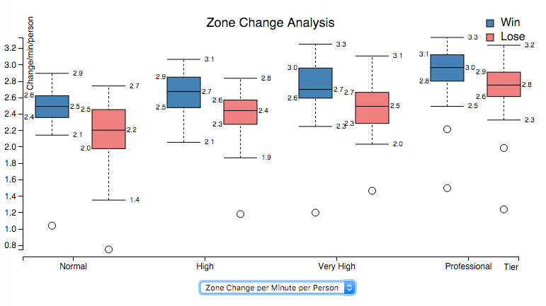lost.

Figure 3 - Zone Change Time within Group per minute per person

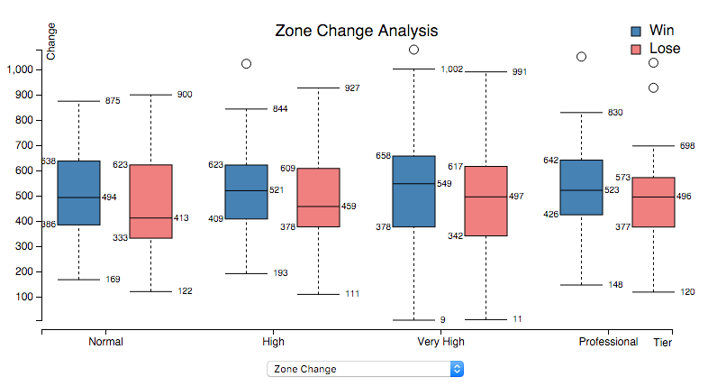

Figure 4 - Zone Change Time Within a Group

Figure - Zone Change Times Within Group

### 3.3 Opening Strategy

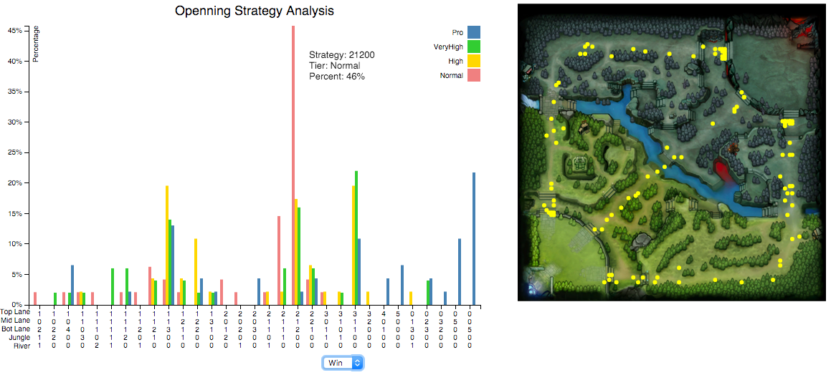The third experiment is focused on opening strategy of different tiers and whether different opening strategy have impact on the result of match. Figure 5 shows the interaction between the chosen strategy of a certain tier from left bar chart and the corresponding positions of players which is shown on the right side of the figure. And also from Figure 6 and Figure 7, we can easily conclude the opening strategy of professional tier is more scattered, while the opening strategy of normal tier is more centralized, especially $46\%$ teams of normal tier have the opening strategy with 2 players at top lane, 1 player at mid lane and 2 players at bot lane. Also, teams from all tiers are more likely to distribute players at the three lanes rather than jungle or river.

Figure 5 - Opening Strategy Analysis

*X axis: player distributions of five different zones, Top Lane, Mid Lane, Bot Lane, Jungle and River at the beginning of the game, with digits representing number of players in a certain zone.*

*Y axis: strategy percentage*

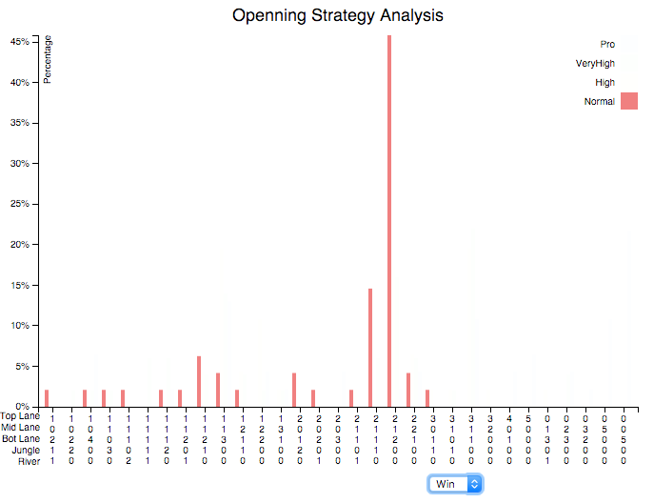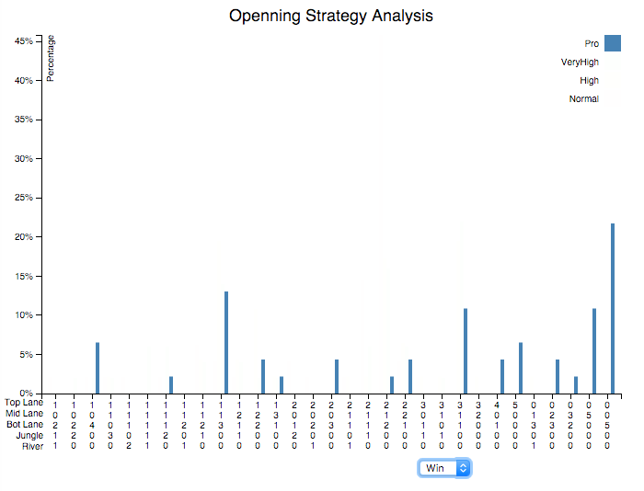

Figure 6 - Opening Strategy of Tier Pro

Figure 7 - Opening Strategy of Tier Normal

## 4. Discussion

### 4.1 Within-Group Distance

As we can see from the figure, the professional tier teams are more likely to maintain their distance within group as well as its variance at lower level than the normal tier teams. The same relation exists between the winning teams and the losing teams. Generally, teams with better performance can be more concentrated while farming instead of being decentralized which can sufficiently prevent themselves from being ganked. Meanwhile the lower variance indicates that better players can be more concentrated on farming instead of meaningless moving during the match.

### 4.2 Zone Change per Group

The result we have shows apparently that players with higher level are more flexible during the matches. They are more likely to apply some tactics by changing their position to gank or farm instead of staying in the same line all the time. The using of these tactics can help them build advantages against their enemies.

### 4.3 Opening Strategy

The opening strategy can be quite different among various tiers. Normal tier players prefer to use regular opening strategies for example 2-1-2-0-0 (top-middle-bottom-jungle-river). Except for the three regular strategies, all other strategies are used less than 5% of possibility. However, things become quite different when it comes to better players. Teams with professional tier prefer to try some new tactics. The opening strategies they use are more decentralized instead of the regular ones. They even often try some extreme strategies like 0-0-5-0-0 which we can never found on teams with lower level. The flexibility and innovation of choosing opening strategy meet their level of playing the game.

## 5. Technical Restrictions

### 5.1 Server

In order to successfully launch our program and load the data successfully, please open it under an Apache server

### 5.2 Time

There is no specific time restrictions about our program, as the data is all pre-processed and the opening speed should fast enough without notice.

## 6 Entry File

There are three entry files in the project, for the three visualizations:

* WithinGroupDistance.html
* ZoneChange.html
* Opening Strategy.html

## 7. References

Drachen, A., Yancey, M., Maguire, J., Chu, D., Wang, I. Y., Mahlmann, T., ... & Klabajan, D. (2014, October). Skill-based differences in spatio-temporal team behaviour in defence of the Ancients 2 (DotA 2). In *Games Media Entertainment (GEM), 2014 IEEE* (pp. 1-8). IEEE.