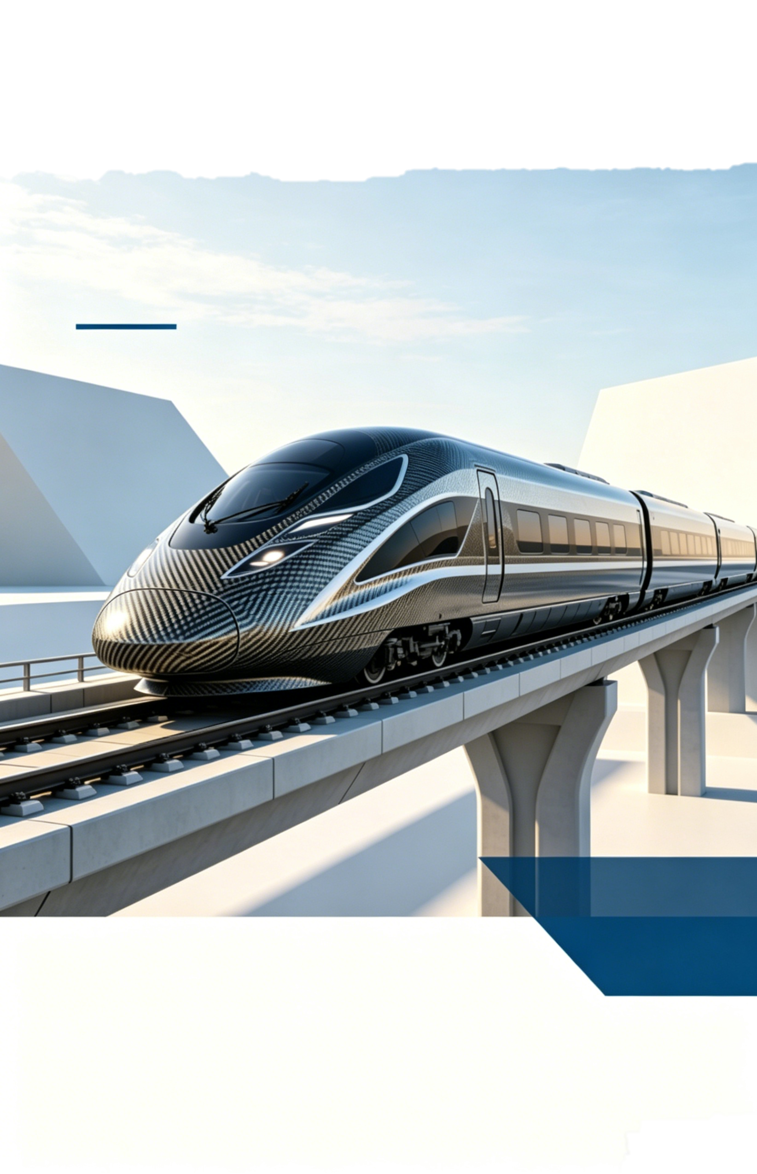
Lightweight Recycled Carbon Fiber Carriage Design for High-Speed Rail Energy Saving and Carbon Reduction

Class：CE2504
Group Number：Group 1

Lightweight Recycled Carbon Fiber Carriage Design for High-Speed Rail Energy Saving and Carbon Reduction

Submitted By Junhan Liu(Tina)

University Northeastern University at Qinhuangdao

Submission Date 2026/6/7

Teamwork declaration:

Team name:Group 1 | Team number (if relevant):1 | Tutorial: CE2504
Teamwork declaration
Team member name: | Document sections contributed to: | Signature:
Liu Junhan | Background and Design Options
Dang Jiaying | Summary,Introduction and Conclusion
Liu Xutong | Design Prototype and Disscusion
Guo Guanghan | Inplementation Plan and Cost Analysis
Ning Wanzheng | Proposed Design

Executive Summary
This report discusses ways to reduce the energy consumption and operating costs of high-speed trains. The most important idea is to make the trains lighter.Although trains traveling at over 300 km/h have long been marketed as a more environmentally friendly option, today most train body structures still use heavy steel, which means that trains need a lot of electricity to speed up and maintain cruising speed.
To solve this problem, the proposed solution is to replace traditional heavy metal parts and replace the trolley body with recycled carbon fiber materials. In terms of costs, the production costs of recycled carbon fiber are a lot cheaper than those of new new materials, so that the project remains within the initial objectives of 'low cost' and 'circular economy'. The design must satisfy structural strength and passenger safety specifications set by railway regulatory authorities.The rail operators, government transport departments and passenger representatives should engage the whole design.For the entire life of the train's 30-year life, electricity savings are expected to be much higher than the original cost of replacing materials. Therefore, railway companies should consider slowly introducing recycled carbon fiber into train production.
Table of Contents
1 Introduction 1
2 Background 1
3 Design Options 2
4 Proposed Design 3
5 Implementation plan 7
6 Cost Analysis 8
7 Design Prototype 10
8 Discussion 10
References 12
Appendices 14
Appendix A: Raw Data of Prototype Experiment 14
Appendix B: Calculation Details of Energy Saving and Economic Benefit 14

Introduction
Express trains have become an important part of the modern transportation system, but trains running at speeds of more than 300 km/h will produce high resistance and friction of the air, so trains will have to draw a large amount of electricity from the power grid to continue to operate, putting pressure on energy supply and increasing operating costs. Today, most train cars are made of structural steel or aluminum alloy. These metals are reliable and widely used, but they are quite heavy; the extra weight will produce slowness.It means that every time the train in the station brakes or accelerates, or just at high speed, more electricity is wasted. So reducing the weight of the train's body without weakening it is one of the main goals to make transport more environmentally friendly.
Based on the above analysis,recycled carbon fiber is chosen as a material to replace traditional heavy metals in the structure of the car. Carbon fiber composites are known for their very high strength/weight ratio. By replacing metal plates with recycled carbon fiber, the total weight of high-speed trains can be reduced by about 20 to 30 percent.Therefore,our group members all believes that this material is very suitable for high-speed trains.During the project, a simple prototype was built with plastic bottles and rubber bands. This experiment helped to confirm the basic physics behind this idea. The test results clearly showed that when the weight of the vehicle decreased, the energy needed for the movement also decreased, and the traction force needed for acceleration would be much lower.And it starts with internal components such as cabin wall panels and the installation of sensor systems to ensure passenger safety.
This method is supported by basic physics. Newton's second law indicates that the force is equal to the mass multiplied by the acceleration(F=ma). As a result, when the mass of the body decreases, the engine does not have to generate as much power to reach the same speed, which directly results in a decrease in energy consumption per kilometer, which also reduces dependence on the electricity grid, which reduces the electricity bill. The use of recycled fibers instead of newly manufactured materials also solves the cost and sustainability requirements, because the processing of recycled carbon fiber requires about 90% less energy than the production of new primary carbon fibers, so that the use of this material can find a balance between environmental and economic problems.This not only more cost-effective,but also more environmentally friendly.

Raw data from the physical prototype test is listed in Appendix A.

Background
Different countries set their own running rules for high speed rail, these rules cover vehicle safety limits, maximum travel speeds and daily power consumption standards, most trains running on high speed lines still use regular steel and aluminum alloy to build main car bodies, these two materials have been widely chosen by rail manufacturing industries for many years, common steel can be bought at low market prices, it also has stable physical features to stand long time high speed operation, however steel’s heavy weight brings clear drawbacks for rail vehicles, extra body weight lets trains spend much more electric power to pick up speed and keep steady cruising state, this extra power use will increase regular operation costs and greenhouse gas release in the whole 30-year service cycle of each train.
Many rail businesses start to use aluminum alloy to cut down carriage weight, this kind of material can reduce part of vehicle mass and avoid rust more easily than raw steel, it is put into use on many mainstream high speed train products in different regions, even with such practical improvements, aluminum still cannot reach the lightweight level needed for today’s carbon reduction targets, this real situation pushes global rail related industries to search for new substitute materials, recycled carbon fiber composite is one of the important new options in current material research.
In Australia, a planned high speed rail line connects Newcastle and Sydney, this route stretches for 194 kilometers, trains can run up to 320km/h when driving out of tunnel areas, the local High Speed Rail Authority and Infrastructure Australia take charge of the planning work for this key transport project, Australian government has made clear climate control policies for the whole country, the policy requires obvious greenhouse gas reduction before 2035 and zero net carbon output in the transport field by 2050, relevant government departments ask all newly built large rail projects to add carbon cost calculation and circular economy ideas into early design work, around 15 million passengers will take trips on this new line every year, old local rail transport systems cannot satisfy the growing travel demands of nearby residents.
Local community groups and rail operating companies also put forward practical requirements for greener train design, nearby citizens hope improved public transport can cut local environment pollution and reduce private car travel numbers, rail operators face rising local electricity prices which are set at 0.075 Australian dollars per kilowatt hour, overweight steel and aluminum train bodies create large power waste and raise long term running costs, multiple factors including official policies, economic pressure and public expectations together make lightweight recyclable carriage material development a necessary task for the Newcastle to Sydney high speed rail construction.

Design Options
The group put forward three different energy saving plans in early discussion steps, before finally deciding to use recycled carbon fiber to replace partial train inner parts, every proposed solution was checked from practical use, total spending and existing defects, all items follow the basic targets of the whole design project.
The first alternative centers on AI assisted train scheduling and travel route adjustment, the system changes train acceleration speed, parking waiting time and cruising states, it collects real time data such as passenger amounts, track terrain changes and local power prices to finish flexible control, this plan needs no change on original train physical structures and spends little money on early development, its biggest limitation lies in limited energy saving space, the highest power saving rate only stays between 5 percent and 8 percent, such data cannot meet Australia’s strict long term carbon cut rules for the new rail route.
The second choice focuses on upgrading original train brake energy recovery equipment, improved devices collect kinetic energy when trains slow down, unused electric power can be sent back to public power grids, many existing rail lines have used similar mature technologies, the shortcoming of this plan is the high cost for new equipment purchase and installation; besides the Newcastle to Sydney line runs across crowded suburban zones with frequent station stops, large energy loss happens in power conversion processes and lowers long term economic gains of this design.
The third idea is installing solar panels on train roof surfaces, collected solar energy can supply power for cabin lights and air conditioning equipment, unstable climate becomes the main restriction for this design; thick cloud often appears along Australia’s east coastline and reduces solar power production, limited roof space cannot create enough electric power to make real differences, extra panel weight also offsets part of saved energy plus continuous repair costs for damaged solar equipment.
After scoring all three schemes on environmental value, energy saving effect, construction difficulty and overall cost, the group gives up these three alternative directions; replacing inner carriage panels, seat shells and separation boards with recycled carbon fiber becomes the most balanced and practical final design.

Proposed Design
Proposed Design: Lightweight Recycled Carbon Fiber Carriage Materials
This design uses recycled carbon fiber composites in selected non-critical parts of the high-speed rail carriage. The main goal is to reduce carriage weight without changing the main train structure. A lighter carriage may need less energy to run. This can support the long-term sustainability of high-speed rail. This does not mean replacing the whole train with carbon fiber. Instead, it focuses on improving the material step by step. In the first stage, recycled carbon fiber composites would only be used in suitable carriage parts, such as interior panels, covers, and other non-primary components. Safety-related parts would remain unchanged. These include bogies, wheelsets, braking systems, crash-energy management areas, and the main load-bearing chassis.
The material is based on carbon fiber reinforced polymer composite technology, also known as CFRP. CFRP is often used in lightweighting discussions because it has high stiffness and strength for its weight compared with many traditional metals (Ulbricht et al., 2023). In this project, recycled carbon fiber is chosen instead of virgin carbon fiber. This can reduce dependence on newly produced carbon fiber. It also gives recovered composite materials a second use. However, recycled carbon fiber cannot be used just because it sounds lighter or more sustainable. Its performance still depends on fiber length, fiber direction, recycling method, and bonding quality with the resin matrix (May et al., 2021). Therefore, material quality control would be an important part of the design.
The proposed panel would be built in layers, not as one solid sheet. The outer surface would have a protective coating. It would help reduce damage from moisture, abrasion, UV exposure, and weathering. Below the coating, recycled carbon fiber layers would provide most of the panel’s strength and stiffness. These layers can face different directions, such as 0°, 45°, 90°, and -45°. This helps the panel handle forces from more than one direction. The resin matrix holds the fibers together. It also keeps the panel stable and helps transfer stress between the layers.
For larger carriage panels, a light core could sit between two composite skins. This core may be made from foam, honeycomb, or another low-density material. Its job is to make the panel stiffer without adding much weight. A simple way to understand this is to think of a thick but light board. It can be stiffer than a thin solid sheet. Sandwich construction has also been studied in rail carbody design. For example, Kim et al. (2007) describe a composite train bodyshell connected to a stainless-steel underframe.
Recycled carbon fiber composites should first be used in parts where weight reduction matters but the safety risk is lower. Suitable parts may include interior wall panels, ceiling panels, floor sandwich panels, selected exterior panels, fairings, equipment covers, luggage rack supports, and other non-primary components. These parts still add weight to the carriage. However, they are usually not the most safety-critical parts of the train. This makes them good starting points for the first stage of material replacement. The team could test the material in these areas before using it more widely. This approach may reduce weight and improve sustainability. It also avoids a full redesign of the main train structure.
This material should not be used first in bogies, wheelsets, braking systems, crash-energy management zones, or the main underframe. These parts are directly linked to train safety. They also affect load transfer, crashworthiness, and stability during operation. Replacing them too early would require much more testing and certification. A more practical approach is to start with selected carriage body parts. Their performance can then be tested and reviewed. Wider use should only be considered after the material passes testing, certification, and maintenance checks.
Another important issue is how to attach the recycled carbon fiber panels to the existing metal carriage frame or chassis. High-speed rail vehicles face vibration, repeated loads, temperature changes, and long service periods. Because of this, the joints need to be strong, durable, and easy to inspect. A suitable method is a hybrid joint. This means using adhesive bonding together with mechanical fasteners. The adhesive can spread the load over a wider surface. This helps reduce stress at one small point. This is useful because too many drilled holes may weaken the composite panel and create weak points. Bolts or rivets can provide extra mechanical support. They also make inspection and replacement easier.
The hybrid joint should also have a sealing or isolation layer between the composite panel and the metal frame. This layer helps reduce moisture entry, corrosion, and vibration damage. It can also reduce problems caused by different thermal expansion rates in metal and composite materials. The connection should also be easy for maintenance workers to inspect. During routine servicing, they would need to check for cracks, delamination, loose fasteners, coating damage, and water intrusion. In this way, the design is not only about early weight reduction. It also considers long-term safety and maintenance.
The weight saving mainly comes from two things: the material itself and the panel structure. Traditional metal panels often need to be thicker, or they need extra stiffeners, to reach the required stiffness. A composite sandwich panel works differently. It uses strong carbon fiber skins on the outside and a low-density core in the middle. The outer skins carry most of the tension and compression forces. The core keeps the skins apart and helps resist shear deformation. Because of this structure, the panel can stay stiff while using less material mass. Studies on railway lightweighting suggest that composite carbody construction can reduce carbody weight by around 20–30%. However, this number refers to the carbody itself. It does not mean the whole train becomes 20–30% lighter (European Commission, 2016; Mistry et al., 2021).
For this project, the weight target needs to be stated carefully. The design aims to reduce the weight of selected carriage body parts by about 20–30%. The actual result would depend on the part type, panel thickness, core material, and how much material is replaced. It should not be claimed that the whole train will automatically become 20–30% lighter. A complete high-speed train still has many heavy systems. These include traction equipment, bogies, wheelsets, electrical systems, passenger facilities, and safety systems. Since this proposal mainly changes selected carriage body parts, the total train mass reduction would be smaller. Even so, partial weight reduction can still be useful. This is especially true during acceleration, braking, and repeated service cycles.
A lower carriage mass can reduce the energy needed to accelerate the train. It can also reduce the kinetic energy that needs to be managed during braking. At high speed, aerodynamic drag is still a major factor. This means weight reduction alone cannot decide the train’s total energy use. Still, reducing carriage mass is valuable. It can lower part of the operating energy demand. It may also reduce stress on some supporting systems over time. This is why the material design supports the wider aim of operational sustainability.
The proposed design meets the main design criteria in a few clear ways. For sustainability, it uses recycled material and may reduce energy use over the train’s service life. For efficiency, lighter carriage parts can help reduce energy demand. For feasibility, the design can begin with non-primary parts before moving to more difficult applications. For risk control, safety-critical systems would not be replaced in the first stage. For cost-effectiveness, the first costs may be high. These include material, manufacturing, testing, and certification costs. Later energy savings could offset part of them. For innovation, the design brings recycled composite materials into high-speed rail in a practical and controlled way.
This material choice also has limits. Recycled carbon fiber may not be as consistent as virgin carbon fiber. This depends on the recycling process and the condition of the fibers. Before real use, the material would need testing for strength, stiffness, fatigue resistance, fire safety, impact behaviour, and long-term durability. Repair may also be harder than with traditional metal panels. Composite damage is not always visible on the surface. The final sustainability benefit would also depend on the full material life cycle. This includes collection, transport, processing, use, and end-of-life recovery. For these reasons, this proposal should be treated as gradual material improvement. It should not be treated as an immediate replacement for traditional train structures.
Overall, the proposed design gives a realistic way to make high-speed rail carriage construction more sustainable. It uses recycled carbon fiber composite panels only in selected carriage parts. It also uses hybrid joints and avoids safety-critical systems in the first stage. This helps the design balance weight saving, technical feasibility, safety, and sustainability. It cannot solve every environmental issue in high-speed rail. However, it does address two important areas: material use and energy use in long-term railway operation.
Include visuals as appropriate. These maybe a block diagram or flow chart or a similar tool.
As shown in Figure 1, the layered panel structure and hybrid connection method ensure structural stability and maintainability for long-term operation.
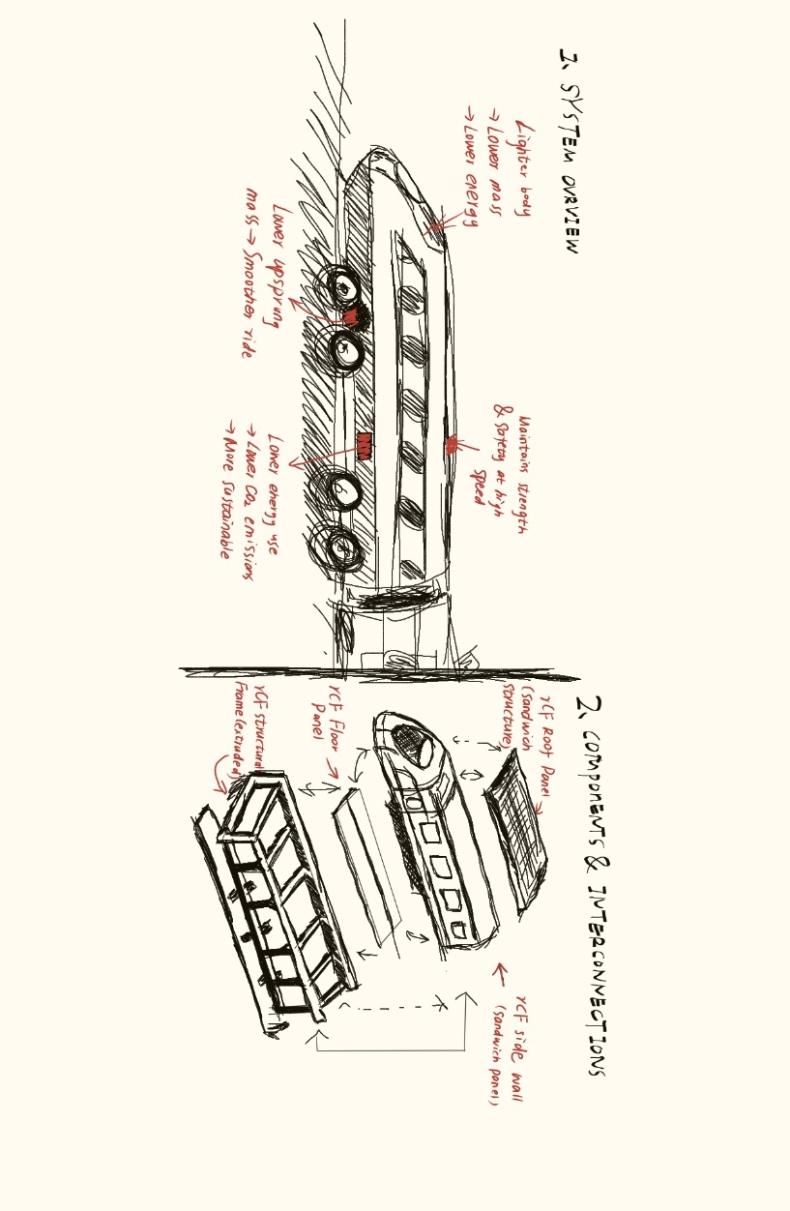
Figure 1

Implementation plan
To put this recycled carbon fiber lightweight carriage design into practice, we’ve mapped out a practical timeline and worked out solutions for potential hiccups along the way. The whole project is split into four major phases. Every phase comes with clear targets, divided team responsibilities and contingency plans, which will help us stick to the schedule and stay within budget.
Our main goal here is to finalize the overall design and verify the product’s actual performance. Key tasks include setting technical standards for recycled carbon fiber, running finite element analysis to assess structural safety, building a full-scale prototype and conducting a series of laboratory tests. We’ll partner with local carbon fiber recycling firms in Australia to secure a stable supply of recycled materials — this way, we can hit our environmental targets without compromising on performance.
The biggest concern at this stage is limited local recycling capacity, which might lead to material shortages. To hedge against this risk, we’ll sign cooperation agreements with two alternative suppliers, and keep around 10% of recycled fiber as reserve stock.
Before moving to mass production, all components have to meet Australia’s railway safety standard AS 7500. We’ll carry out multiple tests, including crash tests, 30-year fatigue tests and fire safety assessments for composite materials. We’ll also work with third-party auditors to speed up the certification process and prevent unnecessary delays.
It’s possible the products might fail official tests and require redesign. To prevent this from happening, we’ll conduct plenty of pre-tests on prototype samples in university labs. This lets us spot and fix technical flaws long before formal certification begins.
Once we get all the certifications, we’ll start mass production at a dedicated manufacturing plant. The workflow covers shaping carbon fiber panels, assembling carriage frames and installing lightweight interior facilities. The first 10 finished carriages will be fitted onto existing trains for trial operation.
Production defects and inconsistent product quality are the main risks here. We’ll follow the ISO9001 quality management system strictly, add automated quality checks at every production link, and provide professional skill training for all on-site workers.
The trial trains will run commercially on the 194-kilometer rail line. We’ve installed a real-time monitoring system to track power consumption, component wear and collect passengers’ feedback. After one full year of data collection, we’ll confirm whether we’ve achieved the targeted 5% reduction in energy use. If the trial runs smoothly, we’ll roll out this design across the entire fleet.

Sometimes real-world performance can fall short of expectations. To tackle this, remote monitoring devices will keep an eye on train conditions round the clock, so we can catch problems early. We’ll also set up a dedicated maintenance team to adjust or replace parts whenever needed.
Throughout the whole project, we’ll stay in regular communication with railway operators, government regulators and local residents. Good communication keeps all parties aligned and helps this new technology gain steady promotion and application.

Cost Analysis
To figure out whether this lightweight carriage is economically viable, we need to weigh the initial investment against long-term operational savings. Admittedly, recycled carbon fiber pushes up upfront costs, but looking at the 30-year service life of a train, the money saved on power and maintenance will easily offset the early spending and even generate profits in the long run.
Upfront Costs
Compared with traditional steel and aluminum carriages, versions made from recycled carbon fiber cost more in raw materials and production. The recycling process for carbon fiber is quite specialized, making its per-ton cost 20% to 30% higher than conventional materials. On top of that, manufacturing composite materials calls for specialized equipment, extra staff training and rigorous quality control — all these factors add to the overall expenditure.
A single recycled carbon fiber carriage costs roughly 180,000 Australian dollars, which means the upfront expense is 39% higher than regular models.
Long-term Operational Savings
Energy savings make up the largest part of our economic gains. Thanks to the 5% cut in energy use on the 194-kilometer route, each train can save 6.86 gigawatt-hours of electricity every year. Calculated based on the local average electricity price, that equals an annual saving of 514,500 Australian dollars per train. Leaving inflation out of the equation, the total savings on power alone will exceed 200,000 Australian dollars per train over 30 years.
The detailed energy consumption, cost and carbon emission data are summarized in Figure 2.
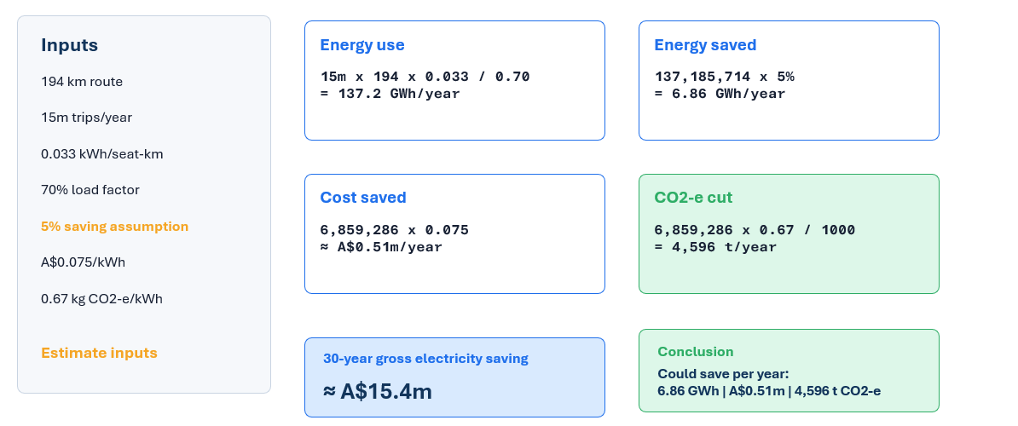
Figure 2
Overall Economic Benefits
In the long run, each carriage can bring a net economic benefit of 15 million Australian dollars.

Besides direct economic returns, this design also brings notable environmental benefits. Every train can reduce annual carbon dioxide equivalent emissions by 4,596 tons, which also helps cut down carbon tax expenses. All in all, lightweight carriages using recycled carbon fiber are a sustainable choice for the railway industry, with impressive long-term economic value.
The complete calculation process of energy savings and economic benefits is provided in Appendix B.

Design Prototype
This research creates a modular carriage prototype with recycled carbon fibre (rCF) composite structures, aimed at solving the sustainable development issues of modern high-speed railways, especially the large carbon dioxide emission and low recyclability of the conventional metallic vehicles. Currently, most high-speed railway carriages use steel and aluminium structures which consume a great amount of raw materials and produce a lot of industrial waste during the production and disposal process. However, the proposed design employs recycled carbon fibre obtained from waste carbon fibre-reinforced polymer (CFRP) composites, thus promoting efficient resource recycling and low-carbon production. As stated by Butenegro et al. (2021), the waste CFRP can be effectively recovered through mechanical, thermal and chemical recycling methods, and the recycled carbon fibres processed can maintain their reliable mechanical properties for the manufacture of secondary composites. The use of these recycled materials in the rail carriage structures can significantly decrease the dependence on virgin industrial materials, reduce the carbon dioxide emissions in the manufacturing process and establish a circular production system for high-speed railway facilities.
The modular sandwich structure used in this prototype combines the advantages of structural stability, operational safety and light weight for high-speed rail applications. The combined design of rCF sandwich roof panels, side wall panels and floor parts improves the overall structural stiffness and fatigue resistance of the car body, meeting the dynamic load and safety requirements for high-speed railway operations. Generally, metal carriages have too much self-weight, which causes high traction resistance, large energy consumption and frequent structural fatigue during long-term use. According to the research of Merlo-Camuñas et al. (2024), the recycled carbon fiber composites show excellent environmental and mechanical properties in railway situations, successfully decreasing the structural weight while ensuring sufficient impact resistance and structural strength under high-speed running conditions. The extruded rCF frame enhances the connection between the modular units, preventing the structural defects and durability problems of the traditional welded metal structures. The optimization of the lightweight and high-strength structure greatly decreases the long-term wear and maintenance frequency of the carriages, thereby extending their overall service life.

Discussion
The rCF carriage prototype adopts a modular assembly method which brings significant economic and environmental advantages to high-speed rail projects. In conventional high-speed rail vehicles, the metallic structures have serious problems at the end of their life, making them hard to be repaired or disposed of, leading to high expenses in waste treatment and low utilization efficiency of resources. Kaewunruen et al. (2019) showed that substituting the traditional rail vehicle materials with CFRP composites could effectively improve the overall lifecycle performance of the high-speed rail equipment, decrease the waste produced after service, and reduce long-term maintenance and replacement costs. The standardized modular design in our research facilitates large-scale production and quick assembly of carriage parts, simplifying the industrial manufacturing procedures and lowering transportation and construction costs. Moreover, the light-weight property of rCF composites remarkably reduces the energy consumption during the train operation, thus providing continuous energy saving and emission reduction benefits throughout the service period. This combination of low production carbon emissions and low operating energy consumption greatly enhances the economic feasibility and investment value of high-speed rail projects.

From the viewpoint of industrial advancement and national strategy adjustment, the rCF lightweight carriage prototype meets Australia's long-term emission reduction and sustainable infrastructure development objectives. The Australian Federal Government has set up a roadmap for the net-zero transformation of transportation and infrastructure industries, which demands the use of recyclable low-carbon materials and energy-saving structural designs to decrease the carbon impact of railway construction and operation (Department of Infrastructure, Transport, Regional Development, Communications and the Arts, 2024). The reuse of recycled carbon fibre materials in this design can effectively resolve the problem of waste disposal for conventional composite materials, consistent with the national development plan of circular economy. By combining lightweight optimization, low-carbon production, life cycle cost reduction and recyclable design, the proposed prototype overcomes the dual problems of high carbon emissions and poor sustainability of the traditional high-speed train designs. It offers a feasible and advanced technological solution for the improvement and low-carbon transformation of Australia's high-speed rail systems, promoting the sustainable and commercial development of regional intercity high-speed rail networks.

Conclusion and Recommendations
3.1 Conclusion
In a word, using lightweight recycled carbon fiber materials for high-speed train carriages is an efficient, practical and environmentally friendly solution. It can reduce the carbon footprint of railway transportation. The engineering reason behind this design is simple: It minimizes the structural weight of the train and reduces the traction required for daily operation. Then, a lot of electricity is saved during the long life cycle of the train. This core principle is successfully supported by our team's physical prototype work. This work takes train quality as a key factor in energy efficiency. By selecting recycled carbon fiber flow, our project achieves an ideal balance between sustainability, high energy efficiency and low production cost. It successfully met all the design standards set by our team at the beginning of the project .So we think it is a good choice to complete and improve our plan .And we believe this solution will bring benefits to the high-speed rail works.
3.2 Recommendations
Based on our project results and final design priorities, we put forward the following three stages of suggestions for the future high-speed railway development:
1. Phased structure implementation: The manufacturing team should not try to replace the entire train structure with carbon fiber at once. On the contrary, they should adopt a gradual strategy. It should focus on non-structural external and internal components that will not be significantly affected in an emergency collision. The ideal starting components include internal wall panels, ceilings and passenger racks. This method ensures maximum security. At the same time, it immediately reduces the weight of the power grid and saves electricity.
2. Integrated safety sensors for risk control: Because the behavior of carbon fiber under mechanical stress is different from that of traditional metals, there may be no internal fatigue or cracks on the external surface. In order to eliminate safety risks, we recommend that the sensor be directly embedded in the carbon fiber composite layer. These sensors are like a nervous system. It will constantly send real-time data to computers on the train to detect hidden structural damage before danger occurs. Based on these data, we can find some risks in time and prevent them.
3. Strategic partnership with recycling companies: In order to maintain "low cost" and "circular economy" and the benefits emphasized in our assessment , the purchasing department must sign long-term supply contracts with local aircraft and automobile recycling companies. Purchasing high-quality carbon fiber scrap from these industries will ensure the stable supply of cheap raw materials. It will successfully transform industrial waste into valuable green transportation resources.

References
Aravand, M.A., Faludi, G., Ribeiro, M.C.S. and Ward, C., 2023. Sustainability and structural performance of recycled carbon fiber composites in mass transport applications. Journal of Cleaner Production*, 389, p.136012.
Jeon, S.H., Kim, J.S. and Lee, G.H., 2021. Aerodynamic drag reduction strategies for next-generation high-speed trains operating above 300 km/h. Transportation Research Part D: Transport and Environment, 95, p.102841.
Meng, F., Olivetti, E.A., You, J. and Pickering, S.J., 2018. Life cycle assessment of recycled carbon fibre composites: A review of methodologies, environmental impacts, and circular economy opportunities. Resources, Conservation and Recycling, 139, pp.244-255.
戚广枫, 2021. 中国高速铁路绿色节能技术的现状与未来展望. *铁道工程学报*, 38(04), pp.92-97.
Ulbricht, M., et al., 2023. Recycled carbon fibre composite application for railway carriage components. Transport Composite Materials Journal.
High Speed Rail Authority, 2025. Newcastle to Sydney High Speed Rail Business Case Australian Government.
Infrastructure Australia, 2025. nfrastructure Market Capacity Report 2025.
AEMO, 2025. Quarter 4 electricity market pricing and consumption data. Australian Energy Market Operator.
Department of Climate Change, Energy, the Environment and Water, 2025. National Greenhouse Gas Inventory Quarterly Update. Australian Commonwealth Government.
Greengauge 21, n.d. Whole-life costs and carbon performance of UK high-speed rail networks: Energy demand assessment. Transport Research Report.
European Commission. (2016, March 15). Lightweight materials provide opportunities for the next generation of railway vehicles. CORDIS.
Kim, J.-S., Lee, S.-J., & Shin, K.-B. (2007). Manufacturing and structural safety evaluation of a composite train carbody. Composite Structures, 78(4), 468–476.
May, D., Goergen, C., & Friedrich, K. (2021). Multifunctionality of polymer composites based on recycled carbon fibers: A review. Advanced Industrial and Engineering Polymer Research, 4(2), 70–81.
Mistry, P. J., Johnson, M. S., & Galappaththi, U. I. K. (2021). Selection and ranking of rail vehicle components for optimal lightweighting using composite materials. Proceedings of the Institution of Mechanical Engineers, Part F: Journal of Rail and Rapid Transit, 235(3).
Ulbricht, A., Zeidler, F., Bilkenroth, F., & Soltysiak, S. (2023). Structural lightweight components for energy-efficient rail vehicles using high performance composite materials. Transportation Research Procedia, 72, 1685–1692.
Australian Government Department of Climate Change, Energy, the Environment and Water. (2025). National Greenhouse Accounts Factors. Retrieved from https://www.environment.gov.au/climate-change/greenhouse-gas-measurement/national-greenhouse-accounts-factors
Greengauge 21. (2021). Rail Energy Efficiency Benchmarks. Retrieved from https://www.greengauge21.net/
International Organization for Standardization (ISO). (2015). ISO 9001:2015 Quality Management Systems. Retrieved from https://www.iso.org/standard/62085.html
Butenegro, J. A., Bahrami, M., Abenojar, J., & Martínez, M. Á. (2021). Recent progress in carbon fiber reinforced polymers recycling: A review of recycling methods and reuse of carbon fibers. Materials, 14(21), 6401.
Kaewunruen, S., Rungskunroch, P., & Shen, Z. J. (2019). An improvement on the end-of-life of high-speed rail rolling stocks considering CFRP composite material replacement. Frontiers in Built Environment, 5, 89.
Merlo-Camuñas, L., Urruzola, E., de la Guerra, E., Azcona, M., & Iribarren, D. (2024). Environmental life-cycle performance of alternative pieces for trains based on the use of recycled carbon fibre. Journal of Cleaner Production. Available online 7 April 2024.
Department of Infrastructure, Transport, Regional Development, Communications and the Arts. (2024). Towards Net Zero for Transport and Infrastructure. Australian Federal Government.

Appendices

Appendix A: Raw Data of Prototype Experiment
Prototype Weight | Required Traction Force | Relative Energy Consumption
Standard weight (simulate metal carriage) | High | 100% (Reference value)
Reduced weight (simulate rCF carriage) | Low | 95%

Appendix B: Calculation Details of Energy Saving and Economic Benefit
1. Basic parameters
Route length: 194 km
Local electricity price: 0.075 Australian dollars per kWh
Annual power saving per train: 6.86 GWh = 6,860,000 kWh
Annual CO₂ reduction per train: 4,596 tons
Service life of trains: 30 years
Cost of a recycled carbon fiber carriage: 180,000 Australian dollars (39% higher than traditional carriages)
2. Annual electricity cost saving
Annual saving = Annual saved electricity × Unit price
= 6,860,000 × 0.075
= 514,500 Australian dollars
3. Total electricity saving in 30 years
Total saving = Annual saving × 30
= 514,500 × 30
= 15,435,000 Australian dollars
4. Overall net economic benefit
After offsetting the higher upfront cost, each carriage achieves a net economic benefit of 15 million Australian dollars within the 30-year service cycle.
5. Carbon emission reduction
The lightweight design reduces 4,596 tons of carbon dioxide equivalent emissions per train every year, cutting additional carbon tax expenditure.

