|  |
| --- |
| SOUTHERN CROSS UNIVERSITY |

**ASSIGNMENT COVER SHEET**

For use with online submission of assignments

Please complete all of the following details and then make this sheet the **first page of your assignments design documentation – do not send it as a separate document.**

Your design documentation must be submitted as either **Word documents (with .doc extension, NOT.docx), text documents with .rtf extension or as .pdf documents**. If you wish tosubmit in any other file format please discuss this with your lecturer well before theassignment submission date.

|  |  |
| --- | --- |
| Student Name: | Ruoyi Wang |
| Student ID No.: | 22009432 |
| Unit Name: | Web Development I |
| Unit Code: | ISY10209 |
| Tutor’s name: | Alex Hendry |
| Assignment No.: | No.2 |
| Assignment Title: | Assignment 2 |
| Due date: | 07/12/2012 |
| Date submitted: | 07/12/2012 |

Declaration:

*I have read and understand the Rules relating to Awards (Rule 3.18) as contained in the University Handbook. I understand the penalties that apply for plagiarism and agree to be bound by these rules. The work I am submitting electronically is entirely my own work.*

|  |  |
| --- | --- |
| Signed:  (please type your name) | Ruoyi Wang |
| Date: | 07/12/2012 |

**Table of Contents**

1. Concept Map ................................................................................................................................................................................................... 4

2. CSS Planning ....................................................................................................................................................................................................... 5

2.1 The CSS layout plan ...................................................................................................................................................................................... 5

2.2 The CSS text plan ........................................................................................................................................................................................... 6

1. Navigation Map (Logical) .................................................................................................................................................................................... 9
2. Structure Chart (Physical) ................................................................................................................................................................................ 10

5. Storyboards ........................................................................................................................................................................................................ 11

Homepage ‐ index.html ...................................................................................................................................................................................... 12

Changing the Websites Look ‐ changing‐look.html ............................................................................................................................................ 14

Changing Images on the Website ‐ changing‐images.html ................................................................................................................................. 16

Changing Hyperlinks on a Webpage ‐ changing‐hyperlinks.html ........................................................................................................................ 18

Changing Text on a Webpage ‐ changing‐text.html ............................................................................................................................................ 20

Contact Page ‐ contact.html ............................................................................................................................................................................... 22

About Enovation ‐ about‐us.html ....................................................................................................................................................................... 24

Recommended Links ‐ links.html ........................................................................................................................................................................ 26

Test Page ‐ advert2.html ..................................................................................................................................................................................... 28

6. Testing Procedures ............................................................................................................................................................................................. 30

1. Concept Map:

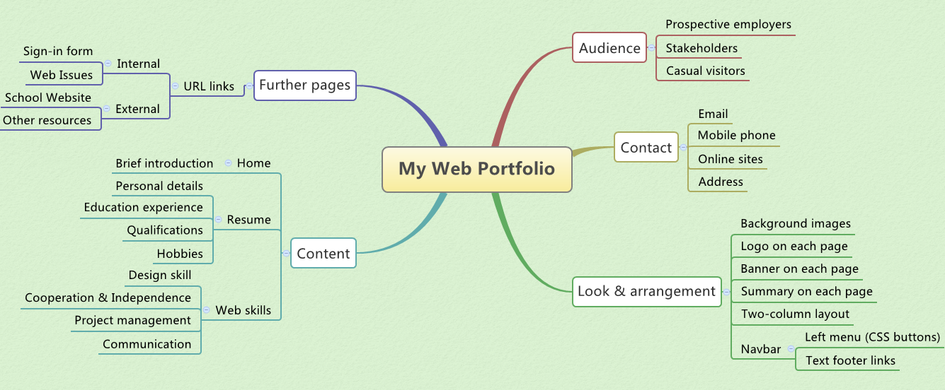

1. CSS Design
   1. The CSS layout plan

The layout for each page on the site will be done using the CSS box model. The layout will be divided up (using divs) into several sections, these sections will be specified in an external CSS style sheet imported into each page on the site. The main sections (divs) are displayed as below.

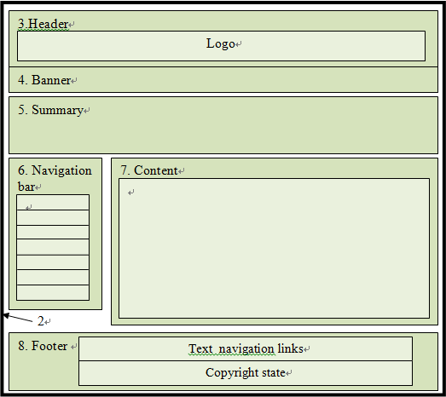

1. Container

2. Outline

3. Pageheader (logo text and image)

4. Banner

5. Summary

6. Navigation Bar

7. Content

8. Footer (text links and copyright state)

This type of a model allows maximum flexibility of the site as each section can be

modified with updated requirements. As the CSS file is imported into all pages any change made to the file is applied to all pages on the site.

1

6. Navigation bar

2

* 1. The CSS text plan

|  |  |  |  |  |
| --- | --- | --- | --- | --- |
| **web_portfolio.css** | **Font Family Text** | **Colour /Special Characteristics** | **Size** | **Align** |
| body | Arial, Verdana, sans-serif, Geneva | color: #333333 (dark green)  margin-top:10px, background image used (background.jpg)  margin-bottom:10px |  |  |
| #logo | Georgia, "Times New Roman", serif, Times | line-height: 26px, font-size:1.70em;  color: #FBD539 (orange), clear: both,  background image used (logo.jpg) |  |  |
| #summary | verdana, arial, Geneva, sans-serif | color: White, float: left, margin: 0 0 0 0 font-size:13px,font-weight: bold | 100% |  |
| #introduction | cursive,Brush Script MT, Comic Sans MS | font-style: italic, font-size:1.30em,  color: #003300, |  |  |
| #container | As body | width: 1000px, background image used (conta,iner.jpg), padding-left: 10px,  padding-right: 10px, |  |  |
| #content | As body | margin-left: 170px, margin-right: 10px;  border: 0px dashed #cccccc (grey) |  |  |
| #linklist li | verdana, arial, Geneva, sans-serif | text-decoration: none, color: white,  list-style: none, font-size: 1.00em, font-weight: bold |  | center |
| #textlink a | As body | font-size: 0.9em, color: #669900, text-decoration: none |  | center |
| #footer | As body | font-weight: lighter, font-size:0.75em |  | center |
| h3 | fantasy, Jokerman, Curlz MT | color: #666600, padding-left: 30px,  font-size:1.50em, background image used (bullet.jpg) |  |  |
| ol | Arial, Verdana, sans-serif, Geneva | color:#333333 |  | left |
| table | As body | margin:auto, border-collapse: collapse,  border: 3px solid #5c743d | 90% |  |
| .navbutton | Tahoma, verdana, arial,sans-serif | display: block, width: 160px, color: white, font-size: 20px, font-weight: bold, text-decoration: none, background image used (button_normal.jpg) |  | center |

1. Navigation Map (Logical)

**Homepage**

Index.html

Screen ID – 1.0

**Written and Spoken Communication Skills** communication.html

Screen ID – 2.5

**Off Site Links**

**No Return Path**

**School’s website on the Internet**

**Contact** contact.html

Screen ID – 2.6

**Resume**

Resume.html

Screen ID – 2.1

**Project Management** management.html

Screen ID – 2.4

**Working Ability** work_ability.html

Screen ID – 2.3

**Design Skill** design.html Screen ID – 2.2

**XHTML Form** form.html

Screen ID – 3.1

**Websites Issues** website_issues.html

Screen ID – 3.2

1. Structure Chart (Physical)

URL of the site ((User Web Root Directory): <http://infotech.scu.edu.au/~rwang16>

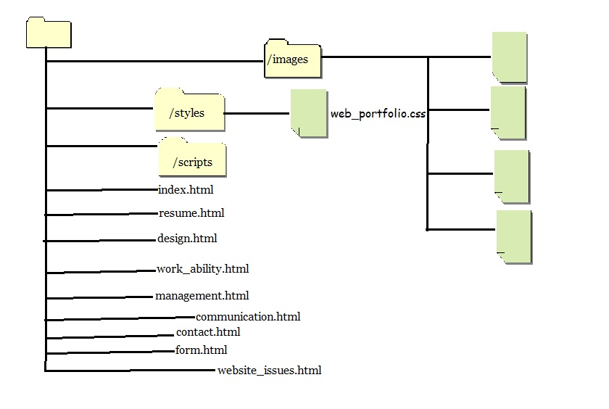

1. Storyboard

TITLE: Homepage (index.html) SCREEN ID: 1.0 DATE: 06/12/2012

**ELEMENTS:**



3.Header

GRAPHICS: There are several graphics showed on this page, they are body and container background images, logo and banner images, CSS buttons with different background images and some graphics, such as developer’s photos, are also present in the content div (7 on the sketch of page).

Logo

4. Banner

5. Summary

TEXT: Homepage mainly introduces this portfolio, including what is this website about and the materials in the web portfolio.

TEXT: *(Student to complete – e.g. Arial Size 12pt*

*Link=purple, Active link=green, Visited link=red,*)

6. Navigation bar

7. Content

AUDIO/VIDEO: There is no audio or video, while a hyperlink to other video website could be added to the content of the site.

AUDIO/VIDEO:

*(not necessary in this site)*

NOTES: The page is designed as a standard two column layout. It contains some divs built inside the container, they are a page header (3) that consist of the site logo text and image, a banner (4) for the page content, a summary (5) that would change on each page, navigation bar (6) provides hyperlinks to other pages in the portfolio, content (7) gives a brief description that introduces the portfolio to possible employers, footer (8) includes copyright information and text links of the navigation bar.

2

Text navigaton links

NOTES:

|  |  |
| --- | --- |
| Description: | Home page |
| Content: | Brief introduction of the web portfolio to possible employers. |
| Interactions: | Hyperlinks, navigation links, graphics/image links. |
| Media Creation: | Nil |
| Navigation: | Navigation links to each page in the site provided by left navigation bar (6) and text footer links (8): index.html, resume.html, design.html, working_ability.html, management.html, conmmunication.html, contact.html. Other hyperlinks from the skill pages are form.html, website_issues.html. |

TITLE: Resume (resume.html) SCREEN ID: 2.1 DATE: 06/12/2012



**ELEMENTS:**

3.Header

GRAPHICS: There are several graphics showed on this page, they are body and container background images, logo and banner images, CSS buttons with different background images and some personal images are also present in the content div (7 on the sketch of page).

Logo

4. Banner

5. Summary

TEXT: Resume page mainly lists personal details, education experience, qualifications, hobbies and other

relevant information, and a hyperlink to the school website.

TEXT: *(Student to complete – e.g. Arial Size 12pt*

*Link=purple, Active link=green, Visited link=red,*)

6. Navigation bar

7. Content

AUDIO/VIDEO: There is no audio or video, while a hyperlink to other video website could be added to the content of the site.

AUDIO/VIDEO:

*(not necessary in this site)*

NOTES: The page is designed as a standard two column layout. It contains some divs built inside the container, they are a page header (3) that consist of the site logo text and image, a banner (4) for the page content, a summary (5) that would change on each page, navigation bar (6) provides hyperlinks to other pages in the portfolio, content (7) gives a description of personal details, footer (8) includes copyright information and text links of the navigation bar.

2

Text navigation links

NOTES:

|  |  |
| --- | --- |
| Description: | Resume |
| Content: | Introduction about web developer in detail to possible employers. |
| Interactions: | Hyperlinks, navigation links, graphics/image links. |
| Media Creation: | Nil |
| Navigation: | Navigation links to each page in the site provided by left navigation bar (6) and text footer links (8): index.html, resume.html, design.html, working_ability.html, management.html, conmmunication.html, contact.html. Other hyperlinks from the skill pages are form.html, website_issues.html. |

TITLE: Design Skill (design.html) SCREEN ID: 2.2 DATE: 06/12/2012

**ELEMENTS:**



3.Header

GRAPHICS: There are several graphics showed on this page, they are body and container background images, logo and banner images, CSS buttons with different background images and some image links to personal web design are also present in the content div (7 on the sketch of page).

Logo

4. Banner

5. Summary

TEXT: Design skill page mainly contains text to explain design skill and a hyperlink to the sign-up form that designed for a King’s Music Store website will be put into the page as a proof about design skill.

TEXT: *(Student to complete – e.g. Arial Size 12pt*

*Link=purple, Active link=green, Visited link=red,*)

6. Navigation bar

7. Content

AUDIO/VIDEO:

*(not necessary in this site)*

AUDIO/VIDEO: There is no audio or video, while a hyperlink to other video website could be added to the content of the site.

NOTES: The page is designed as a standard two column layout. It contains some divs built inside the container, they are a page header (3) that consist of the site logo text and image, a banner (4) for the page content, a summary (5) that would change on each page, navigation bar (6) provides hyperlinks to other pages in the portfolio, content (7) gives a description that introduces design skill, footer (8) includes copyright information and text links of the navigation bar.

2

Text navigation links

NOTES:

|  |  |
| --- | --- |
| Description: | Design skill |
| Content: | This page explains about design skill in detail to possible employers. |
| Interactions: | Hyperlinks, navigation links, graphics/image links. |
| Media Creation: | Nil |
| Navigation: | Navigation links to each page in the site provided by left navigation bar (6) and text footer links (8): index.html, resume.html, design.html, working_ability.html, management.html, conmmunication.html, contact.html. Other hyperlinks from the skill pages are form.html, website_issues.html. |

TITLE:  Working Ability (work_ability.html) SCREEN ID: 2.3 DATE: 06/12/2012

**ELEMENTS:**



3.Header

GRAPHICS: There are several graphics showed on this page, they are body and container background images, logo and banner images, CSS buttons with different background images and some pictures about group works are also present in the content div (7 on the sketch of page).

Logo

4. Banner

5. Summary

TEXT: Working ability page mainly contains text to explain the ability to work as part of a team and independently.

TEXT: *(Student to complete – e.g. Arial Size 12pt*

*Link=purple, Active link=green, Visited link=red,*)

6. Navigation bar

7. Content

AUDIO/VIDEO: There is no audio or video, while a hyperlink to other video website could be added to the content of the site.

AUDIO/VIDEO:

*(not necessary in this site)*

NOTES: The page is designed as a standard two column layout. It contains some divs built inside the container, they are a page header (3) that consist of the site logo text and image, a banner (4) for the page content, a summary (5) that would change on each page, navigation bar (6) provides hyperlinks to other pages in the portfolio, content (7) gives a description that demonstrate the working skill in a group and individual, footer (8) includes copyright information and text links of the navigation bar.

2

Text navigation links

NOTES:

|  |  |
| --- | --- |
| Description: | Working ability |
| Content: | This page explains about working ability in detail to possible employers. |
| Interactions: | Hyperlinks, navigation links, graphics/image links. |
| Media Creation: | Nil |
| Navigation: | Navigation links to each page in the site provided by left navigation bar (6) and text footer links (8): index.html, resume.html, design.html, working_ability.html, management.html, conmmunication.html, contact.html. Other hyperlinks from the skill pages are form.html, website_issues.html. |

TITLE:  Project Management (management.html) SCREEN ID: 2.4 DATE: 06/12/2012

**ELEMENTS:**



3.Header

GRAPHICS: There are several graphics showed on this page, they are body and container background images, logo and banner images, CSS buttons with different background images and some image links to personal project works are also present in the content div (7 on the sketch of page).

Logo

4. Banner

5. Summary

TEXT: Management page mainly contains text to explain the process to do a project and a hyperlink to web_issues.html that displays the changes and reasons that have made to the portfolio, and a report about hosting requirements.

TEXT: *(Student to complete – e.g. Arial Size 12pt*

*Link=purple, Active link=green, Visited link=red,*)

6. Navigation bar

7. Content

AUDIO/VIDEO: There is no audio or video, while a hyperlink to other video website could be added to the content of the site.

AUDIO/VIDEO:

*(not necessary in this site)*

NOTES: The page is designed as a standard two column layout. It contains some divs built inside the container, they are a page header (3) that consist of the site logo text and image, a banner (4) for the page content, a summary (5) that would change on each page, navigation bar (6) provides hyperlinks to other pages in the portfolio, content (7) gives a description that demonstrate skill on project management, footer (8) includes copyright information and text links of the navigation bar.

2

Text navigation links

NOTES:

|  |  |
| --- | --- |
| Description: | Project management |
| Content: | This page explains about managing skill in detail to possible employers. |
| Interactions: | Hyperlinks, navigation links, graphics/image links. |
| Media Creation: | Nil |
| Navigation: | Navigation links to each page in the site provided by left navigation bar (6) and text footer links (8): index.html, resume.html, design.html, working_ability.html, management.html, conmmunication.html, contact.html. Other hyperlinks from the skill pages are form.html, website_issues.html. |

TITLE: Written and Spoken Communication Skills (communication.html) SCREEN ID: 2.5 DATE: 06/12/2012

**ELEMENTS:**



3.Header

GRAPHICS: There are several graphics showed on this page, they are body and container background images, logo and banner images, CSS buttons with different background images and some pictures about communication experience are also present in the content div (7 on the sketch of page).

Logo

4. Banner

5. Summary

TEXT: Communication page mainly contains text to explain the communication examples and experience including writing and speaking.

TEXT: *(Student to complete – e.g. Arial Size 12pt*

*Link=purple, Active link=green, Visited link=red,*)

6. Navigation bar

7. Content

AUDIO/VIDEO: There is no audio or video, while a hyperlink to other video website could be added to the content of the site.

AUDIO/VIDEO:

*(not necessary in this site)*

NOTES: The page is designed as a standard two column layout. It contains some divs built inside the container, they are a page header (3) that consist of the site logo text and image, a banner (4) for the page content, a summary (5) that would change on each page, navigation bar (6) provides hyperlinks to other pages in the portfolio, content (7) gives a description that demonstrate the communication skill, footer (8) includes copyright information and text links of the navigation bar.

2

Text navigation links

NOTES:

|  |  |
| --- | --- |
| Description: | Written and spoken communication skills |
| Content: | This page explains about communication skills in detail to possible employers. |
| Interactions: | Hyperlinks, navigation links, graphics/image links. |
| Media Creation: | Nil |
| Navigation: | Navigation links to each page in the site provided by left navigation bar (6) and text footer links (8): index.html, resume.html, design.html, working_ability.html, management.html, conmmunication.html, contact.html. Other hyperlinks from the skill pages are form.html, website_issues.html. |

TITLE: Contact (contact.html) SCREEN ID: 2.6 DATE: 06/12/2012

**ELEMENTS:**



3.Header

GRAPHICS: There are several graphics showed on this page, they are body and container background images, logo and banner images, CSS buttons with different background images and some image links to online contact ways are also present in the content div (7 on the sketch of page).

Logo

4. Banner

5. Summary

TEXT: Contact page mainly contains text about personal contact detail, including email address, phone number, online contact sites and street address.

TEXT: *(Student to complete – e.g. Arial Size 12pt*

*Link=purple, Active link=green, Visited link=red,*)

6. Navigation bar

7. Content

AUDIO/VIDEO: There is no audio or video.

AUDIO/VIDEO:

*(not necessary in this site)*

NOTES: The page is designed as a standard two column layout. It contains some divs built inside the container, they are a page header (3) that consist of the site logo text and image, a banner (4) for the page content, a summary (5) that would change on each page, navigation bar (6) provides hyperlinks to other pages in the portfolio, content (7) gives contact ways of the web developer, footer (8) includes copyright information and text links of the navigation bar.

2

Text navigation links

NOTES:

|  |  |
| --- | --- |
| Description: | Contact |
| Content: | This page provides contact detail to possible employers. |
| Interactions: | Hyperlinks, navigation links, graphics/image links. |
| Media Creation: | Nil |
| Navigation: | Navigation links to each page in the site provided by left navigation bar (6) and text footer links (8): index.html, resume.html, design.html, working_ability.html, management.html, conmmunication.html, contact.html. Other hyperlinks from the skill pages are form.html, website_issues.html. |

TITLE:  XHTML Form (form.html) SCREEN ID: 3.1 DATE: 06/12/2012

**ELEMENTS:**



3.Header

GRAPHICS: There are several graphics showed on this page, they are body and container background images, logo and banner images, CSS buttons with different background images.

Logo

4. Banner

TEXT: This is a page associated with the design skill page, it mainly contains a XHTML form for the users of a King’s Music Store website to sign up for an email newsletter form the site, it includes user instructions and several fields that name, address, ages, 10 checkboxes for users’ musical taste and text area to inform the shop of further type of music.

5. Summary

TEXT: *(Student to complete – e.g. Arial Size 12pt*

*Link=purple, Active link=green, Visited link=red,*)

6. Navigation bar

7. Content

AUDIO/VIDEO:

*(not necessary in this site)*

AUDIO/VIDEO: There is no audio or video.

NOTES: The page is designed as a standard two column layout. It contains some divs built inside the container, they are a page header (3) that consist of the site logo text and image, a banner (4) for the page content, a summary (5) that would change on each page, navigation bar (6) provides hyperlinks to other pages in the portfolio, content (7) gives a sign-up form for a King’s Music Store website, footer (8) includes copyright information and text links of the navigation bar.

2

8. Footer

Text navigation links

NOTES:

|  |  |
| --- | --- |
| Description: | Sign-up form |
| Content: | This page displays a XHTML form designed by web developer to possible employers. |
| Interactions: | Hyperlinks, navigation links, graphics/image links. |
| Media Creation: | Nil |
| Navigation: | Navigation links to each page in the site provided by left navigation bar (6) and text footer links (8): index.html, resume.html, design.html, working_ability.html, management.html, conmmunication.html, contact.html. Other hyperlinks from the skill pages are form.html, website_issues.html. |

TITLE: Websites Issues (website_issues.html) SCREEN ID: 3.2 DATE: 06/12/2012

**ELEMENTS:**



3.Header

GRAPHICS: There are several graphics showed on this page, they are body and container background images, logo and banner images, CSS buttons with different background images.

Logo

4. Banner

TEXT: This is a page associated with the project management page, it mainly contains text about the changes that have made to the web portfolio, the reasons to change it, and a brief explanation to support each item. In addition, a short report about the requirements for hosting the portfolio will be displayed as a table to present the materials.

5. Summary

TEXT: *(Student to complete – e.g. Arial Size 12pt*

*Link=purple, Active link=green, Visited link=red,*)

6. Navigation bar

7. Content

AUDIO/VIDEO: There is no audio or video.

AUDIO/VIDEO:

*(not necessary in this site)*

NOTES: The page is designed as a standard two column layout. It contains some divs built inside the container, they are a page header (3) that consist of the site logo text and image, a banner (4) for the page content, a summary (5) that would change on each page, navigation bar (6) provides hyperlinks to other pages in the portfolio, content (7) gives text about web portfolio changes and a table for hosting requirements report, footer (8) includes copyright information and text links of the navigation bar.

2

8. Footer

Text navigation links

NOTES:

|  |  |
| --- | --- |
| Description: | Website issues |
| Content: | This page lists some web development issues to display web project management skill of developer to possible employers. |
| Interactions: | Hyperlinks, navigation links, graphics/image links. |
| Media Creation: | Nil |
| Navigation: | Navigation links to each page in the site provided by left navigation bar (6) and text footer links (8): index.html, resume.html, design.html, working_ability.html, management.html, conmmunication.html, contact.html. Other hyperlinks from the skill pages are form.html, website_issues.html. |

6. Testing Procedures

Testing procedure for this Website is as follows.

* Validation of Files
  + All XHTML pages will be validated using XHTML 1.0 Transitional
  + All CSS files will be validated using CSS Level 3.0
* Test “: Look and Arrangement” of display on several browser sizes
* 640 X 480 pixels
* 800 X 600 pixels
* 1024 X 768 pixels
* 1280 X 1024 pixels
* 1440 x 900 pixels
* 1280 x 854 pixels
* 1600 x 1024 pixels
* Test “Look and arrangement” of site on different browsers
* Internet Explorer 8 (Windows XP)
* Internet Explorer 9 (Windows 7)
* Firefox 12 (Mozilla)
* Chrome 20 (Google)
* Safari 5 (Apple)
* Test all hyperlinks on site
* All internal links (site navigation)
* All external hyperlinks
* Test proper functioning of all media on site
* Images
* Test proper functioning of all JavaScript
* Form JavaScript