SOUTHERN CROSS UNIVERSITY
ASSIGNMENT COVER SHEET
For use with online submission of assignments

Please complete all of the following details and then make this sheet the first page of your assignments design documentation – do not send it as a separate document.

Your design documentation must be submitted as either Word documents (with .doc extension, NOT.docx), text documents with .rtf extension or as .pdf documents. If you wish to submit in any other file format please discuss this with your lecturer well before the assignment submission date.

Student Name: | Ruoyi Wang
Student ID No.: | 22009432
Unit Name: | Web Development I
Unit Code: | ISY10209
Tutor’s name: | Alex Hendry
Assignment No.: | No. 3
Assignment Title: | Assignment 3
Due date: | 18/01/2013
Date submitted:

Declaration:

I have read and understand the Rules relating to Awards (Rule 3.18) as contained in the University Handbook. I understand the penalties that apply for plagiarism and agree to be bound by these rules. The work I am submitting electronically is entirely my own work.

Signed:  (please type your name) | Ruoyi Wang
Date: | 20/01/2013

Table of Contents
- Concept Map ................................................................................................................................................................................................... 4

2. CSS Planning ................................................................................................................................................................................................... 5
  - The CSS layout plan .................................................................................................................................................................................... 5
2.2 The CSS text plan ....................................................................................................................................................................................... 6

- Navigation Map (Logical) ................................................................................................................................................................................. 9

- Structure Chart (Physical) ............................................................................................................................................................................... 10

5. Storyboards ........................................................................................................................................................................................................ 11
Homepage ‐ index.html....................................................................................................................................................................................... 12
Resume - resume.html ....................................................................................................................................................................................... 14
Web Development Skills - web.html .................................................................................................................................................................. 16
Working Ability - working_ability.html ............................................................................................................................................................... 18
Project Management - management.html ......................................................................................................................................................... 20
Analysis Skill - analysis.html................................................................................................................................................................................ 22
Contact - contact.html ........................................................................................................................................................................................ 24
Signup Form - form.html ..................................................................................................................................................................................... 26
Websites Issues - website_issues.html................................................................................................................................................................ 28

6. Testing Procedures .............................................................................................................................................................................................
- Concept Map:
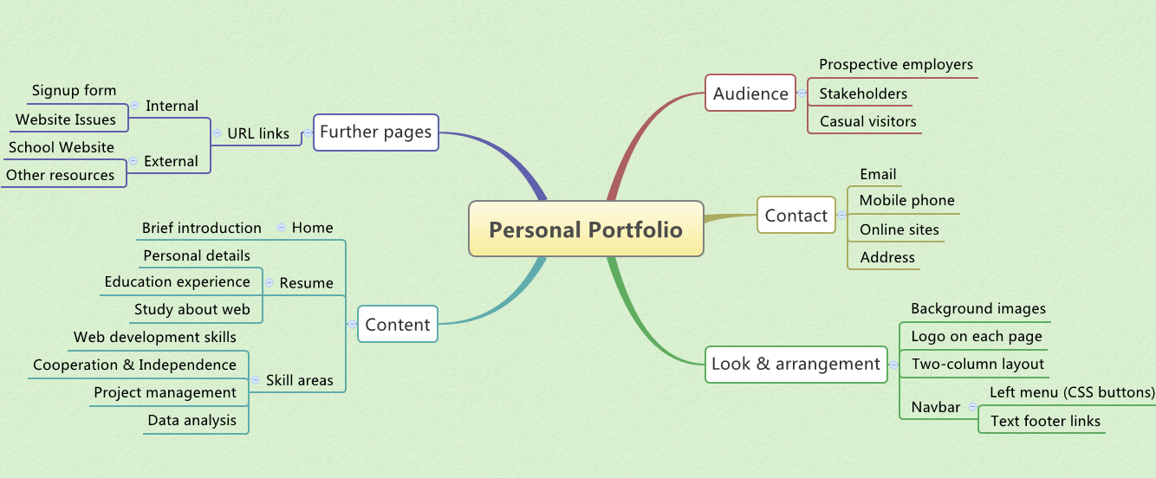
2. CSS Design
  - The CSS layout plan
The layout for each page on the site will be done using the CSS box model. The layout will be divided up (using divs) into several sections, these sections will be specified in an external CSS style sheet imported into each page on the site. The main sections (divs) are displayed as below.
1. Container
2. Outline
3. Header (logo text and background image)
4. Navigation list
5. Content
6. Footer (text links and copyright state)

This type of a model allows maximum flexibility of the site as each section can be
modified with updated requirements. As the CSS file is imported into all pages any change made to the file is applied to all pages on the site.
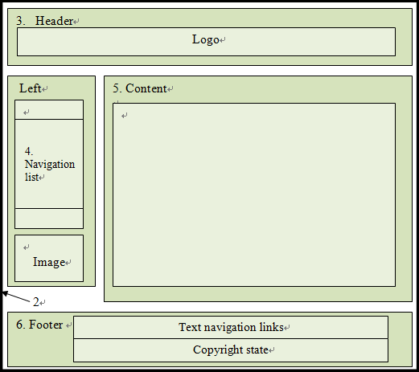

1

6. Navigation bar

2
  - The CSS text plan

Style_Ass3.css | Font Family Text | Color /Special Characteristics | Size | Align
body | Verdana, Arial, Sans-serif | color: #333333 (dark grey)  margin-top:10px, background image used (background.jpg), margin-bottom:10px | 1.08em
#logo | Times New Roman, Georgia, Times | line-height: 120px, color: white, clear: both, background image used (logo.jpg) | 1.60em
#container | As body | width: 1000px, background image used (container.gif), padding-left: 10px,  padding-right: 10px
#content | As body | margin-left:200px, padding-left:5px,  padding-right:5px
#textlink a | As body | color: #993333, text-decoration: none | 0.9em | center
#footer | As body | font-weight: lighter | 0.75em | center
h3 | Jokerman, Curlz-MT, fantasy | color: #666600, padding-left: 40px, background image used (bullet.png) | 1.40em
ol | Arial, Verdana, sans-serif, Geneva | color: #229999 |  | left
ul | As body | font-weight: bold, color: #993333 | 1.0em
legend | As body | font-weight: bold | 1.10em
table | As body | margin: auto, border-collapse: collapse,  border: 3px solid #cc9933 | 100%
.navbutton | Tahoma, verdana, arial, sans-serif | display: block, width: 200px, color: white, font-weight: bold, text-decoration: none, background image used (button_normal.jpg) | 20px | center
.leftlink | As body | color:#993333, text-decoration: none,  font-weight: bold | 1.01em
.labelcol | As body | float: left, width: 240px, padding-right: 10px |  | right

- Navigation Map (Logical)
Home
index.html
Screen ID – 1.0

Resume
resume.html
Screen ID – 2.1

Project Management management.html
Screen ID – 2.4
Web Development Skills
web.html
Screen ID – 2.2

Working Ability working_ability.html
Screen ID – 2.3
Analysis Skill
analysis.html
Screen ID – 2.5
Contact contact.html
Screen ID – 2.6
Off Site Links No Return Path
School’s website on the Internet

Signup Form
form.html
Screen ID – 3.1
Websites Issues website_issues.html
Screen ID – 3.2

- Structure Chart (Physical)
URL of the site (User Web Root Directory): http://infotech.scu.edu.au/~rwang16/Ruoyi_Wang_ISY10209_Ass3/Ruoyi_Wang_Ass3_index.html
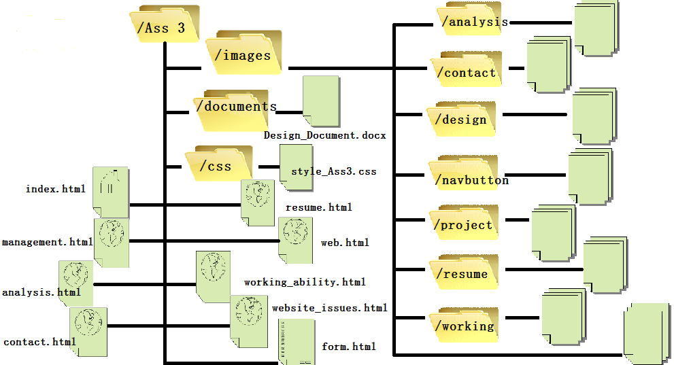
- Storyboards

TITLE: Home (index.html) SCREEN ID: 1.0 DATE: 16/01/2013
ELEMENTS:

3.Header
GRAPHICS: There are several graphics showed on this page, they are body and container background images, logo and banner images, CSS buttons with different background images and some graphics, such as developer’s photos, are also present in the content div (5 on the sketch of page).

Logo

4. Banner

5. Summary

TEXT: (Student to complete – e.g. Arial Size 12pt
Link=purple, Active link=green, Visited link=red,)
TEXT: Homepage mainly introduces this portfolio, including what is this website about and the materials in the web portfolio.

6. Navigation bar
7. Content

AUDIO/VIDEO:
(not necessary in this site)
AUDIO/VIDEO: There is no audio or video, while a hyperlink to other video website could be added to the content of the site.

NOTES: The page is designed as a standard two column layout. It contains some divs built inside the container, they are a page header (3) that consist of the site logo text and image, navigation list (4) on the left side provides links to other pages in the portfolio, content (5) gives a brief description that introduces the portfolio to possible employers, footer (6) includes copyright information and text links of the navigation bar.

2

NOTES:

Text navigaton links

Description: | Home page
Content: | Brief introduction of the web portfolio to possible employers.
Interactions: | Hyperlinks, navigation links, graphics/image links.
Media Creation: | Nil
Navigation: | Navigation links to each page in the site provided by left navigation list (4) and text footer links (6): index.html, resume.html, web.html, working_ability.html, management.html, analysis.html, contact.html. Two hyperlinks at Web Development skills page will be linked to form.html and website_issues.html.

TITLE: Resume (resume.html) SCREEN ID: 2.1 DATE: 16/01/2013

ELEMENTS:
3.Header
GRAPHICS: There are several graphics showed on this page, they are body and container background images, logo and banner images, CSS buttons with different background images and self-portrait are also present in the content div (5 on the sketch of page).

Logo

4. Banner

5. Summary

TEXT: (Student to complete – e.g. Arial Size 12pt
Link=purple, Active link=green, Visited link=red,)
TEXT: Resume page mainly lists personal details, education experience, qualifications, hobbies and other
relevant information, and a hyperlink to the school website.

6. Navigation bar
7. Content

AUDIO/VIDEO:
(not necessary in this site)
AUDIO/VIDEO: There is no audio or video, while a hyperlink to other video website could be added to the content of the site.

NOTES: The page is designed as a standard two column layout. It contains some divs built inside the container, they are a page header (3) that consist of the site logo text and image, navigation list (4) on the left side provides links to other pages in the portfolio, content (5) gives a description of personal details, footer (6) includes copyright information and text links of the navigation bar.

2

NOTES:

Text navigation links

Description: | Resume
Content: | Introduction about web developer in detail to possible employers.
Interactions: | Hyperlinks, navigation links, graphics/image links.
Media Creation: | Nil
Navigation: | Navigation links to each page in the site provided by left navigation list (4) and text footer links (6): index.html, resume.html, web.html, working_ability.html, management.html, analysis.html, contact.html. Two hyperlinks at Web Development skills page will be linked to form.html and website_issues.html.

TITLE: Web Development Skills (web.html) SCREEN ID: 2.2 DATE: 16/01/2013
ELEMENTS:

3.Header
GRAPHICS: There are several graphics showed on this page, they are body and container background images, logo and banner images, CSS buttons with different background images and some image links to personal web design are also present in the content div (5 on the sketch of page).

Logo

4. Banner

5. Summary
TEXT: Web development skills page mainly contains text and some pictures to detail Web design skill and links to a signup form that designed for a King’s Music Store website and to website_issues.html that displays the changes and reasons that have made to the portfolio, and a report about Web hosting requirements will be directly related to web skills.
TEXT: (Student to complete – e.g. Arial Size 12pt
Link=purple, Active link=green, Visited link=red,)

6. Navigation bar
7. Content

AUDIO/VIDEO:
(not necessary in this site)
AUDIO/VIDEO: There is no audio or video, while a hyperlink to other video website could be added to the content of the site.

NOTES: The page is designed as a standard two column layout. It contains some divs built inside the container, they are a page header (3) that consist of the site logo text and image, navigation list (4) on the left side provides links to other pages in the portfolio, content (5) gives a description that introduces web development skills, footer (6) includes copyright information and text links of the navigation bar.

2

NOTES:

Text navigation links

Description: | Design skill
Content: | This page explains about design skill in detail to possible employers.
Interactions: | Hyperlinks, navigation links, graphics/image links.
Media Creation: | Nil
Navigation: | Navigation links to each page in the site provided by left navigation list (4) and text footer links (6): index.html, resume.html, web.html, working_ability.html, management.html, analysis.html, contact.html. Two hyperlinks at Web Development skills page will be linked to form.html and website_issues.html.

TITLE: Working Ability (working_ability.html) SCREEN ID: 2.3 DATE: 16/01/2013
ELEMENTS:

3.Header
GRAPHICS: There are several graphics showed on this page, they are body and container background images, logo and banner images, CSS buttons with different background images and some pictures about group works are also present in the content div (5 on the sketch of page).

Logo

4. Banner

5. Summary

TEXT: (Student to complete – e.g. Arial Size 12pt
Link=purple, Active link=green, Visited link=red,)
TEXT: Working ability page mainly contains text and some screen shots of projects to explain the ability to work as part of a team and independently.

6. Navigation bar
7. Content

AUDIO/VIDEO:
(not necessary in this site)
AUDIO/VIDEO: There is no audio or video, while a hyperlink to other video website could be added to the content of the site.

NOTES: The page is designed as a standard two column layout. It contains some divs built inside the container, they are a page header (3) that consist of the site logo text and image, navigation list (4) on the left side provides links to other pages in the portfolio, content (5) gives a description that demonstrate the working skill in a group and individual, footer (8) includes copyright information and text links of the navigation bar.

2

NOTES:

Text navigation links

Description: | Working ability
Content: | This page explains about working ability in detail to possible employers.
Interactions: | Hyperlinks, navigation links, graphics/image links.
Media Creation: | Nil
Navigation: | Navigation links to each page in the site provided by left navigation list (4) and text footer links (6): index.html, resume.html, web.html, working_ability.html, management.html, analysis.html, contact.html. Two hyperlinks at Web Development skills page will be linked to form.html and website_issues.html.

TITLE: Project Management (management.html) SCREEN ID: 2.4 DATE: 16/01/2013
ELEMENTS:

3.Header
GRAPHICS: There are several graphics showed on this page, they are body and container background images, logo and banner images, CSS buttons with different background images and some screen shots of personal project works are also present in the content div (5 on the sketch of page).
Logo

4. Banner

5. Summary

TEXT: (Student to complete – e.g. Arial Size 12pt
Link=purple, Active link=green, Visited link=red,)
TEXT: Management page mainly contains text to explain the process to do a project and some images of project works for courses.

6. Navigation bar
7. Content

AUDIO/VIDEO:
(not necessary in this site)
AUDIO/VIDEO: There is no audio or video, while a hyperlink to other video website could be added to the content of the site.

NOTES: The page is designed as a standard two column layout. It contains some divs built inside the container, they are a page header (3) that consist of the site logo text and image, navigation list (4) on the left side provides links to other pages in the portfolio, content (5) gives a description that demonstrate skill on project management, footer (6) includes copyright information and text links of the navigation bar.

2

NOTES:

Text navigation links

Description: | Project management
Content: | This page explains about managing skill in detail to possible employers.
Interactions: | Hyperlinks, navigation links, graphics/image links.
Media Creation: | Nil
Navigation: | Navigation links to each page in the site provided by left navigation list (4) and text footer links (6): index.html, resume.html, web.html, working_ability.html, management.html, analysis.html, contact.html. Two hyperlinks at Web Development skills page will be linked to form.html and website_issues.html.

TITLE: Analysis Skill (analysis.html) SCREEN ID: 2.5 DATE: 16/01/2013
ELEMENTS:

3.Header

GRAPHICS: There are several graphics showed on this page, they are body and container background images, logo and banner images, CSS buttons with different background images and some pictures of assignments are also present in the content div (5 on the sketch of page).
Logo

4. Banner

5. Summary

TEXT: (Student to complete – e.g. Arial Size 12pt
Link=purple, Active link=green, Visited link=red,)
TEXT: Analysis page mainly contains text to explain analysis skill in the field of study and some examples of data analysis for assignments in the form of graphics.

6. Navigation bar
7. Content

AUDIO/VIDEO:
(not necessary in this site)
AUDIO/VIDEO: There is no audio or video, while a hyperlink to other video website could be added to the content of the site.

NOTES: The page is designed as a standard two column layout. It contains some divs built inside the container, they are a page header (3) that consist of the site logo text and image, navigation list (4) on the left side provides links to other pages in the portfolio, content (5) gives a description that demonstrate the data analysis skill, footer (6) includes copyright information and text links of the navigation bar.

2

NOTES:

Text navigation links

Description: | Analysis skill
Content: | This page explains about data analysis skill in detail to possible employers.
Interactions: | Hyperlinks, navigation links, graphics/image links.
Media Creation: | Nil
Navigation: | Navigation links to each page in the site provided by left navigation list (4) and text footer links (6): index.html, resume.html, web.html, working_ability.html, management.html, analysis.html, contact.html. Two hyperlinks at Web Development skills page will be linked to form.html and website_issues.html.

TITLE: Contact (contact.html) SCREEN ID: 2.6 DATE: 16/01/2013
ELEMENTS:

3.Header
GRAPHICS: There are several graphics showed on this page, they are body and container background images, logo and banner images, CSS buttons with different background images and some image links to online contact ways are also present in the content div (5 on the sketch of page).
Logo

4. Banner

5. Summary

TEXT: (Student to complete – e.g. Arial Size 12pt
Link=purple, Active link=green, Visited link=red,)
TEXT: Contact page mainly contains text about personal contact detail, including email address, phone number, online contact sites and street address.

6. Navigation bar
7. Content

AUDIO/VIDEO:
(not necessary in this site)
AUDIO/VIDEO: There is no audio or video.

NOTES: The page is designed as a standard two column layout. It contains some divs built inside the container, they are a page header (3) that consist of the site logo text and image, navigation list (4) on the left side provides links to other pages in the portfolio, content (5) gives contact ways of the web developer, footer (6) includes copyright information and text links of the navigation bar.

2

NOTES:

Text navigation links

Description: | Contact
Content: | This page provides contact details to possible employers.
Interactions: | Hyperlinks, navigation links, graphics/image links.
Media Creation: | Nil
Navigation: | Navigation links to each page in the site provided by left navigation list (4) and text footer links (6): index.html, resume.html, web.html, working_ability.html, management.html, analysis.html, contact.html. Two hyperlinks at Web Development skills page will be linked to form.html and website_issues.html.

TITLE: Signup Form (form.html) SCREEN ID: 3.1 DATE: 16/01/2013
ELEMENTS:

3.Header
GRAPHICS: There are several graphics showed on this page, they are body and container background images, logo and banner images, CSS buttons with different background images.
Logo

4. Banner

TEXT: This is a page associated with the Web Development skills page, it mainly contains a XHTML form for the users of a King’s Music Store website to sign up for an email newsletter from the site, it includes user instructions and several fields that name, address, ages, 10 checkboxes for users’ musical taste and text area to inform the shop of further type of music.
5. Summary

TEXT: (Student to complete – e.g. Arial Size 12pt
Link=purple, Active link=green, Visited link=red,)

6. Navigation bar
7. Content

AUDIO/VIDEO:
(not necessary in this site)
AUDIO/VIDEO: There is no audio or video.

NOTES: The page is designed as a standard two column layout. It contains some divs built inside the container, they are a page header (3) that consist of the site logo text and image, navigation list (4) on the left side provides links to other pages in the portfolio, content (5) gives a signup form for a King’s Music Store website, footer (6) includes copyright information and text links of the navigation bar.

2

NOTES:

8. Footer
Text navigation links

Description: | Signup form
Content: | This page displays a XHTML form designed by Web developer to possible employers.
Interactions: | Hyperlinks, navigation links, graphics/image links.
Media Creation: | Nil
Navigation: | Navigation links to each page in the site provided by left navigation list (4) and text footer links (6): index.html, resume.html, web.html, working_ability.html, management.html, analysis.html, contact.html. Two hyperlinks at Web Development skills page will be linked to form.html and website_issues.html.

TITLE: Websites Issues (website_issues.html) SCREEN ID: 3.2 DATE: 16/01/2013
ELEMENTS:

3.Header
GRAPHICS: There are several graphics showed on this page, they are body and container background images, logo and banner images, CSS buttons with different background images.
Logo

4. Banner
TEXT: This is a page associated with Web Development skills page, it mainly contains text about the changes that have made to the web portfolio, the reasons to change it, and a brief explanation to support each item. In addition, a short report about the factors to choose a Web host provider for portfolio will be displayed as a table to present the materials.
5. Summary

TEXT: (Student to complete – e.g. Arial Size 12pt
Link=purple, Active link=green, Visited link=red,)

6. Navigation bar
7. Content

AUDIO/VIDEO:
(not necessary in this site)
AUDIO/VIDEO: There is no audio or video.

NOTES: The page is designed as a standard two column layout. It contains some divs built inside the container, they are a page header (3) that consist of the site logo text and image, navigation list (4) on the left side provides links to other pages in the portfolio, content (5) gives text about Web portfolio changes and a table for hosting requirements report, footer (6) includes copyright information and text links of the navigation bar.

2

NOTES:

8. Footer
Text navigation links

Description: | Website issues
Content: | This page lists some Web development issues to display the web skills to possible employers.
Interactions: | Hyperlinks, navigation links, graphics/image links.
Media Creation: | Nil
Navigation: | Navigation links to each page in the site provided by left navigation bar (6) and text footer links (8): index.html, resume.html, design.html, working_ability.html, management.html, conmmunication.html, contact.html. Other hyperlinks from the skill pages are form.html, website_issues.html.

6. Testing Procedures
Testing procedure for this Website is as follows.
- Validation of Files
  - All XHTML pages will be validated using XHTML 1.0 Transitional
  - All CSS files will be validated using CSS Level 3.0
- Test “: Look and Arrangement” of display on several browser sizes
- 640 X 480 pixels
- 800 X 600 pixels
- 1024 X 768 pixels
- 1280 X 1024 pixels
- 1440 x 900 pixels
- 1280 x 854 pixels
- 1600 x 1024 pixels
- Test “Look and arrangement” of site on different browsers
- Internet Explorer 8 (Windows XP)
- Internet Explorer 9 (Windows 7)
- Firefox 12 (Mozilla)
- Chrome 20 (Google)
- Safari 5 (Apple)
- Test all hyperlinks on site
- All internal links (site navigation)
- All external hyperlinks
- Test proper functioning of all media on site
- Images
- Test proper functioning of all JavaScript
- Form JavaScript

