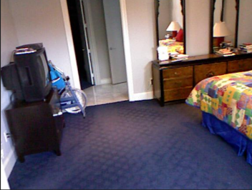Image Understanding



Region 1

Region N

Region 2

CNN



Query 1 1

SOFTMAX

Query 1

Query1 2

Image



Query1 N



Question

What colour is the mat?

Query 0

**GRU**

Question Encoding Reasoning Answering