Work Report

Team- 09

Project Topic-MediTrack

Faculty Guide-Amit Upadhyay

Project Guide-Aditya Shirsath

Project Lead-Rupali Pangare

|  |  |
| --- | --- |
| Student Name | Roll No |
| Rupali Pangare | 200240320094 |
| Nikhil Deshpande | 200240320069 |
| Shubham Nikam | 200240320114 |
| Siddhesh Bhavsar | 200240320121 |
| Subham Singh | 200240320123 |

GitHub Link :

<https://github.com/rupa2997/Team09-MediTrack>

Jira Link :

<https://projectteam-09.atlassian.net/secure/RapidBoard.jspa?projectKey=TEAM9&rapidView=2>

Project Participation :

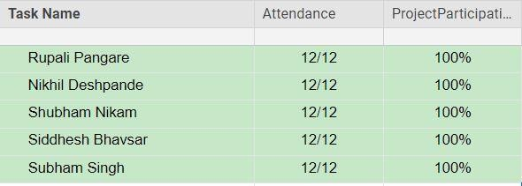

Synopsis Task Report :

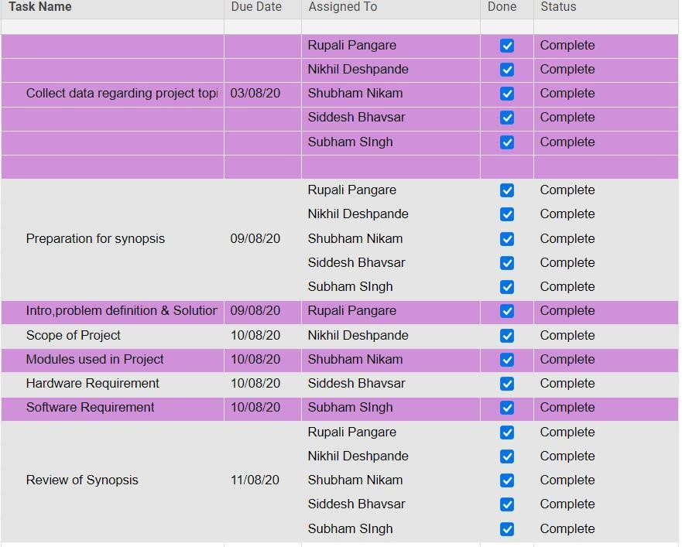

SRS Task Report :

