Design Document

* Commands to execute my program:

Compile: g++ -std=c++11 polynomialtest.cpp Polynomial.cpp Polynomial.h



Run:

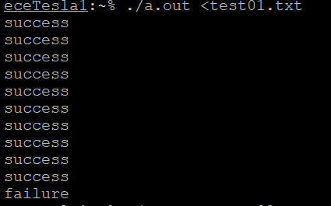

* What class(es) did you design? What are the member variables and member functions for each of these classes?

Class for my design was: Polynomial

Member variables:

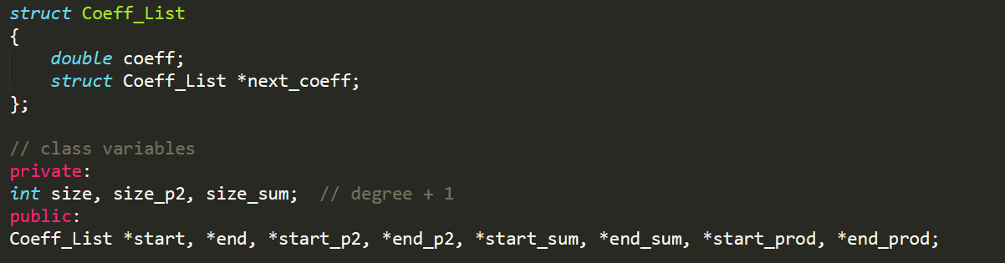

The major member methods/functions and their functionalities I designed are shown below:

|  |  |
| --- | --- |
| **Member Function** | **Function Description** |
| void init(int m) | Initializes the size of polynomial p1 |
| void coeff_p1(const Polynomial &current_polynomial); | Initializes coeffp1 linked list |
| void coeff_p2(int expected_size, const double expected_coeff_p[]); | Initializes coeffp2 linked list |
| void get(int expected_size, const double expected_coeff_p[]) const ; | Checks if the size and the coefficients of polynomial p1 matches with the expected polynomial |
| void evaluate(const double x, const double expected_value) const; | Evaluates polynomial p1 at the value x and compares the result with expected_value |
| void add(int expected_size, const double expected_coeff_p[]) const; | Adds p1 and p2 and compares with the expected size and expected coeff[] |
| void mult(int expected_size, const double expected_coeff_p[]) const; | Multiplies p1 and p2 and compares with the expected size and expected coeff[] |

* For each class, what are your design decisions regarding constructors?
  + 1. **Default Constructor**- Polynomial::Polynomial();. This initializes all the private and public variables to 0/NULL.
    2. **Polynomial given 2 parameters**- Polynomial::Polynomial (int x, const double coeff_p[]); This method initializes the size with the x value and iterates through coeffp[] array assigning values to the p1 linked list.
* For each class, what are your design decisions regarding destructors?
  + - * The destructor sets all the private variable back to null values.