Screenshots:

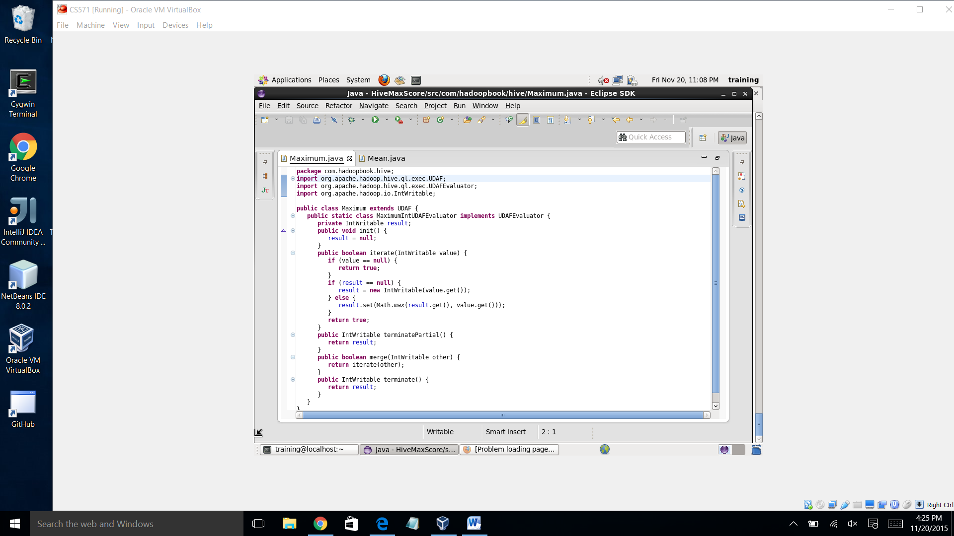

Source code: **Maximum**

package maxScore;

import org.apache.hadoop.hive.ql.exec.UDAF;

import org.apache.hadoop.hive.ql.exec.UDAFEvaluator;

import org.apache.hadoop.io.IntWritable;

public class Maximum extends UDAF {

public static class MaximumIntUDAFEvaluator implements UDAFEvaluator {

private IntWritable result;

public void init() {

result = null;

}

public boolean iterate(IntWritable value) {

if (value == null) {

return true;

}

if (result == null) {

result = new IntWritable(value.get());

} else {

result.set(Math.max(result.get(), value.get()));

}

return true;

}

public IntWritable terminatePartial() {

return result;

}

public boolean merge(IntWritable other) {

return iterate(other);

}

public IntWritable terminate() {

return result;

}

}

}

**Mean:**

package maxScore;

import org.apache.hadoop.hive.ql.exec.UDAF;

import org.apache.hadoop.hive.ql.exec.UDAFEvaluator;

import org.apache.hadoop.hive.serde2.io.DoubleWritable;

public class Mean extends UDAF {

public static class MeanDoubleUDAFEvaluator implements UDAFEvaluator {

public static class PartialResult {

double sum;

long count;

}

private PartialResult partial;

public void init() {

partial = null;

}

public boolean iterate(DoubleWritable value) {

if (value == null) {

return true;

}

if (partial == null) {

partial = new PartialResult();

}

partial.sum += value.get();

partial.count++;

return true;

}

public PartialResult terminatePartial() {

return partial;

}

public boolean merge(PartialResult other) {

if (other == null) {

return true;

}

if (partial == null) {

partial = new PartialResult();

}

partial.sum += other.sum;

partial.count += other.count;

return true;

}

public DoubleWritable terminate() {

if (partial == null) {

return null;

}

return new DoubleWritable(partial.sum / partial.count);

}

}

}

