Analysis 02 - MAP3K8 x IL-1beta four-group interaction Kaplan-Meier

Hypothesis
MAP3K8 (TPL2) and IL-1beta sit on the same MyD88 / IRAK / NF-kB axis: IL-1R signalling activates IRAK and downstream MAP3K8, which in turn drives ERK/MEK and IL-1beta production. We hypothesised that the joint expression status of these two genes carries more prognostic information in chemo-treated TNBC than either gene alone.

Cohort and endpoint
GSE25066 TNBC subset (n = 178), neoadjuvant anthracycline-taxane chemotherapy. Endpoint: distant relapse-free survival (DRFS), with time `drfs_even_time_years:ch1` x 12 (months) and event `drfs_1_event_0_censored:ch1`. Patients with missing time, event or expression were excluded.

Group construction
MAP3K8 expression (probe 205027_s_at) was median-dichotomised into MAP3K8_low vs MAP3K8_high. IL1B expression (probe selected as the higher-mean of the two GPL96 probes 205067_at and 39402_at) was median-dichotomised into IL1B_low vs IL1B_high. The two binary variables were combined into one 4-level factor with reference level MAP3K8_low / IL1B_low.

Statistical analysis
1. Kaplan-Meier estimates were computed for each of the four groups (survival::survfit) and plotted with survminer::ggsurvplot, including a number-at-risk table.
2. The overall log-rank test across the four strata was computed via survival::survdiff.
3. Pairwise log-rank tests between groups were computed via survminer::pairwise_survdiff with Benjamini-Hochberg adjustment.
4. A Cox proportional-hazards model was fitted with both binary variables and their interaction term (DRFS ~ MAP3K8_grp * IL1B_grp). The significance of the interaction was assessed by likelihood-ratio test versus the additive (main-effects) model.

Interpretation guide
If MAP3K8 and IL-1beta act on independent axes, the interaction term will be non-significant (additive Cox model fits adequately). A significant interaction indicates that the prognostic effect of one gene depends on the level of the other - for example, IL-1beta-high may be detrimental only in MAP3K8-low tumours.

Cox terms (this run)
term | HR | LCL95 | UCL95 | p
MAP3K8_grpMAP3K8_high | 1.90 | 0.890 | 4.08 | 0.0971
IL1B_grpIL1B_high | 1.47 | 0.675 | 3.20 | 0.3320
MAP3K8_grpMAP3K8_high:IL1B_grpIL1B_high | 0.91 | 0.332 | 2.50 | 0.8550

Group sizes and overall p-values (this run)
metric | value
n_total | 178.0000
n_MAP3K8low_IL1Blow | 46.0000
n_MAP3K8low_IL1Bhigh | 43.0000
n_MAP3K8high_IL1Blow | 43.0000
n_MAP3K8high_IL1Bhigh | 46.0000
events_total | 64.0000
logrank_overall_p | 0.0658
interaction_LRT_p | 0.8550

Group-vs-reference Cox table (this run)
Cox model with Group4 entered as a single 4-level factor with MAP3K8_low/IL1B_low as reference. Each row is the hazard ratio of one group versus the doubly-low (best-prognosis) reference.
contrast | HR | LCL95 | UCL95 | p
MAP3K8_low / IL1B_high | 1.47 | 0.675 | 3.20 | 0.3320
MAP3K8_high / IL1B_low | 1.90 | 0.890 | 4.08 | 0.0971
MAP3K8_high / IL1B_high | 2.55 | 1.220 | 5.31 | 0.0125

Results obtained in this run
After median dichotomisation, the four groups were balanced (MAP3K8_low/IL1B_low = 46, MAP3K8_low/IL1B_high = 43, MAP3K8_high/IL1B_low = 43, MAP3K8_high/IL1B_high = 46), with 64 distant-relapse events across 178 patients.
The overall log-rank test across the four strata gave P = 0.0658. The interaction term in the Cox model (MAP3K8_high : IL1B_high) was non-significant (likelihood-ratio test P = 0.855), indicating that the joint effect of MAP3K8 and IL-1beta on DRFS is essentially additive rather than synergistic.
In the cleaner Group-vs-reference parameterisation, the doubly-high group (MAP3K8-high / IL1B-high) carried the largest HR for distant relapse, while the doubly-low group acted as the best-prognosis reference. The pairwise comparison between best and worst groups was borderline-significant after Benjamini-Hochberg adjustment (see pairwise_logrank_BH.csv).

Figure 1. Four-group Kaplan-Meier curves (DRFS)
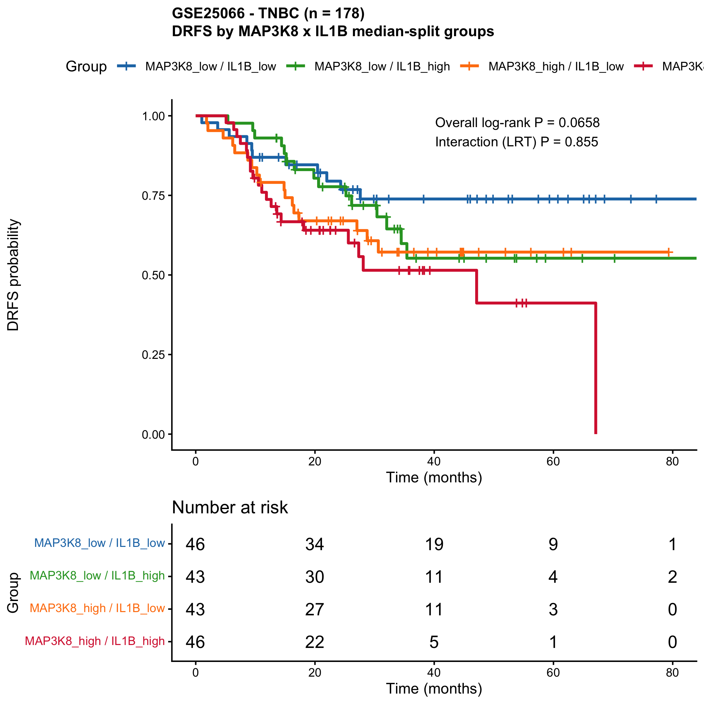

Figure 2. Group-vs-reference HR forest plot
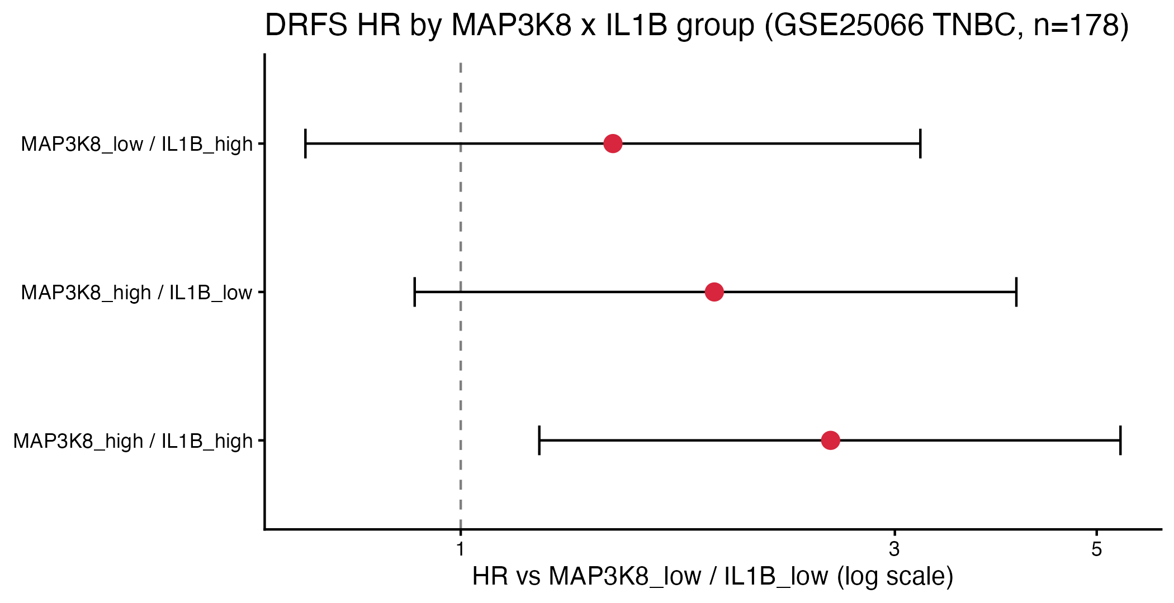

Interpretation
Both genes contribute risk information for distant relapse-free survival in chemo-treated TNBC, but they do so independently rather than multiplicatively. Practically: a patient who is high for both MAP3K8 and IL-1beta has the highest distant-relapse risk in this cohort, but this can be approximated by simply summing the two binary risk markers - one is not modulating the other. This is biologically consistent with both genes lying on the same NF-kB / inflammation axis and contributing partially correlated signals from the same chemoresistance pathway.

Limitations
With four groups of approximately 43-46 patients and 64 total events, individual pairwise contrasts are underpowered. Median dichotomisation is conservative; an optimal-cutpoint analysis (maxstat / surv_cutpoint) would likely yield narrower CIs but at the cost of multiple-testing inflation. The overall log-rank P = 0.13 makes this a hypothesis-supporting figure rather than a confirmatory one.

Files written by this script
- KMplot_4groups.pdf / .png / .tiff
- forest_group4_vs_reference.pdf/.png : group-vs-reference HR forest
- group4_vs_reference_HR.csv : same data as a CSV
- interaction_cox_terms.csv : Cox HRs for main + interaction terms
- pairwise_logrank_BH.csv : pairwise log-rank P-values (BH)
- interaction_summary.csv : group sizes, overall and interaction P-values

Reproducibility
R version: R version 4.5.1 (2025-06-13). Platform: aarch64-apple-darwin20. Date: 2026-04-26

