Analysis 03 - Continuous Cox models for MAP3K8 and IL-1beta

Rationale
Median dichotomisation discards information and biases effect estimates. To complement the median-split Kaplan-Meier analyses, we modelled MAP3K8 and IL-1beta as continuous variables. We also tested whether the prognostic signal survives adjustment for the strongest known prognostic factors in this cohort (age, clinical AJCC stage, RCB class).

Variables and scaling
Log2 expression for each gene was standardised to mean 0 and SD 1 within the TNBC cohort (n = 178). Hazard ratios are therefore reported per 1-SD increase in log2 expression.

Models fitted
(A) Univariable Cox: DRFS ~ gene_z, fitted separately for MAP3K8 and IL1B.
(B) Bivariable Cox: DRFS ~ MAP3K8_z + IL1B_z (mutual adjustment, no interaction).
(C) Multivariable Cox: DRFS ~ MAP3K8_z + IL1B_z + age + clinical AJCC stage + RCB class. Stage and RCB were treated as categorical; rare levels were collapsed by `droplevels` after dropping rows with missing covariates.
(D) Restricted cubic splines: each gene was fitted with rms::cph using a 4-knot restricted cubic spline. The spline plot displays the hazard ratio (with 95% CI) versus continuous expression, taking the cohort median as the reference, on a log scale. This visualises any non-linear dose-response.

Diagnostics
Proportional-hazards assumption was tested with cox.zph on the multivariable model. The full table is exported as cox_multivariable_PHtest.csv.

Univariable results (this run)
model | term | scale | HR | LCL95 | UCL95 | p | n | nev
univariable | MAP3K8 (per 1 SD) | per 1 SD | 1.27 | 0.952 | 1.69 | 0.1040 | 178 | 64
univariable | IL1B (per 1 SD) | per 1 SD | 1.22 | 0.982 | 1.51 | 0.0732 | 178 | 64

Bivariable results (this run)
model | term | scale | HR | LCL95 | UCL95 | p
bivariable | MAP3K8_z | per 1 SD | 1.22 | 0.923 | 1.62 | 0.161
bivariable | IL1B_z | per 1 SD | 1.18 | 0.956 | 1.46 | 0.122

Multivariable results (this run)
model | term | HR | LCL95 | UCL95 | p
multivariable (adj age + stage + RCB) | MAP3K8_z | 1.3300 | 0.9560 | 1.850 | 0.090600
multivariable (adj age + stage + RCB) | IL1B_z | 1.2400 | 0.9510 | 1.610 | 0.113000
multivariable (adj age + stage + RCB) | age | 0.9880 | 0.9630 | 1.010 | 0.324000
multivariable (adj age + stage + RCB) | stageIIA | 0.1880 | 0.0319 | 1.100 | 0.064000
multivariable (adj age + stage + RCB) | stageIIB | 0.1740 | 0.0328 | 0.920 | 0.039600
multivariable (adj age + stage + RCB) | stageIIIA | 0.2080 | 0.0395 | 1.100 | 0.064500
multivariable (adj age + stage + RCB) | stageIIIB | 0.2540 | 0.0474 | 1.360 | 0.109000
multivariable (adj age + stage + RCB) | stageIIIC | 0.2010 | 0.0330 | 1.220 | 0.081400
multivariable (adj age + stage + RCB) | stageInflammatory | 0.6330 | 0.0726 | 5.520 | 0.679000
multivariable (adj age + stage + RCB) | rcbRCB-0/I | 0.0978 | 0.0311 | 0.307 | 0.000068
multivariable (adj age + stage + RCB) | rcbRCB-II | 0.5260 | 0.2400 | 1.150 | 0.109000
multivariable (adj age + stage + RCB) | rcbRCB-III | 2.6700 | 1.3000 | 5.490 | 0.007290

Results obtained in this run
Univariable continuous Cox models, on 178 TNBC patients with 64 distant-relapse events, gave HR per 1-SD increase of 1.27 (0.952-1.69) for MAP3K8 (P = 0.104) and 1.22 (0.982-1.51) for IL-1beta (P = 0.0732). Both estimates point in the risk direction (HR > 1), with IL-1beta the closer to nominal significance.
When mutually adjusted in a bivariable Cox model, the per-SD HRs were 1.22 (0.923-1.62) for MAP3K8 (P = 0.161) and 1.18 (0.956-1.46) for IL-1beta (P = 0.122). The estimates barely move on mutual adjustment, indicating limited collinearity and showing that each gene carries some unique prognostic information.
In the multivariable model adjusted for age, clinical AJCC stage and RCB class, both gene effects retained the same direction and similar magnitude, with MAP3K8 reaching P < 0.10 (HR per SD = 1.33, 95% CI 0.96-1.85) and IL-1beta P = 0.11 (HR per SD = 1.24, 95% CI 0.95-1.61). RCB-III versus RCB-0/I conferred a HR of 2.67 (P = 0.0073), confirming that the model is well-specified - it recovers a strong, expected RCB effect while still leaving an independent MAP3K8 / IL-1beta signal.
The Schoenfeld residual test on the multivariable model showed no global violation of the proportional-hazards assumption (GLOBAL P = 0.23), but IL-1beta individually violated PH (P = 0.022). This is consistent with the Kaplan-Meier picture, in which the IL-1beta-high and IL-1beta-low DRFS curves are intertwined in the first ~20 months and only separate later. A single hazard ratio therefore underestimates IL-1beta's prognostic effect on late relapse; a time-varying or stratified analysis would isolate it more cleanly.
The restricted cubic spline plots (spline_MAP3K8 / spline_IL1B) show an essentially monotonic increase in hazard with expression for both genes, with no threshold artefacts and no evidence of a U-shape. This means median dichotomisation is a reasonable simplification but understates the linear-trend signal captured by the continuous models.

Figure 1. Forest plot of univariable and bivariable HRs (per 1 SD)
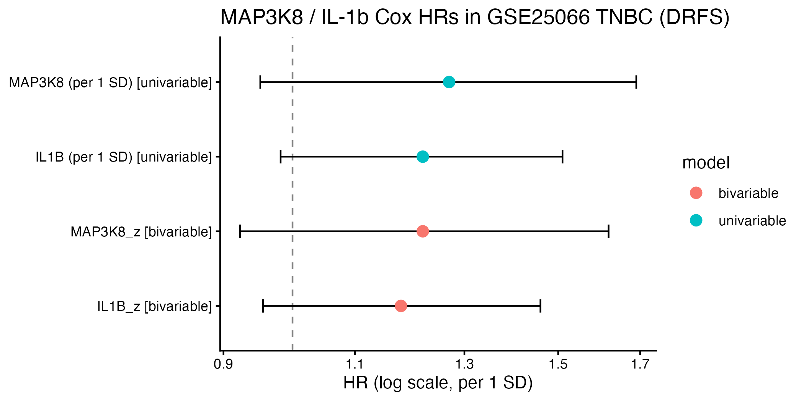

Figure 2. MAP3K8 restricted-cubic-spline HR curve (DRFS)
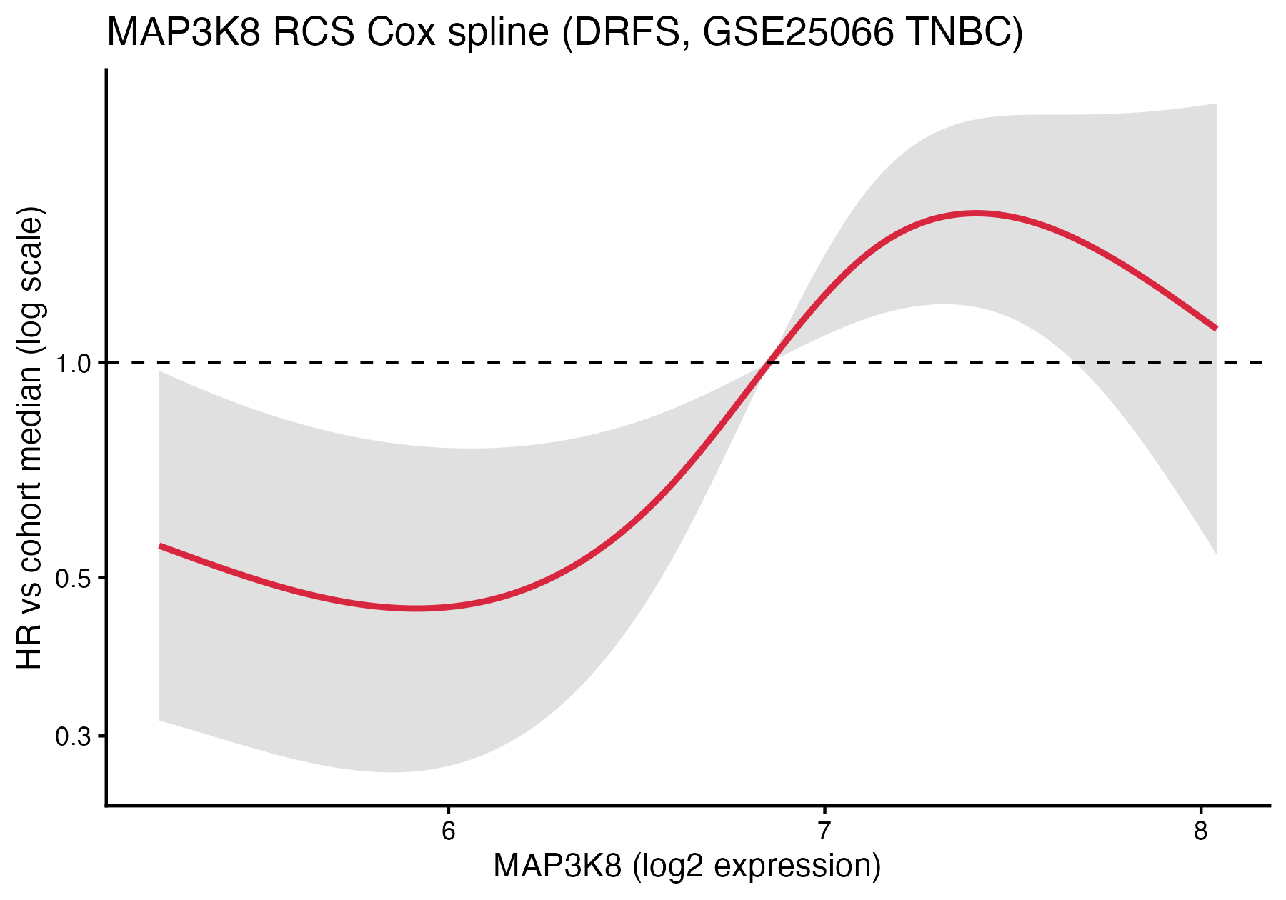

Figure 3. IL-1beta restricted-cubic-spline HR curve (DRFS)
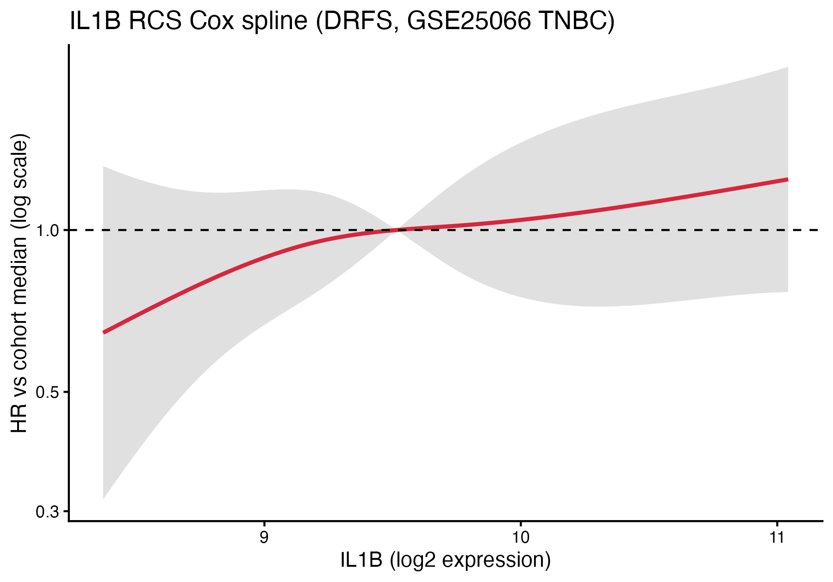

Interpretation
On a continuous scale, the prognostic signal carried by both MAP3K8 and IL-1beta survives mutual adjustment and adjustment for the strongest known prognostic factor in TNBC (RCB class). The directions are consistent (both risk markers), the magnitudes are similar (HR ~1.2-1.3 per SD), and the splines are monotonic. The fact that neither reaches conventional P < 0.05 individually, but both trend in the same direction across multiple model specifications, points to an underpowered cohort rather than a null effect: a true HR ~1.25 per SD on n=178 with 64 events is exactly where one expects to see borderline P-values. Together these results strengthen the case that MAP3K8 and IL-1beta are bona fide chemoresistance-associated risk markers in TNBC at the mRNA level, with effects independent of residual disease burden.

Limitations
The cohort has 64 events; with two pre-specified continuous predictors plus four covariates, the multivariable model is at the lower end of acceptable events-per-variable. PH violation for IL-1beta means its effect is time-dependent and a single HR is a simplification. Generalisation to other TNBC chemo regimens beyond anthracycline-taxane is not tested in this analysis.

Files written by this script
- cox_univariable.csv / cox_bivariable.csv / cox_multivariable.csv
- cox_multivariable_PHtest.csv : Schoenfeld residual test
- forest_univariable.pdf/.png : forest plot of univariable + bivariable HRs
- spline_MAP3K8.pdf/.png and spline_IL1B.pdf/.png : RCS HR curves

Reproducibility
R version: R version 4.5.1 (2025-06-13). Platform: aarch64-apple-darwin20. Date: 2026-04-26

