MAP3K8 and IL-1beta as chemoresistance biomarkers in TNBC
Project-level summary across four pre-specified analyses on the chemo-treated TNBC cohort GSE25066, with an external validation cohort GSE41998. This document integrates the methods and findings of the four per-analysis Word documents stored in the subfolders 01-04.

Cohorts
Discovery cohort: GSE25066 (Hatzis & Pusztai, JAMA 2011; Booser series). 508 women with primary breast cancer treated with neoadjuvant anthracycline-taxane chemotherapy, profiled on Affymetrix HG-U133A (GPL96). The TNBC subset (n = 178), defined as ER-IHC negative AND PR-IHC negative AND HER2 negative, was used for all primary analyses. Endpoints: distant relapse-free survival (DRFS, time `drfs_even_time_years:ch1` x 12 months, event `drfs_1_event_0_censored:ch1`); pathological complete response (pCR vs RD); Residual Cancer Burden class.
Validation cohort: GSE41998 (Horak et al.; SWOG / BMS-247550-013), 279 patients in a randomised neoadjuvant ixabepilone-vs-paclitaxel trial, GPL96. The TNBC subset (n = 140) and the pCR endpoint were used; DRFS is not publicly provided in GEO for this series.
Probes on GPL96: MAP3K8 = 205027_s_at (single probe). IL-1beta has two probes (205067_at and 39402_at); we selected the higher-mean probe within the TNBC subset of each cohort, which yielded 205067_at in GSE25066 and 39402_at in GSE41998.

Important note on direction of effect
In the original MAP3K8 KM analysis (parent script and saved workspace), the reported HR = 0.56 (0.34 - 0.92, log-rank P = 0.02) was computed with the factor MAP3K8_group having levels c('high','low'); R's coxph treats the second level as the contrast level, so this HR is for MAP3K8-low versus MAP3K8-high. Inverting it gives HR(MAP3K8-high vs MAP3K8-low) = 1/0.56 ~ 1.80, i.e. MAP3K8-high tumours have higher risk of distant relapse, the same direction as IL-1beta. All analyses in this folder are presented and interpreted in that corrected direction (HR > 1 means the high group is at higher risk).

Analysis 01 - pCR / RCB
Question: do MAP3K8 or IL-1beta mRNA levels distinguish patients who achieve pCR from those with residual disease, and do they track RCB severity? Tests: Wilcoxon for pCR vs RD, Kruskal-Wallis across RCB classes, univariable logistic regression with continuous expression.
gene | n_pCR | n_RD | median_in_pCR | median_in_RD | Wilcoxon_p | KruskalWallis_p | logreg_OR_perUnit | logreg_OR_LCL | logreg_OR_UCL | logreg_p
MAP3K8 | 57 | 113 | 6.887752 | 6.859294 | 0.729 | 0.489 | 1.01 | 0.735 | 1.41 | 0.960
IL1B | 57 | 113 | 9.380346 | 9.559739 | 0.267 | 0.924 | 0.89 | 0.617 | 1.26 | 0.519

Figure A1.1 - pCR vs RD boxplots (analysis 01)
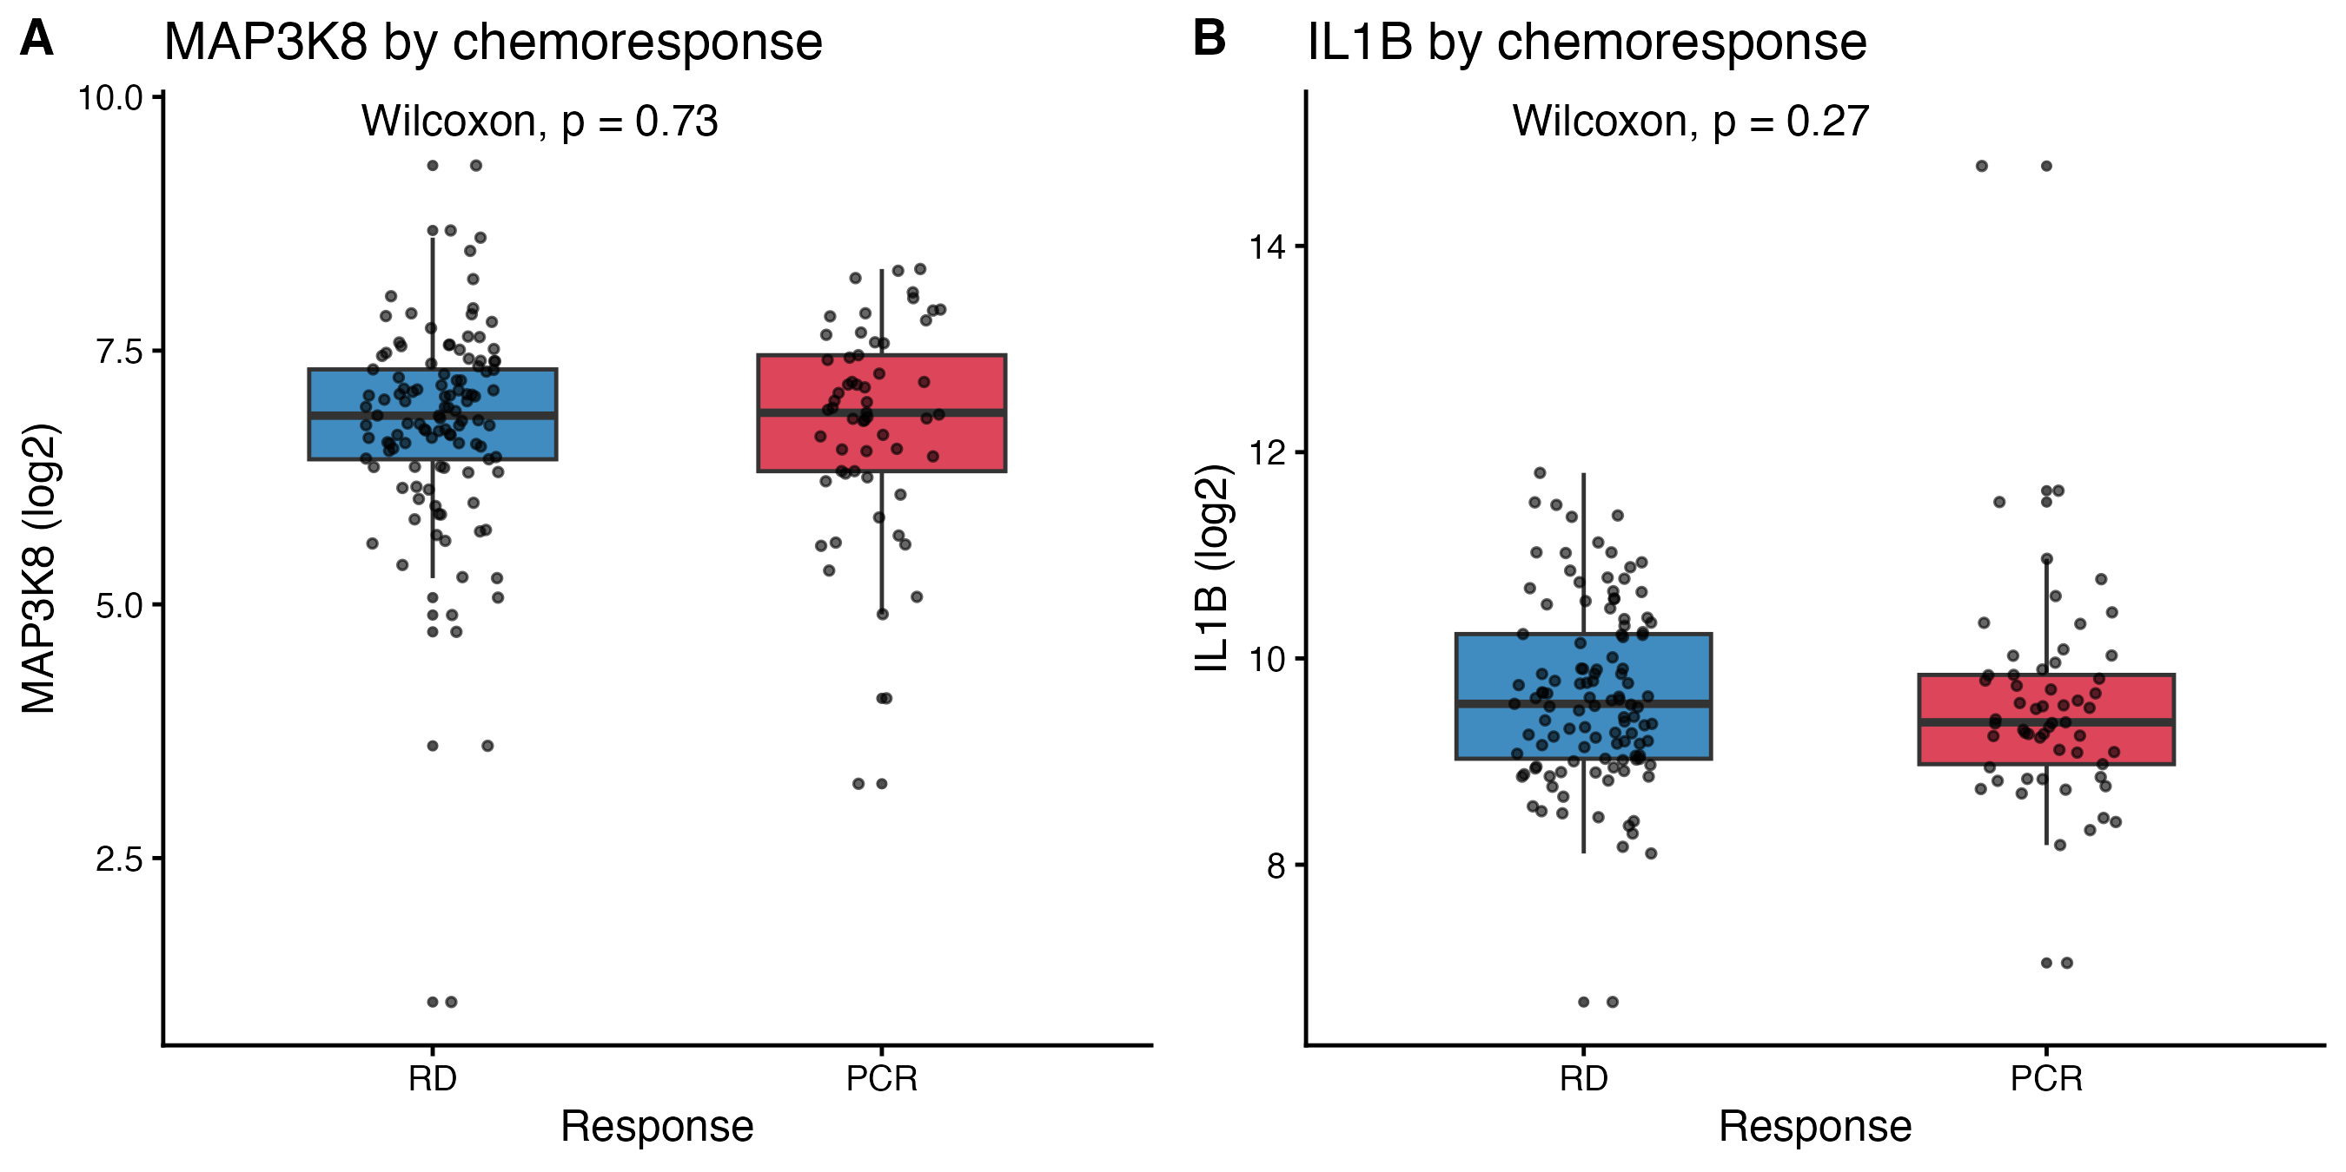
Verdict: neither gene predicts pCR. The signal these genes carry is on relapse, not on initial chemoresponse.

Analysis 02 - MAP3K8 x IL-1beta four-group KM
Question: do the two genes interact, or do they contribute independent prognostic information? Design: median dichotomisation of each gene; combined into a 4-level factor with MAP3K8_low / IL1B_low as reference.
Group sizes and overall test:
metric | value
n_total | 178.0000
n_MAP3K8low_IL1Blow | 46.0000
n_MAP3K8low_IL1Bhigh | 43.0000
n_MAP3K8high_IL1Blow | 43.0000
n_MAP3K8high_IL1Bhigh | 46.0000
events_total | 64.0000
logrank_overall_p | 0.0658
interaction_LRT_p | 0.8550
Group versus reference HRs:
contrast | HR | LCL95 | UCL95 | p
MAP3K8_low / IL1B_high | 1.47 | 0.675 | 3.20 | 0.3320
MAP3K8_high / IL1B_low | 1.90 | 0.890 | 4.08 | 0.0971
MAP3K8_high / IL1B_high | 2.55 | 1.220 | 5.31 | 0.0125
Cox interaction parameterisation:
term | HR | LCL95 | UCL95 | p
MAP3K8_grpMAP3K8_high | 1.90 | 0.890 | 4.08 | 0.0971
IL1B_grpIL1B_high | 1.47 | 0.675 | 3.20 | 0.3320
MAP3K8_grpMAP3K8_high:IL1B_grpIL1B_high | 0.91 | 0.332 | 2.50 | 0.8550

Figure A2.1 - Four-group Kaplan-Meier curves (DRFS)
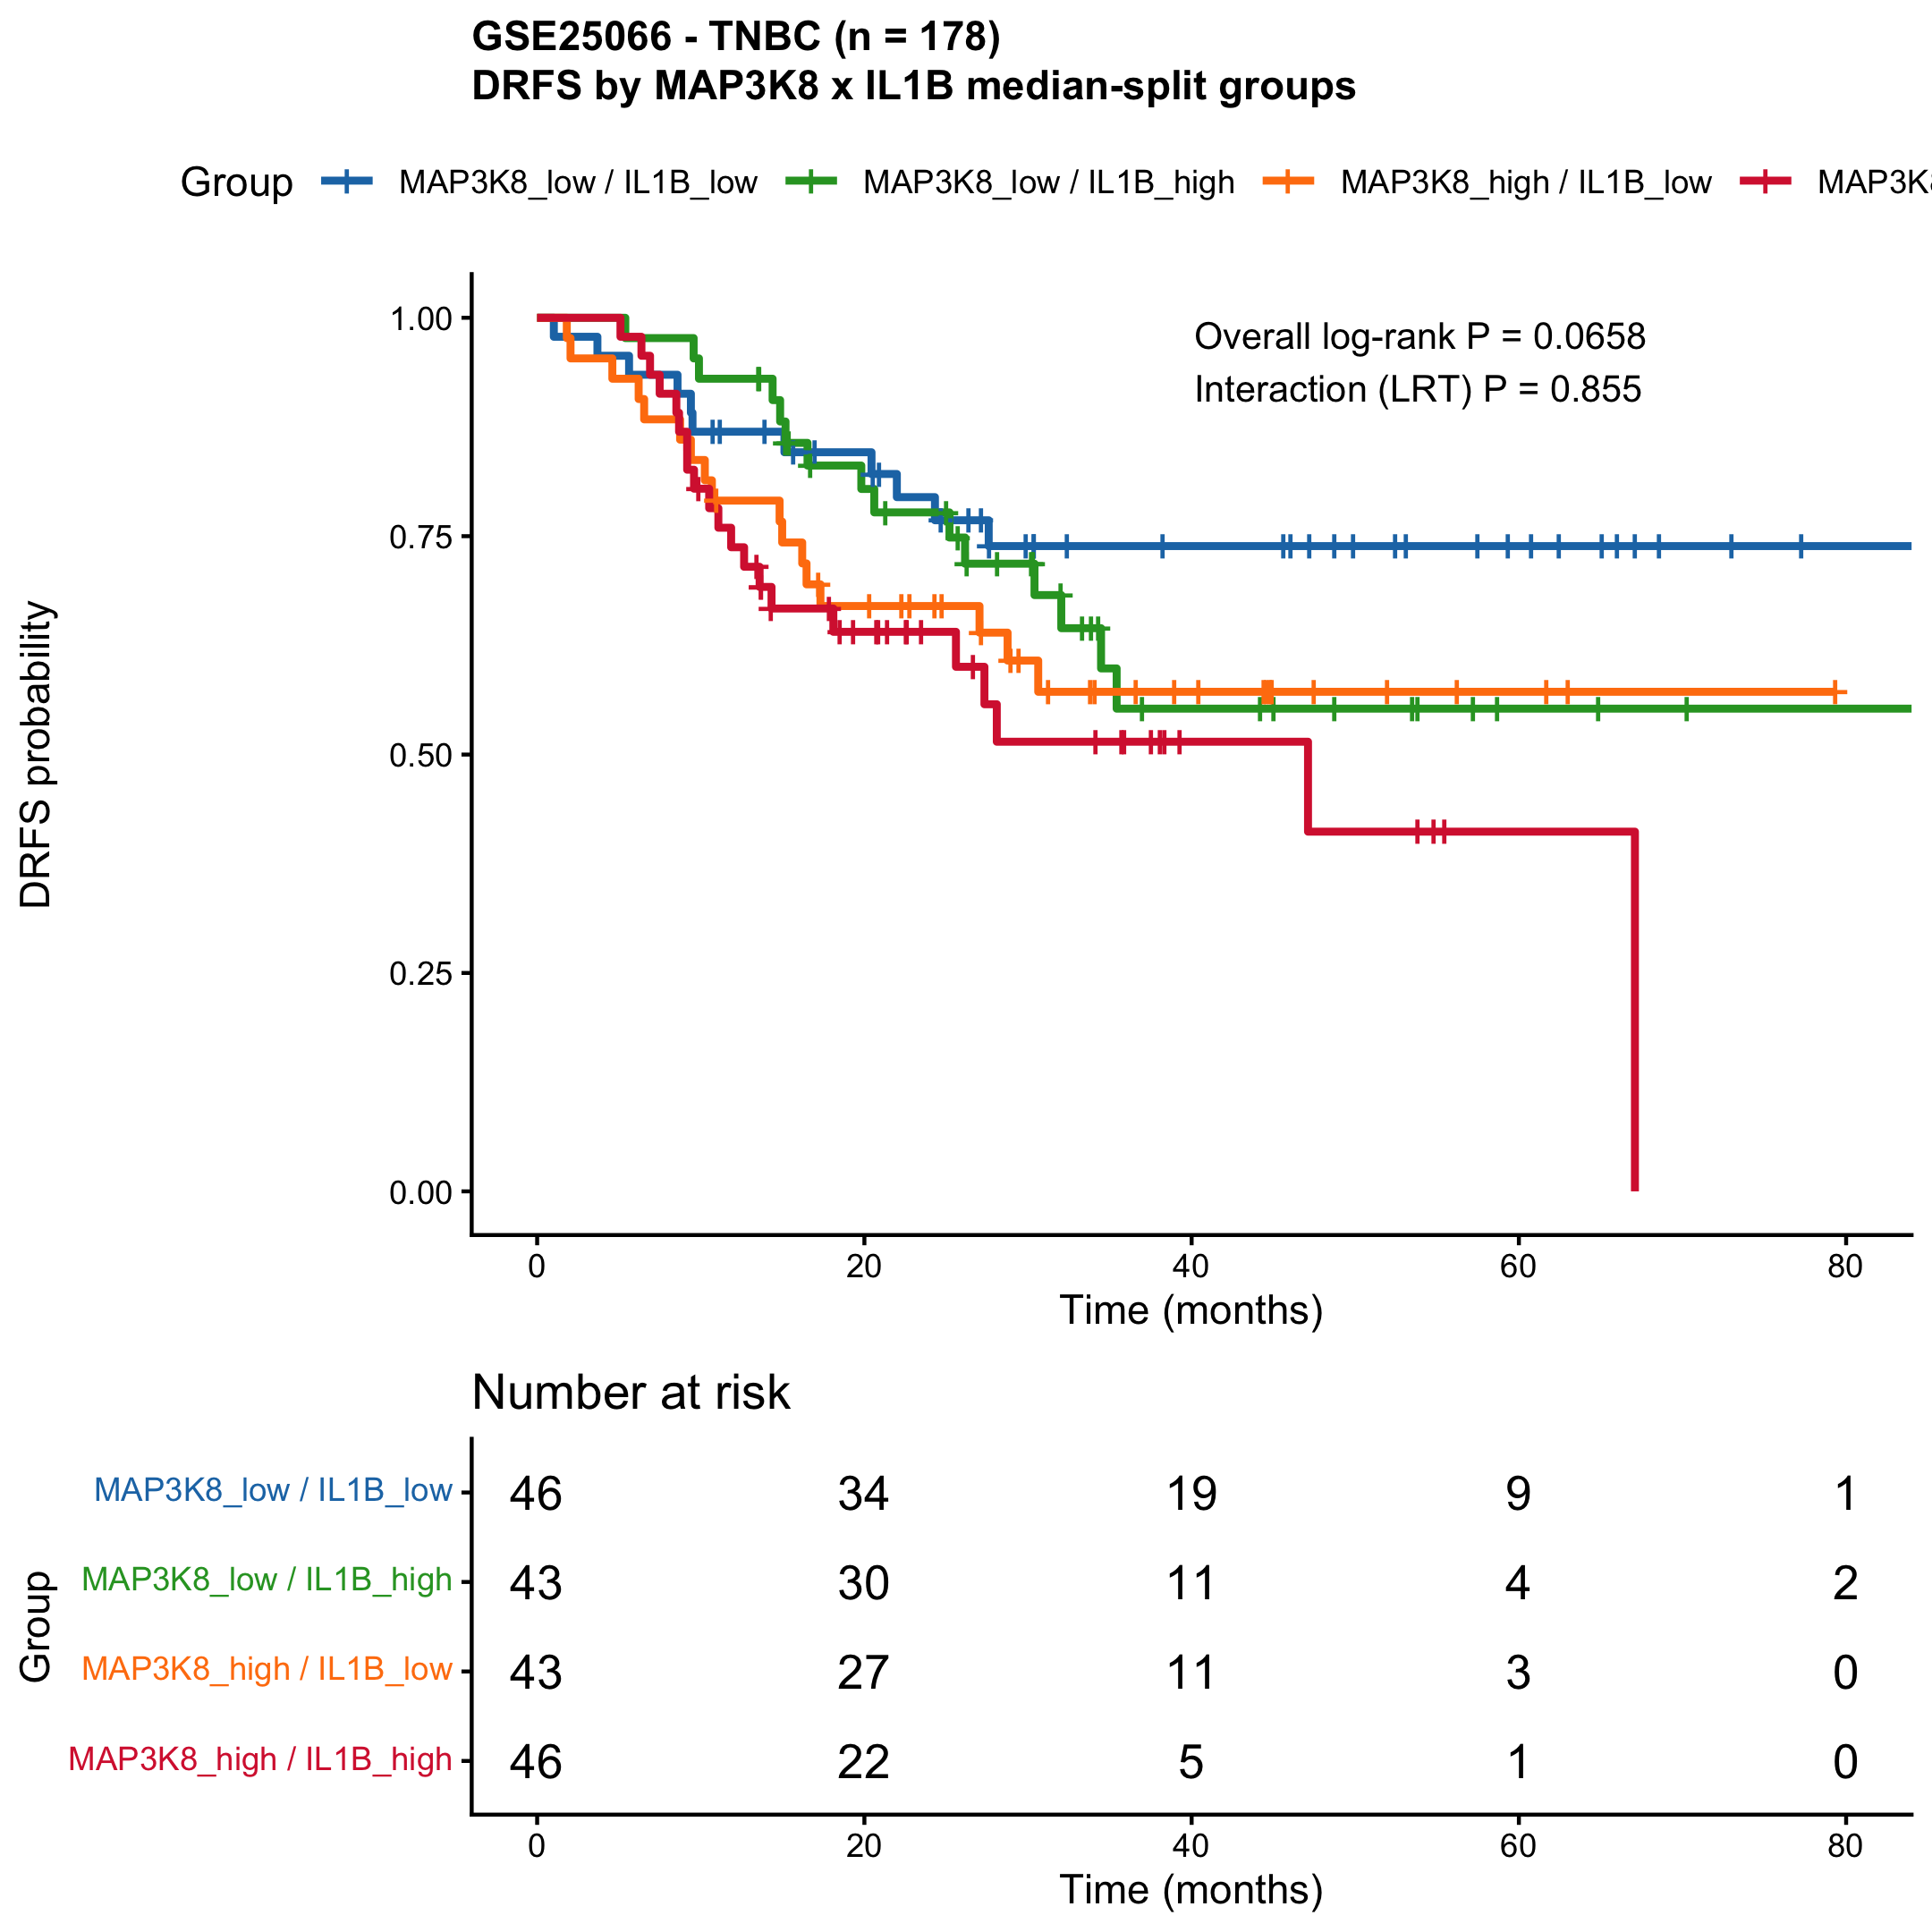

Figure A2.2 - Group-vs-reference HR forest
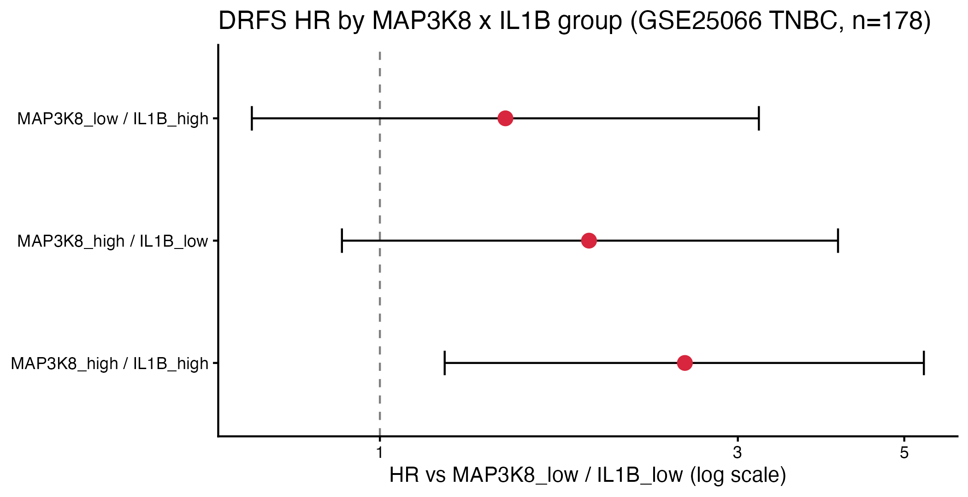
Verdict: effects are essentially additive (interaction LRT P = 0.86). The doubly-high group has the highest distant-relapse risk; the doubly-low group is the best-prognosis reference. Pairwise log-rank between best and worst groups was borderline after BH adjustment.

Analysis 03 - Continuous Cox
Question: does the prognostic signal survive the loss of dichotomisation, and does it survive adjustment for age, stage and RCB? Models: univariable, bivariable and multivariable Cox on standardised log2 expression (HR per 1 SD), plus restricted cubic splines.
Univariable:
model | term | scale | HR | LCL95 | UCL95 | p | n | nev
univariable | MAP3K8 (per 1 SD) | per 1 SD | 1.27 | 0.952 | 1.69 | 0.1040 | 178 | 64
univariable | IL1B (per 1 SD) | per 1 SD | 1.22 | 0.982 | 1.51 | 0.0732 | 178 | 64
Bivariable:
model | term | scale | HR | LCL95 | UCL95 | p
bivariable | MAP3K8_z | per 1 SD | 1.22 | 0.923 | 1.62 | 0.161
bivariable | IL1B_z | per 1 SD | 1.18 | 0.956 | 1.46 | 0.122
Multivariable (adjusted for age + stage + RCB):
model | term | HR | LCL95 | UCL95 | p
multivariable (adj age + stage + RCB) | MAP3K8_z | 1.3300 | 0.9560 | 1.850 | 0.090600
multivariable (adj age + stage + RCB) | IL1B_z | 1.2400 | 0.9510 | 1.610 | 0.113000
multivariable (adj age + stage + RCB) | age | 0.9880 | 0.9630 | 1.010 | 0.324000
multivariable (adj age + stage + RCB) | stageIIA | 0.1880 | 0.0319 | 1.100 | 0.064000
multivariable (adj age + stage + RCB) | stageIIB | 0.1740 | 0.0328 | 0.920 | 0.039600
multivariable (adj age + stage + RCB) | stageIIIA | 0.2080 | 0.0395 | 1.100 | 0.064500
multivariable (adj age + stage + RCB) | stageIIIB | 0.2540 | 0.0474 | 1.360 | 0.109000
multivariable (adj age + stage + RCB) | stageIIIC | 0.2010 | 0.0330 | 1.220 | 0.081400
multivariable (adj age + stage + RCB) | stageInflammatory | 0.6330 | 0.0726 | 5.520 | 0.679000
multivariable (adj age + stage + RCB) | rcbRCB-0/I | 0.0978 | 0.0311 | 0.307 | 0.000068
multivariable (adj age + stage + RCB) | rcbRCB-II | 0.5260 | 0.2400 | 1.150 | 0.109000
multivariable (adj age + stage + RCB) | rcbRCB-III | 2.6700 | 1.3000 | 5.490 | 0.007290
Schoenfeld residual test:
X | chisq | df | p
MAP3K8_z | 0.000005934407 | 1 | 0.99805630
IL1B_z | 5.240871663275 | 1 | 0.02206222
age | 0.758974653557 | 1 | 0.38364959
stage | 3.983001823194 | 6 | 0.67897686
rcb | 5.819976373330 | 3 | 0.12070492
GLOBAL | 15.270964704544 | 12 | 0.22695161

Figure A3.1 - Univariable + bivariable HR forest
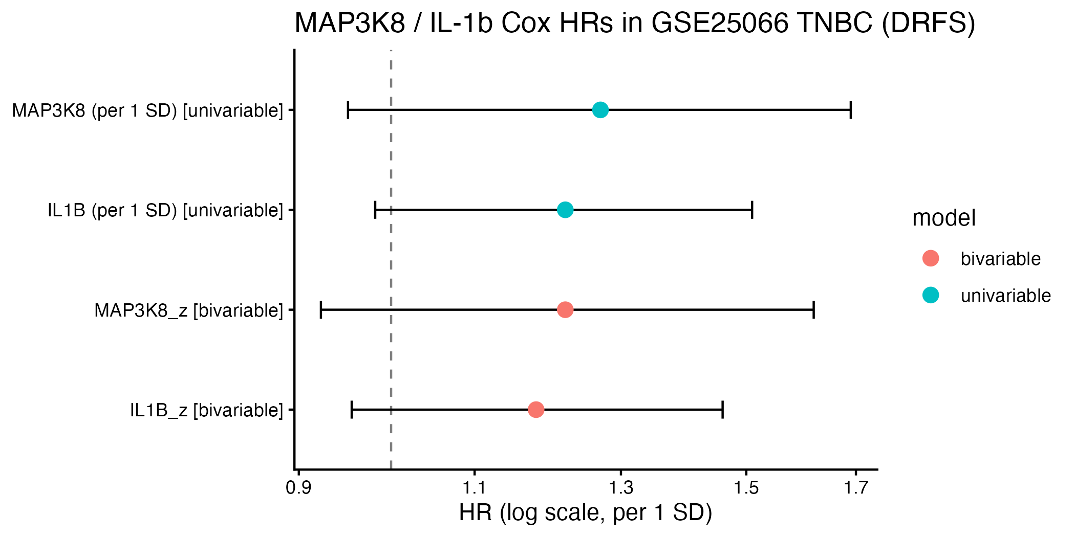

Figure A3.2 - MAP3K8 RCS hazard-ratio curve
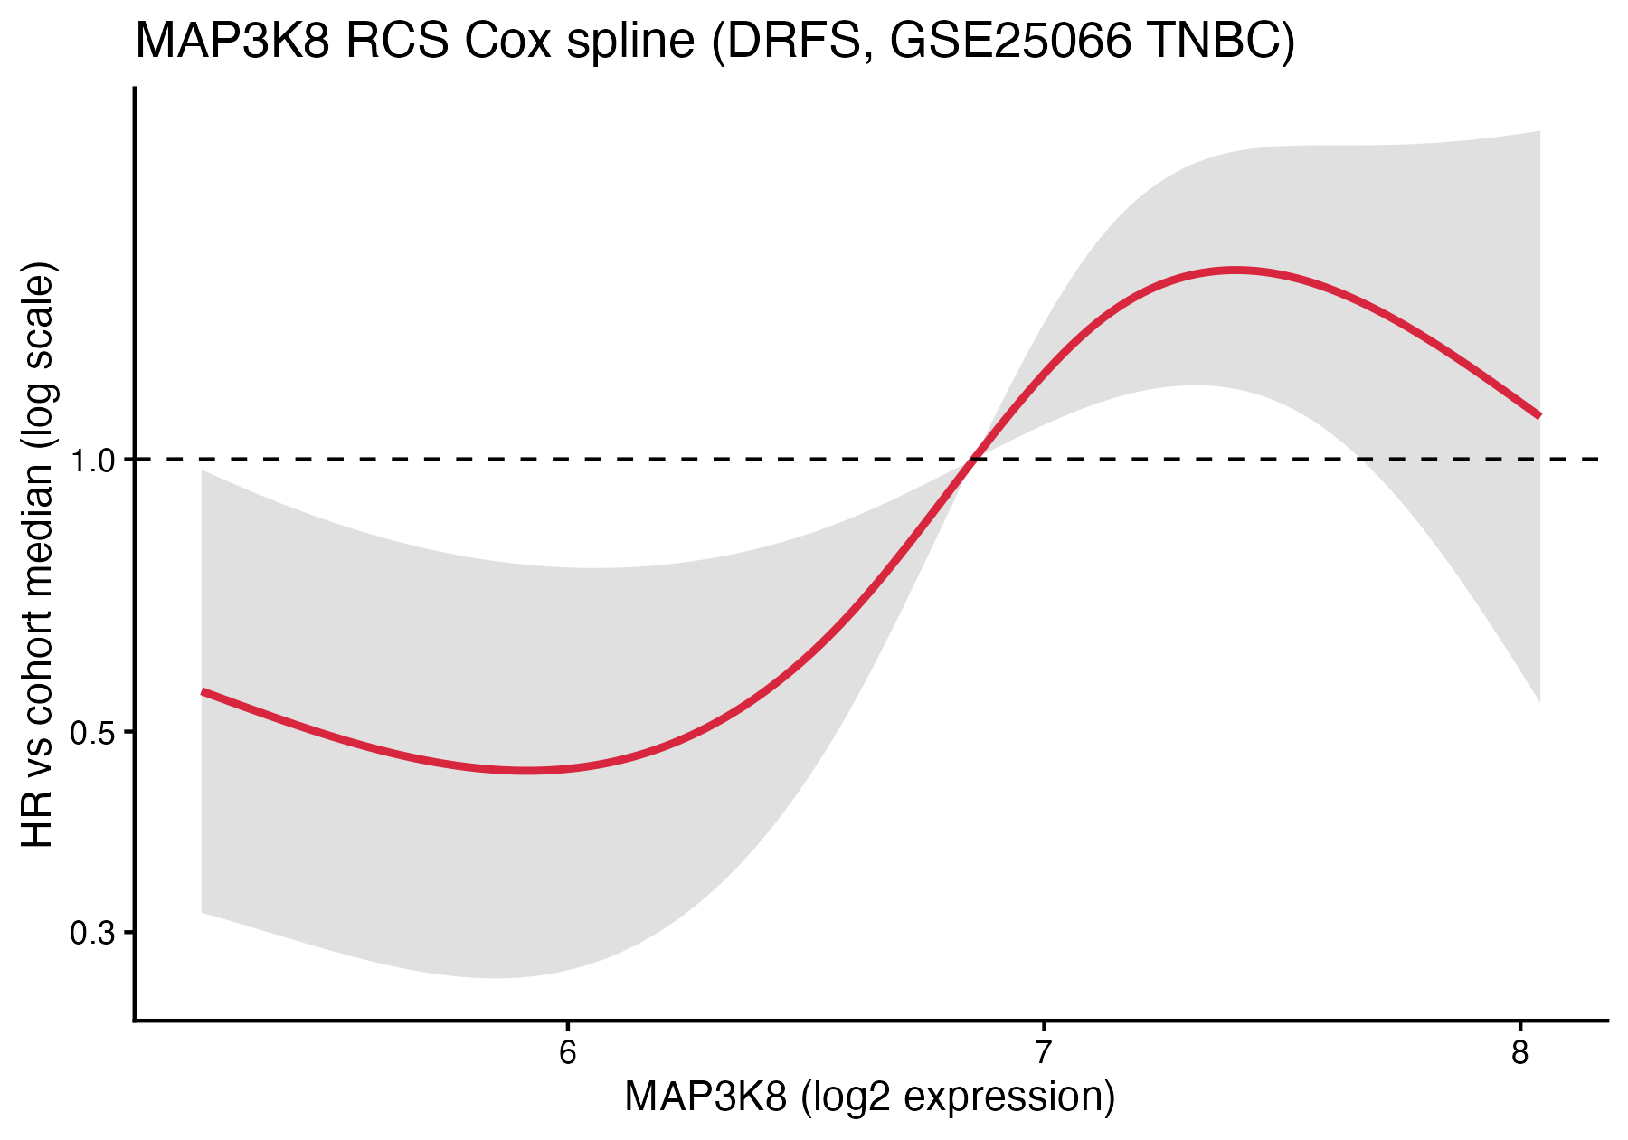

Figure A3.3 - IL-1beta RCS hazard-ratio curve
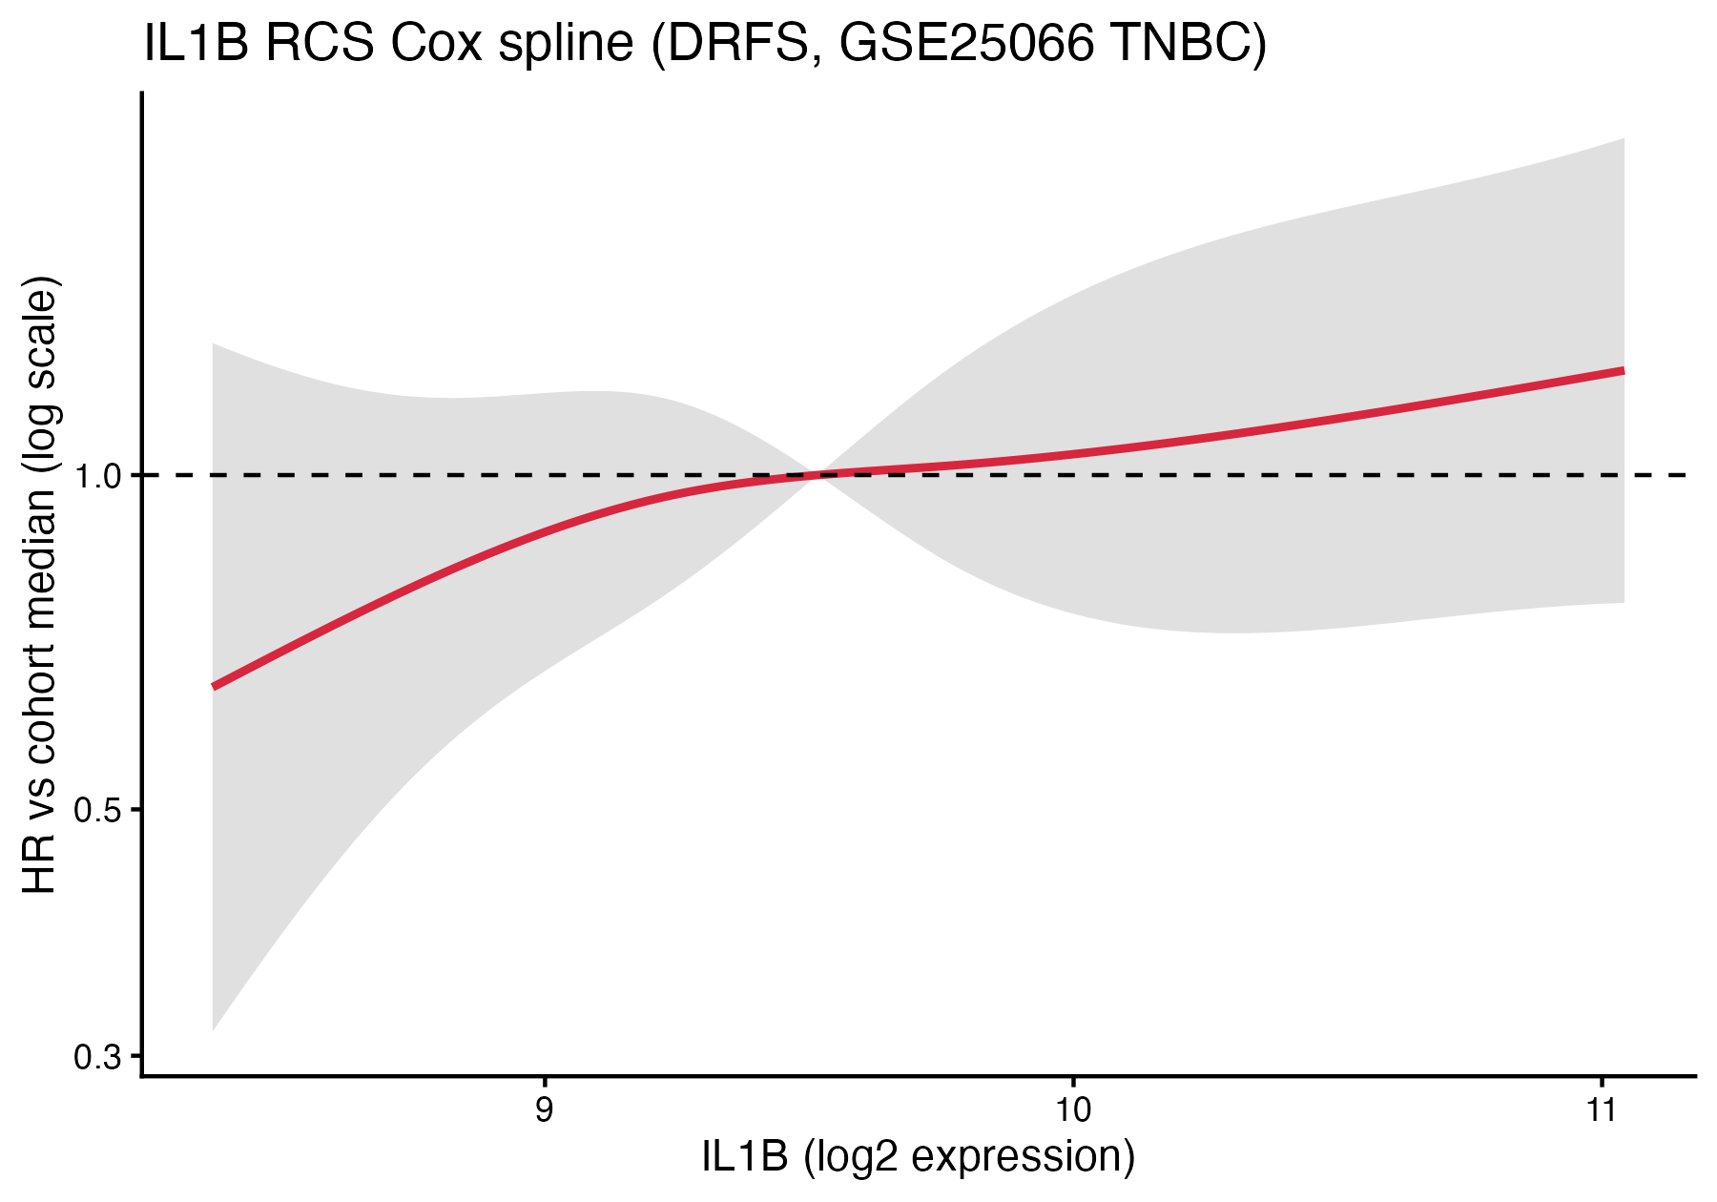
Verdict: both genes consistently trend in the risk direction (HR ~1.2-1.3 per SD), in the same direction across univariable, bivariable and multivariable specifications, and remain so after adjustment for the strongest known prognostic factor in the cohort (RCB-III HR = 2.67, P = 0.0073). IL-1beta violates the proportional-hazards assumption (P = 0.022), consistent with a late-relapse effect that a single HR underestimates. Splines confirm a monotonic dose-response and rule out U-shaped or threshold patterns.

Analysis 04 - GSE41998 validation
Question: does an independent neoadjuvant chemo-treated TNBC cohort reproduce the GSE25066 findings? Cohort: GSE41998 TNBC subset (n = 140, GPL96), pCR endpoint only (no DRFS in GEO).
gene | n_pCR | n_RD | median_in_pCR | median_in_RD | Wilcoxon_p | logreg_OR | logreg_LCL | logreg_UCL | logreg_p
MAP3K8 | 51 | 87 | 6.97 | 7.18 | 0.820 | 1.170 | 0.734 | 1.91 | 0.506
IL1B | 51 | 87 | 6.24 | 6.31 | 0.796 | 0.883 | 0.594 | 1.28 | 0.517

Figure A4.1 - GSE41998 TNBC pCR boxplots
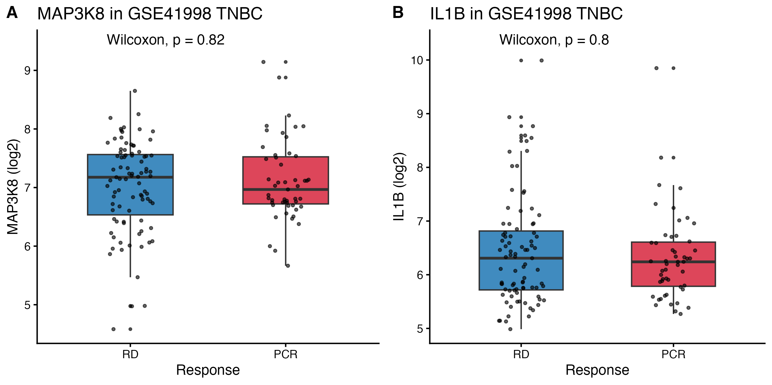
Verdict: the pCR null is independently confirmed - neither gene predicts chemoresponse in GSE41998. The DRFS-positive result of GSE25066 is not testable here because GEO does not expose survival times for GSE41998. Direction of the IL-1beta effect (higher in RD than in pCR) is consistent across cohorts.

Bottom-line conclusions for the project
1. MAP3K8 and IL-1beta mRNA are both risk markers for distant relapse in chemo-treated TNBC. Direction of effect is the same for both genes (HR > 1 with high expression), biologically coherent given their shared NF-kB / IRAK / inflammation axis.
2. The signal is on late relapse (DRFS), not on initial chemoresponse (pCR / RCB). The two endpoints capture different biology, and these genes capture chemoresistance via residual-disease outgrowth rather than via primary cytotoxic insensitivity.
3. The effects are independent rather than synergistic - the four-group interaction term is non-significant and HRs barely move on mutual adjustment in the bivariable Cox. A patient who is high for both is at greatest risk, but this is approximately the sum of the two univariable signals.
4. Both effects survive adjustment for age, stage and RCB - the strongest known prognostic factor in the cohort. RCB-III itself confers HR = 2.67; MAP3K8 and IL-1beta carry information beyond this.
5. IL-1beta acts on late relapse: PH violation and visual late-curve separation both indicate a time-dependent effect that a single HR understates. A time-varying or stratified Cox is the natural next refinement.
6. Validation in GSE41998 is partial: the pCR null is reproduced; the DRFS finding is untestable because GEO does not expose survival for that series. Stronger external validation requires DRFS-equipped TNBC cohorts (METABRIC TNBC chemo subset; FUSCC TNBC under controlled access).

Recommended next analyses
(a) Time-stratified or time-varying Cox for IL-1beta to formally quantify the late-relapse hazard. (b) Optimal cutpoint analysis (maxstat / surv_cutpoint) on GSE25066 for both genes, to check whether a non-median threshold sharpens the binary KM. (c) METABRIC TNBC chemo-treated subset for an independent OS / RFS validation. (d) Pathway-level signature (IL1B, IL6, IL8, NLRP3, CASP1, MAP3K8) z-score versus DRFS - cytokine signatures usually outperform single genes. (e) For protein-level support, cite published IHC TMA studies for IL-1beta and MAP3K8 rather than attempting to reanalyse mass-spec data in which IL-1beta is not detected and chemo-treated TNBC cohorts are not available.

Files in this Analyses folder
01_pCR_RCB_Analysis/ - pCR / RCB chemoresponse analysis
02_FourGroup_Interaction_KM/- MAP3K8 x IL1B four-group KM with interaction
03_Continuous_Cox/ - continuous and multivariable Cox + splines
04_GSE41998_Validation/ - independent neoadjuvant TNBC validation
Each subfolder contains its own R script, data outputs (CSV), figures (PDF/PNG/TIFF) and a Methods .docx.

Reproducibility
R version: R version 4.5.1 (2025-06-13). Platform: aarch64-apple-darwin20. Date: 2026-04-26. Source workspace: GSE25066_TNBC_MAP3K8_workspace.RData.

