PACIFIC CREST BANK
HONG KONG · GROUP RISK & ANALYTICS

Credit Risk Assessment
Retail & SME Lending Portfolio

Prepared by Group Risk & Analytics
June 2026 · Confidential

Contents

Executive Summary
This report presents an end-to-end credit risk assessment of a 12,000-facility sample of Pacific Crest Bank's Hong Kong retail and SME lending book. The portfolio carries a 12-month default rate of 13.6%, concentrated in small-business facilities and unsecured revolving credit.
We built and benchmarked three predictive models and a regulatory-style credit scorecard. The governed WOE scorecard achieves a Gini of 0.65 (AUC 0.826, KS 0.51) — matching the black-box challengers while remaining fully transparent and auditable, the right trade-off for a regulated origination decision under HKMA model-risk expectations.
The scorecard produces well-calibrated probabilities of default and rank-orders cleanly into five risk grades, with realised default rates ranging from 1.6% (Grade A) to 46.6% (Grade E). We recommend a hard 50% DSR cap, adoption of the five-grade scorecard for origination, risk-based pricing, and portfolio steering toward the secured book.
Headline metrics
Portfolio default rate | Scorecard AUC | Scorecard Gini | Scorecard KS
13.6% | 0.826 | 0.65 | 0.51

1. Portfolio Profile
Metric | Value
Facilities analysed | 12,000
12-month default rate (90+ DPD) | 13.6%
Products | Personal Loan, Credit Card, Mortgage, SME Facility
Currency | HKD
Default definition | 90+ days past due within 12 months

Default rate by product
Product | Default rate
SME Facility | 26.5%
Credit Card | 14.7%
Personal Loan | 11.6%
Mortgage | 8.5%
Small-business facilities and unsecured revolving credit run materially hotter than the secured mortgage book, consistent with their risk profile and the HKMA's LTV discipline on residential lending.
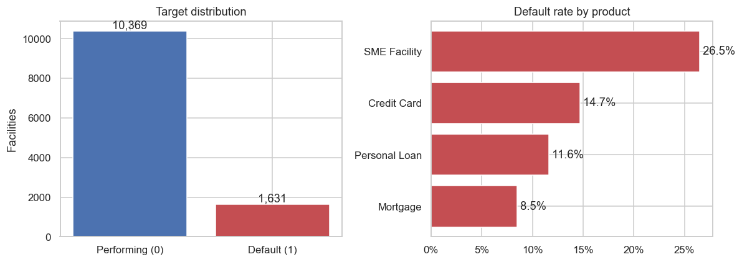
Figure 1. Target distribution and default rate by product.
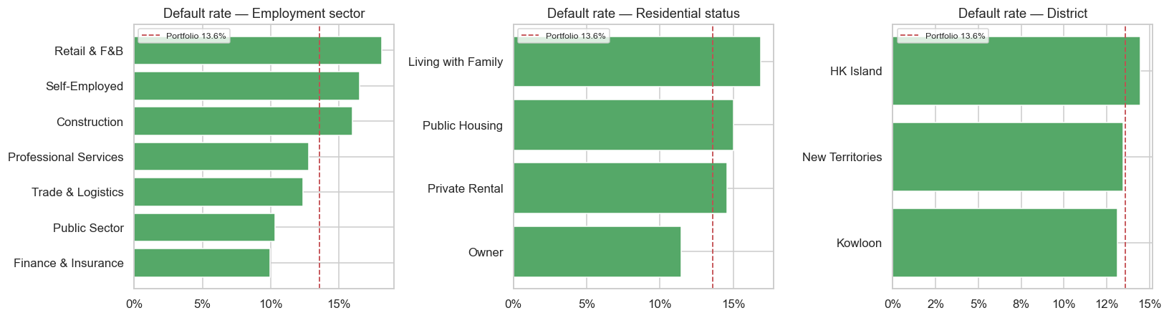
Figure 2. Default rate by employment sector, residential status and district.

2. Key Risk Drivers
Drivers were identified consistently across three independent lenses — Information Value (univariate), machine-learning feature importance, and scorecard points:
Rank | Driver | Information Value | Strength
1 | TU credit score | 1.24 | Very strong
2 | Recent delinquencies (24m) | 0.65 | Very strong
3 | Any prior delinquency | 0.42 | Strong
4 | DSR headroom vs 50% guide | 0.38 | Strong
5 | Debt Servicing Ratio (DSR) | 0.38 | Strong
6 | Product type | 0.16 | Medium
Bureau behaviour and affordability dominate. The TU score and recent delinquency history are the strongest signals, followed closely by the DSR family of affordability measures — direct empirical support for the HKMA's emphasis on debt-servicing capacity.
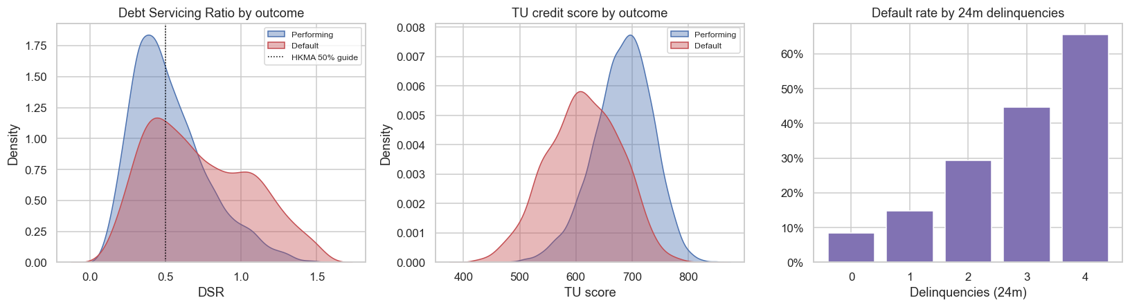
Figure 3. DSR and TU score by outcome; default rate by delinquency count.
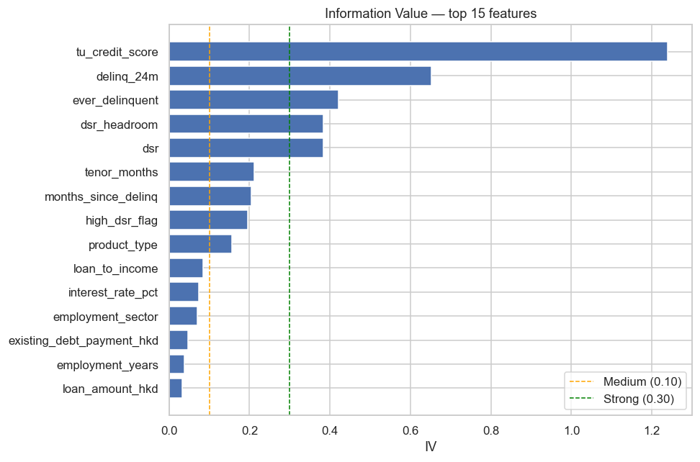
Figure 4. Information Value ranking of candidate features.

3. Model Performance
Performance on a stratified 25% hold-out sample. All preprocessing is fit on the training split only to prevent leakage.
Model | AUC | Gini | KS | Avg. Precision
Logistic Regression | 0.842 | 0.684 | 0.516 | 0.532
Random Forest (challenger) | 0.835 | 0.670 | 0.502 | 0.512
Gradient Boosting (challenger) | 0.826 | 0.652 | 0.486 | 0.499
WOE Scorecard (deployed) | 0.826 | 0.651 | 0.510 | —
The non-linear challengers offer no meaningful uplift over the transparent logistic / scorecard approach. For a regulated lending decision the scorecard is the clear choice: interpretable, monotonic, governable, and statistically on par with the best challenger.
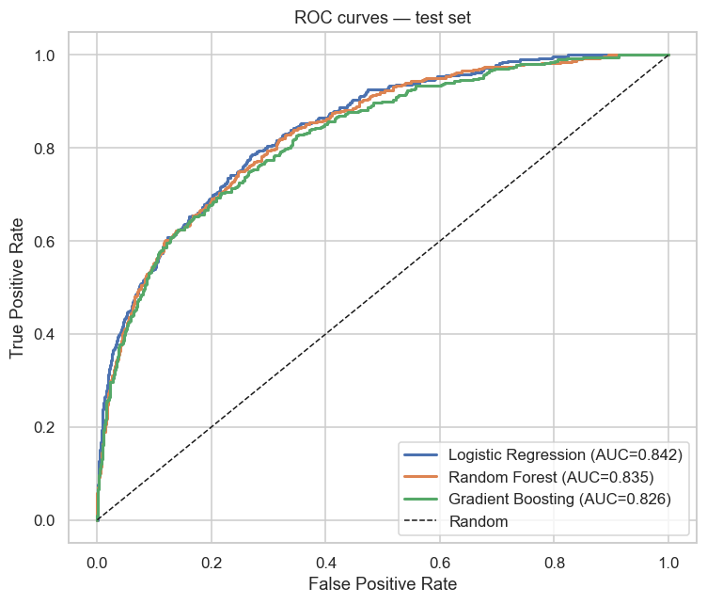
Figure 5. ROC curves on the test set.

4. Risk Grades, Calibration & Expected Loss
The scorecard PD bands into five grades. Realised default rates track model PDs closely — evidence of good calibration — and expected-loss rates rank-order monotonically (EL = PD × LGD × EAD, LGD = 45%):
Grade | Facilities | Actual Default | Model PD | EAD (HK$) | Expected Loss (HK$) | EL Rate
A (Prime) | 609 | 1.6% | 2.1% | 391.2M | 3.4M | 0.87%
B (Low) | 1,117 | 5.7% | 5.0% | 723.9M | 16.2M | 2.24%
C (Medium) | 477 | 10.1% | 10.8% | 318.6M | 16.0M | 5.03%
D (High) | 359 | 22.8% | 21.4% | 299.6M | 29.2M | 9.75%
E (Decline) | 438 | 46.6% | 49.5% | 379.7M | 82.7M | 21.77%
Grade E holds roughly 15% of facilities but a disproportionate share of expected loss (HK$82.7M, about 54% of total modelled EL). The EL-rate spread (0.87% to 21.77%) is the basis for both risk-based pricing and IFRS 9 provisioning.
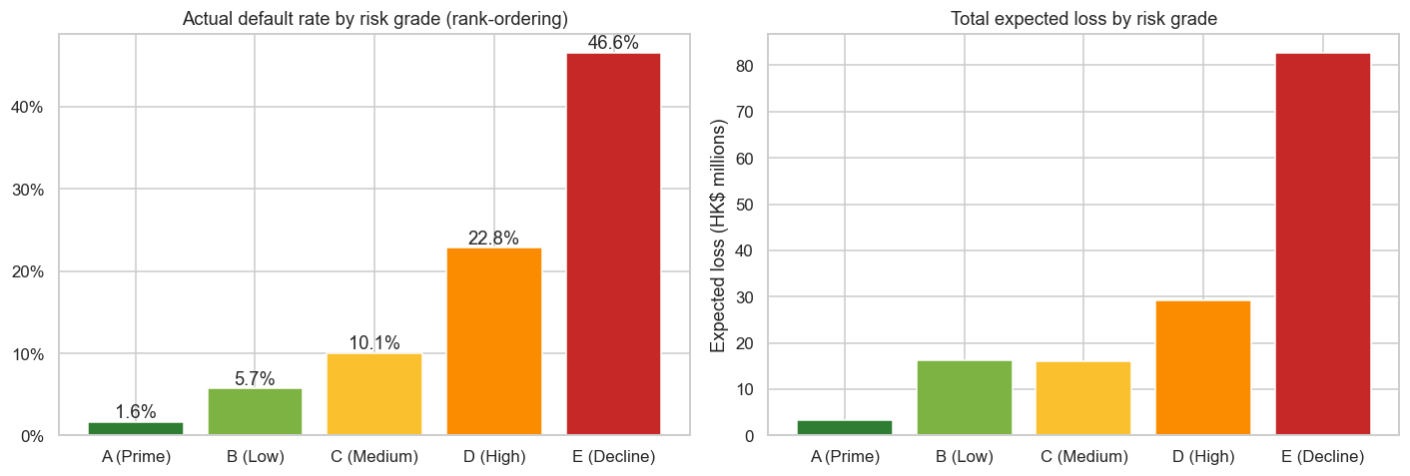
Figure 6. Actual default rate and total expected loss by risk grade.
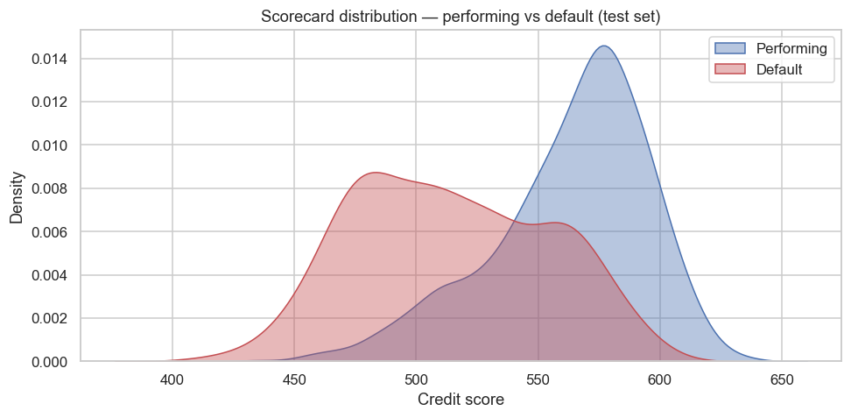
Figure 7. Scorecard distribution — performing vs default.

5. Illustrative Origination Policy
A policy that auto-declines Grade E yields, on the hold-out sample:
Metric | Value
Approval rate | 85.4%
Bad-capture (defaults avoided) | 50.0%
Declining the worst ~15% of applications removes roughly half of all future defaults. Grade D (next ~12%) should route to manual underwriting rather than auto-approval, capturing further loss with human oversight.
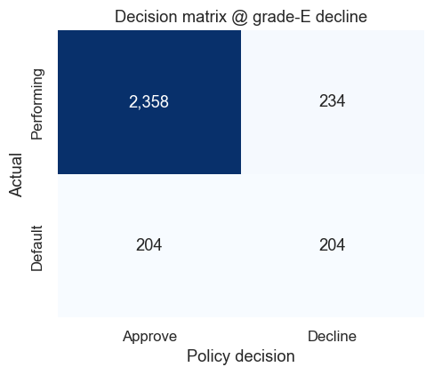
Figure 8. Decision matrix at a Grade-E decline cut-off.

6. Recommendations

Lending policy
- Hard 50% DSR cap with a stressed-rate overlay; second-line sign-off for 50–65% exceptions; auto-decline above 65%.
- Adopt the five-grade scorecard (A–E) for origination — auto-decline Grade E, manual underwrite Grade D, auto-approve A–C within policy.
- Risk-based pricing aligned to grade-level EL rates so margin covers provisioning, especially on the SME and card books.
- Portfolio steering — sub-limits on high-EL unsecured / SME segments; grow the secured mortgage book where EL rates are lowest.

Provisioning & capital
- Use grade-level expected loss as the input to IFRS 9 ECL staging and management overlays.

Model governance (HKMA-aligned)
- Monitor stability with PSI on out-of-time samples; recalibrate at least annually.
- Add macroeconomic overlays (unemployment, HIBOR, residential price index) for forward-looking ECL.
- Conduct fair-lending / disparate-impact testing before deployment.
- Stand up monitoring: monthly score distribution, override rates, early-arrears tracking.

7. Methodology & Reproducibility
- Data: synthetic HKD retail credit portfolio generated with an economically grounded data-generating process (leverage, bureau history, affordability, product mix). No real customer data.
- Pipeline: loading → QA & cleaning → EDA → feature engineering → WOE/IV screening → ML benchmarking → WOE scorecard → calibration, risk grading & expected loss.
- Leakage control: all imputation, scaling and WOE binning are learned on the training split only and applied to the hold-out.
- Full analysis: HK_Credit_Risk_Analysis.ipynb (executed, with inline charts). All figures and tables are saved under outputs/.
Prepared by Group Risk & Analytics, Pacific Crest Bank (Hong Kong). Synthetic data for demonstration of credit-risk methodology only; not a real customer portfolio and not investment or lending advice.

