ShopCart: A Mini E-Commerce Product Catalog and Cart

Rupak Basnet
Student ID: NP071212
React.js Project
Submission Date: September 26, 2026

Table of Contents

Table of Contents 2
Abstract 3
1. Introduction 4
2. Project Objectives 4
3. System Specifications & Technologies Used 5
3.1 Technologies Used 5
3.2 System Requirements 6
4. Application Architecture & Features 6
4.1 Key Features 6
4.2 Project Structure 7
4.3 Application Screens 8
5. Core React Concepts Implemented 12
6. Implementation Details & Code Explanation 12
7. API & Data Storage Documentation 13
8. Application Workflow 14
9. Challenges & Solutions 14
10. Testing & Validation 15
11. System Limitations & Future Enhancements 16
11.1 Limitations 16
11.2 Future Enhancements 16
12. Conclusion 16
13. Repository Information 16
References 18

Abstract
This report is a documentation of the architectural design, implementation, and testing of a single-page, client-side e-commerce storefront named ShopCart implemented with React 19. It's a mock product catalog that supports real-time search, advanced faceted filtering and sorting, includes a persistent shopping cart, and has an interactive checkout simulation. It is designed to show essential concepts of modern web development and works very well with the custom hooks, component modularity, client-side routing and browser-level persistence through the localStorage API. The application is fully styled with Tailwind CSS and deployed on Vercel to comply with the responsive website standards on different devices and viewports.

1. Introduction
ShopCart is a modern client-side e-commerce web application created as a part of the Course Project of the React.js course. The application offers an intuitive interface for the users to browse, search, filter and sort a mock product catalog. Additionally, users can easily add or remove products from their shopping carts and change the quantities of products and complete a simulated checkout procedure. One of the application's core features is the persistence of its state; the cart information is stored in the browser's native localStorage API that persists for a page reload or even across browsers.
The chosen project for the storefront concept for the web development course is built on the principles of modern front-end engineering which are covered in the course: functional components architecture, unidirectional data flow, custom-made React Hooks, client-side routing, event handling, and client-side state management.

2. Project Objectives
The technical objectives achieved during the design and development of ShopCart include:
- Creating and implementing a responsive Single Page Application (SPA) with functional React components.
- Organizing the project into small chunks, communicating each chunk efficiently through props.
- Handling UI state and shared app state at component level with useState and useEffect hooks.
- Using localStorage API for persistent storage to retain the cart between user sessions. Allowing declarative client-side navigation between Catalog and Cart using React Router.
- Efficiently mapping collections with JavaScript array methods (e.g. .map()) with unique key props.
- Capture and process user input using form elements and event handlers. Providing an aesthetically, responsive user interface on mobile and desktop breakpoints with Tailwind CSS.

3. System Specifications & Technologies Used

3.1 Technologies Used
The application relies on a modern front-end stack without external backend dependencies. Table 1 summarizes the core technologies and libraries used in this project.
Table 1
Technologies and Libraries Used in ShopCart Development
Technology | Purpose & Role in System
React 19 (JSX) | Core library for component-based UI rendering, state management, and lifecycle hooks.
JavaScript (ES6+) | Provides application logic, functional state transformations, and event processing.
Tailwind CSS | Utility-first CSS framework for responsive layout design and UI styling.
React Router DOM | Facilitates single-page routing between the main catalog and cart views.
React Hot Toast | Provides lightweight, non-intrusive toast notifications for user interactions.
localStorage API | Enables client-side web storage for persisting shopping cart state locally.
Vite | High-performance build tool and local development server environment.
Git / GitHub | Version control, source code management, and cloud repository hosting.

3.2 System Requirements
Software Requirements: Operating system: Windows 10/11, macOS, or Linux; Node.js runtime environment (v18.0 or higher) with npm; Visual Studio Code or equivalent IDE; a modern web browser (Google Chrome, Mozilla Firefox, or Microsoft Edge); and Git for source control.
Hardware Requirements: A modern multi-core processor, a minimum of 4 GB RAM, and at least 500 MB of available storage space for project dependencies (node_modules) and build outputs. Internet access is required solely for initial package installation and cloud deployment on Vercel.

4. Application Architecture & Features

4.1 Key Features
- Real-Time Search: When the user enters a string into the search box, real-time filtering of items that match that string will occur.

- Multi-Category Filter: Quickly filter by categories such as All, Electronics, Clothing, and Accessories. Sorting Options: Ordering of the catalog items by price (ascending/descending) or by the name (alphabetical).

- Cart Management: Allows to add items with auto incrementing quantity logic and prevent duplicate cart entries. Dynamic Totals: Shows real-time totals of units in the Navigation Badge and money in the running monetary total.

- Simulated Checkout: Interactive checkout confirmation screen which clears the active cart state after it's completed. Responsive Layout: Automatically switches between a desktop multi column layout and a two column mobile viewport layout.

4.2 Project Structure
The codebase is organized into modular directories to maintain separation of concerns. Table 2 outlines the directory structure of the application.
Table 2
Directory Structure and Architectural Roles
Directory / File | Architectural Purpose
src/components/ | Houses reusable presentational components (ProductCard, Navbar, FilterBar, CartItem, EmptyState, SummaryPanel).
src/data/ | Contains mock data configurations (products.js) representing catalog inventory.
src/hooks/ | Encapsulates custom reusable state logic (useCart.js, useLocalStorage.js).
src/pages/ | Top-level route components for the main catalog (CatalogPage.jsx) and checkout page (CartPage.jsx).
src/App.jsx | Configures application routes and maintains top-level lifted cart state.
src/main.jsx | Application entry point responsible for mounting the React root DOM node.

4.3 Application Screens
Figure 1. Catalog Page View (Desktop Layout) displaying the top navigation bar, search input, multi-category filter controls, sorting menu, and product grid.
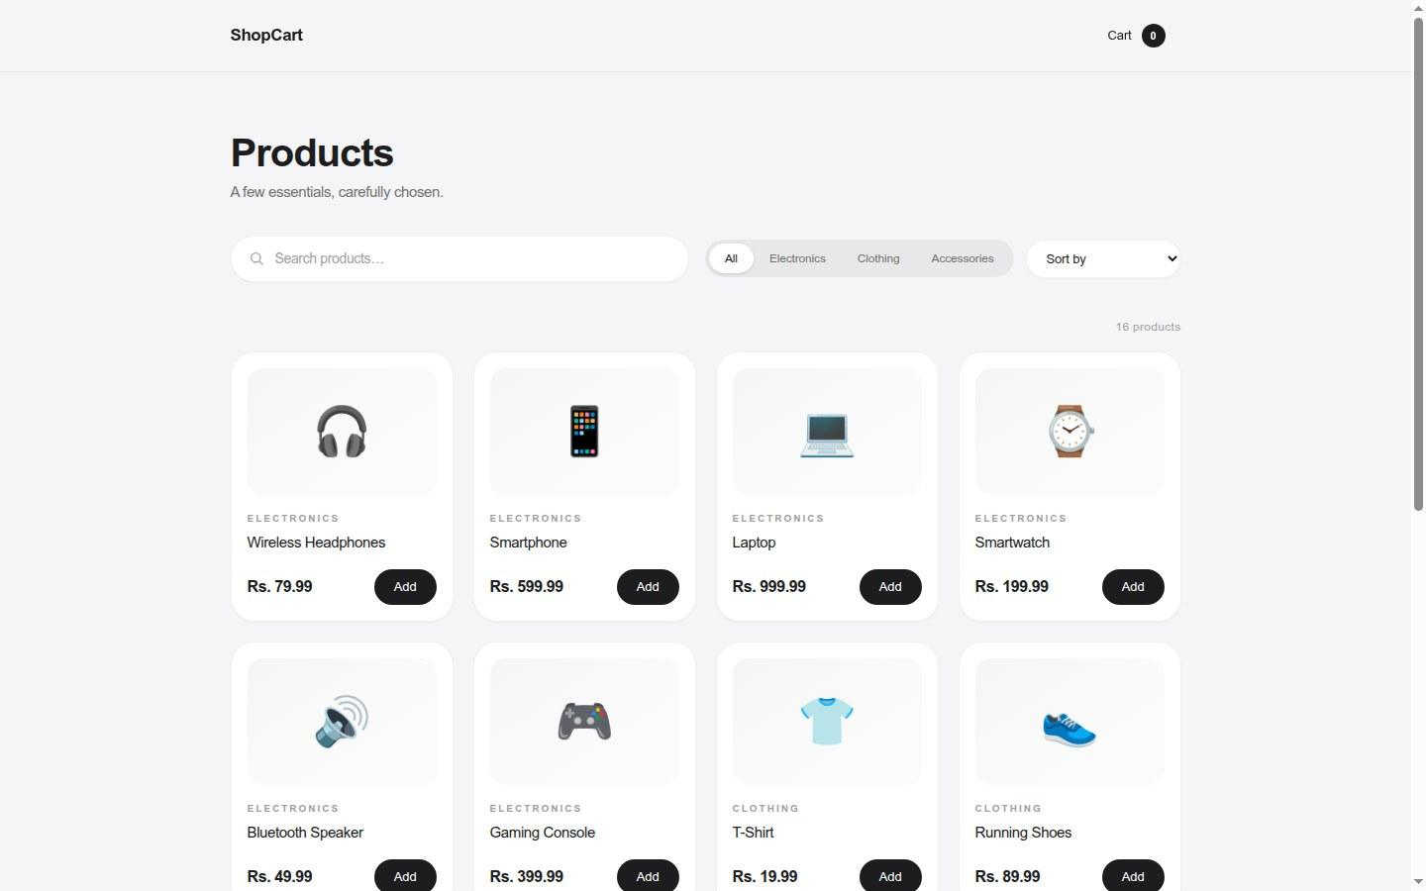
Figure 2. Cart Page View (Desktop Layout) displaying active cart entries, quantity management controls, itemized subtotals, and checkout summary panel.
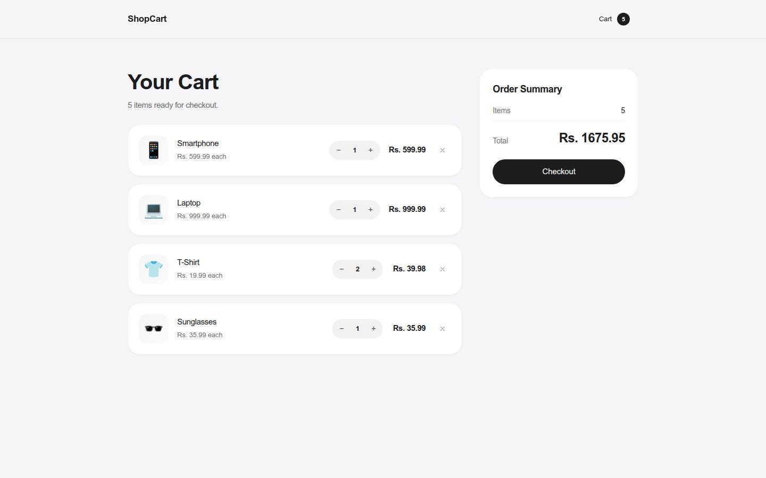
Figure 3. Catalog View (Mobile Viewport) exhibiting a responsive two-column grid layout adapted for narrow displays.
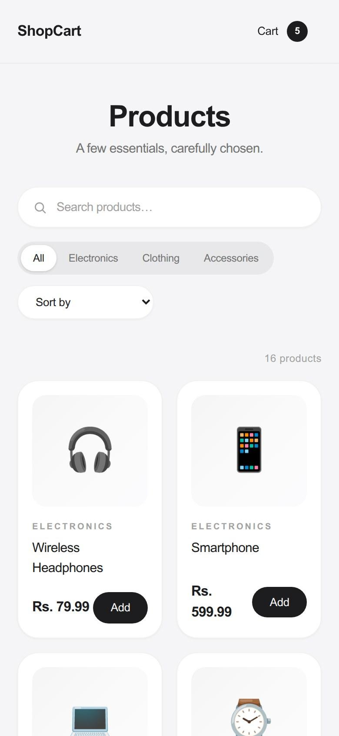

5. Core React Concepts Implemented
The application demonstrates practical applications of several key React standards and paradigms:
- Components & JSX: Modular functional components return JSX structures. Reusable components like EmptyState serve multiple operational contexts (e.g., empty cart state and no-search-results message).
- Props & Unidirectional Data Flow: Data flows strictly from parent components down to child components. For example, ProductCard receives item metadata and an onAdd callback via props, remaining strictly presentational.
- State Management (useState): Utilized for localized component state (e.g., search, category, and sort parameters) as well as global cart state lifted to App.jsx to enable cross-page sharing.
- Side Effects (useEffect): Synchronizes react state changes back to browser storage:
- Custom Hooks: Custom utility hook useLocalStorage abstracts synchronization with browser storage, while useCart exposes operational methods (addToCart, changeQuantity, removeFromCart, clearCart).
- List Rendering & Keys: Renders catalog items dynamically using array iteration while enforcing unique identifier keys (e.g., key={product.id}) to maintain rendering performance and component stability.
- Client-Side Routing: Integrated react-router-dom using BrowserRouter, Routes, and Route components to navigate between screens without inducing browser page reloads.

6. Implementation Details & Code Explanation
Table 3
Key Code Implementations and System Functionality
# | Implementation Reference | Functional Description
1 | addToCart() in useCart.js | Adds a new product to the cart or increments existing quantity using functional state updates to prevent direct mutation.
2 | changeQuantity() in useCart.js | Adjusts item counts dynamically and filters out zero-quantity lines to auto-remove items when reduced below one.
3 | filteredProducts in CatalogPage.jsx | Utilizes useMemo to recompute search, filtering, and sorting calculations efficiently upon state changes.
4 | Lazy state initializer in useLocalStorage.js | Reads initial data from localStorage once on initial mount, avoiding expensive re-parsing on subsequent renders.
5 | handleCheckout() in CartPage.jsx | Triggers confirmation states, clears stored cart items, and displays user success notifications.

7. API & Data Storage Documentation
ShopCart operates entirely client-side without consuming external third-party HTTP APIs. Mock catalog data is statically defined in src/data/products.js, adhering to the structure: { id, name, price, category, emoji }.
Local state persistence is handled using the browser's localStorage under the key shopcart.cart. Data is serialized and deserialized using standard JSON.stringify and JSON.parse methods. Exception handling is built into storage hooks to allow seamless fallback operation in restricted or private browsing environments.

8. Application Workflow
The standard user workflow within the ShopCart application follows a logical sequence:
- Landing page (Catalog Page).
- Interacts with search inputs, category filter pills, or price sorting menus.
- User selects desired products, triggering the addToCart handler.
- Navigates to the Cart page via the persistent navigation bar link.
- The user reviews selected items, adjusts item quantities, or removes line items.
- The user inspects the dynamically updated order total.
- The user initiates checkout, clearing local cart state and displaying a confirmation message.

9. Challenges & Solutions
During the development lifecycle, several front-end engineering challenges were encountered and solved, as summarized in Table 4.
Table 4
Summary of Technical Challenges and Implemented Solutions
Technical Challenge | Implemented Solution
Sharing cart state across disconnected page routes | Lifted cart state up to App.jsx using a custom useCart hook and passed operational state via props.
Preventing state/storage synchronization mismatch | Implemented useLocalStorage hook combining a lazy state initializer with a useEffect sync hook.
Handling item removal when quantity reaches zero | Utilized array .filter() methods within changeQuantity to remove lines reaching zero count.
Avoiding accidental state mutation during catalog sorting | Applied sorting algorithms to shallow copies of state arrays (e.g., [...products].sort()).
Resolving single-page application 404s on static deployment | Configured a vercel.json rewrite rule directing all route requests back to index.html.

10. Testing & Validation
Application functionality was thoroughly validated through manual testing procedures and build verification steps:
- Verified item addition, quantity updates, and line-item removals accurately reflect in total calculations.
- Confirmed cart state retention by refreshing the browser and reopening closed sessions.
- Tested real-time search, category filtering, and sorting combinations against edge cases and empty result sets.
- Verified checkout flow behavior, including cart clearing and toast alert displays.
- Tested responsive layouts across standard viewports (1440×900 desktop and 390×844 mobile).
- Executed npm run build and code linters to ensure zero compilation or syntax errors prior to deployment.

11. System Limitations & Future Enhancements

11.1 Limitations
- Checkout functionality is simulated without real-world payment gateway processing.
- Lacks a backend server or persistent database; all item metadata is static mock data.
- Uses emoji icons in place of hosted high-resolution product imagery.
- No user account management, order history tracking, or shipping address validation.
- Cart state is restricted to individual browser instances and does not sync across devices.

11.2 Future Enhancements
- Integration with a REST or GraphQL backend API and relational database.
- User authentication, user profiles, and order history tracking.
- Third-party payment gateway integration (e.g., Stripe or PayPal).
- Dedicated product detail pages complete with user reviews and rating systems.
- Automated testing suites built using Vitest and React Testing Library.

12. Conclusion
ShopCart project has successfully created a modern single page storefront application, showcasing the core concepts of designing a React-based application. The project demonstrates best practices in modern client-side web development, including breaking the application into modular components, lifting state from the components, abstracting persistent logic into custom hooks, and using utility-first styling with Tailwind CSS.

13. Repository Information
The complete source code, configuration files, and documentation for this project are available on GitHub:
GitHub Repository: https://github.com/rupak-at/react_project_college

References
MDN Web Docs. (n.d.). Window: localStorage property. Mozilla. Retrieved September 26, 2026, from https://developer.mozilla.org/en-US/docs/Web/API/Window/localStorage
Meta. (n.d.). React documentation. Retrieved September 26, 2026, from https://react.dev
React Hot Toast. (n.d.). React Hot Toast documentation. Retrieved September 26, 2026, from https://react-hot-toast.com
React Router. (n.d.). React Router documentation. Retrieved September 26, 2026, from https://reactrouter.com
Tailwind Labs. (n.d.). Tailwind CSS documentation. Retrieved September 26, 2026, from https://tailwindcss.com
Vite. (n.d.). Vite build tool documentation. Retrieved September 26, 2026, from https://vite.dev

