ShopCart Course Project Documentation
Mini E-Commerce Product Catalog & Cart (React.js)
Project: ShopCart | Type: React Single-Page Application
Course: React Course Assignment
Repository: github.com/rupak-at/react_project_college
Live Demo: react-project-college.vercel.app

1. Project Overview and Objective
ShopCart is a lightweight single-page e-commerce storefront built entirely with functional React components. The objective of this project is to demonstrate hands-on application of the core React concepts covered in the course, namely component-based architecture, props, state management with hooks, event handling, conditional and list rendering, client-side routing, and persistence.
Users can browse a mock product catalog, search and filter products, sort the results, add items to a cart, adjust quantities, remove items, and place a simulated order. The cart is stored in localStorage so it survives page refreshes, and the interface is fully responsive across desktop and mobile widths.

2. Modules / Features Implemented

2.1 Modules
- Product Catalog Module: displays 16 local mock products across Electronics, Clothing, and Accessories, rendered as a responsive card grid.
- Search, Filter & Sort Module: live search by name, category filter (segmented control), and sorting by price or name.
- Cart Management Module: add to cart with automatic quantity merging, update quantities, remove items, running totals and live item-count badge.
- Checkout Module: order summary panel and a simulated order-confirmation state with toast notification.
- Persistence Module: custom useLocalStorage hook syncing cart state with the browser’s localStorage.
- Routing Module: React Router views for Catalog (/) and Cart (/cart).

2.2 Feature List
- Product catalog with .map() list rendering and unique keys
- Search by product name (controlled form input)
- Category filter with Apple-style segmented control
- Sort by price (low to high / high to low) and name (A to Z)
- Add to cart; repeated adds increment quantity
- Quantity controls (increase and decrease) and item removal
- Running order total and live cart-count badge in the navbar
- Toast notifications for add / remove / order-placed events
- Cart persistence via localStorage (survives refresh)
- Empty-cart, no-results, and order-confirmation states
- Responsive layout for desktop and mobile (Tailwind utilities)

2.3 Component Structure
Component / Hook | Responsibility
App.jsx | Router setup, cart state wiring, toast container
Navbar | Brand link and cart navigation with live count badge
FilterBar | Search input, category segmented control, sort select
ProductGrid | Responsive grid, maps products into cards
ProductCard | Single product tile with image, price, Add button
CartItem | Cart line with quantity controls and remove button
CartSummary | Order totals and checkout button
EmptyState | Reusable empty / confirmation state panel
useCart | Custom hook: cart state + add, change, remove, clear handlers
useLocalStorage | Custom hook: state synced to localStorage via useEffect
CatalogPage / CartPage | Route-level view components

3. Technologies / Tools Used
Tool | Purpose
React 19 | Functional components and hooks
Vite 8 | Build tool and dev server
React Router DOM 7 | Client-side routing (/, /cart)
Tailwind CSS 4 | Utility-first responsive styling
React Hot Toast | Toast notifications
localStorage API | Cart persistence across refreshes
Git / GitHub | Version control and public repository
Vercel | Deployment and SPA hosting
Oxlint | Linting

3.1 Setup / Run Instructions
- git clone https://github.com/rupak-at/react_project_college.git
- npm install
- npm run dev, then open http://localhost:5173
- npm run build for a production build; npm run lint for linting.

4. Screenshots
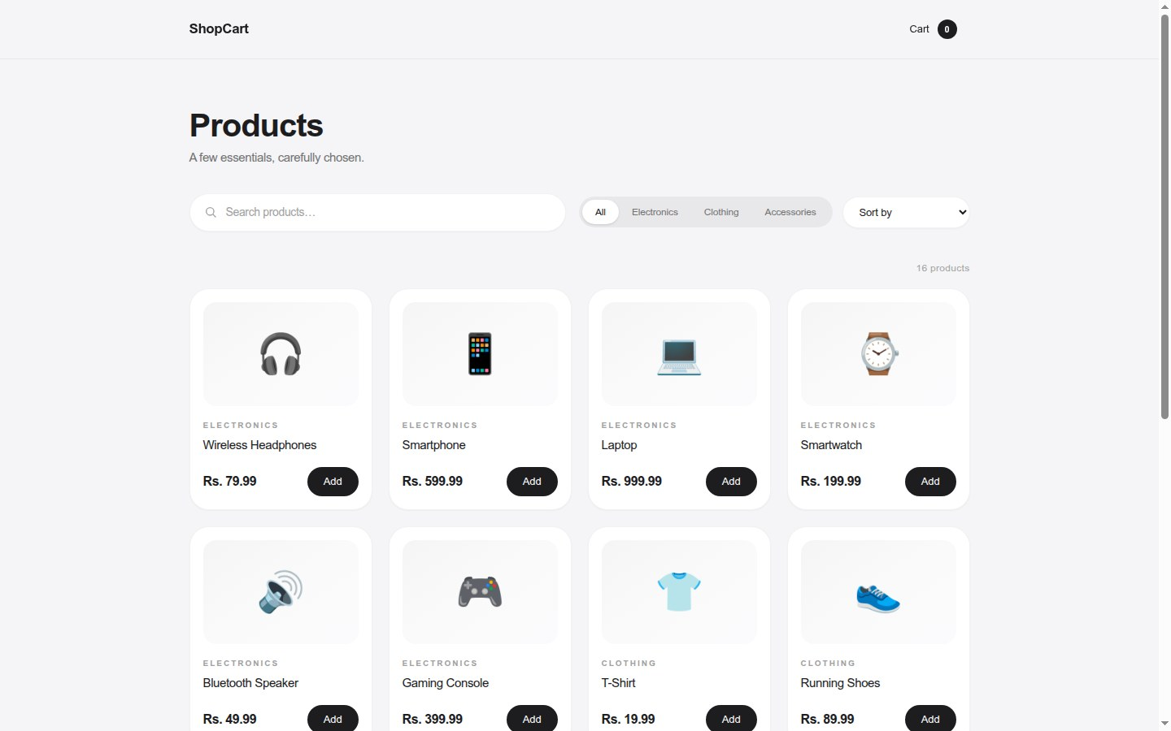 Fig 1: Product catalog (desktop): navbar, search bar, segmented category filter, and product grid. 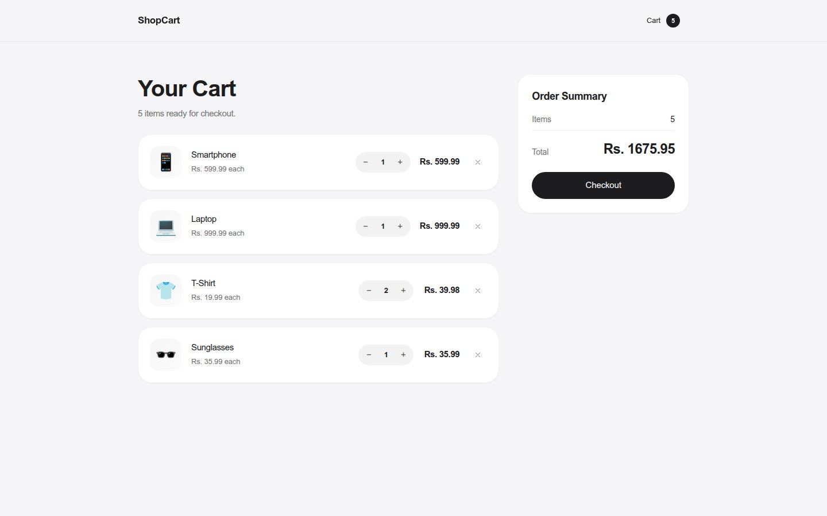 Fig 2: Cart page (desktop): cart items with quantity controls, running total, and order summary. 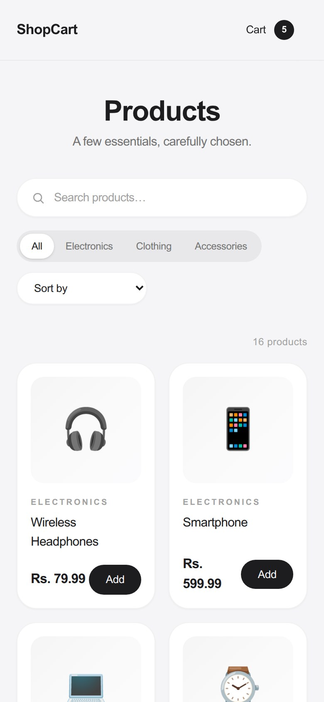 Fig 3: Catalog view on a mobile viewport showing the responsive two-column layout.

5. Appendix

5.1 References
- React documentation (react.dev)
- React Router documentation (reactrouter.com)
- Tailwind CSS documentation (tailwindcss.com)
- Vite guide (vite.dev)
- React Hot Toast (react-hot-toast.com)

5.2 Git History (Abridged)
- Initialize Vite React project with sample store name
- Add mock product catalog data
- Add reusable UI components
- Add useCart hook with cart handlers
- Add catalog page with search, filter and sort and wire routing
- Add cart page with quantity controls and checkout
- Persist cart in localStorage
- Replace custom CSS with Tailwind utility classes
- Add toast notifications for cart actions
- Refactor to clean premium UI with rupee pricing
- Add app screenshots to README
- Add Vercel SPA rewrite and live demo link

5.3 Extra Notes & Known Limitations
- Checkout is simulated: there is no real payment processing or order history.
- Product artwork uses emoji tiles rather than real product photography.
- Prices are shown in rupees (Rs.) for display purposes.
- No user accounts; cart is device-local via localStorage.
- Cart contents persist indefinitely (no expiry).

