**1. Hello, World!**

* Write a Python program that prints "Hello, World!" to the console.

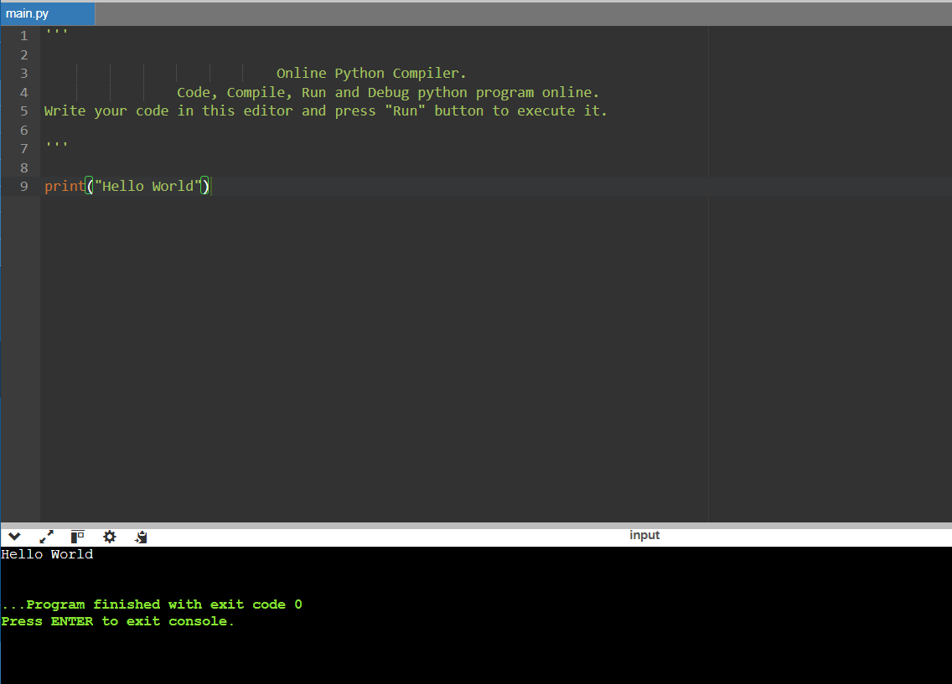

**2. Variables and Types**

* Declare a variable x with the value 10. Assign another variable y with the string "Python". Print both values along with their types.

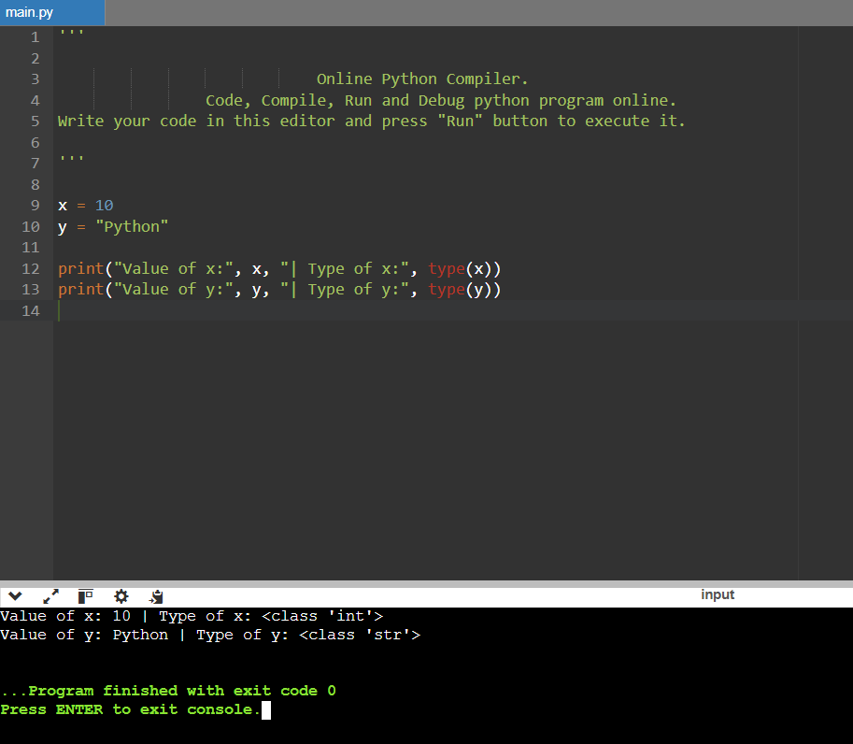

**3. Lists**

* Create a list of five numbers. Write a Python program to find the sum and average of all numbers in the list.

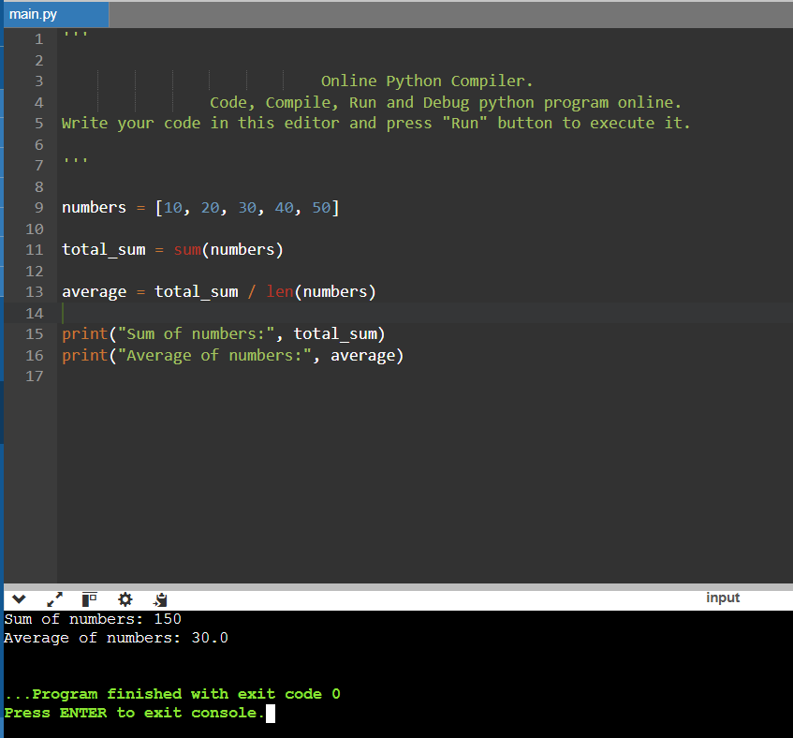

**4. Basic Operators**

* Write a Python program that takes two numbers as input and prints their sum, difference, product, and quotient.

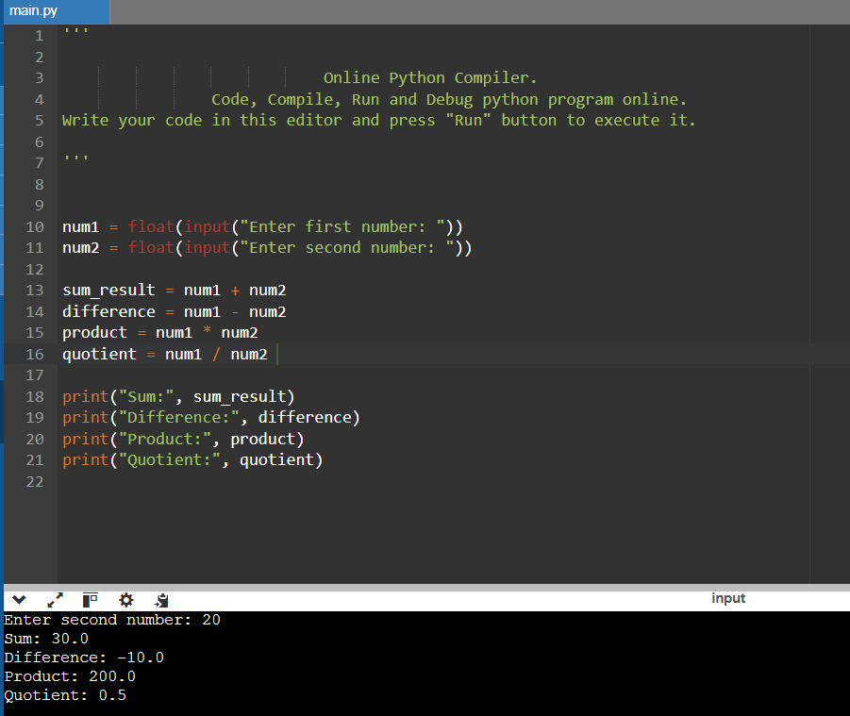

**5. String Formatting**

* Given name = "Alice" and age = 25, use different string formatting techniques (%, .format(), and f-strings) to print "Alice is 25 years old."

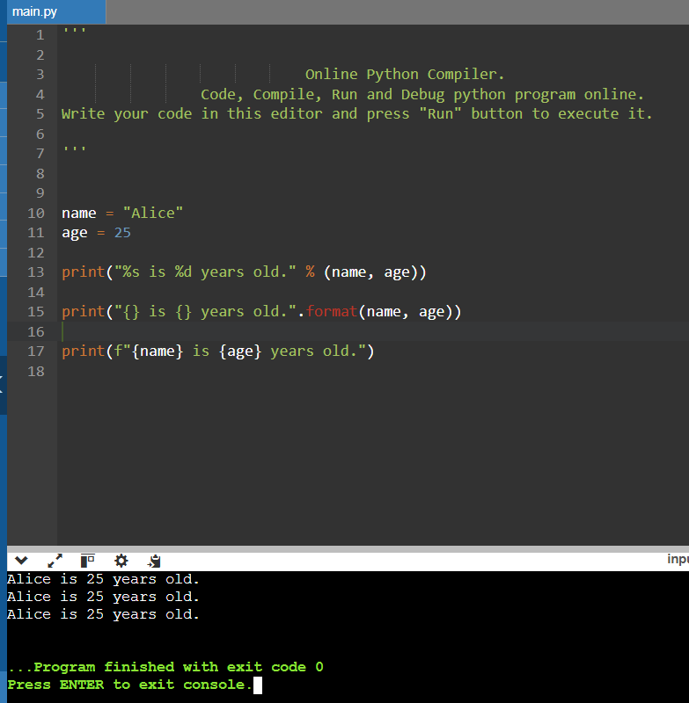

**6. Basic String Operations**

* Write a Python program that takes a string as input and:
  + Converts it to uppercase and lowercase.
  + Counts the number of vowels in the string.
  + Reverses the string.

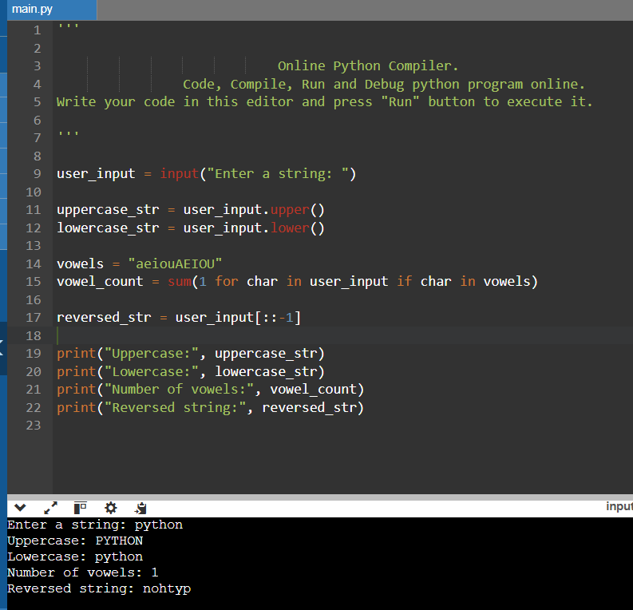

**7. Conditions**

* Write a Python program that takes a number as input and checks whether it is even or odd.

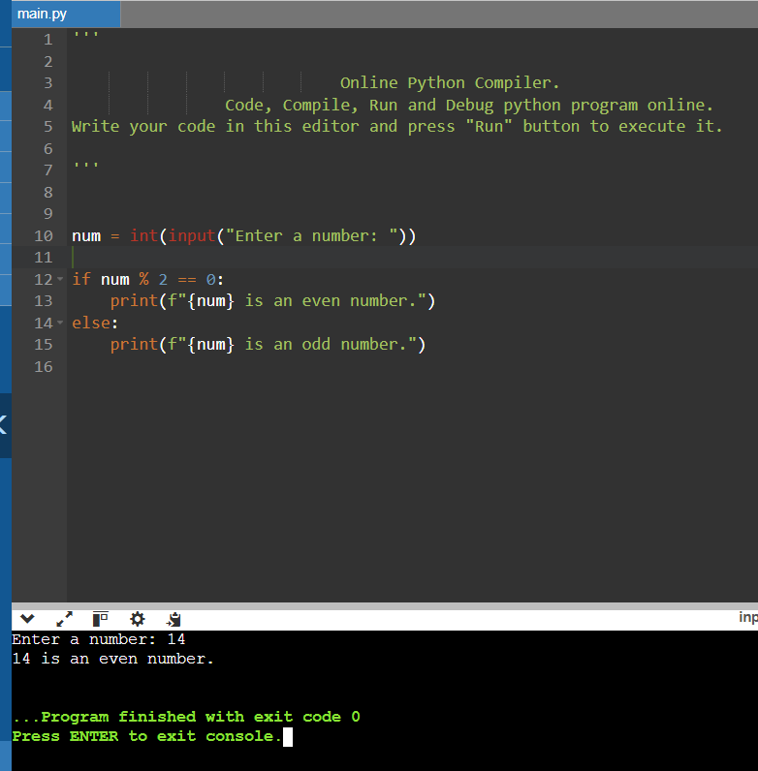

**8. Loops**

* Write a Python program that prints all prime numbers between 1 and 50.

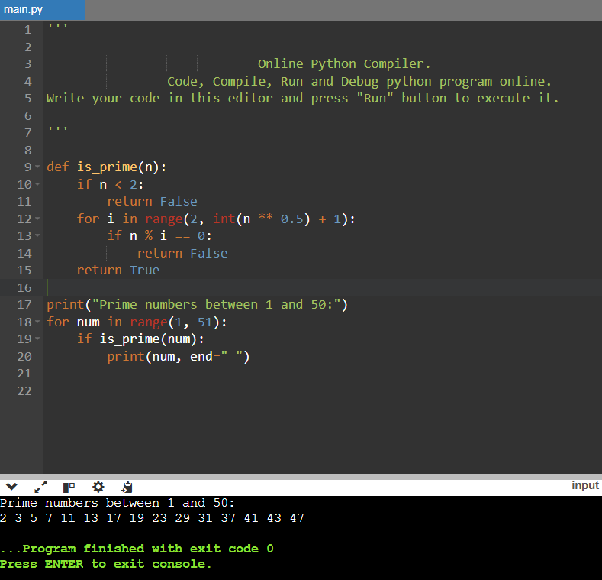

**9. Functions**

* Write a function factorial(n) that returns the factorial of a given number n.

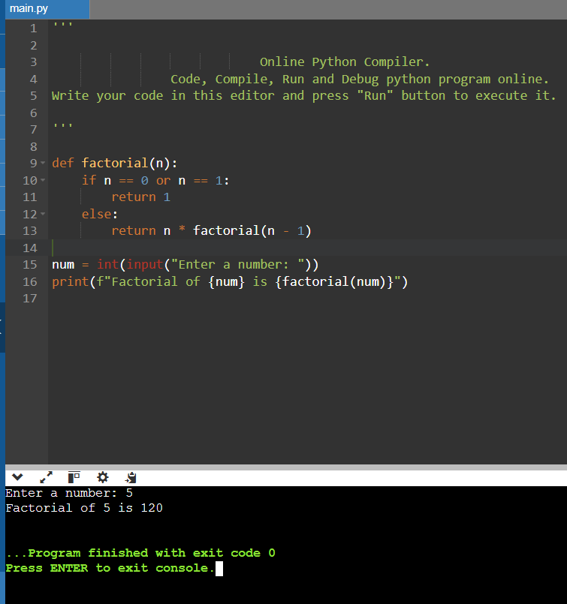

**10. Classes and Objects**

Create a Car class with attributes brand, model, and year. Define a method display_info() that prints car details. Instantiate an object and call the method.

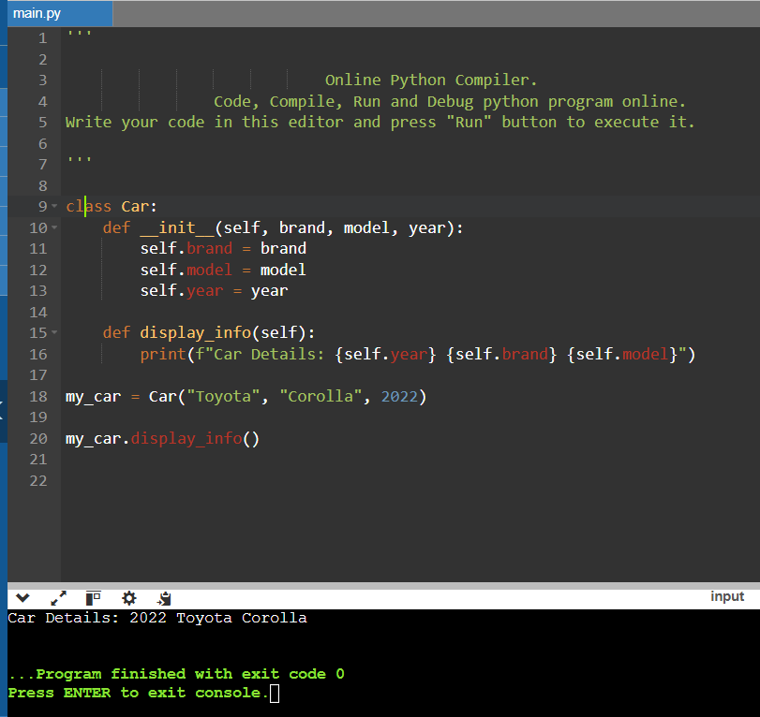

**11. Dictionaries**

* Create a dictionary containing three students' names as keys and their scores as values. Write a program to:
  + Print all keys and values.
  + Find the highest score.

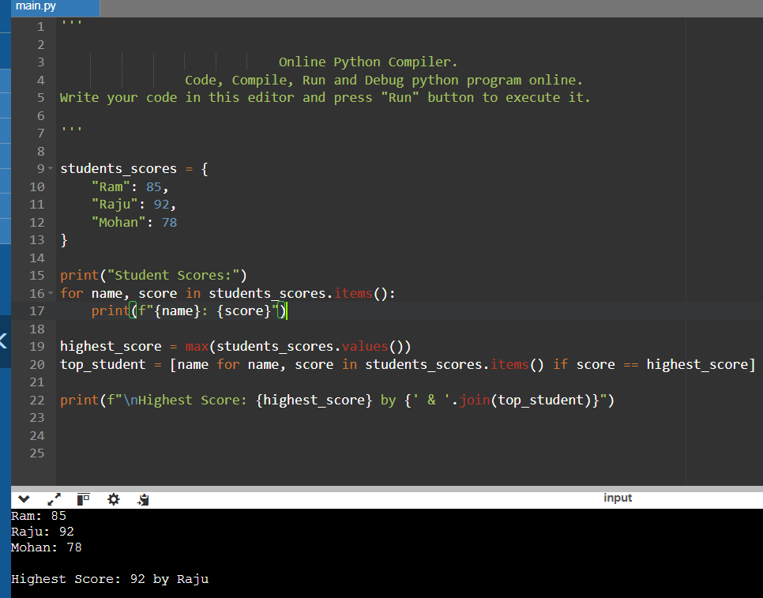

**12. Modules and Packages**

* Write a Python program that imports the math module and calculates the square root and factorial of a given number.

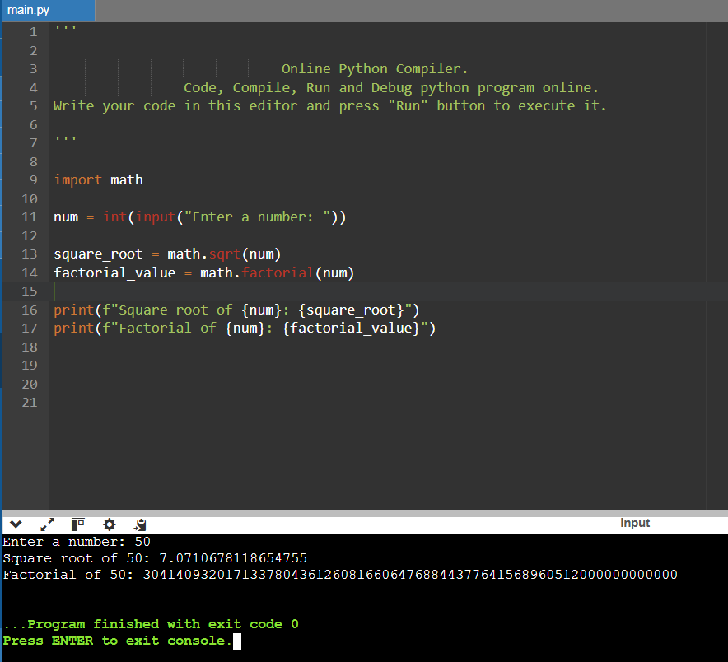

**13. Input and Output**

* Write a Python program that asks the user for their name and age, then prints a message saying "Hello [name], you are [age] years old!".

