The Institution of Engineers (India)
(ESTABLISHED 1920, INCORPORATED BY ROYAL CHARTER 1935)
8 GOKHALE ROAD, KOLKATA – 700 020
PROFORMA OF REPORT FROM STUDENTS’ CHAPTER
(1 April 2023 - 31 March 2024)
Name of the Students’ Chapter: CSDIEI
Branch of Engineering (for Engg College only): Computer Science & Design
Chapter Code: 534204/SRKR/CD/
Date of Enrolment as Students’ Chapter of IEI:
of the Name of Adviser with contact no and e-mail: Dr. Suresh Mudunuri, 9866600002
suresh.mudunuri@srkrec.edu.in
1. Date of Election: 7th Dec 2022
2. Date of AGM:
Sl No | Technical Activity | No of activities per Quarter (Qtr) |  |  |  | Details with photograph in Page No (range) (From__To __)
Sl No | Technical Activity | Qtr 1 | Qtr 2 | Qtr 3 | Qtr 4 | Details with photograph in Page No (range) (From__To __)
3. | Committee Meeting/s
4. | Lecture |  | 1
4. | Paper presentation
5. | Seminar
5. | Workshop
5. | Conference |  | 1
6. | Technical/Project Demonstration |  | 1
6. | Model competition
6. | Poster Competition |  | 1
7. | Group Discussion
7. | Technical Quiz
7. | Aptitude Test
8. | Technical Visit
9. | Film show
9. | Display of Technical Information
10. | Short term course  (Course duration minimum 3 days)
11. | Any other technical activity

________________
Signature of the Principal
with date affixed with seal

________________
Signature of the Faculty Advisor
with date affixed with seal
Number of photographs attached.
First Quarter____________
Second Quarter___________
Third Quarter___________
Fourth Quarter_______

________________
Signature of the Principal with date affixed with seal
Number of photographs attached.
First Quarter____________
Second Quarter___________
Third Quarter___________
Fourth Quarter_______

Details of Technical Activity
Title /Theme: Software Development Life Cycle

Date: 9th Aug 2023 Duration: 2 Hrs.

No of Students Participated: 60

Photographs:
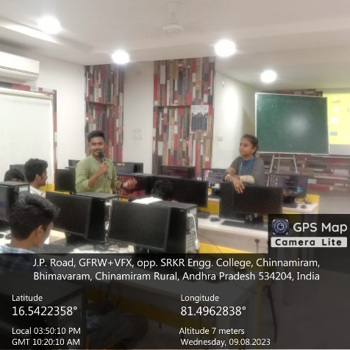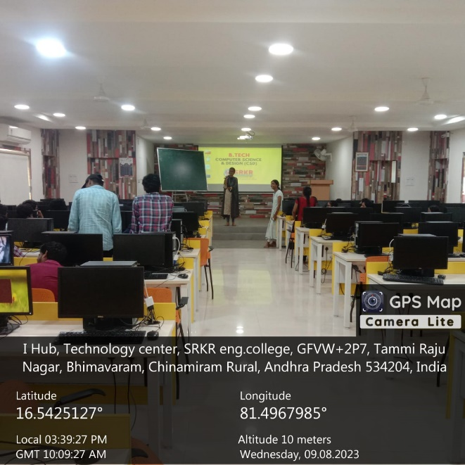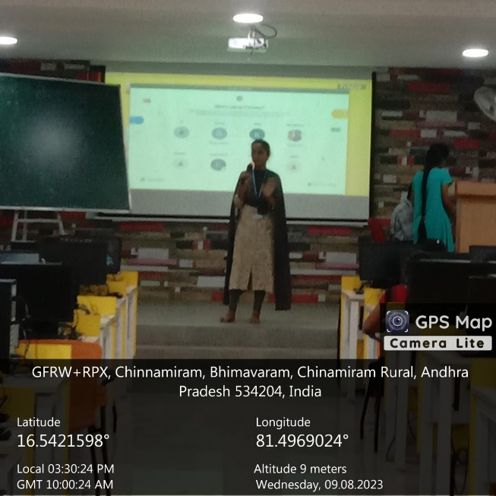

Details:
Chief Guest/ Guest of Honor: Dr. M. Jagapathi Raju
Designation: Principal, SRKREC

Speaker: Ch. Anusha  Designation/Organization: ¾ CSD Student | Speaker: P. Revathi  Designation/Organization: ¾ CSD Student
Speaker: Dr. M. Suresh Babu  Designation/Organization: HOD CSD | Speaker: Dr. N. G. K Murthy  Designation/Organization: Honorable Secretary, IEI Bhimavaram Local Center
Report

Dear IEI,

I am pleased to provide a brief report on the recent Software Development Life Cycle (SDLC) talk conducted by our third-year students, [Anusha & Revathi], which proved to be an insightful and well-received event.

Event Details:
Date: 9th Aug, 2023
Topic: Software Development Life Cycle (SDLC)
Duration: Approximately 2Hrs.
Audience: The event had 60 students and faculty members in attendance.

Students delivered a comprehensive presentation on SDLC, covering its phases, including Planning, Design, Coding, Testing, and Deployment. Real-world examples and case studies were used to illustrate each phase's significance in the software development process.

The audience actively engaged with questions and discussions, making the event interactive and enriching. Students provided insightful responses, enhancing the learning experience.

Attendees praised the clear and informative presentation, expressing interest in more talks on related topics. The event showcased our students' ability to deliver insightful presentations on complex subjects.

Please feel free to reach out to us if you have any questions or suggestions. We welcome your feedback and support as we embark on this new chapter of our academic journey.
Thank you for your attention, and we look forward to working with you.

Sincerely,
SRKREC CSD
CSDIEI

Title /Theme: Poster Making Competition on Independence Day / Colors of Freedom

Date: 15th Aug 2023 Duration: 3 Hrs.

No of Students Participated: 30

Photographs:

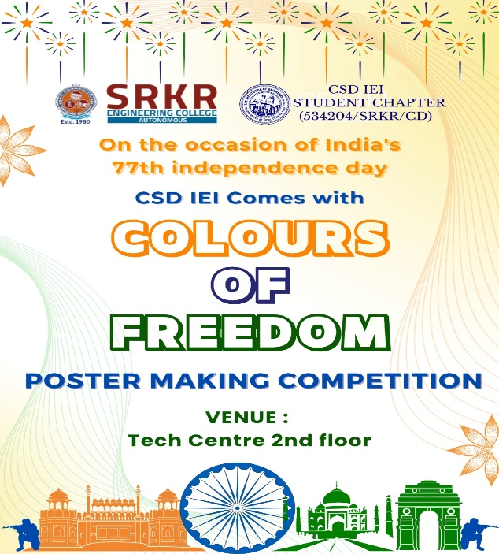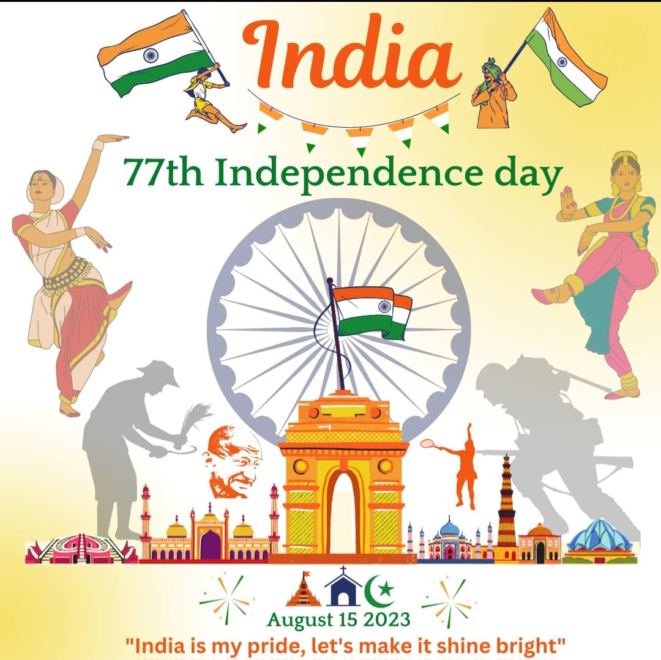
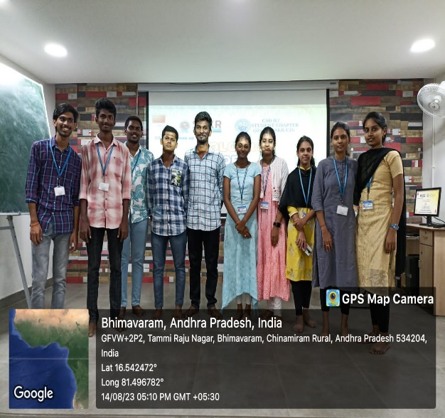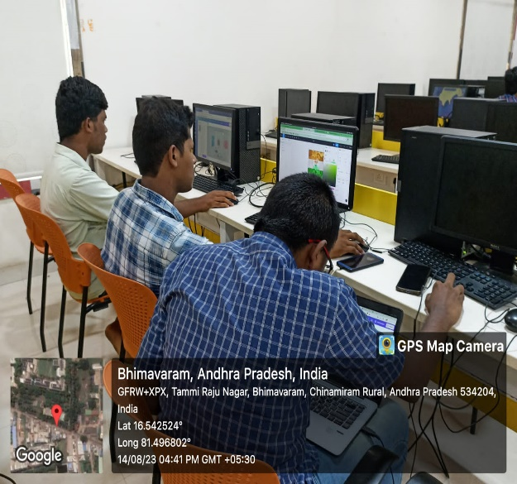

Details:
Chief Guest/ Guest of Honor: Dr. M. Suresh Babu
Designation: HOD CSD

Report

Dear IEI,

I am pleased to submit a report on the recently conducted Independence Day Poster Making Competition held at our institution. This event celebrated our nation's Independence Day and showcased the artistic talents of our students.

Event Details:
Date: 15th Aug, 2023
Event: Independence Day Poster Making Competition
Participants: 30 students from various disciplines
Theme: "Colors of Freedom"

The Independence Day Poster Making Competition aimed to encourage creativity and patriotism among our students. Participants were provided with art supplies and a canvas to create posters that reflected the theme of "Colors of Freedom." The competition allowed students to express their thoughts and emotions related to Independence Day through their artwork.

Winners received prizes as tokens of appreciation for their outstanding artwork.

All submitted posters were displayed on campus, allowing our community to appreciate the talents and creativity of our students.

Feedback from participants was overwhelmingly positive, with students expressing gratitude for the chance to showcase their artistic talents and celebrate Independence Day through art.

The competition successfully celebrated Independence Day through art, highlighting our students' creativity. We look forward to organizing more such events in the future.

Please feel free to reach out to us if you have any questions or suggestions. We welcome your feedback and support as we embark on this new chapter of our academic journey.
Thank you for your attention, and we look forward to working with you.

Sincerely,
SRKREC CSD
CSDIEI

Title /Theme: Startup Meet and Interaction Program

Date: 19th Aug 2023 Duration: 2 Hrs.

No of Students Participated: 120

Photographs:

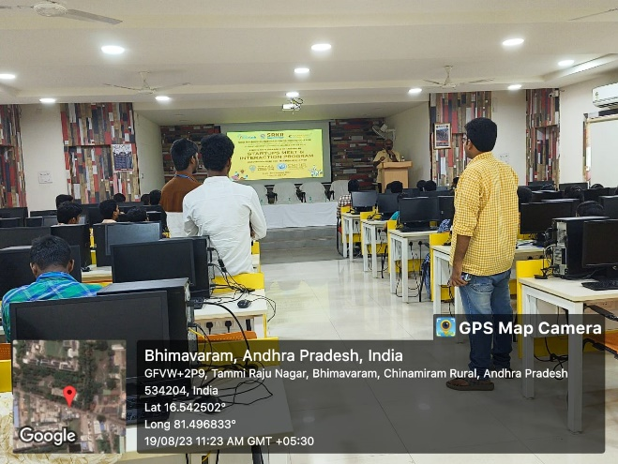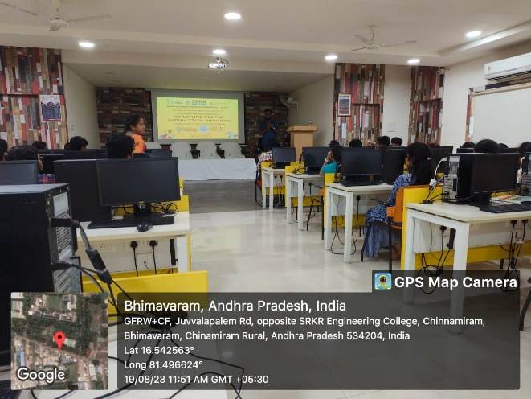

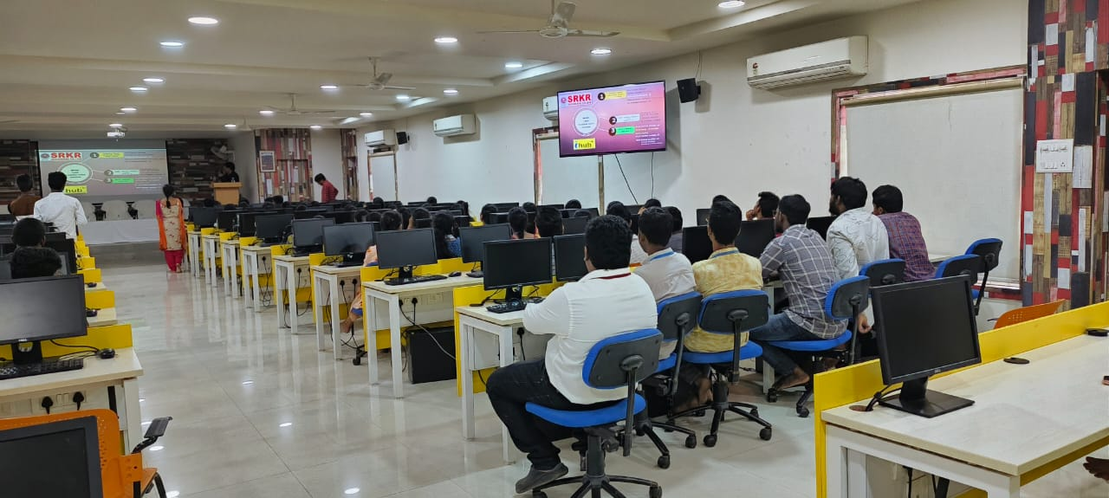

Details:
Chief Guest/ Guest of Honor: Dr. M. Jagapathi Raju
Designation: Principal, SRKREC

Speaker: Ch. Anusha  Designation/Organization: ¾ CSD Student | Speaker: P. Revathi  Designation/Organization: ¾ CSD Student
Speaker: Dr. M. Suresh Babu  Designation/Organization: HOD CSD | Speaker: Dr. N. G. K Murthy  Designation/Organization: Honorable Secretary, IEI Bhimavaram Local Center
Report

Dear IEI,

I am pleased to present a comprehensive report on the highly successful Startup Meet and Interaction Program that took place recently. This unique event brought together all the startup heads from West Godavari District, fostering collaboration, knowledge exchange, and innovation in our local startup ecosystem.

Event Details:
Date: 19th Aug 2023
Venue: SRKREC Innovation Lab
Participants: Startup Heads from West Godavari District
Theme: Startup Meet and Interaction Program

The Startup Meet and Interaction Program was designed to create a platform for startup leaders within our district to connect, share experiences, and explore opportunities for collaboration. The program included the following key components:

Guest Speakers: Esteemed guest speakers, including successful entrepreneurs and industry experts, delivered inspiring talks on topics such as startup growth strategies, innovation, and navigating challenges in the entrepreneurial journey.
Panel Discussions: Interactive panel discussions featured startup leaders who discussed critical aspects of the local startup ecosystem, funding opportunities, and best practices for sustainable growth.
Networking Sessions: Extensive networking breaks allowed participants to establish valuable connections, exchange ideas, and explore potential partnerships.

Guest Speakers:
We were honored to host renowned guest speakers, including:
[Carryshare Solution Pvt Ltd Director & Founder: Mantena Siva Pavankumar Raju]
[Dronefusion llp Director & Founder: Kasani Jyothi Prakash]
[Electropro India & Global Founder & CEO: Venkatesh Sappagaddi ]
[Localfilings India Pvt Ltd Founder & CEO: Lokesh Komatlapalli]
[Nutri Revive Pvt Ltd Founder & Director: Marisetti Ravi Manikanth & Evuri Jagan Sainadh]
[Primestudents & Co Founder: Bhaskar Lakkoju]
[Plantelo Founder: Bhaskar Lakkoju, Anusha Lakkoju & Dileep Lakkoju]
[Tejas Open Haul Freight Logistics Pvt Ltd Founders: Palaparthi Teja and Anabilli Santosh]

Panel Discussions:
Our panel discussions covered a wide range of topics, such as:
“Leveraging Local Resources for Startup Growth”
" Fundraising and Investment Strategies for Startups "
" Building a Thriving Startup Community in West Godavari District "
Participants expressed overwhelming enthusiasm for the program, emphasizing the value of networking and the insights gained from experienced speakers and fellow startup heads. Many discussed their intent to pursue collaborative initiatives and partnerships as a result of the connections made during the event.
The Startup Meet and Interaction Program with West Godavari District Startup Heads was a resounding success. It contributed significantly to the growth and cohesion of our local startup ecosystem, fostering innovation and entrepreneurship within our district.

Please feel free to reach out to us if you have any questions or suggestions. We welcome your feedback and support as we embark on this new chapter of our academic journey.
Thank you for your attention, and we look forward to working with you.

Sincerely,
SRKREC CSD
CSDIEI

Title /Theme: Expert Talk

Date: 29th Aug 2023 Duration: 2 Hrs.

No of Students Participated: 120

Photographs:
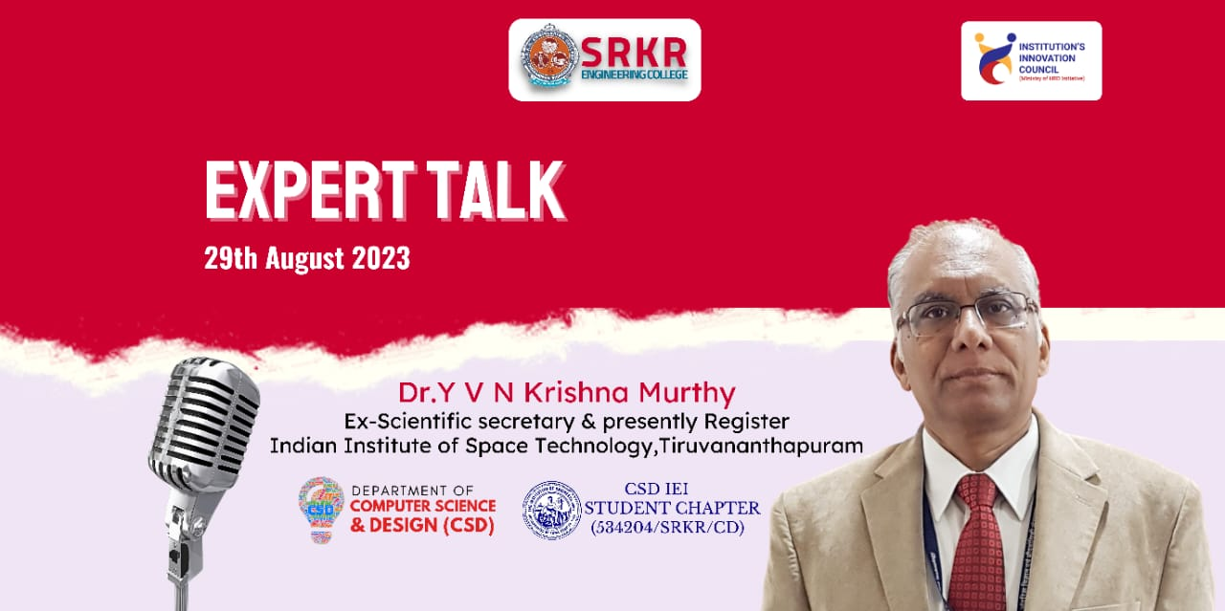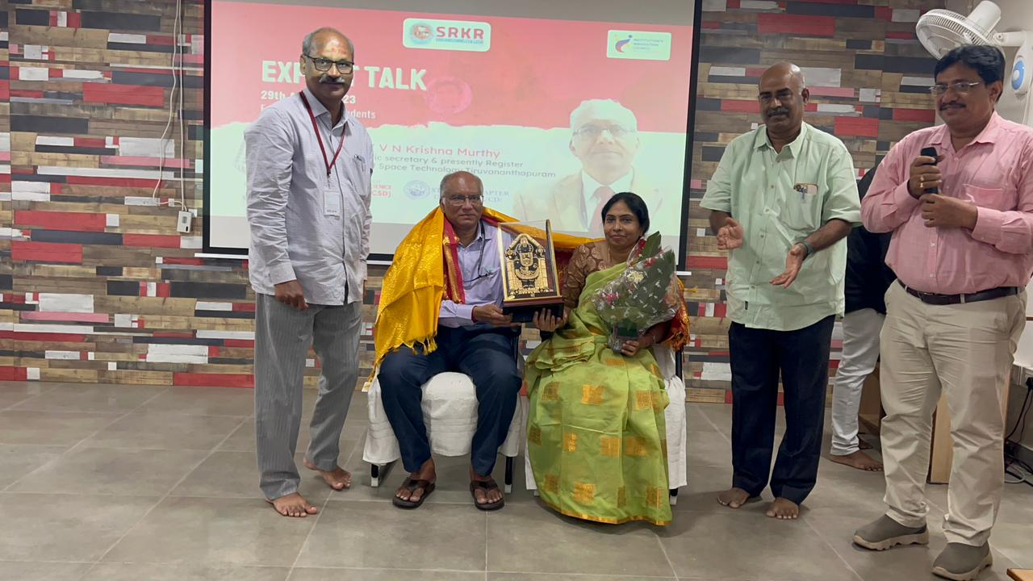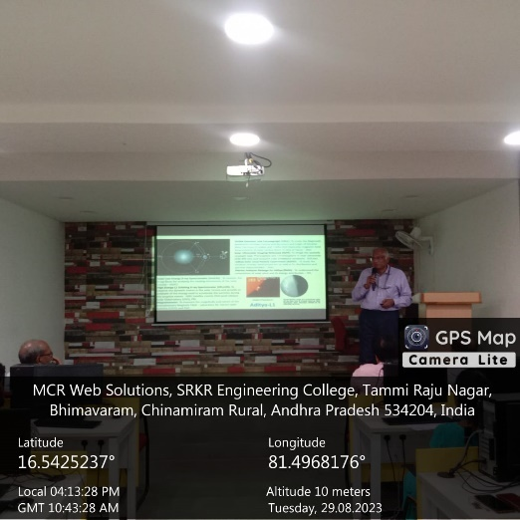

Details:
Chief Guest/ Guest of Honor: Dr. M. Jagapathi Raju
Designation: Principal, SRKREC

Speaker: Dr. K. Suresh Babu  Designation/Organization: Chairman, IEI Bhimavaram Local Center | Speaker: Dr. P. A. Rama Krishnam Raju  Designation/Organization: Dean R&D
Speaker: Dr. M. Suresh Babu  Designation/Organization: HOD CSD | Speaker: Dr. N. G. K Murthy  Designation/Organization: Honorable Secretary, IEI Bhimavaram Local Center
Report

Dear IEI,

I am pleased to provide a report on the highly successful Expert Talk organized by our esteemed Ex-Scientific Secretary, Dr. Y. V. N Krishna Murthy. This event, which focused on fostering Indian Institute of Space Technology events and knowledge exchange, garnered substantial participation, and received positive feedback from attendees.

Event Details:

Date: 29th Aug 2023
Venue: SRKREC Innovation Lab
Participants: 120
Theme: Expert Talk

As part of the program, Dr. Y. V. N Krishna Murthy highlighted the significant events and knowledge exchange efforts undertaken by the Indian Institute of Space Technology (IIST). These initiatives play a pivotal role in fostering innovation, entrepreneurship, and collaboration within the space technology sector.

Dr. Y. V. N Krishna Murthy provided insights into IIST's endeavors, including but not limited to:

Conferences and Workshops: IIST regularly organizes conferences and workshops that bring together experts, researchers, and industry leaders to discuss the latest developments in space technology, research, and applications.
Student-Led Initiatives: IIST encourages student-led initiatives, such as technical symposia and innovation challenges, to nurture the entrepreneurial spirit among its students and provide them with hands-on experience.
Research Collaboration: IIST actively collaborates with research institutions, government agencies, and the private sector to drive innovation and knowledge exchange in the field of space technology.
International Partnerships: IIST seeks international partnerships and collaborations to leverage global expertise and promote cross-border knowledge exchange in space technology.

Participants of the Expert Talk appreciated the insights shared by Dr. Y. V. N Krishna Murthy regarding IIST's commitment to fostering innovation and entrepreneurship in the space technology domain. Many attendees expressed their interest in exploring potential collaborations and engagement with IIST in the future.

Please feel free to reach out to us if you have any questions or suggestions. We welcome your feedback and support as we embark on this new chapter of our academic journey.
Thank you for your attention, and we look forward to working with you.

Sincerely,
SRKREC CSD
CSDIEI
