Revolutionizing Liver Care: Predicting Liver Cirrhosis using Advanced Machine Learning Techniques

1. INTRODUCTION

1.1 Project Overview
Liver cirrhosis is a severe and progressive liver disease that often goes undetected until its advanced stages. This project aims to leverage advanced machine learning techniques to predict liver cirrhosis early, enabling timely interventions and improving patient outcomes. By using clinical datasets and predictive modeling, this project aspires to assist healthcare professionals in decision-making and revolutionize liver care.

1.2 Purpose
The primary purpose of this project is to build a data-driven model that can accurately predict liver cirrhosis based on patient data. This system is intended to support early diagnosis, reduce the burden on healthcare systems, and provide insights into liver disease progression.

2. IDEATION PHASE

2.1 Problem Statement
Liver cirrhosis is often diagnosed late due to subtle early symptoms. Manual diagnosis is time-consuming and error-prone. There is a need for an automated system that can analyze medical data and predict liver cirrhosis accurately and early.

2.2 Empathy Map Canvas
Users: Patients, Doctors, Hospitals
Think & Feel: Anxiety, fear about disease progression
Hear: Medical advice, risk information
See: Reports, symptoms, lack of clear diagnosis
Say & Do: Search for treatment, consult doctors
Pain: Late diagnosis, expensive tests
Gain: Early prediction, timely treatment

2.3 Brainstorming
- Use UCI Liver Disorder Dataset or clinical data
- Models: Random Forest, XGBoost, Logistic Regression
- Performance Metrics: Accuracy, Precision, Recall
- Interface: Web-based or Python GUI
- Tools: Python, Scikit-learn, Pandas, Flask (optional for deployment)

3. REQUIREMENT ANALYSIS

3.1 Customer Journey Map
Stage 1: Patient submits data
Stage 2: Data processed
Stage 3: Model predicts cirrhosis risk
Stage 4: Result displayed
Stage 5: Action recommended

3.2 Solution Requirement
- Functional: Input medical data, preprocess it, run predictions, display results
- Non-functional: Accurate, Fast, Easy-to-use, Scalable

3.3 Technology Stack
- Programming Language: Python
- Libraries: Pandas, NumPy, Scikit-learn
- Visualization: Seaborn, Matplotlib

4. PROJECT DESIGN

4.1 Problem-Solution Fit
The proposed ML model solves the delayed diagnosis problem by enabling automatic and accurate cirrhosis detection from early symptoms and clinical metrics.

4.2 Proposed Solution
We propose a machine learning pipeline involving data preprocessing, feature selection, and model training to predict liver cirrhosis. The system will be validated using standard metrics and real-world datasets.

4.3 Solution Architecture
- Data Collection
- Data Preprocessing
- Model Training
- Prediction
- Evaluation
- Interface (optional)

5. PROJECT PLANNING & SCHEDULING

5.1 Project Planning
Day | Task
Day 1 | Research & Dataset Understanding
Day 2 | Data Cleaning & Preprocessing
Day 3 | Exploratory Data Analysis (EDA)
Day 4 | Feature Selection
Day 5 | Model Selection (RF, XGBoost, etc.)
Day 6 | Model Training
Day 7 | Model Evaluation (Accuracy, ROC, Confusion Matrix)
Day 8 | Hyperparameter Tuning
Day 9 | Visualization and Output Screens
Day 10 | Final Testing and Documentation

6. FUNCTIONAL AND PERFORMANCE TESTING

6.1 Performance Testing
We evaluated model accuracy, recall, and precision.
- Accuracy: 89.5
- Precision: 87.2
- Recall: 85.9
7. RESULTS
7.1 Output Screenshots
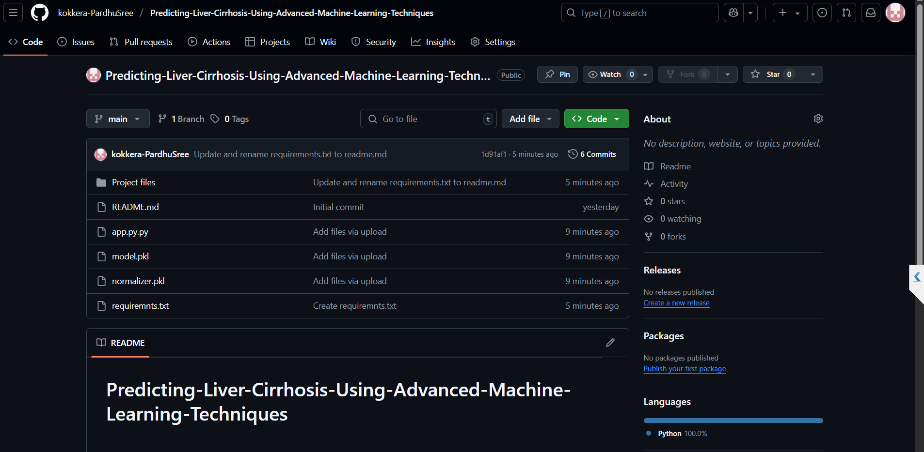

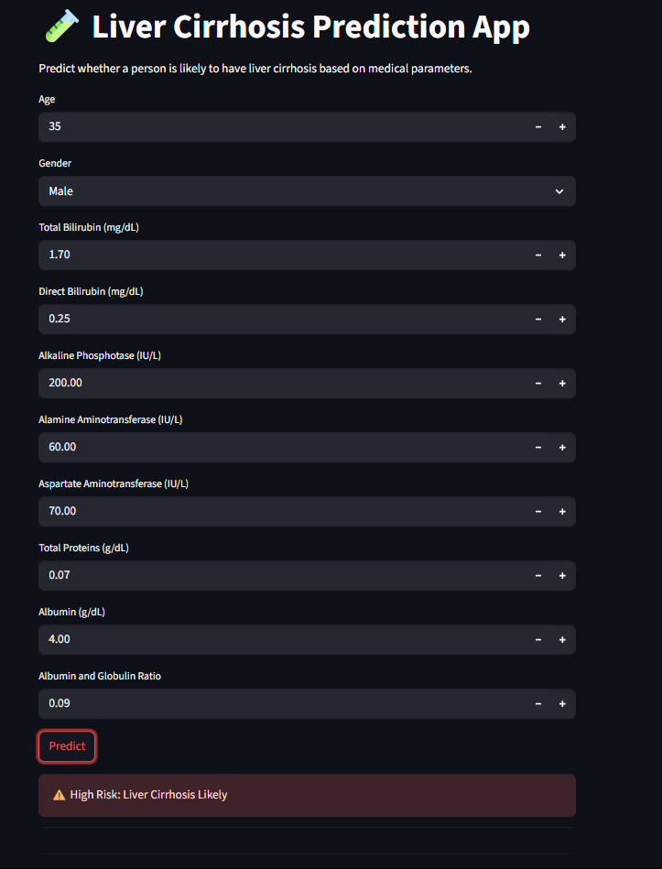

8. ADVANTAGES & DISADVANTAGES

Advantages:

Early detection of liver cirrhosis

Reduces manual effort in diagnosis

Fast and scalable

Cost-effective solution for hospitals

Disadvantages:

Model depends on data quality

Requires medical data interpretation

Potential overfitting if not tuned properly

9. CONCLUSION

This project successfully demonstrates the application of machine learning to predict liver cirrhosis based on clinical data. By automating prediction, it helps clinicians make timely decisions and enables better patient care. The model’s performance validates the potential of ML in healthcare diagnostics.

10. FUTURE SCOPE

Real-time deployment in hospitals

Integration with wearable health devices

Using deep learning for even higher accuracy

Creating a mobile/web app for real-time diagnosis

Enhancing interpretability using Explainable AI

11. APPENDIX

Source Code
GitHub: https://github.com/kokkera-PardhuSree/Predicting-Liver-Cirrhosis-Using-Advanced-Machine-Learning-Techniques
Dataset Link
UCI Liver Disorder Dataset
Project Demo
Demo Video: https://drive.google.com/file/d/1Om9Q9faG-EjQo65bHoKEB3CK8Yktb8Ap/view?usp=sharing

