Project Report: AI Medical Chatbot using IBM Watson API
Name: Rupak
Reg. No.: 22BCE10127
VIT Mail ID: rupak2022@vitbhopal.ac.in

1. Project Title
AI-Powered Medical Chatbot using IBM Watson API

2. Abstract
This project involves developing a medical chatbot using IBM Watson Assistant to provide intelligent, real-time support for healthcare-related queries. The chatbot assists users by answering health-related questions, suggesting possible conditions based on symptoms, providing general medical advice, and helping users navigate healthcare resources. The use of IBM Watson’s advanced natural language processing capabilities ensures a scalable and reliable digital health assistant.

3. Summary of Work Done
Phase 1 – Proposal and Idea Submission (10 Marks):
We identified the need for a virtual medical assistant to support users with general healthcare queries. The project objectives were:
- Understand the scope and application of AI-driven conversational systems in healthcare.
- Use IBM Watson Assistant to design intents, entities, and dialog specific to the medical domain.
- Integrate the chatbot with a website for user interaction.
A detailed proposal was submitted including problem definition, goals, required tools, and the expected outcome tailored to a healthcare chatbot.
Phase 2 – Execution and Demonstration (15 Marks):
In this phase, the chatbot was built using IBM Watson Assistant and integrated into a sample health support website. Completed tasks include:
- Created a new assistant named Medical Support ChatBot.
- Defined intents such as symptoms inquiry, general health tips, and doctor suggestions.
- Created entities like @symptom, @body_part, @disease to recognize user input.
- Built a structured dialog tree for tailored responses.
- Published the assistant and generated integration code.
- Embedded the chatbot on the website for real-time interaction.
- Tested the chatbot using real-world scenarios to ensure accuracy.
GitHub Link: [Replace with your GitHub repo]

4. Project Architecture Components
- User Interface: Embedded chat interface on the medical support website.
- Watson Assistant: Handles intents, entities, dialog management, and responses.
- Backend (optional): Could integrate with APIs for doctor listings, health articles, etc.

5. Features Implemented
- Symptom-based Query Handling: Users can ask about symptoms and get possible conditions.
- First-Aid Information: Provides general guidance for common emergencies.
- Health Tips: Offers preventive care suggestions.
- Doctor/Clinic Search: Suggests nearby medical facilities (planned for future).
- FAQ Resolution: Covers common questions like diet, vaccinations, mental health.
- Fallback & Handoff: Escalates to a human or provides emergency contact info if needed.

6. IBM Watson Configuration
- Create Watson Assistant Service
- Define Intents (e.g., symptoms_check, general_advice)
- Define Entities (e.g., @symptom, @body_part)
- Create Dialog Flow
- Preview and Publish
- Website Deployment

7. Integration with Website
- Watson Assistant deployed via embedded code snippet.
- Chatbot launches automatically or on clicking a chat icon.
- UI customized to match medical site aesthetics.

8. Testing Phase
8.1 Testing Strategy
Testing included multiple use cases and both manual and automated methods:
- Input Handling: Tested with diverse query formats.
- Context Understanding: Checked coherence across multi-turn conversations.
- Edge Cases: Handled vague or unrelated input effectively.
8.3 Challenges Faced
- Mapping user symptom descriptions to intents.
- Handling multi-symptom or ambiguous health queries.
- Managing limitations of static data without live backend integration.

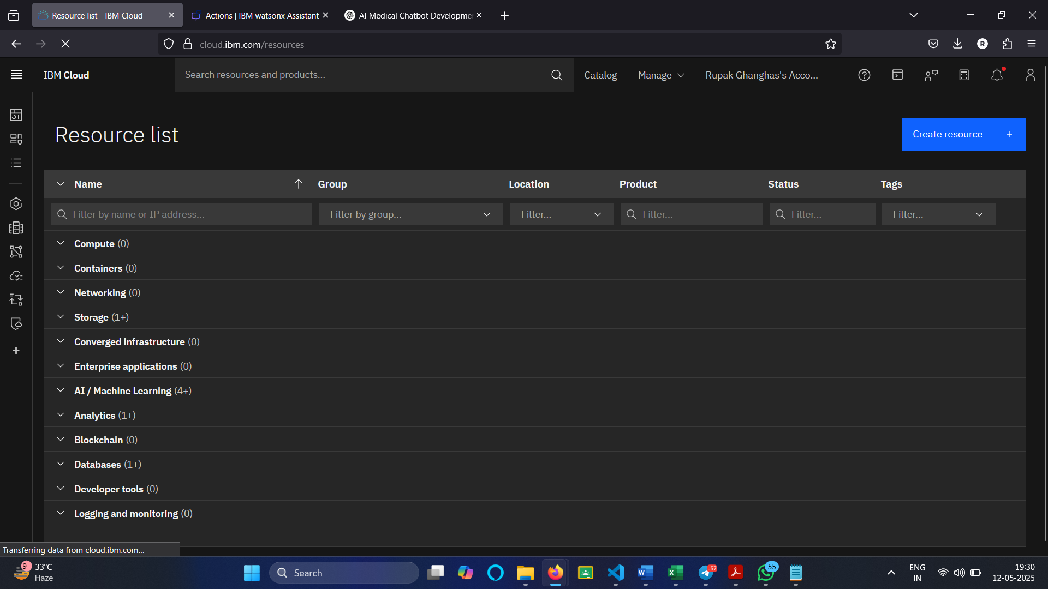
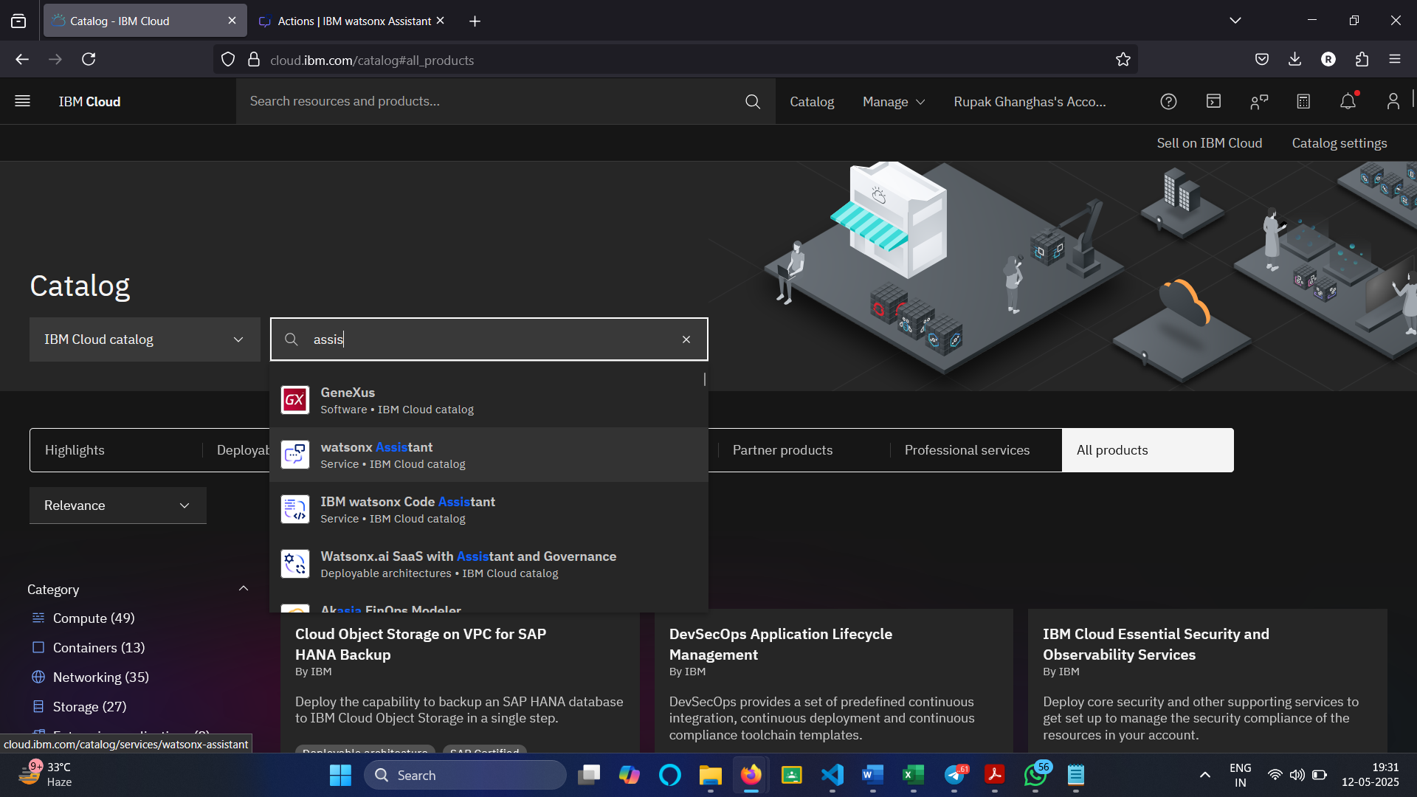
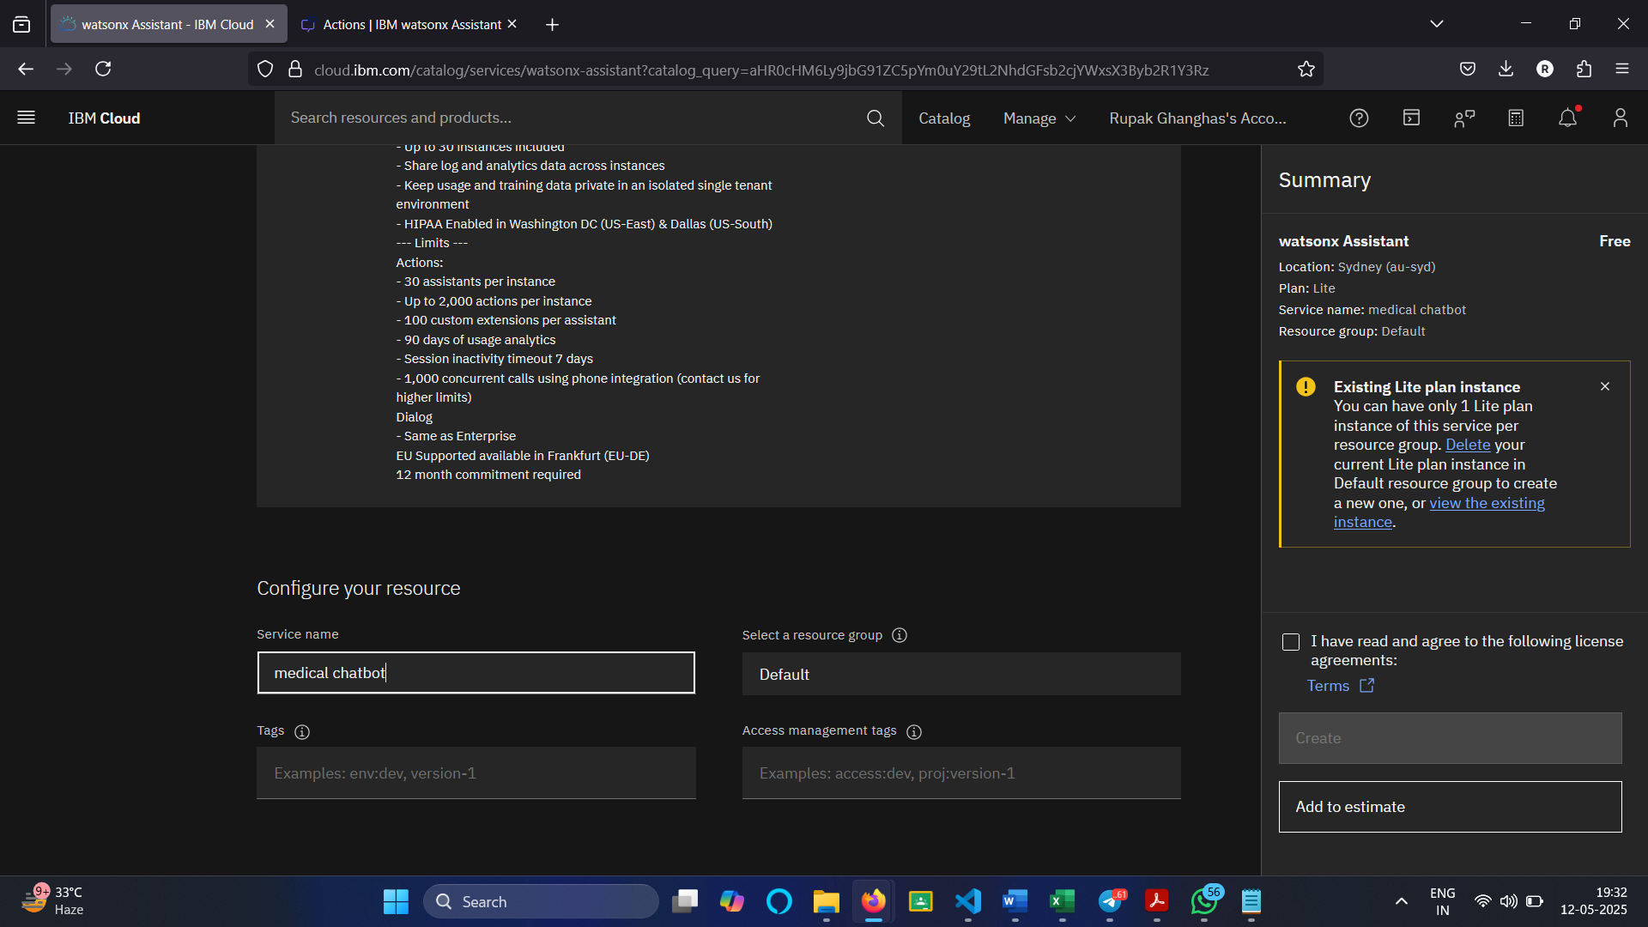
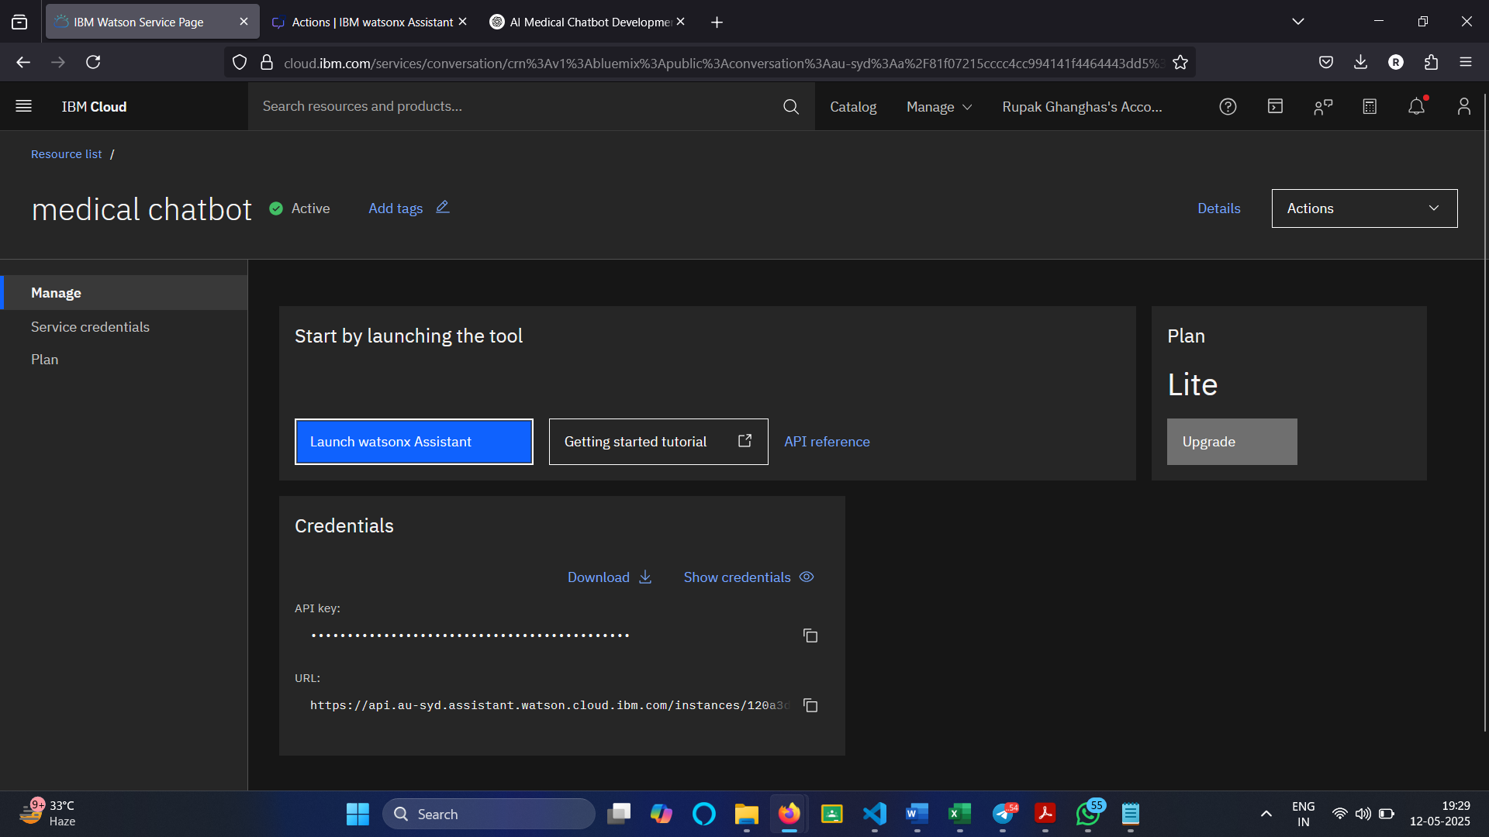

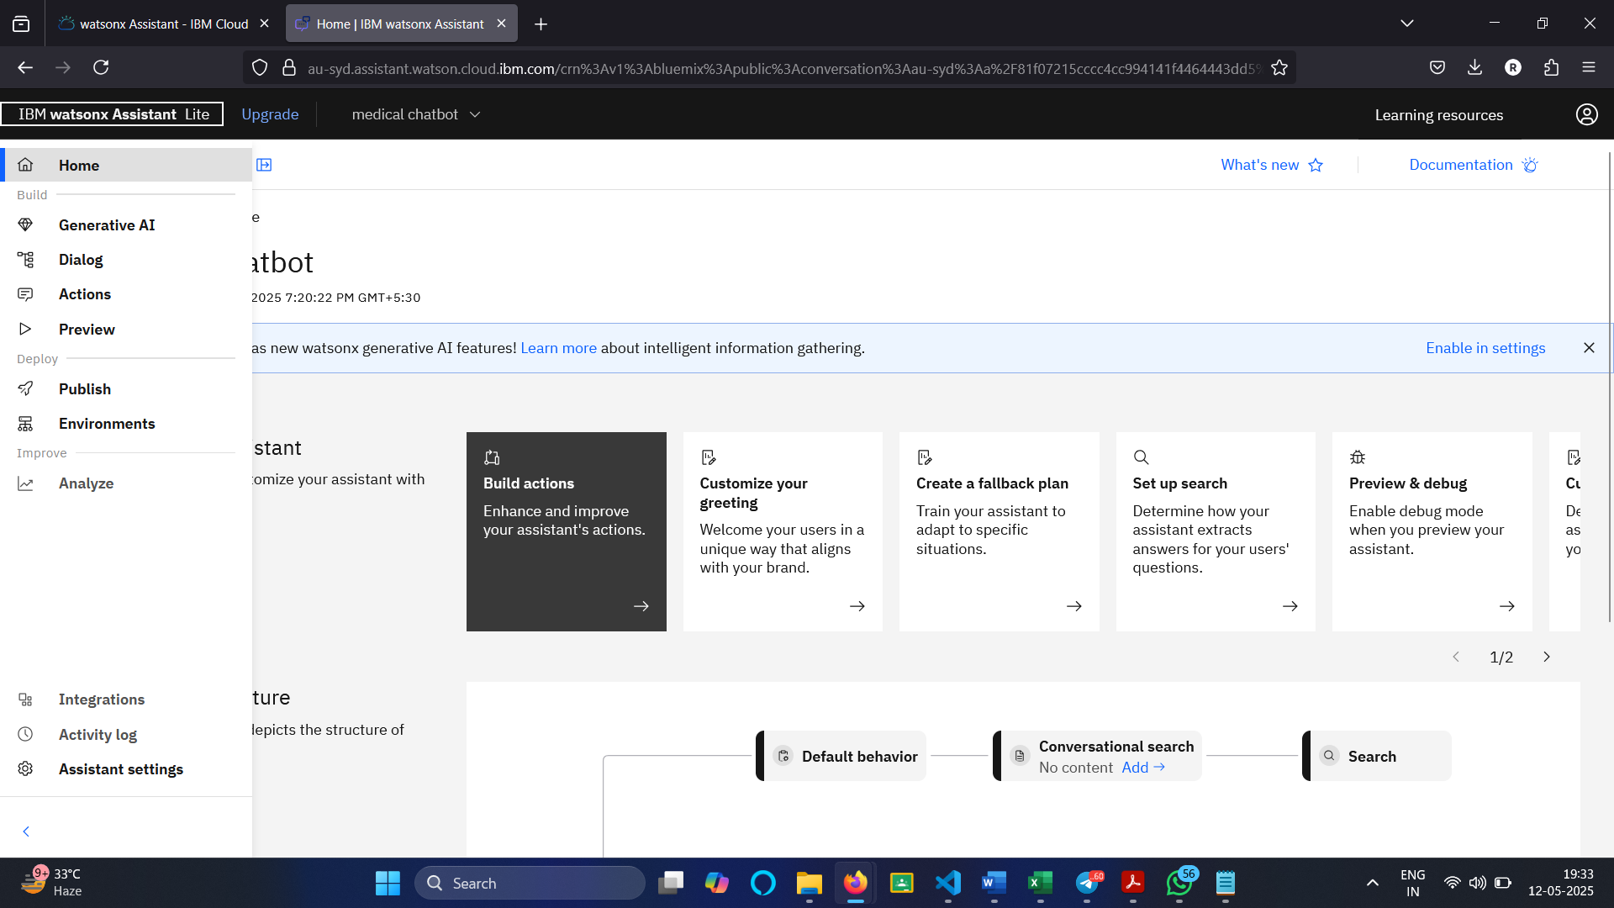
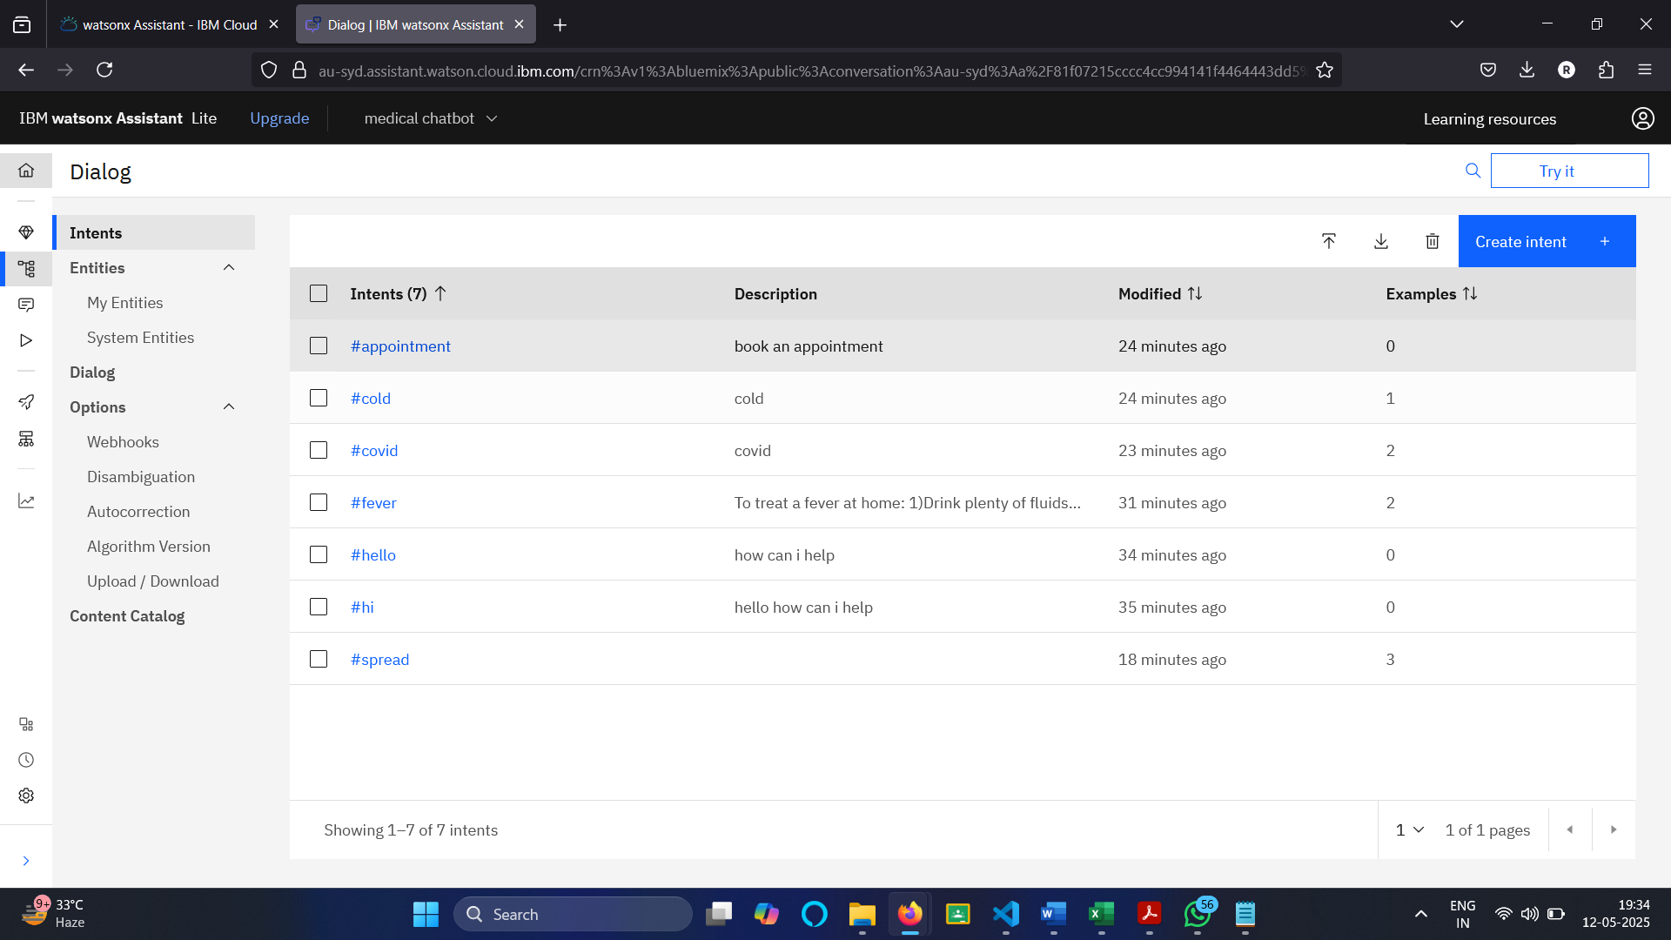
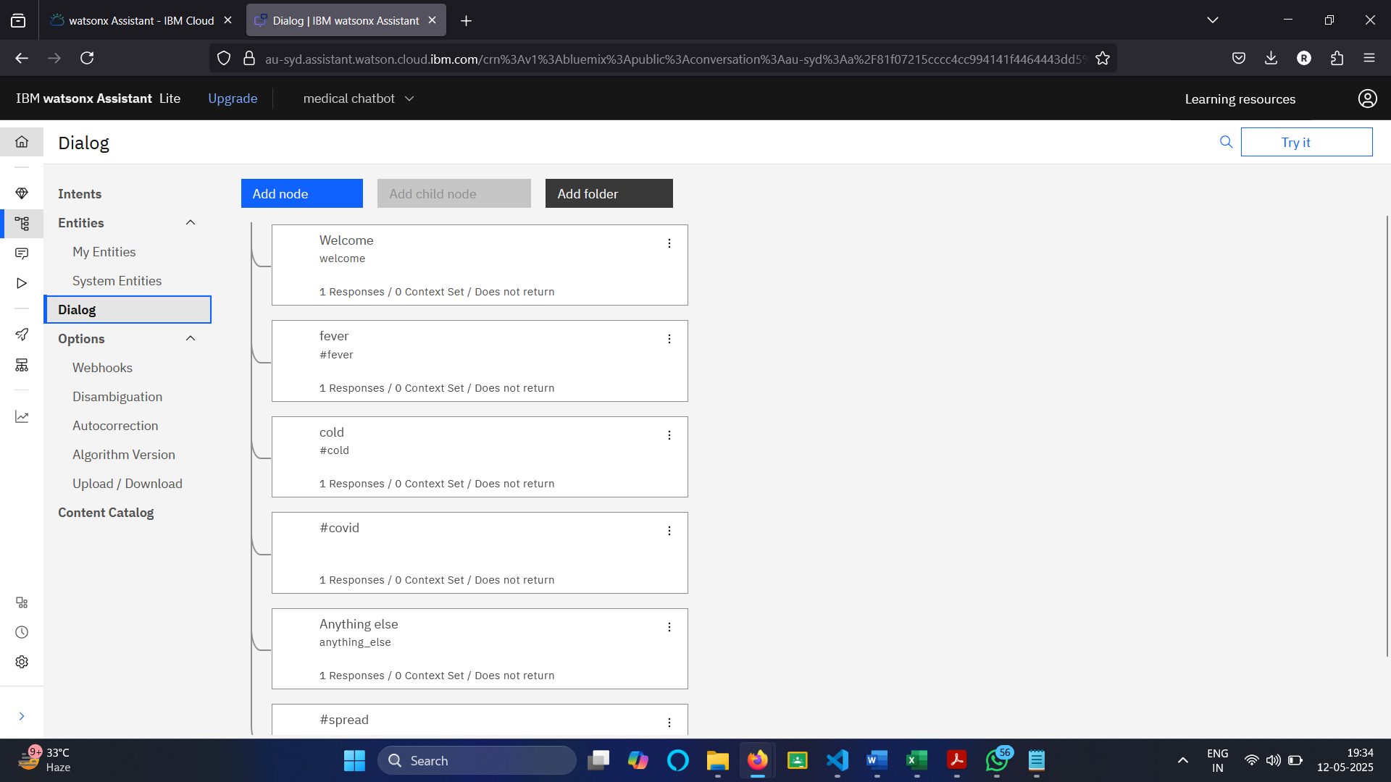
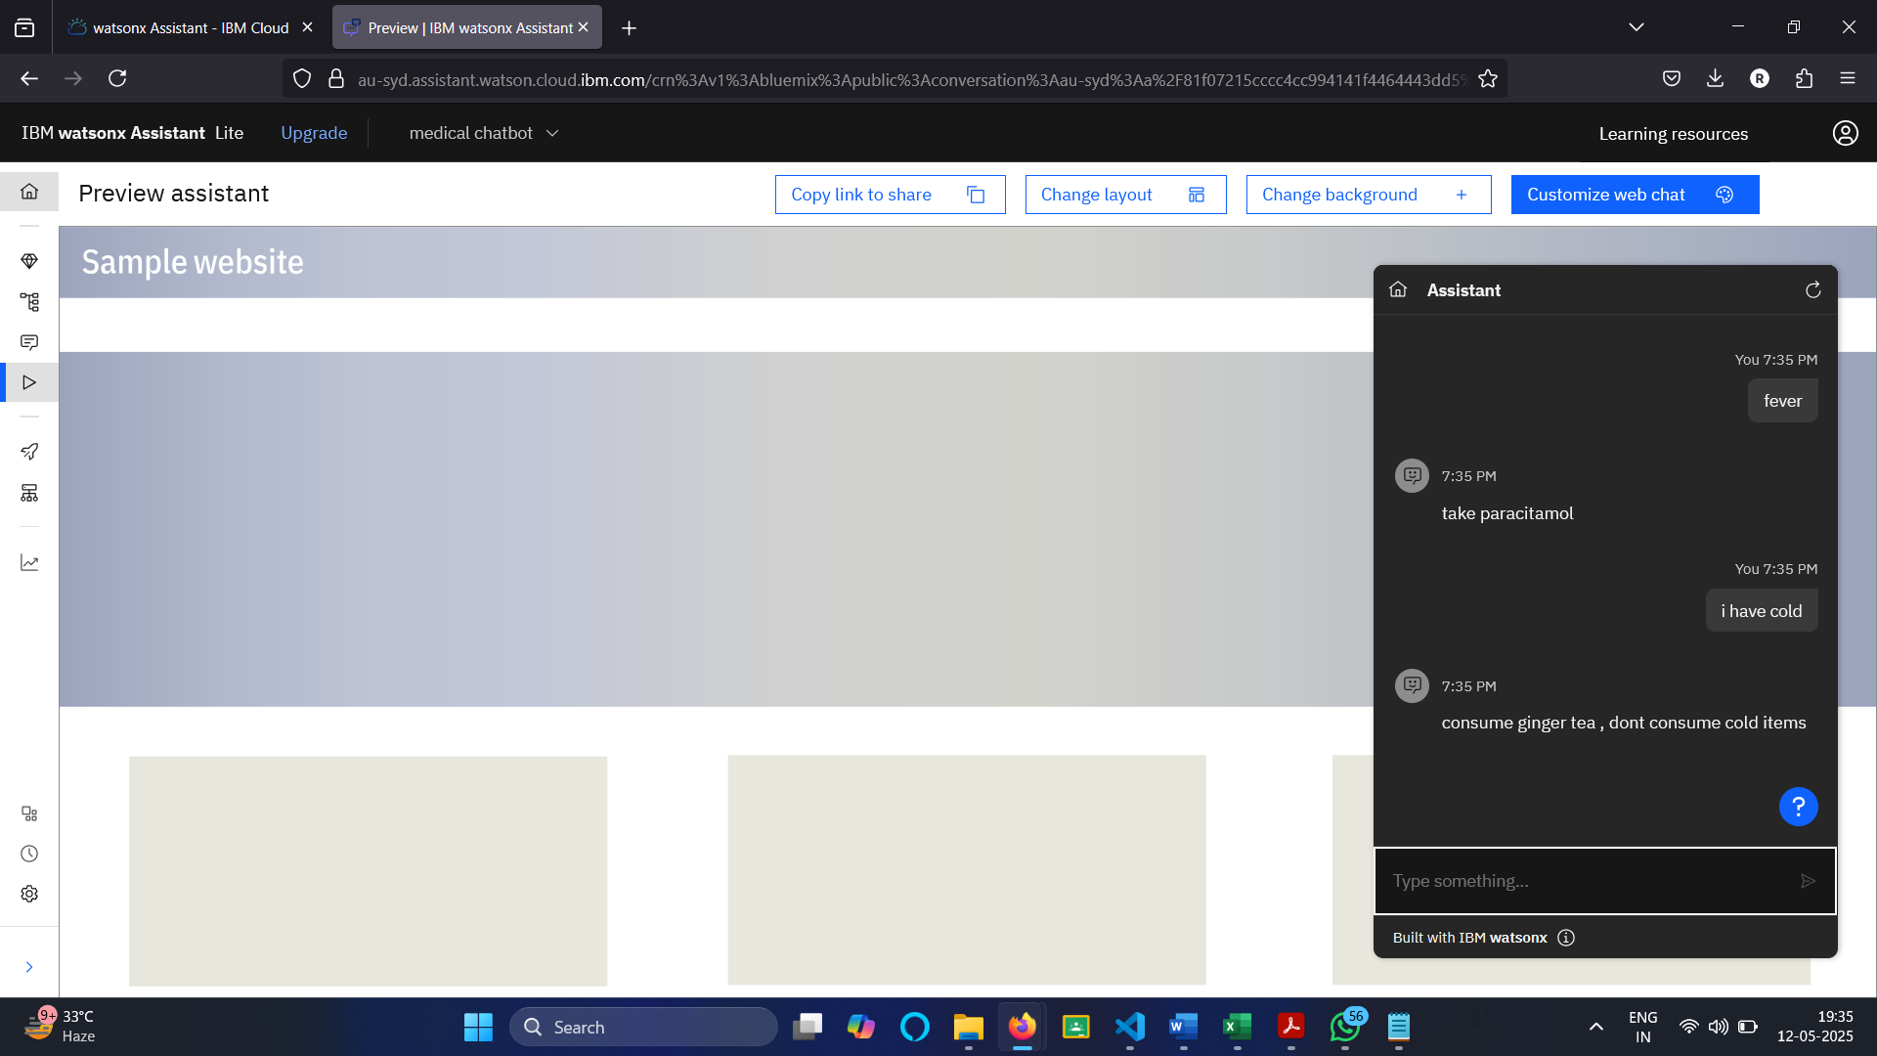
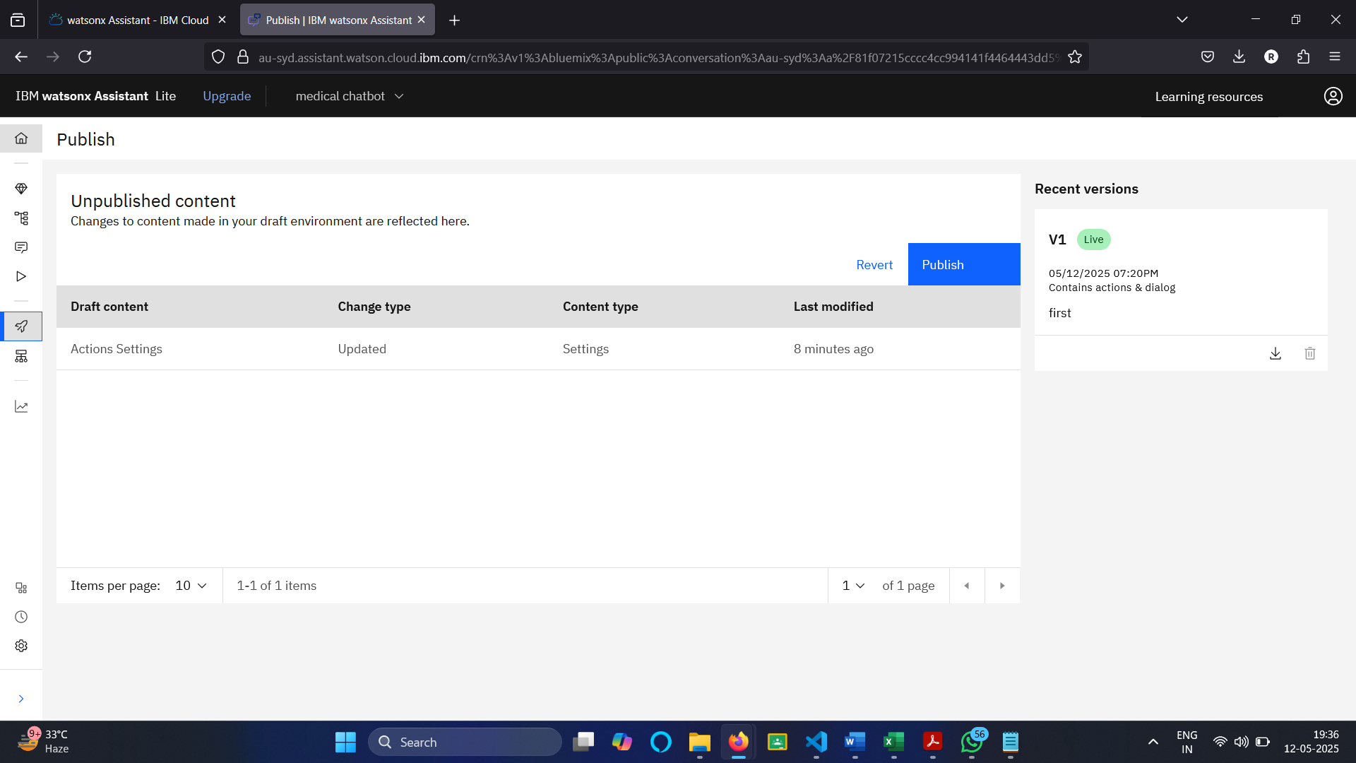

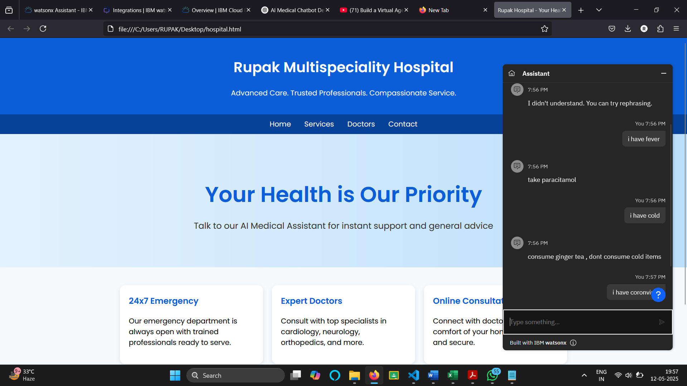

9. Future Enhancements
- Integrate with live medical databases or APIs.
- Enable voice interface for easier access.
- Add multilingual support via Watson Language Translator.
- Include visuals (diagrams, icons, basic anatomy images).
- Add appointment scheduling and emergency support features.

10. Conclusion
The AI medical chatbot powered by IBM Watson delivers quick, intelligent health-related assistance. It offers a scalable solution to support basic healthcare queries and helps reduce load on medical professionals by handling common questions, setting the stage for more advanced digital health services.

