Solar Schools Programme: Maintenance Guide
This guide tells school staff how to keep a rooftop solar installation working. Read it before the first cleaning.

1. Monthly tasks
Do these tasks once a month, on a dry day:
- Clean every panel with water and a soft cloth
- Check that no cable is loose or exposed
- Write the inverter reading in the log book

1.1 Cleaning steps
- Switch off the inverter
- Rinse the panels from the top down
- Switch the inverter on and check the green light

2. Who does what
Table 1: Responsibilities
Task | Person | How often
Cleaning | Caretaker | Monthly
Inverter check | District engineer | Quarterly
Log review | Head teacher | Monthly
The next table shows the fault codes; the first column is shared by two rows.
Code | Meaning | Action
E1 | Low voltage | Wait for sunlight
E1 | No voltage | Call the engineer
Table 2: Fault codes

3. A clean installation
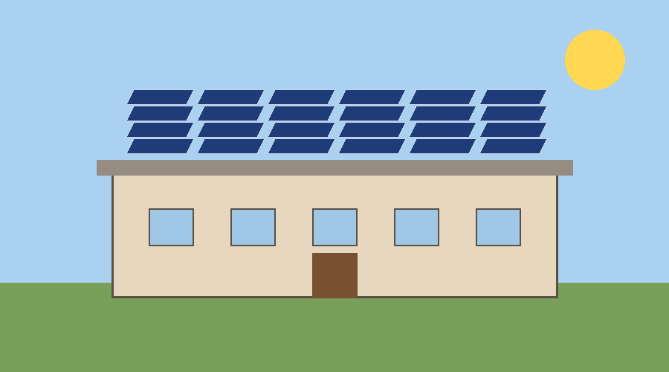
Figure 1: Panels after cleaning
Panels should look like this after every cleaning. Dust cuts output by a fifth.
A clean panel is a working panel.

