***WAR’S GRIP ON GLOBAL TRADE***

The world's interconnectedness isn't just about social media or shared trends. It's starkly evident in the economic tremors echoing from distant battlefields. As the shadows of the Russia-Ukraine war lengthen and the Israel-Palestine conflict continues to simmer, their impacts are being felt far beyond the immediate zones of conflict, reshaping the global market in profound ways.

Imagine a delicate web, intricate and vital. Each strand represents a nation, industry, or commodity. Now, picture two sharp stones thrown into this web – the grinding gears of war. The impact sends ripples outward, tugging at every thread, some snapping, others stretching thin. This is the image we must hold as we delve into the complex tapestry of how these conflicts are unravelling and reweaving the fabric of the global market. From surging energy prices and disrupted supply chains to the Specter of food insecurity and the recalibration of geopolitical alliances, the consequences are multi-layered and far-reaching.

***Russia-Ukraine war impacting globally***

A year into the war, rising debt among emerging markets and an increased risk of ‘geo-economic fragmentation’ are causes for concern. However, rising oil prices and supply chain disruptions have largely eased. One of the most visible signs of the war was its effect on food grain prices. Before the war, Ukraine was the fourth-largest exporter of corn and wheat, accounting for 8.9 percent of global wheat exports. The country was also the largest exporter of sunflower oil, which accounts for 9 percent of vegetable oil. Together, Ukraine and Russia exported as much as 23 percent of the world's wheat. They were also responsible for 63.6 percent of the world's sunflowers and seeds.

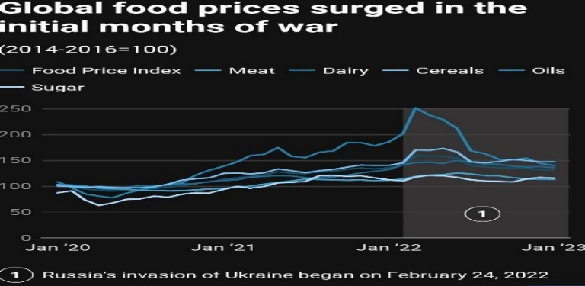

***Israel-Palestine war impacting globally***

The fallout of Israel-Hamas war on the global economy may take time to become clear but would become more severe if the conflict spreads to the rest of the Middle East, especially Iran, which is both a major oil producer and supporter of Hamas. “A major channel of impact on the global economy would be via oil prices which have already risen near to $90 level. Further escalation of the conflict towards other Middle Eastern nations which are key oil producers poses a bigger threat and needs a very close watch given that the global economy is currently facing a ‘higher for longer’ interest rate scenario". The issue is that if the war persists for long, then the oil dynamics will change. Brent had crossed the $90 mark but then retreated. Now we can use the 90 number to be the threshold beyond which there is trouble for the world economy. India can get affected if the price remains high due to further supply disruptions.

***Conclusion***

The Russia-Ukraine war's global impact has been a ripple of devastation, shaking food markets, fuel inflation, and displacing millions. Its tremors reach even distant shores, leaving a world more divided, insecure, and grappling with a renewed hunger crisis. The long-term echoes of this conflict-in political alliances, energy dependence, and the shadow of nuclear threat - will loom for years to come. The Israel-Hamas war has spooked equity markets all over with investors shifting towards safe-haven assets. Investors remain cautious and watchful of the global events with risk-off sentiment grappling the market.

***References:***- Moneycontrol.com, livemint.com