Integrated Project Report

On

***”STUDENT ISSUES, FEEDBACK & SOLUTION SYSTEM”***

Submitted in partial fulfillment of the requirement for the

Course Integrated Project III (CSP2208) of

**COMPUTER SCIENCE AND ENGINEERING**

**B.E. Batch-2016**

**in**

**May-2018**



|  |
| --- |
| **Submitted By** |
| **Robin Gupta** |
| **1610991720** |
| **Rohan Arora** |
| **1610991724**  **__________** |
| **Rudra** |
| **1610991736**  **__________** |
| **Rupali Choudhary** |
| **1610991737** |

**DEPARTMENT OF COMPUTER SCIENCES**

**CHITKARA UNIVERSITY**,

**PUNJAB**

**CERTIFICATE**

This is to be certified that the project entitled “Student issues, feedback & solution system” has been submitted for the Bachelor of Computer Science Engineering at Chitkara University, Punjab during the academic semester January 2018- May-2018 is a bonafide piece of project work carried out by “Robin Gupta (1610991720), Rohan Arora (1610991724), Rudra (1610991736), Rupali Coudhary (1610991737)” towards the partial fulfillment for the award of the course Integrated Project (135) under the guidance of Ms. Seema Gulati and supervision.

Submitted to: Ms. Seema Gulati

Designation : Assistant Professor

**CANDIDATE’S DECLARATION**

We, “Robin Gupta (1610991720), Rohan Arora (1610991724), Rudra (1610991736), Rupali Coudhary (1610991737)” **,** B.E.-2016 of the Chitkara University, Punjab hereby declare that the Integrated Project Report entitled “Student issues, feedback & solution system” is an original work and data provided in the study is authentic to the best of our knowledge. This report has not been submitted to any other Institute for the award of any other course.

|  |  |  |
| --- | --- | --- |
| **Sign. of Student 1** | **Sign. of Student 2** | **Sign. of Student 3** |
| Robin Gupta | Rohan Arora | Rudra |
| ID No: 1610991720 | ID NO: 1610991724 | ID No:1610991736 |
|  |  |  |
| **Sign. of Student 4** |  |  |
| Rupali Choudhary |  |  |
| ID No: 1610991737 |  |  |

**Place:**

**Date:**

**ACKNOWLEDGEMENT**

It is our pleasure to be indebted to various people, who directly or indirectly contributed in the development of this work and who influenced my thinking, behaviour and acts during the course of study.

We express our sincere gratitude to all for providing me an opportunity to undergo Integrated Project as the part of the curriculum.

We are thankful to “Project Guide Name” for his support, cooperation, and motivation provided to us during the training for constant inspiration, presence and blessings.

We also extend our sincere appreciation to Ms. Seema Gulati who provided her valuable suggestions and precious time in accomplishing our Integrated project report.

Lastly, We would like to thank the almighty and our parents for their moral support and friends with whom we shared our day-to day experience and received lots of suggestions that improve our quality of work.

|  |  |  |
| --- | --- | --- |
| **Robin Gupta** | **Rohan Arora** | **Rudra** |
| **ID NO: 1610991720** | **ID NO: 1610991724** | **ID NO: 1610991736** |

|  |
| --- |
| **Rupali Choudhary** |
| **ID NO: 1610991737** |

1. **Abstract**

The objective of this project is to design a fully functional website that would help students to express the issues faced by them, their feedback to various departments. This would help to create a better environment to allow their overall development.

This website is created using html, css, JavaScript and database linking with the website.

It helps the students to raise their issues and also communicate with the concerned department. It also helps the departments to get the feedback of the students in order to improve.

1. **Introduction to the project** 
   1. **Background**

This solution system is a web based portal for students to give their feedback or raise any issues and to help them resolve their issues the portal plats a vital role. This will help the students to communicate with the concerned staff in a better, efficient, flexible manner.

* 1. **Problem Statement**

We had to design a working solution system for student feedback, and where they can raise their issues and get satisfactory reply as soon as possible. So we made this portal where they can easily raise their issues.

1. **Software and Hardware Requirement Specification**

This needs to be run on a web browser and all the css and javascript files should have the correct source address in order to run it smoothly.

We have used many languages in this:

It is a 2 tier architecture.

1.Frontend : HTML,CSS

2.Backend : Php,Sql

A program for database collection is also used in order to save all the information in a database.

4. **Program’s Structure Analyzing and GUI Constructing**

Feedback Form

Database

Data Display

* **Student**

In our system student is playing a role of user/client.

Student of any course can fill the feedback form because it is felxible.

System requires the basic details of students like Name,Branch,Email etc.

* **Feedback Form**

This form plays an intermediate role or interface for storing student data in database.

This form consist of simple design and easy to use.

**(Feedback Form)**

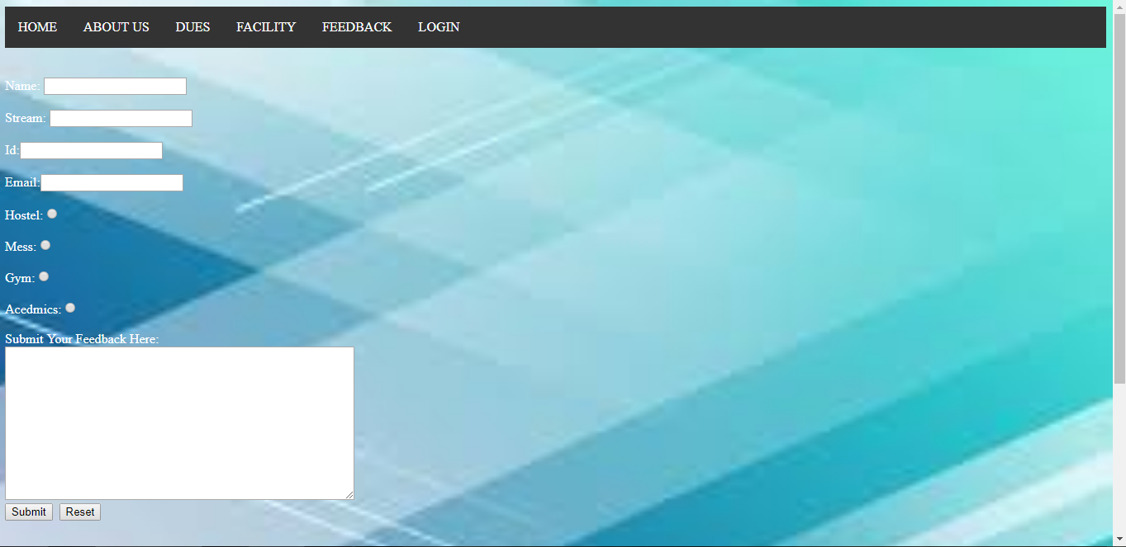

By clicking on submit button data will be saved.

* **Database**

Database is a systematic collection of data. Databases support storage and manipulation of data. Databases make data management easy.

Student data is stored in the table(Feedback Table).

**(Feedback Table)**

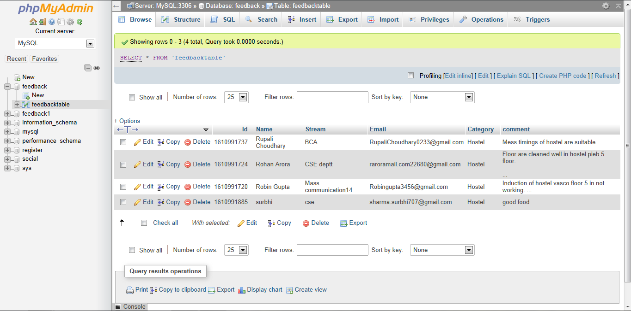

* **Admin**

Admin is root user having special access to database.

Database is manipulated on by the admin.

All security features are handle by admin.

**(Login Page)**

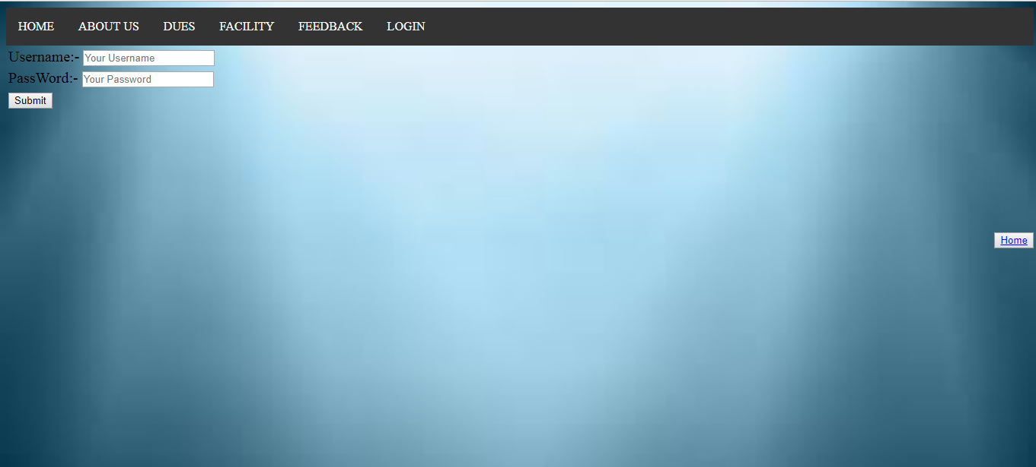

* **Data Displayed**

Data is displayed on new tab.

Data is only visible to the respective admin.

**(Output)**

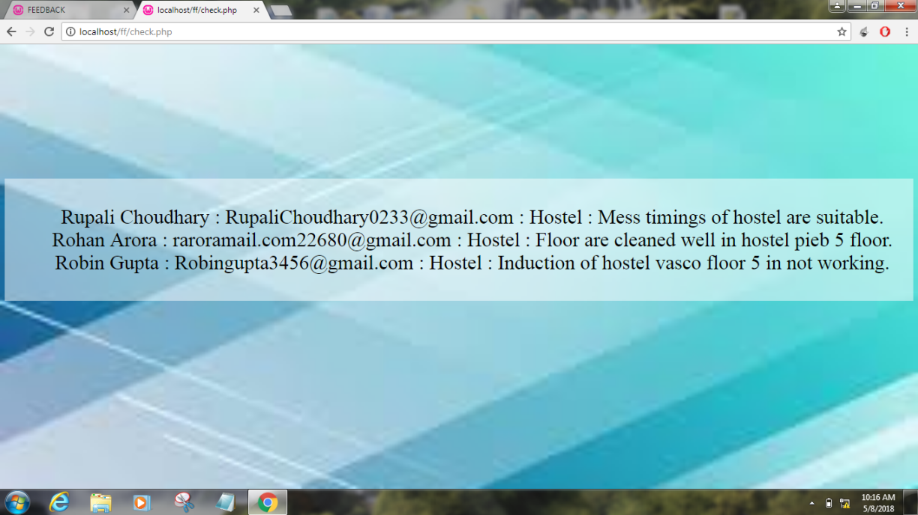

1. **Conclusion**

* The task of designing and developing a student issues, feedback & solution system that is functional requires good technical knowledge of how the various languages and applications function. Also, logic selection and other principles involving the concept of web designing and how it can be effectively reduced were used to design this portal.

1. **Future Scope**
2. Minimizes the hassle for students in order to raise their issues.
3. Ensures that every issue is reported to the concerned department.
4. Provides a systematic and easy way of communication between students and departments.
5. Can be used to get a quick glance at student issues.
6. **References**
7. https://www.w3schools.com/
8. https://stackoverflow.com/