A **Reporting Services subscription** is a configuration that delivers a report at a specific time or in response to an event, and in a file format that you specify. For example, every Wednesday, save the MonthlySales.rdl report as a Microsoft Word document to a file share.

An **Ad**-**Hoc Query** is a **query** that cannot be determined prior to the moment the **query** is issued. It is created in order to get information when need arises and it consists of dynamically constructed SQL which is usually constructed by desktop-resident **query** tools.

On Transact SQL language the sp_helpdb is part of Database Engine Stored Procedures and shows information about a specified database or all databases.

A linked dimension is based on a dimension created and stored in another Analysis Services database of the same version and compatibility level. By using a linked dimension, you can create, store, and maintain a dimension on one database, while making it available to users of multiple databases. To users, a linked dimension appears like any other dimension.

Linked dimensions are read-only. If you want to modify the dimension or create new relationships, you must change the source dimension, then delete and recreate the linked dimension and its relationships. You cannot refresh a linked dimension to pick up changes from the source object.

A perspective is a definition that allows users to see a cube in a simpler way. A perspective is a subset of the features of a cube. A perspective enables administrators to create views of a cube, helping users to focus on the most relevant data for them. A perspective contains subsets of all objects from a cube. A perspective cannot include elements that are not defined in the parent cube.

**dbo** is the default schema in **SQL** Server. You can create your own schemas to allow you to better manage your object namespace

Data **integrity** is the maintenance of, and the assurance of the accuracy and **consistency** of, data over its entire life-cycle, and is a critical aspect to the design, implementation and usage of any system which stores, processes, or retrieves data.

Hierarchies, in tabular models, are metadata that define relationships between two or more columns in a table.

A stored procedure is nothing more than prepared SQL code that you save so you can reuse the code over and over again.  So if you think about a query that you write over and over again, instead of having to write that query each time you would save it as a stored procedure and then just call the stored procedure to execute the SQL code that you saved as part of the stored procedure.

**stored** in the database in compiled form

Views that access multiple tables can only modify one of the tables in the view. Views that use functions, specify DISTINCT, or utilize the GROUP BY clause may not be updated.

OLE DB is Microsoft's strategic low-level application program interface ([API](http://searchexchange.techtarget.com/definition/application-program-interface)) for access to different data sources. OLE DB includes not only the Structured Query Language ([SQL](http://searchsqlserver.techtarget.com/definition/SQL)) capabilities of the Microsoft-sponsored standard data interface Open Database Connectivity ([ODBC](http://searchoracle.techtarget.com/definition/Open-Database-Connectivity)) but also includes access to [data](http://searchdatamanagement.techtarget.com/definition/data) other than SQL data.

A **relational database** is a collection of data items organized as a set of formally-described tables from which data can be accessed or reassembled in many different ways without having to reorganize the**database** tables

A relational database is a set of tables containing data fitted into predefined categories. Each table (which is sometimes called a *relation*) contains one or more data categories in columns. Each [row](http://searchoracle.techtarget.com/definition/row) contains a unique instance of data for the categories defined by the columns.

The standard user and application program interface to a relational database is the *structured query language* ([SQL](http://searchsqlserver.techtarget.com/definition/SQL)).

A relational database (the concept) is a data structure that allows you to link information from different 'tables', or different types of data buckets

A non-relational database just stores data without explicit and structured mechanisms to link data from different buckets to one another.

**Fragmentation** occurs in a dynamic [memory](http://ecomputernotes.com/fundamental/input-output-and-memory/what-are-the-different-types-of-ram-explain-in-detail) allocation system when many of the free blocks are too small to satisfy any request.

 number of columns have to be equal to the number of columns in the GROUP BY clause,

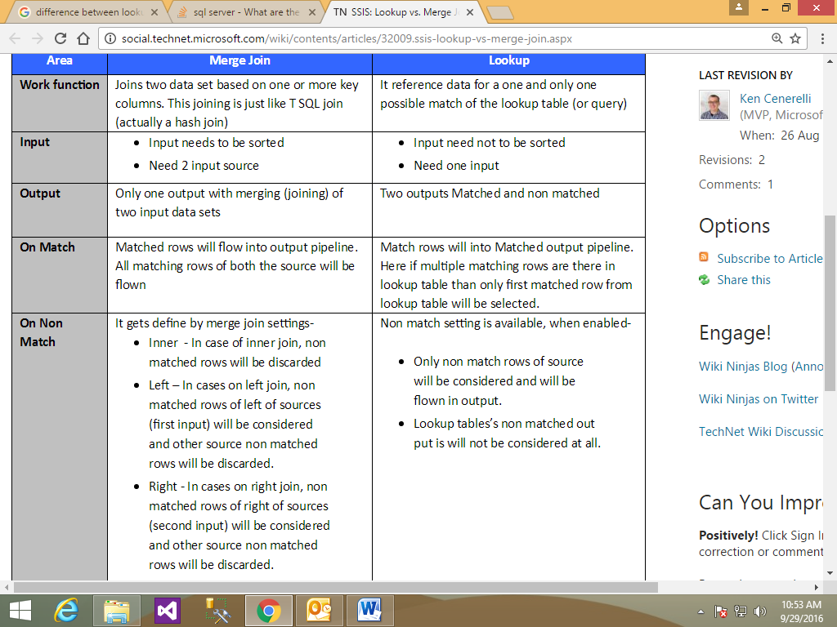

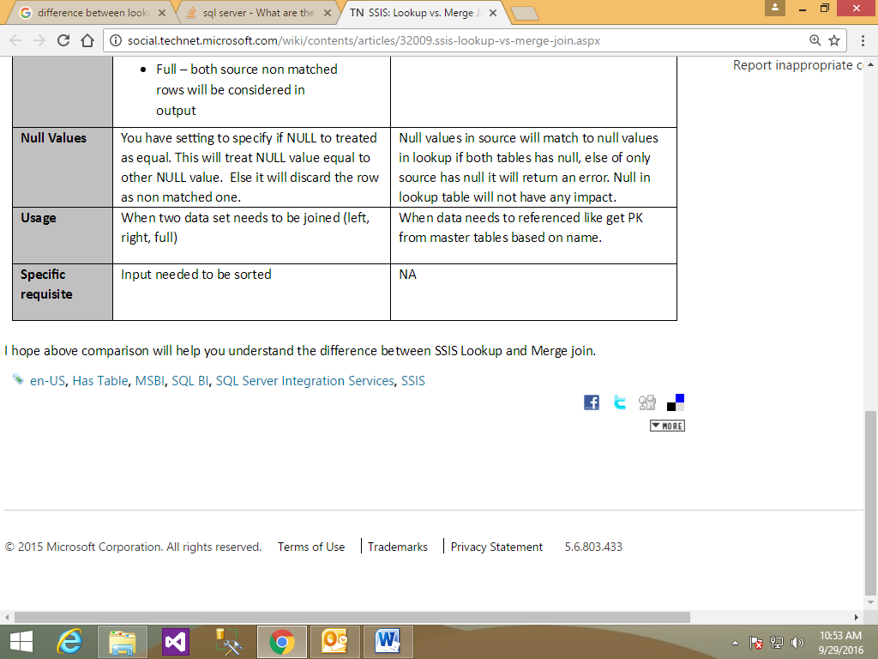

**Indicators** are minimal gauges that convey the state of a single data value at a glance and are mostly used to represent state value of Key Performance **Indicator** (KPI).

A **key performance indicator** (**KPI**) is a business metric used to evaluate factors that are crucial to the success of an organization.

