# Kickstarter Campaign Report

Billions of dollars have been raised using the Kickstarter crowdfunding service. This report presents some of the trends that are seen after analyzing about four thousand past projects using this campaign.

## Current Analysis:

From the graphs shown below we have three main conclusions:

1. There are more projects in the art and entertainment categories (theatre, music, film&video) and their success rate is higher too. The number of technology projects are also high with a good success rate. Journalism does not look that popular and interesting for funding. Projects in the sub-category of “Plays” seem to have the highest popularity and success rates.
2. There seem to be a greater success rate of projects created in April-May and Sept-Oct timeframe of most years. This is probably because of available budget (new or unspent) that is used funding projects during that time of the year.
3. Projects with lower funding goals (less than $10000) seem to have a high success rate (greater than 50%) while projects with high funding goals (greater than $45000) seem to have a lower success rate (less than 40%). Hence the lower the funding goal, the better chance one has of getting funded.

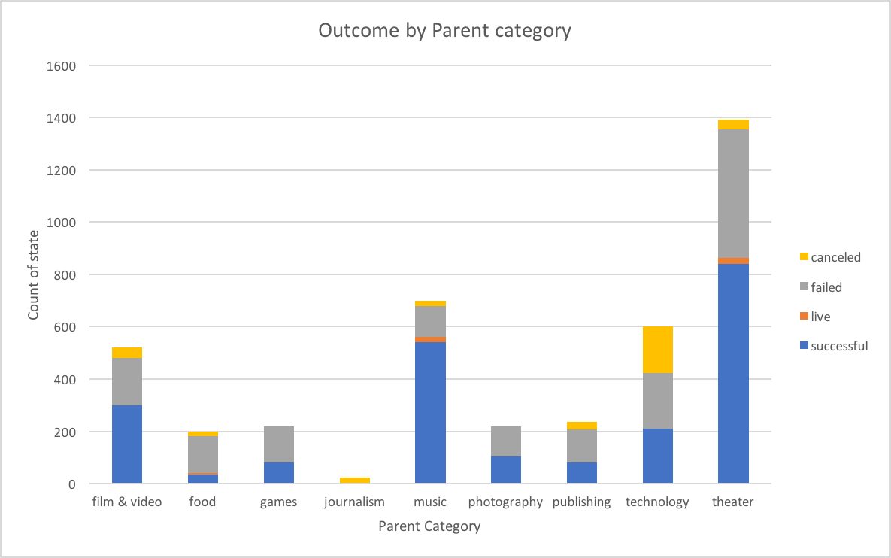

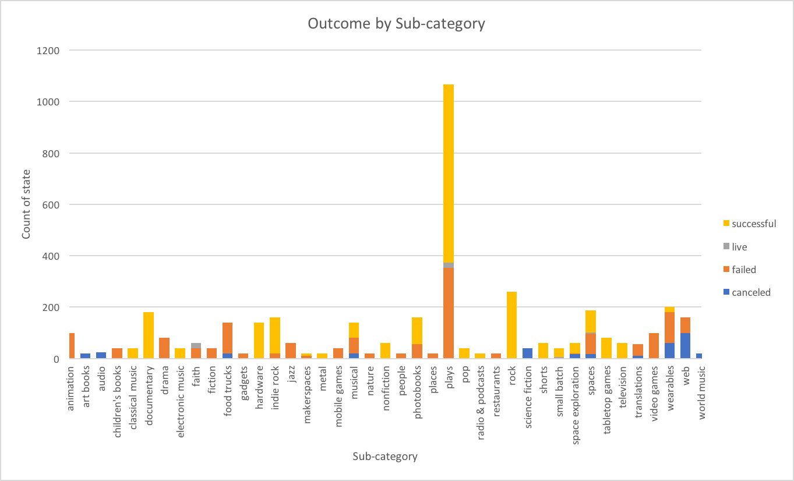

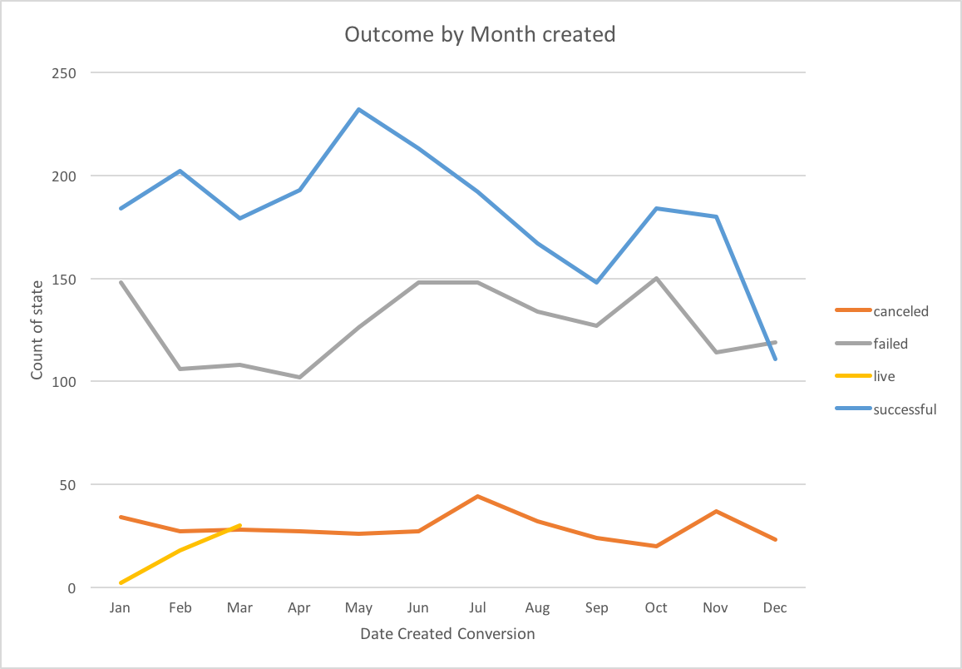

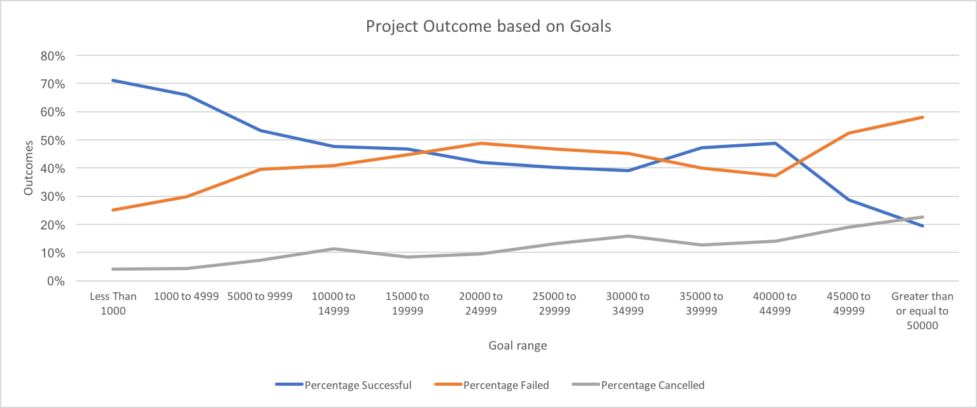

## Limitations:

Although this is a large amount of data points for analysis, some of the limitations of the available data are:

1. The data set does not seem to be uniform across all countries. Either there are not many projects outside of the US or probably most projects are from US.
2. The project timeline is very short -0 to 3 months between the launch date and deadline date. There isn’t any data outside that range.

## Other possible Analysis:

More analysis based on the outcomes per country or duration could be done. We could also look at what type/categories of projects are done in different countries and their success rates. Some of these graphs/tables are shown below.

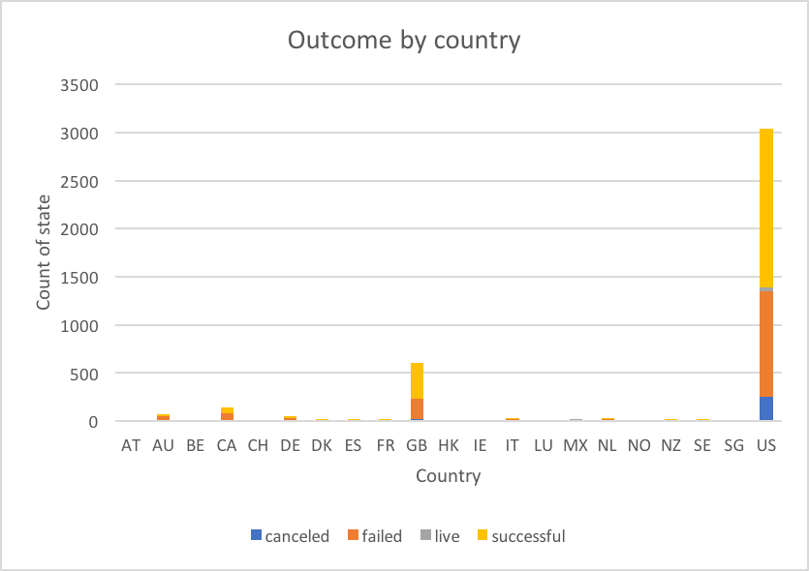

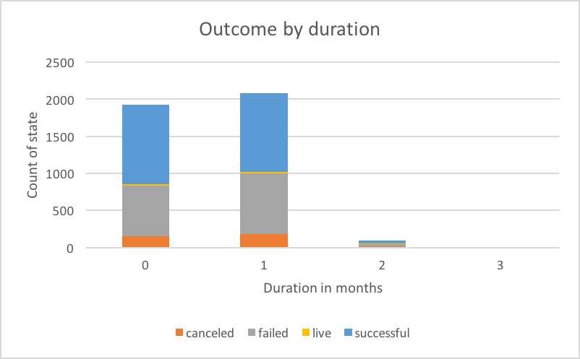

|  |  |  |  |  |  |  |  |  |  |  |
| --- | --- | --- | --- | --- | --- | --- | --- | --- | --- | --- |
| **Country** | **film & video** | **food** | **games** | **journalism** | **music** | **photography** | **publishing** | **technology** | **theater** | **Grand Total** |
| AT |  | 1 |  |  | 1 | 1 |  | 2 | 1 | 6 |
| AU | 12 | 4 | 9 |  | 1 | 5 | 6 | 16 | 21 | 74 |
| BE |  | 1 |  |  |  | 1 |  |  |  | 2 |
| CA | 16 | 10 | 11 |  | 12 | 13 | 9 | 31 | 44 | 146 |
| CH |  |  | 1 |  |  | 1 |  | 3 | 1 | 6 |
| DE | 3 | 2 | 8 | 1 | 4 | 8 | 5 | 16 | 6 | 53 |
| DK | 1 | 1 |  |  | 1 | 1 | 3 | 3 | 4 | 14 |
| ES | 4 |  | 2 |  | 3 |  | 3 | 7 | 2 | 21 |
| FR | 3 | 1 | 2 |  | 5 |  | 2 | 8 | 6 | 27 |
| GB | 53 | 10 | 33 |  | 34 | 45 | 17 | 53 | 359 | 604 |
| HK | 1 |  |  |  |  | 1 |  | 1 |  | 3 |
| IE |  |  | 1 |  |  | 1 | 1 | 3 | 9 | 15 |
| IT |  |  | 1 |  | 1 | 3 | 9 | 11 | 4 | 29 |
| LU |  |  |  |  |  | 1 |  |  | 1 | 2 |
| MX |  |  | 1 |  |  |  | 1 | 3 | 7 | 12 |
| NL | 1 |  |  |  |  | 2 | 1 | 13 | 4 | 21 |
| NO | 1 | 1 | 2 |  |  | 1 |  |  | 2 | 7 |
| NZ | 1 |  |  |  |  |  | 1 | 5 | 5 | 12 |
| SE | 2 | 1 | 1 |  | 2 | 2 | 1 | 8 | 4 | 21 |
| SG |  |  |  |  |  |  |  |  | 1 | 1 |
| US | 422 | 168 | 148 | 23 | 636 | 134 | 178 | 417 | 912 | 3038 |
| **Grand Total** | **520** | **200** | **220** | **24** | **700** | **220** | **237** | **600** | **1393** | **4114** |