Remove state selection option
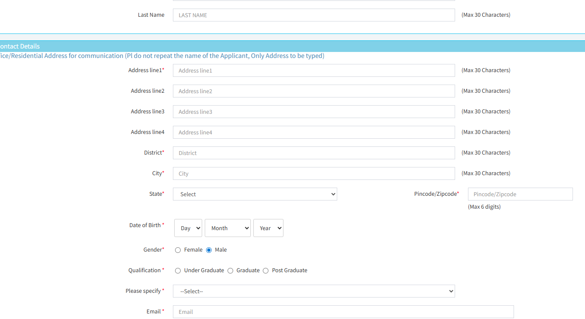

Remove from point 2 to point 5
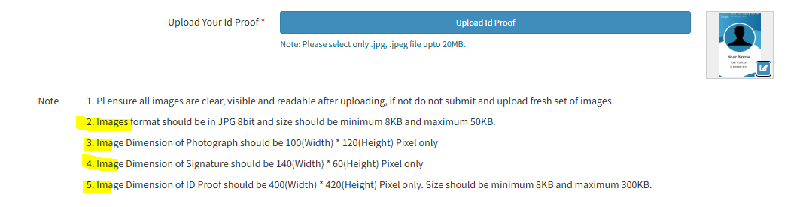
Remove state code and state name
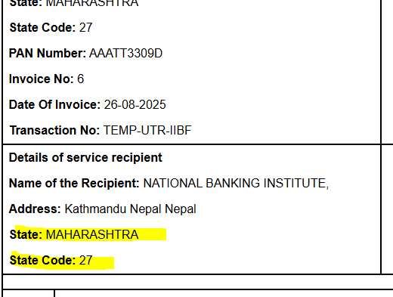

Remove highlighted net amount

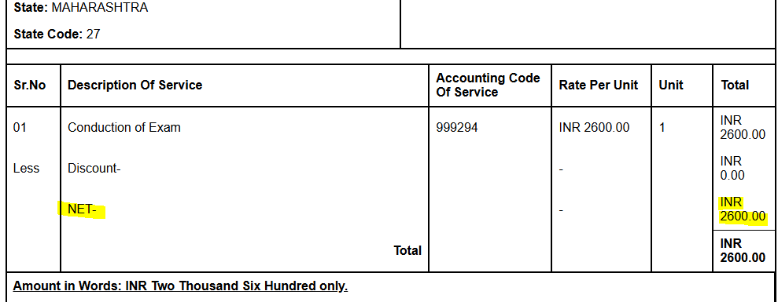

In IIBF Admin login, discounted amount word replaced with Bank charges. Also on verify page, add bank charges tab for IIBF admin to insert manually.

