The names of some of the good Books for preparation of CAIIB (Certified Associate of Indian Institute of Bankers) Exam conducted by Indian Institute of Banking and Finance (IIBF) are as follows:

Advance Bank Management
by IIBF

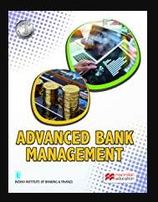

Legal and Regulatory Aspects of Banking - JAIIB (3rd Edition)
by IIBF

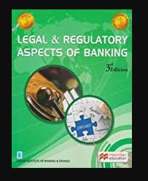

Bank Financial Management
by IIBF

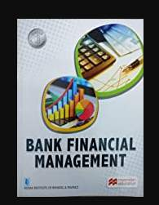

Risk Management (CAIIB 2018)
by Indian Institute of Banking & Finance (IIBF)

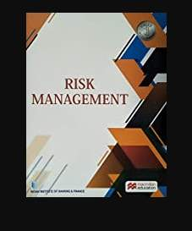

Advanced Bank Management & Bank Financial Management For CAIIB Examination
by IIBF (Indian Institute Of Banking & Finance)

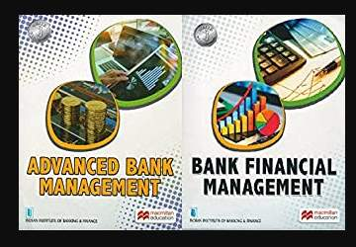

CAIIB Exam Syllabus of Indian Institute of Banking and Finance (IIBF)

Compulsory Paper - I : ADVANCED BANK MANAGEMENT

MODULE - A: Economic Analysis
The fundamentals of Economics: Scarcity and Efficiency - Microeconomics & Macroeconomics in brief - Types of economies - Market, Command and Mixed Economies - Macroeconomics : Business cycles - Money and banking - Unemployment & inflation - Interest rate determination and various types of interest rates

Indian Economy (a) Overview of the Indian economy including recent reforms (b) Interaction between fiscal, monetary & exchange rate policies in India - Financial Markets (i) Money Market (ii) Capital Market (iii) Foreign Exchange Market - globalisation and its impact – Challenges ahead - Banking & Finance - current issues

MODULE - B: Business Mathematics
Concept of time Value of Money - Net Present Value - Discounted Cash Flow - Sampling methods - presentation of data - analysis and interpretation of sample data - hypothesis testing – Time series analysis - mean / standard deviation - co-relation - Regression - covariance and volatility - Probability distribution - Confidence interval analysis - estimating parameters of distribution - Bond valuation - duration - modified duration.
Attached Files

