Requirement: Macro Research Form
- User Story:
Title: Macro Research Form | Jira Id: | Priority: High | Estimate:
User Story:

As a Candidates (Individual, Joint and Institutional)

I want to register for Macro Research Proposal,

So that: User will get register for Macro Research Proposal

Acceptance Criteria:
1. Page Elements
Given I am at Macro Research Page,

When the page loads,

Then I should see the following elements:
- User will select the type of registration: Individual, Joint and Institutional.

2. Individual Registration
Given I am at Macro Research Page,

When I am select the type of registration (Individual),

Then I should see the following elements:
- User will view Name, DOB, Designation, Employer, Nature of Job, Address, Email, Phone No., Theme, Title of Research proposal, Major Objective/s of Research, Forwarding Letter, Proposal, CV.

3. Joint Registration
Given I am at Macro Research Page,

When I am select the type of registration (Joint),

Then I should see the following elements:
- User will view Name, Designation, DOB, Employer, Nature of Job, Address, Email, Phone No., Forwarding Letter, CV (Can add this element up to 4), Theme, Title of Research proposal, Major Objective/s of Research, upload, Proposal.

4. Institutional Registration
Given I am at Macro Research Page,

When I am select the type of registration (Institutional),

Then I should see the following elements:
- User will view Institute Name, Project Co-Ordinator Name, DOB, Designation, Employer, Nature of Job, Address, Email, Phone No. (Can add this element up to 4), Theme, Title of Research proposal, Major Objective/s of Research, Proposal, CV.

5. Age Limit
Given The user should not be beyond 58 years old.

When the user enters date of birth.

Then the system should automatically calculate age of the candidate and check if he/she is above 58 years old then following message should appear on the screen “We regret to inform you that you are not eligible to participate in this scheme”.

6. Previous year’s winners
Given the user should not be able apply for competition if they have won in past 3 years or won twice in past 10 years,

When they should enter name,

Then the system should display message “We regret to inform you that you are not eligible to participate in this scheme”.

7. Submitting the Form
Given that I have entered all the required details,

When I click on the Submit button (If Mandatory field is not filled then it will drag to that field and show error message “Enter details for the Mandatory field”.),

Then the system should validate all fields, ensure there are no missing or incorrect entries, and successfully submit the new user profile. The system will also display message “Registration submitted successfully.”

- Functional Requirement:
- The user can access the Macro Research form by navigating to the IIBF website (iibf.org.in) and selecting the "Academics" option. From the Academics page, they should choose the "Research" option, followed by selecting "Macro Research."
- The user will click on "Register here" to access the Macro Research registration form.
- User will view the Macro Research Form. In which user will able to select the type of registration as Individual, Joint and Institutional.

Individual Registration
- User will able to enter details of Name, DOB, Designation, Employer, Nature of Job, Address, Email, Phone No., Theme, Title of Research proposal, Major Objective/s of Research.
- User will upload the data like Forwarding Letter, Proposal, CV.

Joint Registration
- User will able to enter details and upload documents (up to 4 records) Name, DOB, Designation, Employer, Nature of Job, Address, Email, Phone No., Forwarding Letter and CV.
- User will able to enter details and upload documents Theme, Title of Research proposal, Major Objective/s of Research and Proposal.

Institutional Registration
- User will enter institution name.
- User will enter details of Project Co-Ordinator Name, DOB, Designation, Employer, Nature of Job, Address, Email, Phone No (up to 4 records)
- User will enter details Theme, Title of Research proposal, Major Objective/s of Research
- User will upload Proposal, CV.
- Non-functional Requirement:
- NFR1- Performance-

Sr. No. | Number of Records/Users | Expected Response Time
1 | 1 (Signle User) Admin | <= 2 Seconds
2 | 1 (Signle User) Client | <= 2 Seconds
3 | Upto 100 Users | <= 2 Seconds
4 | 100 to 500 Users | <= 4 Seconds
5 | More than 500 Users | <= 6 Seconds

- NFR2- Compatibility- The login page shall be compatible with major web browsers (Chrome, Firefox, Safari, Edge) and mobile devices.

- Roles & Permissions: NA

- Field level specification:
Individual Form
Field Name | Type | Constraint | Mandatory
Name | Textbox | Character: 100  Alphanumeric with Special character | Yes
Date of Birth | Date time picker | Date | Yes
Designation | Textbox | Character: 100  Alphanumeric with Special character | Yes
Employer | Textbox | Character: 100  Alphanumeric with Special character | Yes
Nature of Job | Dropdown | Content  Regular Contractual Part-time | Yes
Address | Textbox | Character: 500  Alphanumeric with Special character | Yes
Email | Textbox | Character: 100  Alphanumeric with Special character | Yes
Phone No. | Textbox | Character: 100  Numeric only | Yes
Theme | Dropdown | NA | Yes
Title of Research proposal | Textbox | Character: 200  Alphanumeric with Special character | Yes
Major Objective/s of Research | Textbox | Character: 200  Alphanumeric with Special character | Yes
Forwarding Letter | Attachment | Size: 5 MB  Pdf only | Yes
Proposal | Attachment | Size: 5 MB  Pdf or word document | Yes
CV | Attachment | Size: 5 MB  Pdf only | Yes

Joint Form
Note:
Give + sign to add up to 4 co-authors for the fields (Name, Designation & Employer, Nature of job, Address, E-mail, Phone no. Forwarding Letter, CV)

Field Name | Type | Constraint | Mandatory
Name | Textbox | Character: 100  Alphanumeric with Special character | Yes
Date of Birth | Date time picker | Date | Yes
Designation | Textbox | Character: 100  Alphanumeric with Special character | Yes
Employer | Textbox | Character: 100  Alphanumeric with Special character | Yes
Nature of Job | Dropdown | Content  Regular Contractual Part-time | Yes
Address | Textbox | Character: 500  Alphanumeric with Special character | Yes
Email | Textbox | Character: 100  Alphanumeric with Special character | Yes
Phone No. | Textbox | Character: 100  Numeric only | Yes
Theme | Dropdown | NA | Yes
Title of Research proposal | Textbox | Character: 200  Alphanumeric with Special character | Yes
Major Objective/s of Research | Textbox | Character: 200  Alphanumeric with Special character | Yes
Forwarding Letter | Attachment | Size: 5 MB  Pdf only | Yes
Proposal | Attachment | Size: 5 MB  Pdf or word document | Yes
CV | Attachment | Size: 5 MB  Pdf only | Yes

Institutional Form
Note:
Give + sign to add up to 4 co-authors for the fields (Name, Designation & Employer, Nature of job, Address, E-mail, Phone no)
Field Name | Type | Constraint | Mandatory
Institute Name | Textbox | Character: 100  Alphanumeric with Special character | Yes
Project Co-Ordinator Name | Textbox | Character: 100  Alphanumeric with Special character | Yes
Date of Birth | Date time picker | Date | Yes
Designation | Textbox | Character: 100  Alphanumeric with Special character | Yes
Employer | Textbox | Character: 100  Alphanumeric with Special character | Yes
Nature of Job | Dropdown | Content  Regular Contractual Part-time | Yes
Address | Textbox | Character: 500  Alphanumeric with Special character | Yes
Email | Textbox | Character: 100  Alphanumeric with Special character | Yes
Phone No. | Textbox | Character: 100  Numeric only | Yes
Theme | Dropdown | NA | Yes
Title of Research proposal | Textbox | Character: 200  Alphanumeric with Special character | Yes
Major Objective/s of Research | Textbox | Character: 200  Alphanumeric with Special character | Yes
Proposal | Attachment | Size: 5 MB  Pdf or word document | Yes
CV | Attachment | Size: 5 MB  Pdf only | Yes

- Exception Handling
- The system should handle exceptions and errors gracefully. When exceptions occur, the system should provide clear and user-friendly error messages to guide the user and ensure a positive user experience.
- Exception scenarios to consider:
- Exception: The user enters name, institution name, project coordinator name, designation and Employer which is more than 100 characters.
Handling: Display a clear error message: "Please enter valid data"
- Exception: The user enters invalid Email Id
Handling: Display a clear error message: "Please enter valid Email"
- Exception: The user enters invalid Mobile No.
Handling: Display a clear error message: "Please enter valid Mobile No."
- Exception: The user uploads Forwarding letter and CV more than 5 Mb and in other form of documents except pdf.
Handling: Display a clear error message: "Please upload valid document"
- Exception: The user uploads Proposal more than 5 Mb and in other form of documents except pdf and Word.
Handling: Display a clear error message: "Please upload valid document"
- Exception: The user should not be more than 58 years. the system should automatically calculate age of the candidate and check if he/she is above 58 years old
Handling: Display a clear error message: “We regret to inform you that you are not eligible to participate in this scheme”.
- The system should log exceptions and errors for analysis and debugging purposes. These logs should not expose sensitive information and should only be accessible to authorized personnel.

- Prerequisites:
- The user will navigate to the IIBF website (iibf.org.in).
- The user will select the "Academics" section.
- From the Academics page, the user will choose the "Research" option.
- The user will then proceed to select the "Macro Research" option from the Research page.

- Impact Analysis on Other Modules: NA

- Risks:
- All the fields are mandatory.
- Candidates above age 58 will not be eligible to apply for registration of Macro Research.
- Candidate who has won the competition in past 3 years and who have won twice in past 10 years will not be able to apply for Macro research.

- Wireframes:
This design is just for the reference, it may change as per the designer perspective.
Individual Form
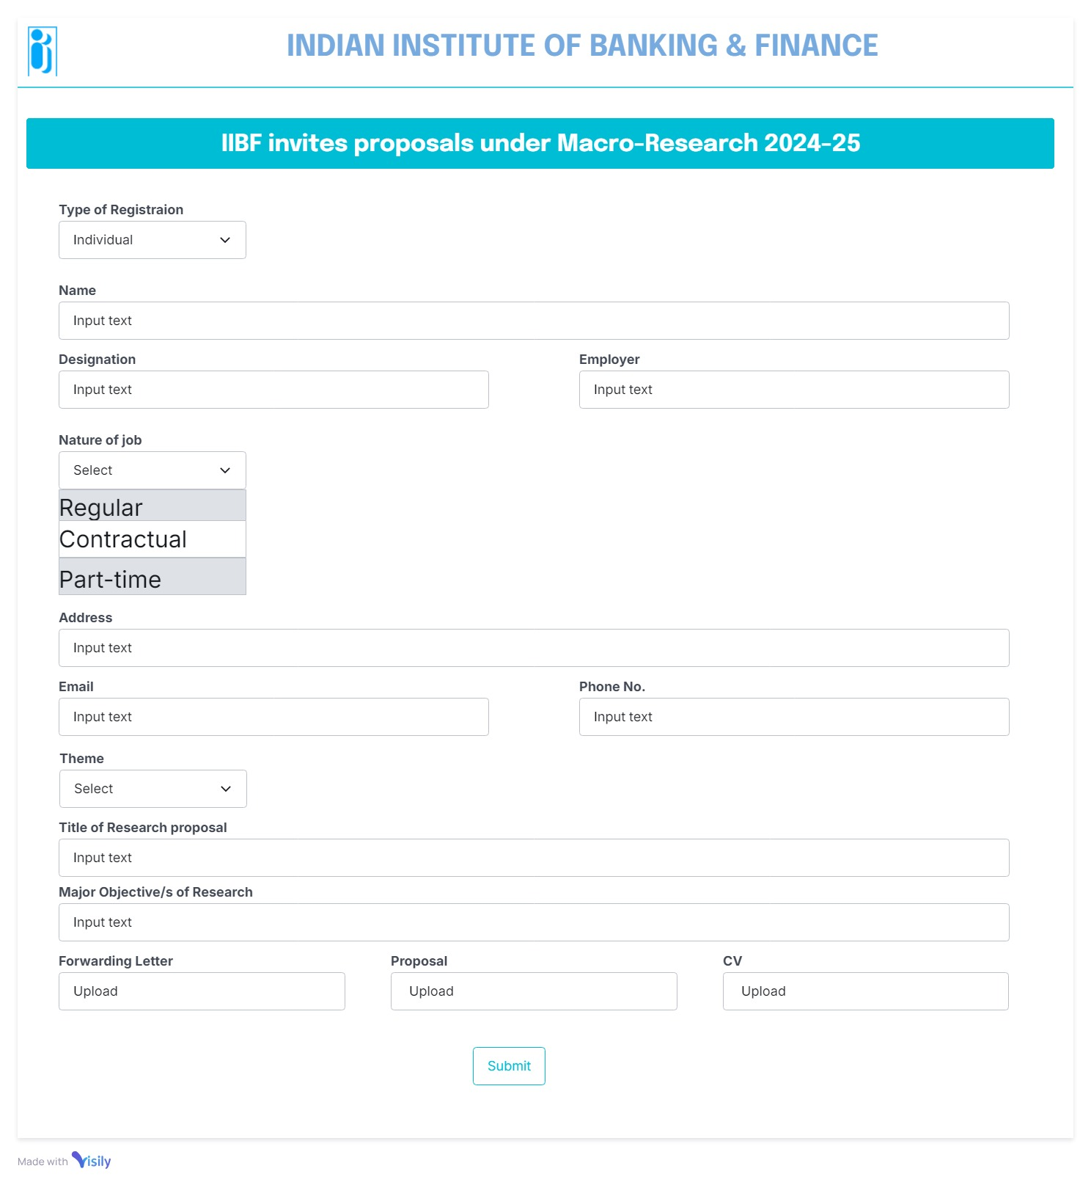

Joint Form
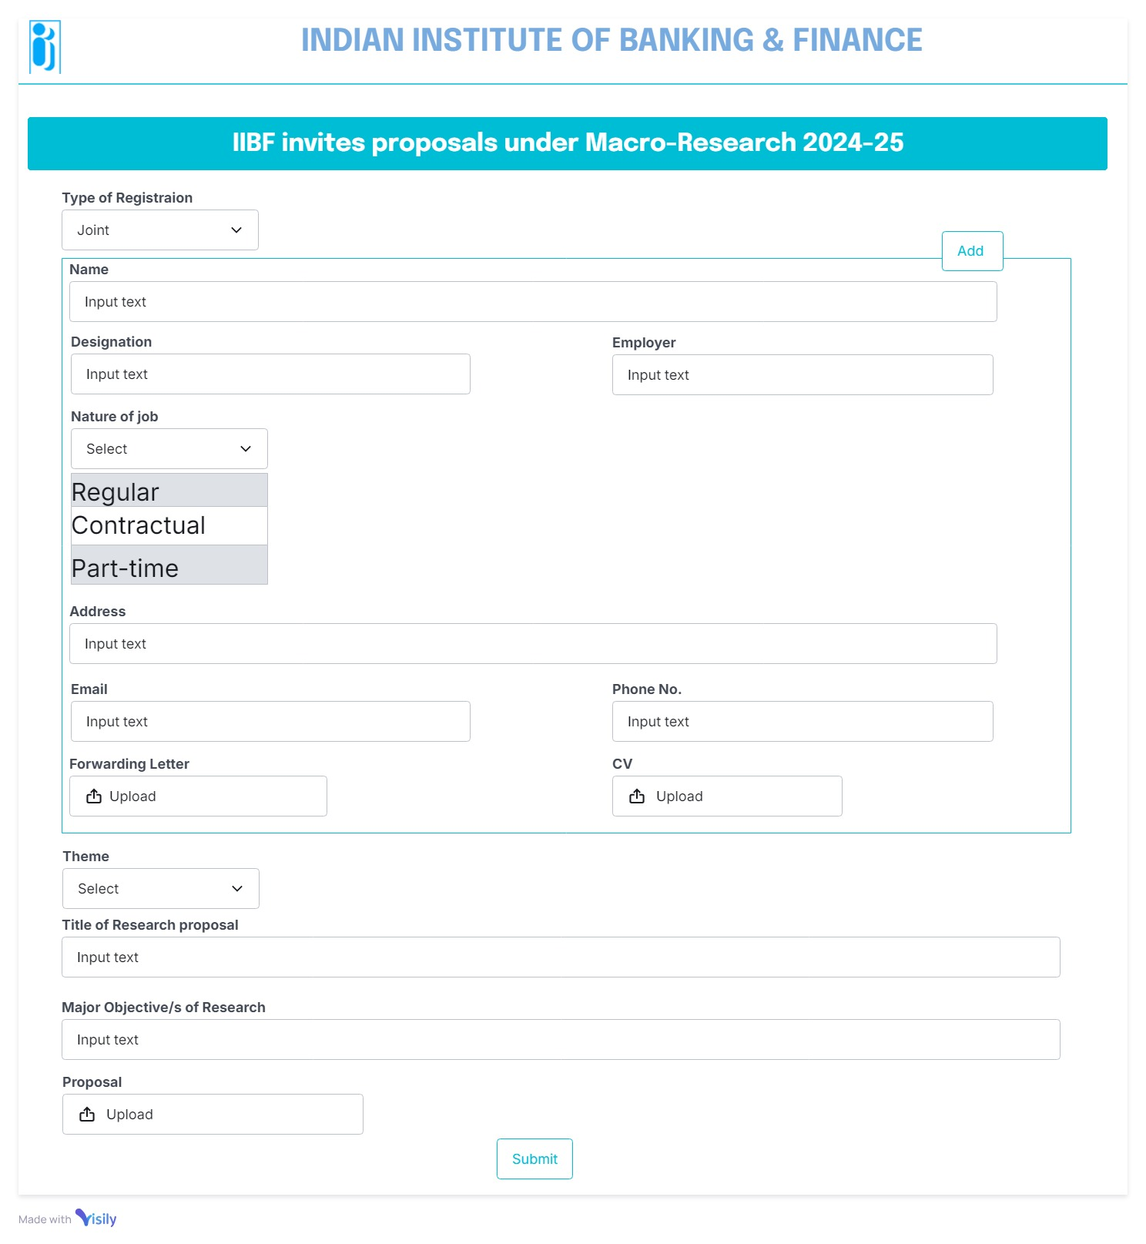

Institutional Form
